I N C O N F I D E N C E

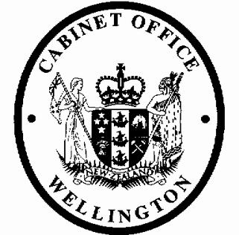
Cabinet Legislation Committee
Minute of Decision

LEG-21-MIN-0027

This document contains information for the New Zealand Cabinet. It must be treated in confidence and handled in accordance with any security classification, or other endorsement. The information can only be released, including under the Official Information Act 1982, by persons with the appropriate authority.

Tax Administration (Direct Credit of Totalisator Duty, Lottery Duty, Casino Duty, and Unclaimed Money) Order 2021

Portfolio Revenue

On 18 March 2021, the Cabinet Legislation Committee:

- noted that Section 184A of the Tax Administration Act 1994 provides for the phased implementation of compulsory direct crediting of tax refunds through Orders in Council for the various tax types;

- agreed that Inland Revenue issue refunds of totalisator duty, lottery duty, casino duty, and unclaimed money by direct credit, unless doing so would result in undue hardship or is not practicable;

- noted that the Tax Administration (Direct Credit of Totalisator Duty, Lottery Duty, Casino Duty, and Unclaimed Money) Order 2021 gives effect to the decision referred to above;

- authorised the submission to the Executive Council of the Tax Administration (Direct Credit of Totalisator Duty, Lottery Duty, Casino Duty, and Unclaimed Money) Order 2021 [PCO 23417/4.0];

- noted that the Order will come into force on 27April 2021.

Gerrard Carter Committee Secretary

Present: Officials present from:
Hon Chris Hipkins (Chair) Office of the Prime Minister
Hon Andrew Little Officials Committee for LEG Hon David Parker
Hon Poto Williams Hon Kris Faafoi
Hon Michael Wood (Deputy Chair)
Keiran McAnulty, MP (Senior Government Whip)

Hard-copy distribution:
Minister of Revenue

1
2r4hxlcklw 2022-03-07 10:50:31 I N C O N F I D E N C E

