I N C O N F I D E N C E

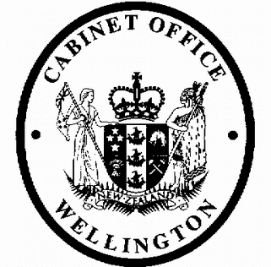
Cabinet Legislation Committee
Minute of Decision

LEG-19-MIN-0179

This document contains information for the New Zealand Cabinet. It must be treated in confidence and handled in accordance with any security classification, or other endorsement. The information can only be released, including under the Official Information Act 1982, by persons with the appropriate authority.

Income Tax (Minimum Family Tax Credit) Order 2019

Portfolio Revenue

On 19 November 2019, the Cabinet Legislation Committee:

- noted that in April 2004, the government agreed to increase the minimum family tax credit on 1 April each year by an amount sufficient to ensure that families do not suffer a reduction in income when moving off a welfare benefit and into full-time paid work, from 1 April 2006 onwards [CAB Min (04) 13/4];

- noted that the Income Tax (Minimum Family Tax Credit) Order 2019 increases the annual amount of the minimum family tax credit from $26,572 to $27,768 for the tax year beginning 1 April 2020, as allowed under section MF 7 of the Income Tax Act 2007;

- authorised the submission to the Executive Council of the Income Tax (Minimum Family Tax Credit) Order 2019 [PCO 22507/2.0];

- noted that the Income Tax (Minimum Family Tax Credit) Order 2019 comes into force on 1 April 2020.

Gerrard Carter Committee Secretary

Present:
Hon Chris Hipkins (Chair) Hon Andrew Little
Hon David Parker Hon Stuart Nash
Hon Iain Lees-Galloway Hon Jenny Salesa
Hon Tracey Martin Hon Eugenie Sage
Hon Ruth Dyson (Senior Government Whip)

Hard-copy distribution:
Minister of Revenue
Officials present from: Office of the Prime Minister Officials Committee for LEG

1
I N C O N F I D E N C E

