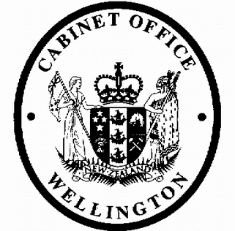
Cabinet Legislation Committee
Minute of Decision

This document contains information for the New Zealand Cabinet. It must be treated in confidence and handled in accordance with any security classification, or other endorsement. The information can only be released, including under the Official Information Act 1982, by persons with the appropriate authority.

Extending the Commissioner of Inland Revenue's Care and Management Role: Supplementary Order Paper

Portfolio Revenue

On 19 February 2019, the Cabinet Legislation Committee:

- noted that on 21 March 2018, the Cabinet Economic Development Committee (DEV) agreed to a proposal to enable new processes to allow exemptions to be issued to address legislative anomalies, either by way of an Order in Council, a determination or an administrative power of the Commissioner [DEV-18-MIN-0019];

- agreed to recommend that Cabinet agree to rescind the decision referred to in paragraph 1; and instead replace it with agreement to a proposal to enable new processes to allow the Commissioner of Inland Revenue to address legislative anomalies by way of an Order in Council on the recommendation of the Minister of Revenue, or through the use of an exemption-making power;

- agreed that exemptions issued by the Commissioner under the proposed power should be legislative instruments and disallowable instruments to ensure that these are subject to review by the Regulations Review Committee and can be disallowed by the House of Representatives;

- agreed that modifications made by an Order in Council can, depending on the circumstances, apply to taxpayers for a period including up to the most four recently completed income years from when the modification comes into force;

- noted that the attached Supplementary Order Paper is proposed to be released and considered by the Finance and Expenditure Committee as part of the Taxation (Annual Rates for 2019-20, GST Offshore Supplier Registration, and Remedial Matters) Bill;

- noted that the Supplementary Order Paper makes substantive amendments to the Tax Administration Act 1994;

- approved the Supplementary Order Paper [IRD 21621-1/4.0] for release, subject to the final approval of the government caucuses and sufficient support in the House of Representatives;

- delegated the Minister of Revenue authority to make minor amendments of a technical nature to the measures recommended in the paper under LEG-18-SUB-0012 without further reference to Cabinet;

- agreed that the Supplementary Order Paper should be released as soon as practicable following Cabinet agreement, and at the latest before 6 March 2019.

Vivien Meek Committee Secretary
Present:  Hon Chris Hipkins (Chair) | Officials present from:  Officials Committee for LEG
Hon Andrew Little
Hon David Parker
Hon Nanaia Mahuta
Hon Stuart Nash
Hon Iain Lees-Galloway
Hon Tracey Martin
Hon Ron Mark
Hon Kris Faafoi
Hon Ruth Dyson (Senior Government Whip)
Hard-copy distribution:
Minister of Revenue

