I N C O N F I D E N C E

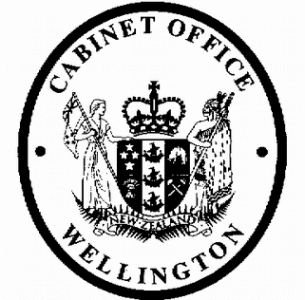
Cabinet Legislation Committee
Minute of Decision

LEG-19-MIN-0005

This document contains information for the New Zealand Cabinet. It must be treated in confidence and handled in accordance with any security classification, or other endorsement. The information can only be released, including under the Official Information Act 1982, by persons with the appropriate authority.

Taxation (New Due Date for New and Increased Assessments) Commencement Order 2019

Portfolio Revenue

On 12 February 2019, the Cabinet Legislation Committee:

- noted that the attached Order in Council prescribes when section 142AB of the Tax Administration Act 1994 in respect of income tax comes into force, on 8 July 2019;

- authorised the submission to the Executive Council of the attached Taxation (New Due Date for New and Increased Assessments) Commencement Order 2019 [PCO 21714/2.0].

Vivien Meek Committee Secretary

Present:
Rt Hon Winston Peters Hon Chris Hipkins (Chair) Hon Andrew Little
Hon Dr David Clark Hon David Parker Hon Stuart Nash Hon Tracey Martin
Hon Julie Ann Genter Hon Eugenie Sage
Hon Ruth Dyson (Senior Government Whip)

Hard-copy distribution:
Minister of Revenue
Officials present from:
Officials Committee for LEG

1
I N C O N F I D E N C E

