I N C O N F I D E N C E

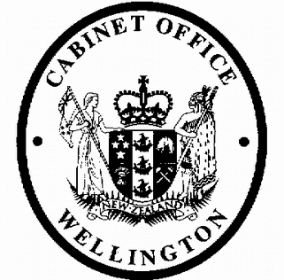
Cabinet Legislation Committee
Minute of Decision

LEG-18-MIN-0187

This document contains information for the New Zealand Cabinet. It must be treated in confidence and handled in accordance with any security classification, or other endorsement. The information can only be released, including under the Official Information Act 1982, by persons with the appropriate authority.

Student Loan Scheme (Repayment Threshold) Regulations 2018

Portfolio Revenue

On 13 December 2018, the Cabinet Legislation Committee:

- noted that on 5 December 2016, the Cabinet Legislation Committee agreed to the methodology for calculating the student loan repayment threshold and funding changes for 2017/18 and out-years [CAB-16-MIN-0655];

- noted that an Order in Council is required under section 215(a) of the Student Loan Scheme Act 2011 to set the student loan income repayment threshold;

- noted that the Student Loan Scheme (Repayment Threshold) Regulations 2018 will increase the student loan repayment threshold to $19,760 for the 2019/20 tax year;

- noted that increasing the student loan repayment threshold for the 2019/20 tax year has no impact on the operating balance and no changes to appropriations are required;

- authorised the submission to the Executive Council of the Student Loan Scheme (Repayment Threshold) Regulations 2018 [PCO 21752/2.0];

- noted that the Student Loan Scheme (Repayment Threshold) Regulations 2018 will come into force on 1 April 2019.

Vivien Meek Committee Secretary

Present: Officials present from:

Rt Hon Winston Peters Hon Chris Hipkins (Chair) Hon Andrew Little
Hon Iain Lees-Galloway Hon Damien O’Connor Hon Julie Ann Genter Hon Eugenie Sage
Hon Ruth Dyson (Senior Government Whip)
Officials Committee for LEG

Hard-copy distribution:
Minister of Revenue

1
I N C O N F I D E N C E

