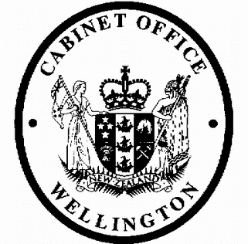
Cabinet External Relations and Security Committee
Minute of Decision

This document contains information for the New Zealand Cabinet. It must be treated in confidence and handled in accordance with any security classification, or other endorsement. The information can only be released, including under the Official Information Act 1982, by persons with the appropriate authority.

Amending Protocols to Tax Treaties with Switzerland and Guernsey: Approval for Signature

Portfolio Revenue

On 25 June 2019, the Cabinet External Relations and Security Committee:

- noted that, to ensure the underlying agreements meet minimum international standards relating to base erosion and profit shifting, officials have negotiated the following Protocols:

  - Protocol Amending the Convention between New Zealand and the Swiss Confederation for the Avoidance of Double Taxation with Respect to Taxes on Income (Amending Protocol with Switzerland), attached as Annex I to the paper under ERS-19-SUB-0014;

  - Protocol Amending the Agreement between the Government of New Zealand and the States of Guernsey for the Exchange of Information with Respect to Taxes and the Allocation of Taxing Rights with Respect to Certain Income of Individuals (Amending Protocol with Guernsey), attached as Annex II to the paper under
ERS-19-SUB-0014;

- approved the text of the two Amending Protocols referred to above, subject to any minor or technical changes arising from the process of legal verification;

- agreed that New Zealand sign each Amending Protocol;

- approved the extended National Interest Analyses (NIAs) prepared in relation to each of the Amending Protocols, attached as Annexes III and IV to the paper under ERS-19-SUB-0014;

- noted that, following signature, the texts of each Amending Protocol and its accompanying extended NIA will be presented to the House of Representatives for parliamentary treaty examination, in accordance with Standing Orders 397-400;

- noted that the Amending Protocols will each be incorporated into New Zealand domestic law through an Order in Council, pursuant to section BH 1 of the Income Tax Act 2007;

- invited the Minister of Revenue to issue drafting instructions to the Parliamentary Counsel Office to draft the Orders in Council to give effect to the Amending Protocols;

- noted that, following the signing and satisfactory completion of parliamentary treaty examination, the Orders in Council will be submitted to Cabinet for approval;

- authorised officials, following signature, the satisfactory completion of parliamentary treaty examination, and promulgation of the Orders in Council, to bring the Amending Protocols into force by exchanging diplomatic notes with Switzerland and Guernsey.

Janine Harvey Committee Secretary

Present: Officials present from:

Rt Hon Winston Peters (Chair) Hon Grant Robertson
Hon David Parker Hon Stuart Nash Hon Ron Mark
Office of the Prime Minister
Department of the Prime Minister and Cabinet Ministry of Foreign Affairs and Trade Ministry of Defence

Hard-copy distribution:
Minister of Revenue

