Simplifying taxpayer requirements

A Government discussion paper on proposals for change

First published in December 1997 by the Inland Revenue Department, PO Box 2198, Wellington, New Zealand.

Simplifying taxpayer requirements; a Government discussion paper on proposals for change.
ISBN 0-478-10325-5

FOREWORD

The proposals set out in this discussion paper reflect the Government’s continuing commitment to simplification of the tax system and reducing compliance costs for the taxpayers of New Zealand.

If adopted, the measures proposed here would significantly reduce the compliance burden on taxpayers. They would remove many of the onerous, repetitive requirements that the current tax system places on salary and wage earners and employers.

They would eliminate the need for IR 5 income tax returns, many of the Family Assistance forms and procedures that are part of the tax system, and a number of tax-related employer forms. This would have significant benefits for the 1.2 million individuals who file IR 5 returns each year. The only requirement for about 400,000 of them would be to check an Inland Revenue-generated statement compiled from information provided by employers.

Employers would also benefit. The 200,000 PAYE reconciliations and 4 million tax deduction certificates they process each year would no longer be needed.

Improved technology would be essential to the success of the proposals. To this end, Inland Revenue intends to provide new services such as electronic transfer of information with employers, and improve services such as telephone technology.

We welcome submissions on the proposals.

Hon Winston Peters Rt Hon Bill Birch
Deputy Prime Minister and Minister of Finance and
Treasurer Minister of Revenue

CONTENTS

1 OVERVIEW 1

Introduction 1
Summary of key proposals 1
Benefits of the proposals 4
Context of the reforms 4
Background to the simplification proposals 5
Key questions 6
Timeline 6
Submissions 7

2 THE NEW INCOME STATEMENT 8

Proposed policy 8
The income statement 9
Benefits of the proposals 12
Timeline 12
Submissions 12

3 IMPROVEMENTS IN THE ACCURACY OF THE PAYE
SYSTEM 13

Proposed policy 13
Secondary income 14
Deductions for extra emoluments 14
Employee declaration form 15
Non-declaration rate of deduction 15
Tax codes for special circumstances 16
Easier tax codes 17
Future improvements 18
Timeline 19
Submissions 19

4 IMPROVEMENTS IN THE ACCURACY OF THE RWT
SYSTEM 20

Proposed policy 20
Accurate deduction of RWT 20
Joint bank accounts 21
The new process 22
Dividends 23
Benefit of the proposals 23
Timeline 23
Submissions 23

5 SIMPLIFYING EMPLOYER PAYE OBLIGATIONS 24

Proposed policy 24
The new schedule 25
The new process 27
Benefits of the proposals 30
Timeline 31
Submissions 32

6 THE NEW REBATE CLAIM FORM 33

Proposed policy 33
Donation rebate 33
Childcare-housekeeper rebate 34
The new process 34
Removal of extra pay rebate 37
Benefits of the proposals 37
Timeline 37
Submissions 38

7 RECEIVING FAMILY ASSISTANCE UNDER THE NEW
SYSTEM 39

Proposed policy 39
Applications during the year 40
Applications at the end of the year 41
The new process 41
Guaranteed minimum family income 44
Benefits of the proposals 44
Timeline 45
Submissions 45

1
OVERVIEW

INTRODUCTION

1.1 Each year about 1.2 million New Zealanders fill in an IR 5 income tax return showing the income they received during the year and the rebates they are claiming. This takes each of them an average of one hour. About 50 percent of them need some help to complete their form – half an hour’s worth, on average. That adds up to 1.5 million hours each year devoted to filling in the nation’s IR 5 tax returns.

1.2 This discussion paper presents for public consideration a series of proposals to eliminate the IR 5 tax return. The proposals depend on information provided to Inland Revenue by third parties, such as employers and banks, and improvements in both the way it is provided and the detail. The principal benefit of the proposals is the removal of the obligation for salary and wage earners to file a tax return.

1.3 Under the proposals, employers would provide Inland Revenue with a monthly schedule detailing each employee’s salary and wage income and deductions such as PAYE, student loan repayments or child support payments. Both the PAYE reconciliation obligation and the requirement to issue IR 12 and IR 13 forms would be removed. The PAYE information from employers would be used by Inland Revenue to issue an income statement if required. The income statement would replace the annual IR 5 return and certain social policy forms.

1.4 The proposals represent the most significant reform of tax administration since the introduction of the PAYE system in 1958. Implementation of the proposals would also reduce the extent to which the tax system intrudes on the lives of most individual taxpayers. For this reason the Government welcomes the views of taxpayers, their advisers and other interested parties on the proposals outlined here.

1.5 The Government aims to achieve significant reductions in the compliance cost burden on wage and salary taxpayers, but not at the cost of the integrity of the tax system or failure to meet its social policy objectives.

SUMMARY OF KEY PROPOSALS

Income statements
IR 5 income tax returns would be eliminated.
Inland Revenue would create income statements from the information supplied by employers and send an income statement to taxpayers who:
- have a student loan repayment obligation;
- receive, or are entitled to receive, Family Assistance;
- had PAYE or resident withholding tax (RWT) deducted at an incorrect rate.

Income statements would be pre-printed with taxpayers’ wage and salary information and related details.

All taxpayers would have the right to request a certificate confirming their total earnings. If taxpayers consider they have overpaid or underpaid tax, they could request an income statement for confirmation.

Taxpayers with more than $200 income incorrectly taxed at source should request an income statement.

Taxpayers who earn income that does not have tax deducted at source, such as business or rental income, would have to complete an individual income tax return in the same way as they do now. Inland Revenue would issue these taxpayers with a pre-printed return showing all source deductions for the year.

Improvements to the PAYE system

A simplified employee declaration form would replace the IR 12 and IR 13 tax deduction certificates and would be completed only when employees started work or had a change in their tax code.

Easier tax codes would help taxpayers select the correct code for use during the year.

The non-declaration rate for taxpayers who do not provide their tax code and/or IRD number would be increased from 33 percent to 45 percent.

The tax codes for special circumstances would be removed. This would affect employees currently using the following codes:

- casual agricultural worker (CAW);
- election day worker (EDW);
- shearer (SHR); and
- shed-hand (SSH).

Improvements to the RWT system

Taxpayers would be able to elect a new 33 percent withholding rate if their total income is expected to exceed $38,000. Those who chose the correct tax rate would avoid end-of-year debts and the need to request an income statement.

The non-declaration rate for taxpayers who do not give their bank their IRD number would increase from 33 percent to 45 percent.
Resident Withholding Tax (RWT) certificates issued by banks would contain a statement reminding taxpayers that they need to request an income statement if insufficient tax has been deducted. A letter would also be sent in certain circumstances.

Monthly schedule

A new monthly schedule would:

- combine all information provided by employers in one form;
- remove the year-end reconciliation undertaken by employers; and
- remove the obligation to provide IR12 and IR13 deduction certificates.

Large employers would be required to provide information electronically, and small employers would be encouraged to do so.

Employer group schemes would cease.

The monthly schedules would be used to identify invalid IRD numbers and the incorrect use of tax codes.

Rebate claim form

Taxpayers claiming donation and housekeeper-childcare rebates would complete a new annual rebate claim form.

The annual maximum rebate would not change.

Family Assistance

All taxpayers claiming Family Assistance would complete a registration form which would replace the current annual application.

For those wishing to claim during the year, Inland Revenue would provide a suggested estimate of income on which entitlement should be based.

The Family Assistance renewal date would be moved from 1 April to 1 July.

Family Assistance would be calculated on the basis of information contained in the income statement.

Overpayments of Family Assistance would be remitted automatically if taxpayers have used Inland Revenue’s income calculation and have advised any changes in circumstances.

Overpayments of Family Assistance that do not qualify for automatic remission would be recovered from the current year’s entitlement.

Benefits of THE PROPOSALS

1.6 As a package, these proposals are expected to achieve further reductions in the compliance costs imposed on employees and provide administrative savings.

1.7 Research shows that 25 percent of taxpayers find it difficult to complete their IR 5 return. The proposals would eliminate this tax return.

1.8 Pre-coding the income statement with wage and salary information would reduce compliance costs for those who received them.

1.9 The proposals would, at the same time, reduce the compliance cost burden on employers.

1.10 The new rebate claim form process would allow taxpayers to receive their refunds without having to complete income tax returns. It would also allow those filing individual returns (previously IR 3) to receive refunds for rebates before the due date for the return.

context of the reforms

1.11 Over the last decade there have been extensive reforms of both tax policy and tax administration in New Zealand. These reforms include broadening the tax base, the implementation of various social policy measures through the tax system, and the modernisation of the tax system through the increased use of technology and a new organisational structure for Inland Revenue.

1.12 The Government has been seeking ways to minimise the compliance costs associated with paying tax. Compliance costs consist of both the monetary and non-monetary costs imposed on taxpayers when complying with their tax obligations. Compliance costs do not include tax itself. For taxpayers who earn income from salary, wages, interest and dividends, compliance costs are mainly the costs associated with completing forms and dealing with Inland Revenue. There are also minor costs associated with making the tax payment and meeting various PAYE and RWT obligations.

1.13 In considering measures to reduce the compliance costs of individual taxpayers, the Government is not simply imposing the costs on others. Although the Government has attempted to look for compliance cost reductions and simplifications for all taxpayer groups, it is inevitable that any tax system will impose some compliance costs, and it therefore becomes a matter of balancing those costs.

1.14 The Government has been reviewing simplification opportunities since the publication of the discussion paper Tax Simplification Issues. The first step of this review was to establish the minimum information required for the tax system to achieve its goals in relation to IR 5 taxpayers. Information is required to:

- provide accurate revenue forecasting; and
- ensure the integrity of the income tax base.

1.15 The next step was to establish the best source from which to obtain that information. Although in some cases this was the individual taxpayer, often it was a third party such as an employer or a bank. Finally, the review considered the best way of providing the information, placing an emphasis on methods involving low compliance and administrative costs.

1.16 Research has identified those tasks that taxpayers and third parties consider repetitive and onerous. In considering new ways of providing information to Inland Revenue, an objective was to remove or reduce these tasks.

Background to the simplification proposals

1.17 In 1992 the International Monetary Fund reported that it was in favour of countries installing final withholding systems so as to reduce the number of returns to be processed. Adoption of such a system in the United States was considered feasible with improved technology.

1.18 This is the second of the Government’s discussion papers on reducing the compliance costs imposed on taxpayers. The first discussion paper, Tax Simplification Issues, published in August 1996, proposed reductions in the requirement to file IR 5 returns. It proposed that employees on the top marginal tax rate not be required to file income tax returns if they chose to have interest, bonuses and secondary employment withheld at 33 percent. The paper also proposed to transfer the required income information to a new social policy return.

Information technology

1.19 Information technology is an essential part of business and it is becoming an essential component of the tax system. It provides a significant opportunity to reduce the compliance costs imposed by the tax system.

1.20 The proposals contained in this discussion paper rely on information technology to reduce both compliance and administrative costs. In fact, some proposals, such as that to process information provided by employers monthly, would not be possible without the use of improved technology.

1.21 The proposals incorporate simplified methods for those who use manual systems, such as smaller employers. The proposals would, however, require large employers to provide all information to Inland Revenue electronically.

Supporting the transition

1.22 The Government recognises that some employers could face implementation and compliance difficulties during the transitional period. Inland Revenue would support employers during this period and would adopt a flexible approach to the application of penalties where appropriate.

Key questions

1.23 Before making final decisions on whether to proceed with the various simplification proposals discussed in this paper, the Government wishes to seek the views of interested people. Key areas for comment are:

- the proposed elimination of IR 5 returns;
- the introduction of the income statement, the rebate claim form and the monthly schedule;
- suggestions for further simplification; and
- suggestions for further compliance cost reduction.

1.24 These suggestions do not have to be limited to the proposals in this discussion paper but may cover any legislative or administrative issue.

Timeline

1.25 The Government recognises the substantial changes required by employers and financial institutions to give effect to the proposals and the system constraints caused by the year 2000 issue. However, the benefits to employers and taxpayers arising from the proposals would also be significant and would outweigh the transitional costs. Therefore the Government supports a general 1 April 1999 application date.

1.26 The proposed timeline is as follows:

Proposal | Proposed  Implementation Date
Income statement (chapter 2) | 1 April 2000
PAYE changes (chapter 3) | 1 April 1999
Resident withholding tax changes (chapter 4) | 1 April 1999
Monthly schedule (chapter 5) | 1 April 1999
Rebate claim form (chapter 6) | 1 April 2000
Family Assistance (chapter 7) | 1 July 2001

Submissions

1.27 The Government seeks public submissions on the proposals contained in this discussion paper.

Submissions should be addressed to:

Simplifying Taxpayer Requirements
General Manager (Operations)
Inland Revenue Department
P O Box 2198
WELLINGTON

OR sent via e-mail to:

Feedback@ird.govt.nz

1.28 Submissions should be made before 27 February 1998. They should include a brief summary of their major points and recommendations. They should also indicate whether it would be acceptable for officials to contact those making the submission to discuss their submission if required.

2
THE NEW INCOME STATEMENT

PROPOSED POLICY

- Introduce a certificate confirming total earnings.

- Replace the income tax return (IR 5) with an income statement issued automatically by Inland Revenue to taxpayers who meet certain criteria, or on request.

- Pre-code income statements with wage and salary information and other taxpayer-specific information obtained from employers during the year.

- Require taxpayers who now complete an IR 3 tax return to complete a simplified version of the tax return. The main difference between the returns would be that wage and salary information would be pre-coded on the simplified return.

- Require taxpayers to advise Inland Revenue of income that has had tax incorrectly deducted at source only if it exceeds $200.

- Regard the income statement as an assessment at the terminal tax due date.

- Credit refunds into a bank account rather than issue them by cheque.

2.1 At present, those who file IR 5 tax returns are individuals who earn income solely from salaries, wages and resident withholding income (New Zealand sourced interest and dividends). For other forms of income they must file an IR 3 return.

2.2 Taxpayers must file an IR 5 return if they:

- earn more than $38,000 gross income;
- derive gross income as a shearer or shearing shed-hand;
- are absentee but still considered resident for tax purposes;
- participate in some way in one of the various social policy measures administered through the tax system (for example, the student loan scheme).

2.3 Unless they meet the current non-filing criteria, they must file an IR 5 tax return by 7 June. They are required to include in that tax return their salary or wage income and interest and dividend income.
2.4 The main purpose of the income tax return is to confirm their income and allow any rebates to which they are entitled. The information they provide is also used to assess obligations relating to income tax, Family Assistance, child support and student loans.

2.5 Once Inland Revenue processes the return, it issues a Notice of Assessment in relation to these obligations. Those who agree with their assessment either receive a refund or have to pay the amount assessed by 7 February of the following year. If the amount assessed is not paid by this date, Inland Revenue imposes a late payment penalty and use of money interest.

THE INCOME STATEMENT

2.6 The Government proposes to replace the IR 5 tax return with an income statement. The income statement would be prepared from the information supplied by employers and financial institutions. It would show the gross income, taxes deducted, and any refund or payment due.

2.7 Inland Revenue would send an income statement to individuals if:

- they have a student loan;
- they receive Family Assistance or Inland Revenue believes they are entitled to receive it;
- they have a special tax code or are covered by one of the special PAYE codes such as the shearing shed-hand code (if these are retained);
- they used an incorrect PAYE or RWT tax code, or an incorrect rate, at any time during the year that resulted in an underpayment of tax; or
- they request it.

2.8 The statement would inform them of any refund or tax to pay.

2.9 About 1.2 million people currently complete an IR 5 tax return. Under these proposals, the IR 5 return would be replaced by the income statement for 400,000 of these taxpayers. The remaining 800,000 taxpayers would be freed of the annual obligation to complete a tax return.

2.10 Taxpayers with income over $38,000 a year would not receive an income statement unless they met one of the criteria outlined above. In other words, the return filing obligation on those taxpayers with more than $38,000 income would be removed. To gain the benefit of this measure, they would have to ensure that any extra emoluments or secondary employment had PAYE withheld at 33 percent and that RWT applied to their interest income at 33 percent. Otherwise they would receive an income statement and have to pay the tax shortfall.

2.11 The income statement would detail an individual’s salary and wage income and the amount of PAYE deducted from that income, using information provided by employers during the year on monthly schedules (see chapter 5). Inland Revenue would calculate income-related rebates such as the low-income rebate on the basis of information it holds. Inland Revenue would also calculate whether someone was due a refund or had tax to pay. The income statement process is outlined in figure 1.

2.12 Inland Revenue would issue the statements by the end of May of each year, along with a guide so taxpayers could check the calculations if they wished.

2.13 With the proposed improvements to the PAYE system, and the introduction of the rebate claim form, the number of taxpayers owed a refund would decrease.

2.14 The success of eliminating return filing envisaged by the proposals is largely dependent on people accepting the accuracy of the PAYE system. If they did not accept its accuracy, they could request an income statement to verify their tax position. However, if it resulted that they had tax to pay, it would have to be paid.

2.15 Taxpayers who thought they might be entitled to a refund could request a certificate of earnings to determine whether this was so. (The certificate is discussed later in this chapter.) Then, after checking it, if they still believed they were due a refund they could request an income statement, and any refund would be paid into their bank account.

Figure 1: The income statement process

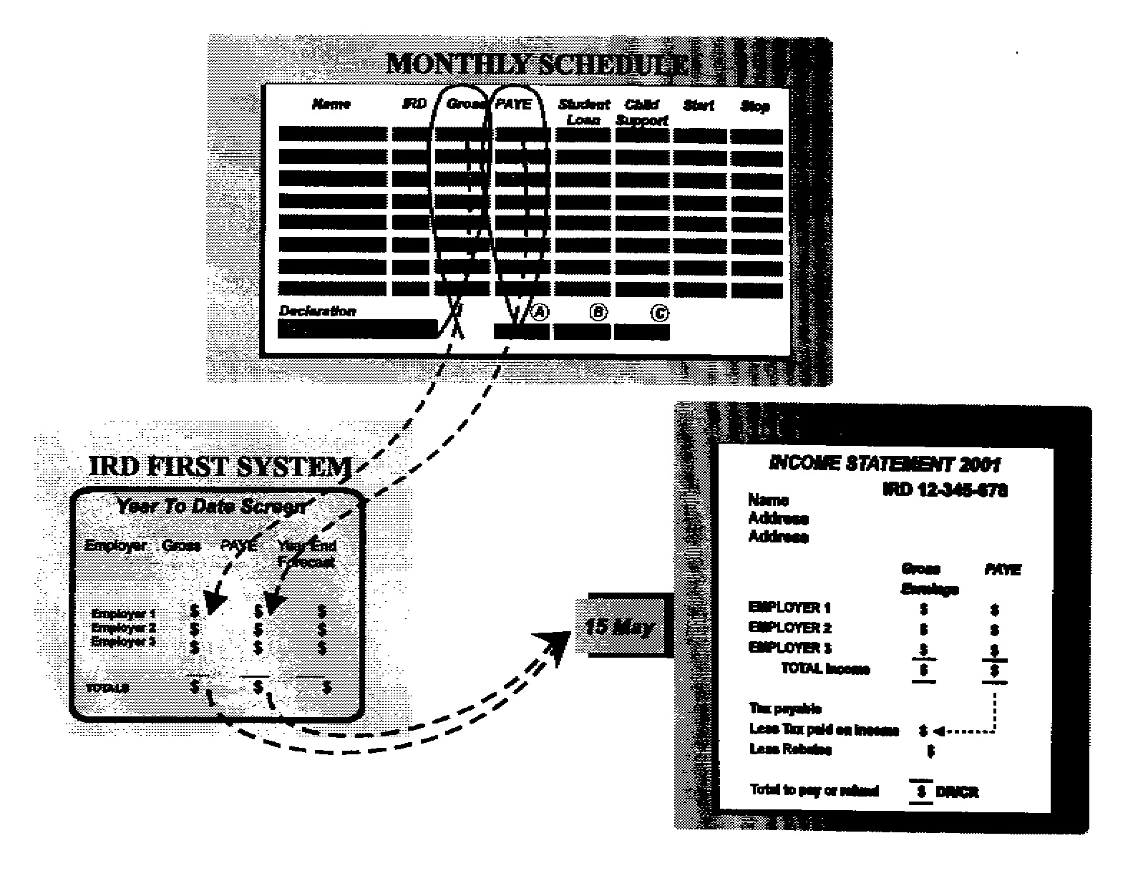
2.16 Taxpayers would have to check their statement to ensure their income was complete. They would have to declare other income exceeding $200 from which tax had been incorrectly deducted but not shown on their income statement. The $200 threshold would provide the non-filing system with a degree of flexibility, reducing both compliance and administrative costs. Taxpayers would be required to return any income they earned that was not taxed at source (which would mean they would receive an individual tax return in subsequent years).

2.17 Taxpayers could make amendments to an income statement up to, and including, the terminal tax due date, at which point the income statement would become an assessment. After the terminal tax due date, taxpayers who disagreed with an income statement/assessment would have to contact Inland Revenue to make any necessary amendments or file a Notice of Proposed Adjustment and start dispute proceedings, as at present.

2.18 The next step for those who accepted the income statement as correct would depend on whether the statement showed:

- a nil balance, in which case no further action would be required;
- a refund, which would be direct-credited to their bank account; or
- tax to pay as well as any liability in relation to one of the social policy measures administered through the tax system. This would be payable by the terminal tax due date. Any income tax debt under $20 would not be payable, as at present.

Individual tax return

2.19 Individual taxpayers who now complete an IR 3 tax return would instead be required to complete an individual tax return (a simplified version of the current IR 3 tax return). The principal difference is that the front page of the new return would be pre-coded with the taxpayer’s wage and salary information.

Treatment of donation and housekeeper-childcare rebates

2.20 The donation and housekeeper-childcare rebates would be claimed through the new rebate claim form. Chapter 6 outlines this new process.

Treatment of expenses

2.21 The IR 5 return allows taxpayers to claim various expenses such as the return preparation fee charged by tax agents or accountants or income protection insurance. Under the proposed system, taxpayers wishing to claim these expenses would need to advise Inland Revenue and their income statement would be amended accordingly.

Certificates of earnings

2.22 Anyone would be entitled to request a certificate of earnings as a permanent record of their income for the year. A record would be available from Inland Revenue because, with the introduction of the monthly schedule, employers would no longer provide the IR 12 and IR 13 tax deduction certificates. The certificate of earnings would detail a taxpayer’s wage and salary income and PAYE deductions but, unlike income statements, would not show tax calculations.

Benefits of the proposals

2.23 The principal benefit of these proposals is the outright removal of the obligation to complete a tax return by over 1.2 million salary and wage earners.

2.24 About 400,000 salary and wage earners would not have to complete a tax return but would instead receive an income statement with their wage and salary details already included. The compliance costs involved in checking an income statement would be considerably less than those incurred in completing an IR 5 tax return. Further, it is expected that most income statements would be correct, meaning only a small minority of taxpayers would be required to contact Inland Revenue with further information.

2.25 Since individual tax returns would also be pre-coded with wage and salary information, taxpayers completing these returns would also have their compliance costs reduced.

TIMELINE

2.26 The proposals outlined in this chapter would apply from 1 April 1999. This would see the last IR 5 returns filed for the income year ending 31 March 1999. The first income statements would be issued in May 2000, with simplified IR 3 returns being received from the year 2000.

SUBMISSIONS
The Government seeks public submissions on:
- the introduction of a certificate of earnings;
- the introduction of an income statement to replace the income tax return (IR 5);
- the impact on taxpayers of the introduction of a $200 threshold;
- the proposal that income statements would be deemed assessments as at the terminal tax due date; and
- the proposed timeline.
3
IMPROVEMENTS IN THE ACCURACY OF THE PAYE SYSTEM

PROPOSED POLICY

- Simplify the employee declaration form.

- Introduce a new system of tax codes that are easier to understand.

- Increase the non-declaration rate from 33 percent to 45 percent.

- Remove the tax codes for special circumstances.

3.1 The object of the PAYE system is to deduct tax on salary and wage income at source. It was introduced in 1958 and is administered by Inland Revenue and employers. Previously, taxpayers had to declare their income each year and pay their total tax liability in a lump sum. The PAYE system assists taxpayers by allowing them to pay their tax throughout the income year.

3.2 Since 1958 the PAYE system has remained largely untouched, except to incorporate the collection of employee premiums on behalf of the Accident Rehabilitation and Compensation Insurance Company (ACC), child support contributions, and student loan repayments.

3.3 Employees are required to complete a tax deduction certificate (IR 12 or IR 13 form) when they start work, and if their employers do not operate a computer payroll, at the beginning of each new tax year. These certificates require employees to provide details of their name and address, IRD number and tax code. They select the tax code appropriate for their employment and circumstances.

3.4 Employers use the tax code to calculate the correct PAYE deduction. If employees fail to complete the IR 12 or IR 13 form before the first pay-day, employers are required to deduct tax at the currently higher 33 percent non-declaration rate.

3.5 At the end of each tax year, employers total the income received and deductions made for the year on the IR 12 or IR 13 certificate and return it to the employees. Employees attach the IR 12 or IR 13 form to their IR 5 tax return and send it to Inland Revenue, where their tax liability for that year is assessed and balanced. Not all taxpayers are required to file returns, although anyone may do so if they wish.

3.6 A non-filing system would require a more accurate PAYE system. This is because PAYE would become more like a final tax than a withholding tax that requires checking at the end of the year.

3.7 Although the PAYE system satisfies its purpose, it is not entirely accurate, resulting in individual taxpayers paying either too much or not enough tax at the end of the year.

3.8 The objective is to increase the accuracy of the PAYE system, minimising the need to undertake an end-of-year “square-up”.

3.9 The IR 5 tax return allows Inland Revenue to work out how much tax the individual taxpayer is liable to pay compared with the amount actually paid through the PAYE system. The difference is an amount either overpaid (which is refunded to the taxpayer) or underpaid (paid by the taxpayer).

SECONDARY INCOME

3.10 The Taxation (Remedial Provisions) Bill (No. 2) 1997, currently before Parliament, proposes that employees may elect to have a 33 percent tax rate apply to secondary employment. From 1 July 1998, the secondary employment rate will be 21 percent. This will result in an underpayment of tax by those whose income from all sources exceeds $38,000.

3.11 The bill proposes a new tax code (SH) to support the new secondary employment rate.

DEDUCTIONS FOR EXTRA EMOLUMENTS

3.12 From 1 July 1998 extra employment income such as annual bonuses, back-pay and other lump sum payments will be taxed at 21 percent. This raises issues similar to those relating to the secondary employment rate, principally that under-deduction of PAYE for employees who earn over $38,000 will occur on all extra emoluments taxed at 21 percent.

3.13 Research conducted by Inland Revenue shows that under-deduction of tax on extra emoluments paid to employees earning more than the top tax rate threshold is a significant source of tax to pay at the end of the income year. The average tax bill for taxpayers who fall into this category is $179.79.

3.14 As a solution, the Taxation (Remedial Provisions) Bill (No. 2) 1997 also proposes that employers apply a 33 percent extra emolument rate if the combined total of the annualised value of an employee’s last four weeks’ pay and the extra emoluments exceeds $38,000. Employees may also elect to use this rate.

EMPLOYEE DECLARATION FORM

3.15 A tax deduction certificate (IR 12 or IR 13 form), which employees fill in when they start a new job, serves two purposes:

- as a signed declaration of personal details including their name and address, IRD number and tax code; and

- an end of the year tax deduction certificate providing confirmation of total yearly income and deductions.

3.16 Employers complete the form in duplicate: one copy is given to employees to include in their tax return, and the other copy is sent to Inland Revenue after the end of the tax year with the employer’s IR 68P PAYE Reconciliation forms.

3.17 It is proposed that Inland Revenue receive all income and deduction information for employees from employers by means of the monthly schedules (chapter 5). This would eliminate the need for employers to do the end-of-year reconciliation and prepare IR 12 and IR 13 forms. Inland Revenue would use this information from the employer to assess a taxpayer’s liability rather than having the taxpayer file an IR 5 return.

3.18 The proposal is to introduce a simplified declaration form to replace the IR 12 and IR 13 forms. The sole purpose of this form would be for employees to make a formal declaration of their name, address, IRD number and tax code.

3.19 Unlike the current IR 12 and IR 13 forms, which apply to specific years and are therefore completed annually, the simplified employee declaration form would continue to apply until changed by the employee.

3.20 Since employees are rarely required to change tax codes, many would only ever complete one form, resulting in compliance cost savings for both employers and employees. When an employee’s tax code did change, the employee would simply provide the employer with a new form.

NON-DECLARATION RATE OF DEDUCTION

3.21 The non-declaration rate is used by employers when employees do not complete their IR 12 or IR 13 form in full. The current non-declaration rate is 33 percent and represents the top marginal tax rate for individuals.

3.22 This rate prevents an under-deduction of tax when the employee’s total income exceeds the $38,000 top tax rate threshold. It encourages employees to provide their IRD number so that Inland Revenue can associate income with the correct taxpayer and ensure the correct tax rate is applied throughout the year.

3.23 The Government considers the 33 percent non-declaration rate insufficient to achieve these objectives. The current rate of 33 percent results in insufficient deductions when taxpayers have social policy responsibilities such as student loan and child support payments, and does not provide sufficient incentive for them to comply.

3.24 For these reasons it is proposed that the non-declaration rate be increased to 45 percent, to be applied when employees fail to complete the proposed declaration form in full, including the provision of their IRD number.

3.25 Taxpayers could arrange to have any overpayment of tax refunded after the end of the tax year provided they eventually furnished their IRD number. If they did not provide their IRD number, Inland Revenue would not be able to credit the tax paid to their account.

3.26 The Government is aware that an increased non-declaration rate might increase compliance costs for employers. The increase in costs should diminish over time, given the strong incentives on employees to provide their number promptly.

3.27 This proposal would require supporting administrative measures. Inland Revenue would give priority to applications for IRD numbers. In urgent cases Inland Revenue would confirm an IRD number by telephone, which would allow an employer to apply the correct tax code until the employee received formal notification of his or her IRD number.

TAX CODES FOR SPECIAL CIRCUMSTANCES

3.28 At present, a number of special PAYE tax codes apply to specific employment types: election-day workers, casual agricultural workers, shearers and shed-hands. There are two reasons for this.

3.29 The first is to ensure an accurate level of PAYE deduction for employees when the standard PAYE codes are likely to result in an over-deduction or under-deduction of tax. However, the benefit of special rates has declined in line with the reductions in income tax rates. Further, these rates have not been reviewed recently and it is likely that in many cases more PAYE is being deducted than would be under the standard PAYE rules.

3.30 The second reason for these special tax codes is that the 20 percent and 25 percent rates reduce the compliance costs imposed on employers of election-day workers, casual agricultural workers, shearers and shed-hands. Otherwise, the transitional nature of these types of employment would mean relatively high compliance costs for employers.

3.31 Tax deductions using standard tax codes are expected to be more accurate, reducing the need to complete an end-of-year “square-up”. This would reduce the overall administrative and compliance costs imposed by retaining these special codes.
3.32 On this basis the Government is considering removing all special PAYE codes. However, if a clear compliance cost benefit from a particular code is identified it would be retained. In this case the codes would be reviewed to ensure they were accurate in light of current tax reductions, and any changes would come into effect in July next year.

EASIER TAX CODES

3.33 Inland Revenue research indicates that about 9 percent of PAYE errors arise through the use of incorrect tax codes. This results in an average end-of-year debt of approximately $215 for employees using the wrong codes.

3.34 The Government proposes to improve the tax codes to make it simpler for taxpayers to select the right code by changing to more descriptive and self-explanatory codes. The proposed codes are shown in table 1.

Table 1: Proposed tax codes

Code | Description | Equivalent old code
M | Main source of income. Only one job can have this code. | G
M SL | Main source of income with a student loan. Only one job can have this code. | G ED
ML | Main source of income if annual taxable income is less than $9,880 a year from all sources. To use this code the employee must work full-time (more than 20 hours per week). | T
S | Secondary sources of income if annual taxable income is less than $38,000. | SEC
SH | Secondary sources of income if annual taxable income is higher than $38,000.
S SL | Secondary source of income if taxpayer’s annual taxable income is less than $38,000 and he or she has a student loan. | SEC ED
SH SL | Secondary sources of income if annual taxable income is higher than $38,000 and he or she has student loan.
STC 99 | Special tax code rate issued by Inland Revenue (99 indicates the special tax code rate in cents per dollar). | IR 23

3.35 Student loan holders would continue to select the student loan code only if their income was expected to exceed the minimum repayment threshold.

3.36 The selection of the correct code would reduce the need for employees to have any end-of-year tax “square-up” and result in significant compliance cost and administrative savings.

3.37 There would be a transitional education cost for both employers and employees. To ease the transition from the old codes to the new codes, employers would be able to make the following changes automatically:

- Employees using the G tax code would now use the M tax code.
- Employees using the G ED code would now use the M SL code.

3.38 All employees using any of the remaining tax codes would need to confirm their tax code using the simplified employee declaration form.

FUTURE IMPROVEMENTS

3.39 At its core the PAYE system assumes an employee’s pay, for a single pay-period, can be grossed up to give an accurate representation of annual income. While this is reasonable for most employees, it can lead to errors, mainly for those who have a fluctuating source of income.

3.40 From 1 April 2001 the Government will consider implementing a more accurate cumulative PAYE calculation method for employers using computer payroll systems.

3.41 Under the proposal an employer would gross up an employee’s year-to-date earnings to represent a full year’s income, add any extra emoluments paid year-to-date and calculate the PAYE on that income. The annual PAYE figure would then be scaled downward to determine the total current PAYE liability. Any PAYE paid in an earlier pay-period would then reduce this amount. The amount remaining would be the amount of PAYE to be deducted in the current pay-period.

3.42 The principal advantage of this measure is that it would provide an accurate and self-balancing level of PAYE deduction during the year, reducing under-deductions and over-deductions of tax. The system would also automatically take lump sum payments into account, eliminating the need for a separate extra-emolument rate of deduction, thus reducing compliance costs on employers.

3.43 By increasing the accuracy of PAYE deductions this measure would increase the integrity of the tax system. There would also be a reduction in compliance and administrative costs because some taxpayers would no longer have their PAYE over-deducted and be required to get that over-deduction refunded by requesting an income statement.

3.44 Only employers with computerised pay systems would have to use the cumulative PAYE calculation method. Because of the time needed for the relevant systems changes, the Government would aim to introduce the method from 1 April 2001.

TIMELINE

3.45 The changes to the withholding rate for secondary income and extra emoluments proposed in the Taxation (Remedial Provisions) Bill (No. 2) 1997 have an application date of 1 July 1998.

3.46 The cumulative PAYE system for employers using computer payroll packages would be timed for an application date of 1 April 2001.

3.47 The balance of the proposals in this chapter would have an application date of 1 April 1999.

SUBMISSIONS
The Government seeks public submissions on:
- the introduction of a simpler employee declaration form;
- an increased non-declaration rate;
- the impact of the removal of tax codes for special circumstances, especially on employers;
- the introduction of easier to understand tax codes; and
- the proposed transitional measures for moving employees from existing tax codes to the new tax codes.
4
IMPROVEMENTS IN THE ACCURACY OF THE RWT SYSTEM

PROPOSED POLICY

- Introduce a new 33 percent withholding rate which taxpayers will be able to select if their income is expected to exceed $38,000.

- Increase the non-declaration from 33 percent to 45 percent.

- Incorporate a statement in RWT certificates issued by financial institutions, informing taxpayers to contact Inland Revenue if insufficient tax has been deducted from their interest.

4.1 Resident Withholding Tax (RWT) is deducted by financial institutions each time interest is credited to taxpayers’ bank accounts. The measures outlined in this chapter would help to ensure that it is deducted correctly.

4.2 From 1 July 1998, RWT will be deducted from interest income for all taxpayers who do not have a certificate of exemption, at the rate of 19.5 percent (decreased from 21.5 percent) provided they have supplied their IRD number to their financial institution. If they have not supplied their IRD number, the financial institution will deduct RWT at the existing non-declaration rate of 33 percent.

4.3 This means those taxpayers with income over $38,000 who receive interest will either:

- have their interest under-deducted at the rate of 13.5 cents in the dollar (33 percent - 19.5 percent); or

- if they have not supplied their IRD number to their bank, have their interest taxed at the non-declaration rate of 33 percent, which is the correct rate for income over $38,000.

ACCURATE DEDUCTION OF RWT

4.4 In a non-filing system, the RWT flat rate of 19.5 percent would result in considerable under-deduction of tax from those who should be on the 33 percent tax rate.

4.5
The existing system also encourages some taxpayers not to provide their financial institution with an IRD number, so that the non-declaration rate of 33 percent is used and the correct amount of tax paid. Taxpayers do this to avoid a year-end tax bill. However, the absence of an IRD number restricts Inland Revenue’s ability to associate this income with the correct taxpayer.

4.6 To encourage taxpayers to provide financial institutions with an IRD number, it is proposed:

- to allow taxpayers to elect a 33 percent withholding rate if their total income exceeds $38,000; and
- to increase the non-declaration rate for failure to provide an IRD number from 33 percent to 45 percent, making the non-declaration rate consistent with the PAYE rate.

4.7 This proposal would require financial institutions to update their systems to provide for the following RWT deduction options:

- 19.5 percent - if the IRD number has been provided;
- 33 percent - if the IRD number has been provided and the taxpayer has elected the higher deduction rate (which means the taxpayer probably earns more than $38,000 taxable income); and
- 45 percent - if the IRD number has not been provided.

4.8 Financial institutions would not be required to verify the accuracy of the RWT rate provided.

JOINT BANK ACCOUNTS

4.9 Ensuring that the correct rate of tax is applied to joint accounts is difficult because the rate to be applied may differ, depending on the holders’ respective taxable income.

4.10 To minimise compliance costs to financial institutions and taxpayers, joint account holders are currently required to provide the IRD number of only one of the account holders. Under the proposals, the rate applied would either be 19.5 or 33 percent, depending on the deduction rate elected by the account holder.

4.11 One option would be to require each joint account holder to provide IRD numbers to their financial institutions and select the appropriate withholding rate. This was not considered a viable option because of the compliance costs it would impose on financial institutions.

4.12 The Government proposes to continue with the single IRD number for joint accounts. Taxpayers would be required to advise Inland Revenue if the wrong amount of tax is deducted from their interest. RWT certificates issued by financial institutions would incorporate a request for taxpayers to do this. The statement would indicate when the low deduction rate of 19.5 percent had been applied.

4.13 The income statement would be used to balance any overpayments or underpayments of RWT. This is explained in chapter 2.

THE NEW PROCESS

4.14 At the end of the income year financial institutions would issue RWT deduction certificates, as they do now. These certificates would contain details of account holders’ total gross interest and resident withholding tax deductions. Nothing would be required of taxpayers who elected the correct tax rate before the start of the tax year, since their correct amount of tax would have been withheld.

4.15 Interest income would not automatically be included in income statements unless taxpayers advised Inland Revenue of that income. Some taxpayers might be unaware that RWT had been insufficiently withheld, and that they were required to advise Inland Revenue of the situation. This would happen mainly to those earning over $38,000 who were using the lower RWT withholding rate, a common problem for people with joint bank accounts.

4.16 To help overcome this difficulty, Inland Revenue would write to all taxpayers earning over $38,000 and receiving over $200 in interest income, informing them of their interest and RWT deductions, as supplied to Inland Revenue by their financial institutions. If this information is correct the taxpayer need do nothing. In this case, and if RWT had been under-deducted, Inland Revenue would send the taxpayer an income statement including interest income and the tax owing.

4.17 If the information is not correct - for example, if the taxpayer has a joint bank account to which his or her IRD number is not attached - the taxpayer would need to amend the letter and return it to Inland Revenue. Inland Revenue would update its information and then send the taxpayer an income statement including the correct interest information.

4.18 Taxpayers using the higher 33 percent withholding rate but earning less than $38,000 might be entitled to a refund. In this case they would need to advise Inland Revenue of their total investment income and RWT for the year. Inland Revenue would then generate an income statement.

DIVIDENDS

4.19 The process relating to dividends would be similar to that for interest except that the provision of two deduction rates and an increase in the non-declaration rate would not apply. This means RWT would be deducted at the single rate of 33 percent during the year. Taxpayers with a taxable income of less than $38,000 would receive a refund for any overpaid RWT through the income statement process.

BENEFIT OF THE PROPOSALS

4.20 The principal benefit is the accurate deduction of RWT during the year for those whose income is over $38,000 and who select the RWT rate of 33 percent.

TIMELINE

4.21 The proposals outlined in this chapter would have an application date of 1 April 1999.

SUBMISSIONS

The Government seeks public submissions on:

- the proposal that taxpayers be able to elect the higher 33 percent withholding rate;

- the increase in the non-declaration rate from 33 percent to 45 percent;

- the compliance cost to financial institutions of updating their systems; and

- the proposal to include a statement on RWT certificates.

5
SIMPLIFYING EMPLOYER PAYE OBLIGATIONS

PROPOSED POLICY

- Introduce a simplified monthly schedule.

- Require employers to provide information on gross wages and PAYE deductions for all employees on a monthly basis.

- Eliminate IR 12 and IR 13 forms.

- Eliminate the end-of-year PAYE reconciliation.

5.1 Employers make deductions every pay-period, on behalf of employees, for:

- PAYE;
- earner premium;
- student loan repayments; and
- child support.

5.2 Employers also record the dates employees started and stopped working for them, as well as their tax codes. They give this information to Inland Revenue once or twice a month.

5.3 The IR 66N form includes details of the gross earnings and PAYE deductions accumulated for all employees for the PAYE period. Information on child support, student loan and start/finish dates is provided by the employer to Inland Revenue on separate schedules. This form, which is due by the 20th of the month following the deduction, is sent to Inland Revenue along with the payment. In the case of large employers, PAYE is due twice a month, on the 5th and 20th of the month.

5.4 At the end of each tax year employers provide their employees with an IR 12 or IR 13 tax deduction certificate which shows the total income and deductions (including earner premium) for that year. A second copy of these certificates is attached to the IR 68 PAYE reconciliation form. Its purpose is to balance the PAYE remitted to Inland Revenue on the IR 66N form throughout the year.

THE NEW SCHEDULE

5.5 Employers provide much of the information also supplied to Inland Revenue by taxpayers in their IR 5 tax return. The information is provided either during the year on schedules, or at the end of the year on the PAYE reconciliation form. Obtaining the same information from two sources imposes unnecessary compliance costs.

5.6 The Government believes the best source of this information is the employer. Making a number of improvements to the PAYE system operated by employers would remove the need for individual employees to supply this information. These improvements would simplify the requirements, as well as reducing employers’ compliance costs. The proposed changes would also increase the level of accuracy and improve the timeliness of PAYE information.

5.7 It is proposed that employers complete monthly schedules combining the start/finish dates, and student loan and child support information on one form. This schedule would replace the IR 66N or IR 66W forms. The main difference between the current system and the proposed system is that under the latter, employers would need to provide individual employees’ gross earnings for that period and deduction details on the monthly schedule. This is all information employers hold in their wage books.

5.8 The aim is to reduce the overall cost of the tax system, not to simply transfer compliance costs from one group - individuals - to another group - employers. The Government is aware of the compliance cost burden currently faced by employers, especially small employers. It therefore considered an approach that would both satisfy the information needs of the Government in order to implement a non-filing system for salary and wage earners, and reduce the overall burden on employers.

5.9 Recent Inland Revenue research shows employers’ main concerns relating to PAYE are:

- completing multiple forms;
- issuing IR 12 and 12 forms to employees;
- replacing lost IR 12 and 13 forms;
- completing the annual reconciliation process; and
- answering questions about tax bills from employees.

5.10 The proposed schedule would deal with employers’ main concerns by:

- combining all the information most employers currently have to provide on multiple forms on a single page;
- removing the end-of-year reconciliation process (IR 68P returns);

Figure 2: Example of the proposed monthly schedule

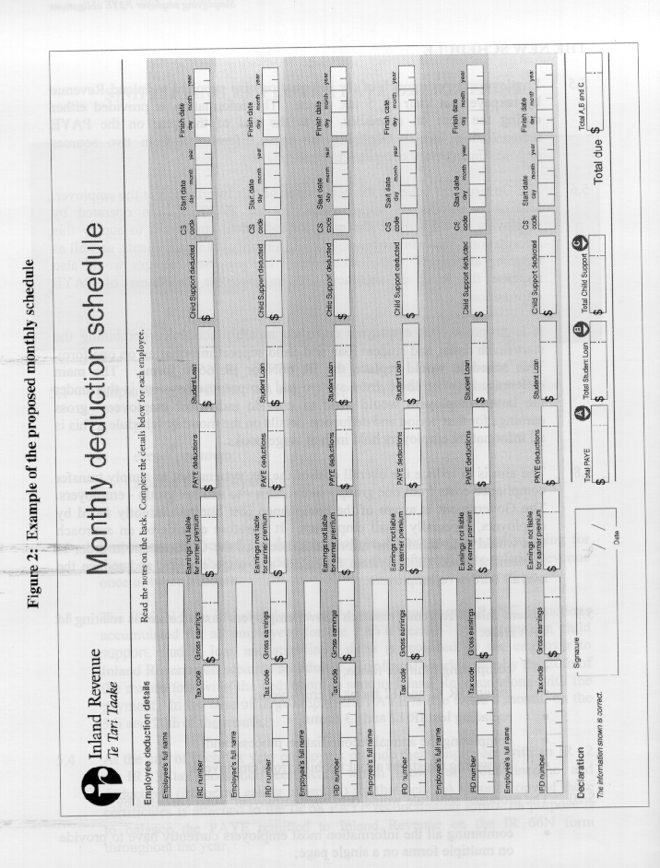
- removing the requirement for employers to provide employees with an IR 12 or IR 13 tax deduction certificates at the year’s end; and
- requiring that the information be provided monthly.

5.11 Because the ACC Employer Premium Statement (IR 68A) is used to calculate any yearly ACC employer premium, no changes are proposed to this form.

5.12 Employers would complete the monthly schedule with all details about gross earnings, PAYE, student loans, child support and start/finish dates for each employee. Figure 2 shows what this schedule might look like.

THE NEW PROCESS

5.13 Figure 3 illustrates the current and proposed filing requirements for employers.

Figure 3: The current and proposed system

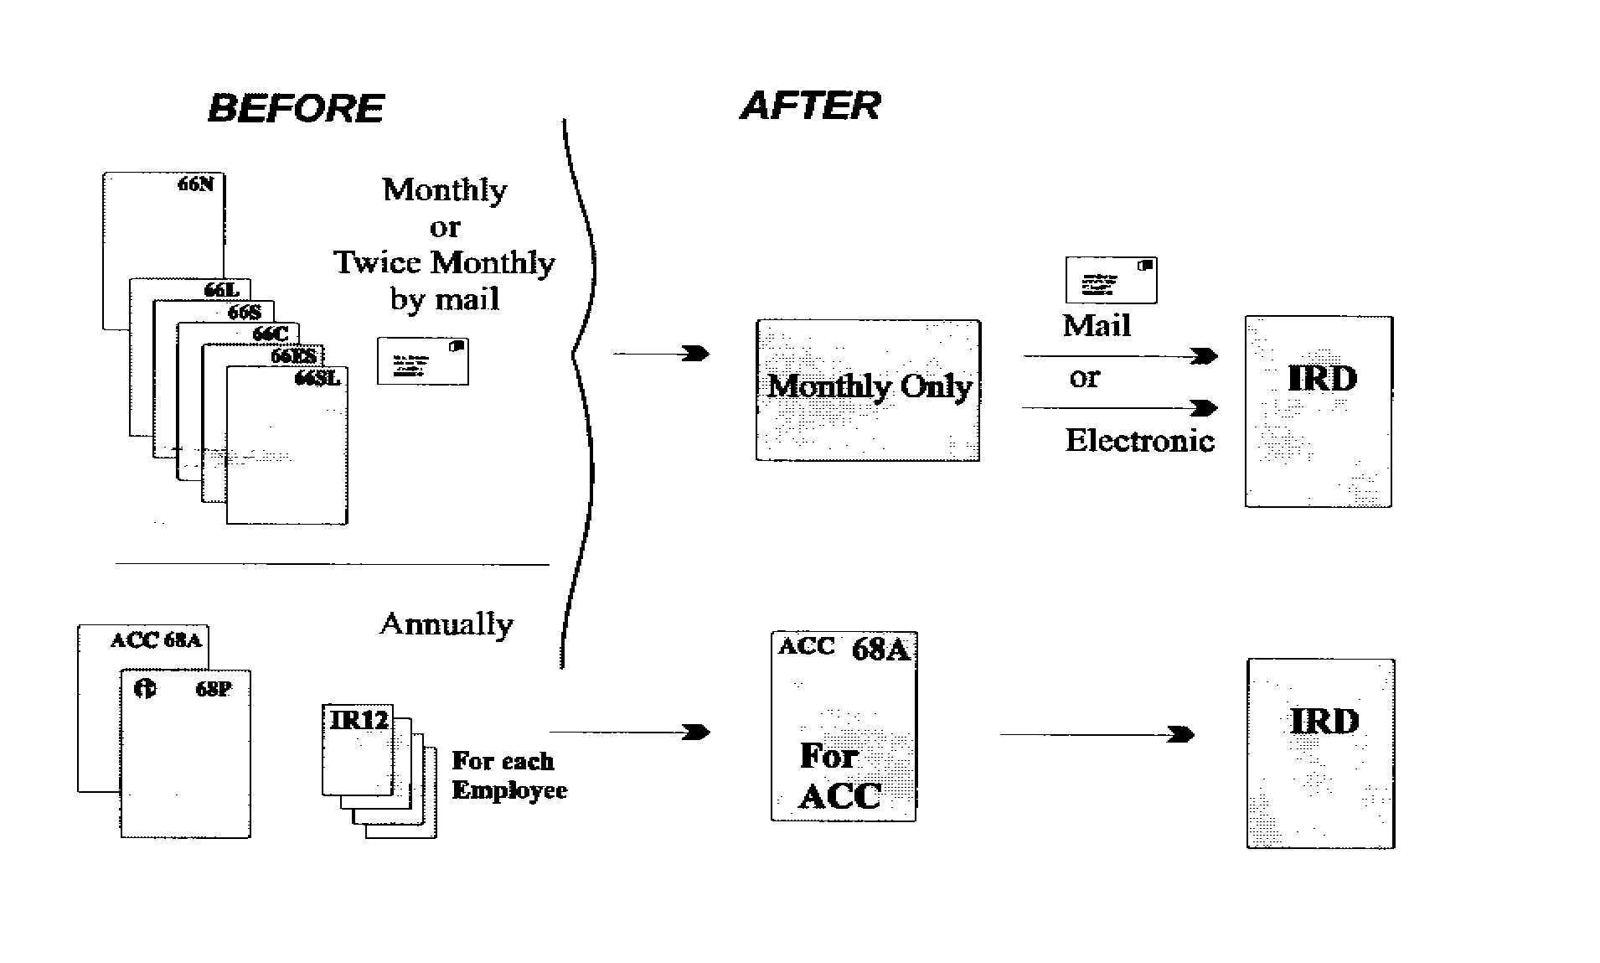

5.14 The new process would differ for employers operating a manual payroll system and employers operating a computer payroll system.

Employers with manual systems filing monthly

5.15 For employers using manual payroll systems, Inland Revenue would issue the schedules pre-printed with each employee’s name, their IRD numbers, their x codes and their start dates taken from information previously provided.

5.16 Employers would then record the following information about each of their employees (if applicable):

- gross earnings/withholding payments;
- PAYE deductions/withholding tax;
- student loan deductions;
- child support deductions;
- child support variation code; and
- start and/or finish date(s).

5.17 They would take most of this information directly from the wage records.

5.18 When a new employee started work, the employer would write the employee’s name, IRD number, tax code and start date at the end of the schedule. Future schedules would have the employee’s details pre-printed on them.

5.19 Once the schedule was completed, the employer would return the schedule, a payment slip, and any payment to Inland Revenue for processing. As a supporting measure, Inland Revenue would set up a new electronic payment reference system to allow employers to make payments using their bank’s telephone banking service.

5.20 The process would continue each month, with the pre-printed information showing only current employees. Once the employer entered a finish date for any employee, he or she would appear on only one further schedule. This would allow the employer to check that the correct finish date had been recorded by Inland Revenue.

5.21 Inland Revenue would continue to contact employers regarding any schedules that had been completed incorrectly, and schedules with major discrepancies would be returned to the employer for correction.

5.22 Once Inland Revenue had processed the March schedule (the final for the tax year), it would send employers a schedule showing total gross earnings and deductions for each employee for the year. Employers would be able to use the gross earnings figure when completing their ACC Employer Premium Statement (IR 68A).

5.23 The intention is this schedule should be readily available if employees wish to know their total earnings and PAYE deductions, or if employers prefer to use Inland Revenue’s records rather than their own for the purposes of calculating their ACC employer premiums. It would reduce employer compliance costs because employers would not have to determine these totals for themselves.

Employers with computer systems filing monthly

5.24 Employers with a computer payroll would supply the same information to Inland Revenue as those operating a manual payroll, but they would be able to extract the information from their computer payroll system instead of having to prepare it manually.

5.25 To minimise both compliance and administrative costs, employers with computer systems would be encouraged to use electronic methods for communicating with Inland Revenue. Inland Revenue is considering ways of doing this, which include E-file (Inland Revenue’s current electronic tax return service), magnetic tapes, Internet E-mail, and world-wide web page access. Electronic transfer would remove transcription and transposition errors, improving the overall integrity of the system as well as the speed with which Inland Revenue processes the information received.

Employers with computer systems filing twice a month

5.26 Although these employers would still be required to calculate and make a payment of PAYE twice a month, to avoid unnecessary compliance costs, the schedule would be required only once a month. There would be a small compliance cost reduction from this measure.

5.27 The example shows how the new schedule process would work:

Example

Deduction period Due date for payment Information required
1-15 April 20 April Payment only
16-30 April 5 May Payment and schedule

On 20 April employers would pay their total deductions for the period 1-15 April to Inland Revenue using a payment slip only. On 5 May they would pay their total deductions for the period 16-30 April to Inland Revenue. Their monthly schedule would accompany this payment and would include details for the entire month (1-30 April).

5.28 The balance of the process would remain the same as described for employers with computer systems who file monthly.

5.29 Although most New Zealand employers have a small number of people working for them, most employees are employed by a small number of large employers. For example, the 100 largest employers issue over 1.7 million of the 4 million IR 12 and IR 13 forms annually. To work effectively, the proposed system requires timely and accurate information, which can best be achieved through the electronic transfer of information. Therefore it is proposed that all employers with an electronic payroll who file twice a month provide the monthly schedule information electronically.
5.30 Inland Revenue would be able to allow those filing twice a month to continue to provide information manually if the compliance costs of providing it electronically were excessive. This exemption would not be available to any such employers with more than 50 employees.

5.31 The late filing penalty would be amended so that it would apply to employers who were required to provide information electronically but who provided it on paper or did not provide it at all. The penalty would reflect the importance placed on dealing with taxpayers in an electronic format.

5.32 The penalty would not be imposed automatically but at the discretion of the Commissioner of Inland Revenue. The penalty would be the greater of $250 or $1 per employee covered by the paper statement.

Employers in PAYE group schemes

5.33 Group schemes would no longer operate because each employer would be required to supply the monthly schedule.

Transitional impact

5.34 One-off compliance costs would be incurred in the transition to the new process but would be justified given the longer-term benefits to employers and employees.

5.35 Employers with manual systems would be required to provide all their employee details on their first schedule because Inland Revenue would not have the up-to-date information required for pre-printing the forms.

5.36 Employers with computer payrolls would have costs associated with upgrading their systems to provide an acceptable format for transmission to Inland Revenue.

BENEFITS OF THE PROPOSALS

5.37 The principal benefit for employers of the proposed system is a reduction in compliance costs. The monthly schedule would remove the end-of-year reconciliation process and the requirement for employers to complete and issue end-of-year tax deduction certificates. Research by Inland Revenue shows that many employers find these tasks time-consuming and complex.

5.38 The IR 12 and IR 13 forms would no longer be required, thus removing the problems of replacing lost forms and locating employees who have left without a forwarding address.

5.39 PAYE would become a monthly process, removing the need for special training of staff for the end-of-year reconciliation. Many employers also seek the help of a tax agent at the end of the year to deal with the annual activities, so professional fees associated with this would not be incurred.

5.40 The benefits of this schedule combined with the proposed simplifications of the current fortnightly and monthly schedule process would outweigh the compliance costs associated with increased provision of information. It would be of substantial benefit to salary and wage earners, who would not be required to file income tax returns.

5.41 Other benefits for the PAYE system would arise from the monthly provision of information:

- Invalid IRD numbers would be identified early. The use of an invalid IRD number by an employee would prevent that employee’s name and number being pre-printed on subsequent schedules. To minimise the resulting compliance costs, Inland Revenue would tell employers about this problem as quickly as possible so they could follow it up with their employee and correct the number. While also reducing errors, early correction would substantially reduce abuse of the tax system.

- Incorrect use of tax codes would be identified and corrected during the income year. This would prevent over-deductions or an unexpected year-end tax liability for employees. For example, if a student loan holder had income over the repayment threshold and was not using a student loan tax code, the employee would be advised by Inland Revenue to use the correct code.

- More accurate deductions would also minimise the number of requests to employers for an explanation of a deduction error which resulted in an end-of-year liability.

- Because Inland Revenue would be receiving each taxpayer’s individual information, transposition and mathematical errors could be identified and the employer informed accordingly.

5.42 Using the information provided through the proposed new process would allow Inland Revenue to build customer profiles which would allow information to be tailored to meet individual taxpayer needs.

TIMELINE

5.43 The proposals outlined in this chapter would have an application date of 1 April 1999.

SUBMISSIONS

The Government seeks public submissions on:
- the compliance cost impact of the proposed changes on employers;
- the preferred method by which information could be delivered electronically to Inland Revenue;
- the criteria for employers who must provide PAYE information electronically;
- any other impact of the proposals which might require consideration; and
- the proposed timeline.
6

THE NEW REBATE CLAIM FORM

PROPOSED POLICY

- Introduce a new claim form for donation and housekeeper-childcare rebates.

- Continue the existing annual maximum claim thresholds.

- Limit the amount of donations and housekeeper-childcare payments that can be claimed to the amount of taxable income, up to a maximum of $1,500 for donations and $940 for the housekeeper-childcare rebates in the year before payments.

- Repeal the extra pay rebate.

6.1 The Government uses tax returns for several reasons. Their main use is to “square up” taxpayers’ residual tax and social policy liabilities at the end of a financial year. They also serve as a mechanism to provide rebates for people who have made donations or paid for childcare or a housekeeper. To continue to deliver these rebates under a non-filing system requires a new mechanism, a rebate claim form.

6.2 These rebates are limited to the amount of tax payable by the taxpayer. This means taxpayers without any tax to pay during the year cannot benefit from the rebates they claim.

Donation REBATE

6.3 The donation rebate was introduced on 1 April 1978. It provided a special exemption for charitable donations and school fees. It was initially a flat rebate of 50 percent up to a maximum amount of $175 but has become a rebate equal to 33 percent for each dollar donated to a charity up to a maximum rebate of $500.

6.4 The amount of the donation must exceed $5, and the taxpayer must hold a receipt. The receipts must be attached to the taxpayer’s income tax return and the rebate is calculated on the basis of the total amount of donations made.

6.5 If the total amount donated was less than $1,500, the rebate claimed is one-third of the total amount. If the total amount was more than $1,500, the rebate is $500. This is the maximum annual rebate a taxpayer can claim.
6.6 Over 400,000 taxpayers claimed the rebate in the 1995/96 income year, with the cost to Government being approximately $68.6 million.

Childcare-housekeeper REBATE

6.7 This rebate was originally introduced to provide relief to widows and widowers who engaged a housekeeper to care for their child or to tend their home. A later amendment extended the exemption to apply to those who engage someone to care for their child, or to tend their home if they or their spouse are incapacitated. The rebate was also extended to allow it to be claimed for childcare costs if both parents work.

6.8 This rebate is also claimed in the income tax return, but taxpayers are not required to attach the receipts to the return.

6.9 If the total amount paid was less than $940, the rebate claimed is one-third of the total amount. If the total amount was more than $940, the rebate is $310. This is the maximum rebate a family can claim.

6.10 Over 69,000 taxpayers claimed this rebate in the 1994/95 income year, with the total cost to the Government being approximately $17.7 million.

THE NEW PROCESS

6.11 To claim either a donation or housekeeper-childcare rebate, taxpayers would be required to complete a new rebate claim form. It would allow taxpayers to claim their rebates without having to complete a tax return, as they must do now.

6.12 At present, 15 percent of IR 5 returns are filed simply so taxpayers can claim these rebates. This places compliance costs on taxpayers, costs which could be avoided by using a stand-alone form.

6.13 The current eligibility rules, including maximum rebate entitlements, would remain unchanged. As at present, receipts would continue to be required for donations but not for the housekeeper-childcare rebate claims.

6.14 Taxpayers would file a rebate claim form after the end of the income year in which they made donations or incurred housekeeper or childcare expenses. Because the rebate claim process would be separated from the current income tax returns, it is necessary to set a date by which any claim must be made. Currently, this date is effectively set by the due dates for filing the various tax returns. Given the simplicity of the new process, the Government proposes that all rebate claim forms for a year must be filed by 30 September of the following year. No claim for donations or housekeeper-childcare expenses could be made after that date.

6.15 The present legislation limits the rebate which may be claimed to the amount of tax payable in any given year. Because taxpayers would not necessarily know their tax position without tax returns, it is proposed the new process limit the amount of gross payments upon which rebates could be claimed to taxable income.

6.16 The taxable income in the year before the year of the claim would be used because the current year’s income information might not be available before the terminal tax due date. This would also apply to individual return filers who use tax agents, since they generally have an extension of time to file their returns.

6.17 Once a rebate claim form had been processed, Inland Revenue would issue a confirmation of Rebate Claim Notice. This notice would detail the amount of rebate claimed and the amount deposited into the taxpayer’s bank account.

6.18 Rebate claim forms would be automatically distributed to taxpayers who made a claim in the previous year. Those not receiving a claim form automatically would be able to request a blank form from Inland Revenue.

6.19 The example in figure 4 shows how the proposed system would work.

6.20 The new rebate claim form would be available to everyone wishing to make a claim, including those who would still be required to file individual returns.

6.21 The Government accepts that under the proposed system some taxpayers might be required to complete an individual return for income tax purposes and a rebate claim form for rebate purposes. However, this approach would eliminate the need for people to make special adjustments in years they changed between receiving income statements and filing returns. It would also provide clients of tax agents with the benefit of the rebate refund before the due date for the individual return. For these reasons the Government believes most taxpayers would favour this approach.

Figure 4: The rebate claim process

In June 2000 a taxpayer completes a rebate claim form, with donations of $600 and housekeeper-childcare costs of $1,000 for the income year ended 2000.

The claim relates to payments made for donations, housekeeping and childcare during the income year 1 April 1999 to 31 March 2000. The entitlement would be based on taxable income for the year ended 31 March 1999.

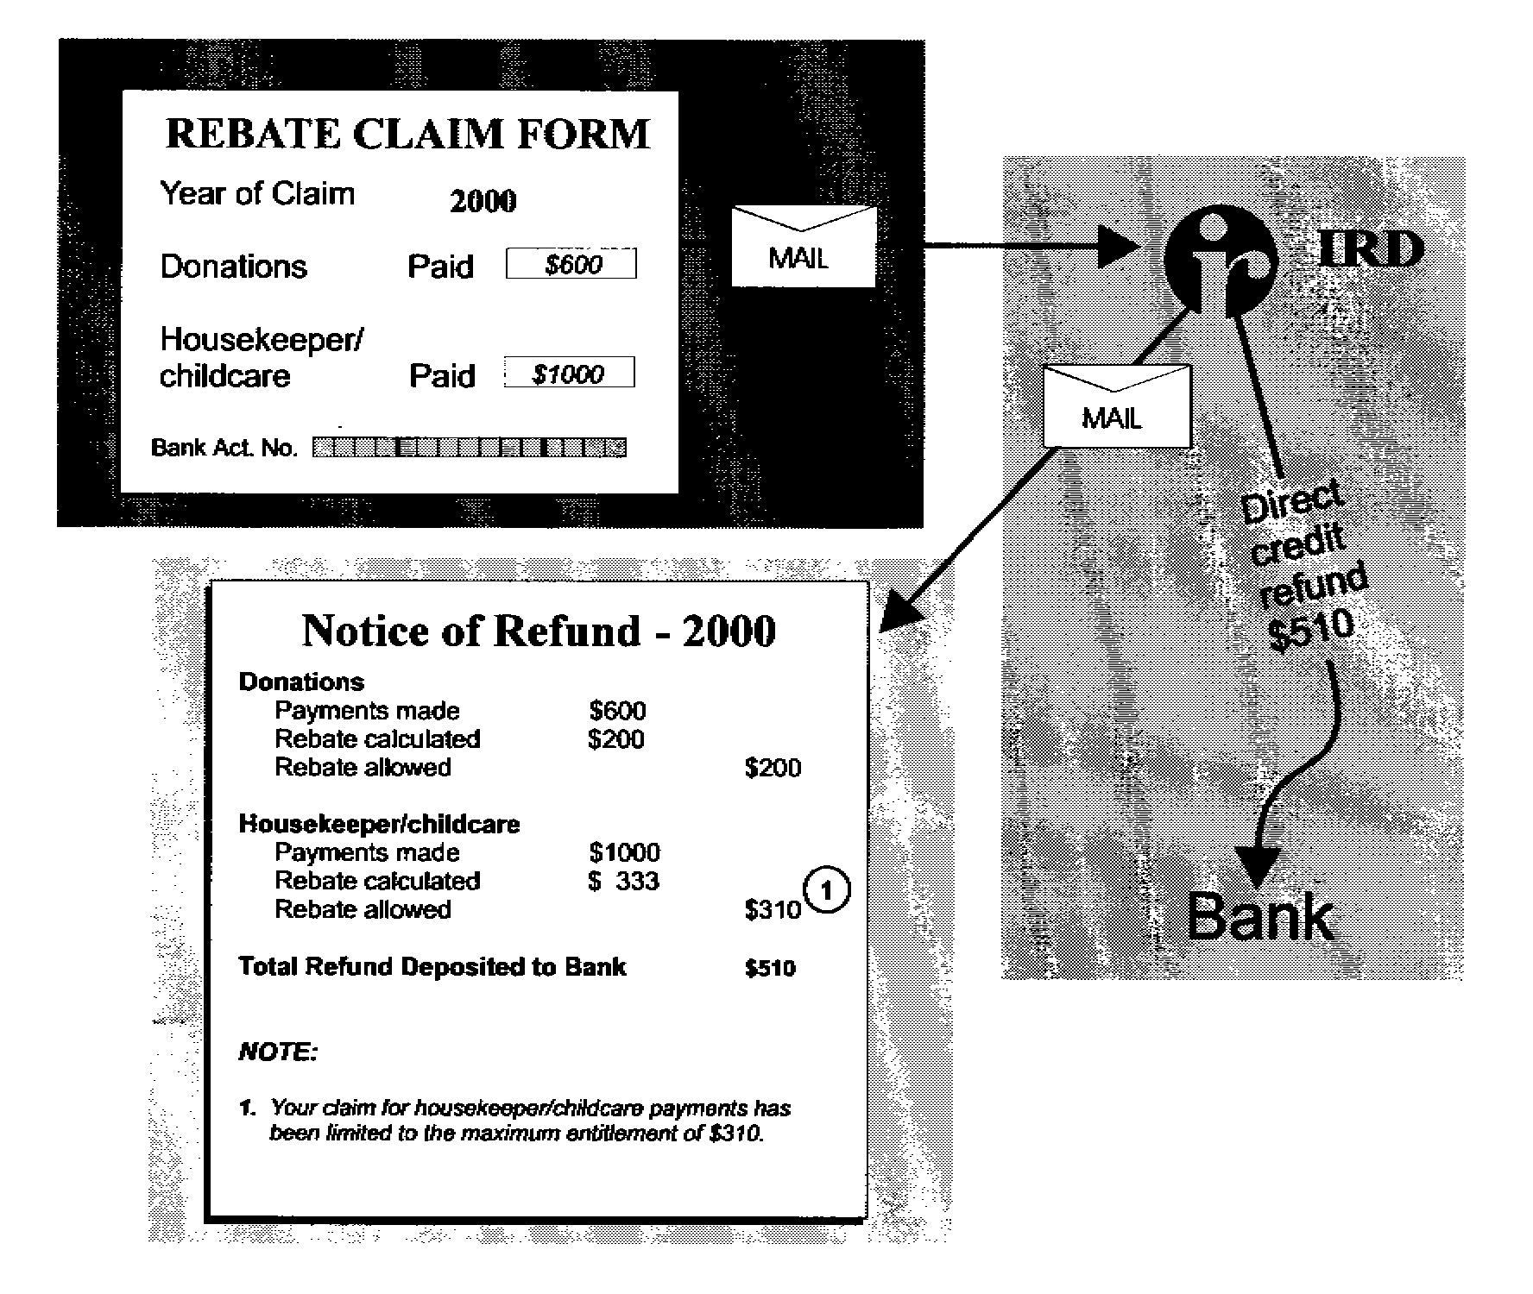

In this example, the taxpayer has claimed $200 of a $500 maximum donations claim and the maximum $310 housekeeper-childcare rebate.

The annual maximum childcare rebate is $310 because the rebate allowed has been limited to this amount.

Because Inland Revenue has received a claim for the 2000 income year, a blank rebate claim form will be issued automatically in the year 2001.

REMOVAL OF EXTRA PAY REBATE

6.22 The extra pay rebate compensates taxpayers for the loss, in an annual assessment, of the rebates allowed in any extra pay-period or periods. The rebate is available to employees who received more than 52 weekly, 26 fortnightly or 13 four-weekly full and regular pays in an income year. Employers enter the number of pays employees receive during the year on their IR 12 form. The granting of the rebate is a matter for Inland Revenue’s discretion.

6.23 The Government proposes removing the extra pay rebate to streamline the tax return process in readiness for the introduction of income statements. The extra pay rebate, in its current form, could not be successfully incorporated into the proposed income statement without placing high compliance costs on employers and individual taxpayers who receive an extra pay.

6.24 Removal of this rebate would correct a minor administrative inconsistency because it is the only rebate subject to Inland Revenue’s discretion. It is also arguable that because employees pay tax on a cash basis, rather than an accrual basis, it would be inappropriate to make an accrual-type adjustment by means of this rebate.

6.25 Inland Revenue information shows that the impact of removing the rebate would be small. A total of 6,060 taxpayers claimed this rebate in the 1994/95 income year, at a cost to the Government of $62,000.

BENEFITS OF THE PROPOSALS

6.26 The main benefit of the proposal is that the claiming of these rebates could be separated from the income statement process. This means that income statements would not have to be issued to taxpayers only because they wished to claim one of the rebates. This would bring both administrative and compliance cost benefits. Inland Revenue would not be required to process information to prepare an income statement and the taxpayer would not be required to check that information.

6.27 Research by Inland Revenue shows that 15 percent of taxpayers filed a tax return mainly to claim a rebate.

TIMELINE

6.28 The proposals relating to the introduction of the rebate claim form would need to have application dates corresponding to the introduction of the income statement. Accordingly, this would apply from the income year beginning 1 April 1999. This would mean donation and housekeeper-childcare rebates would be claimed for the last time in the 1999 tax returns. From the year 2000 the rebate claim form would be used.

6.29 The extra pay rebate would be repealed from 1 April 1999.

SUBMISSIONS

The Government seeks public submissions on:

- whether the requirement that all claims for donations and childcare and housekeeper expenses made in an income year had to be claimed by the following 30 September provides sufficient time for taxpayers to finalise their claims;

- the implications of the proposed removal of the extra pay rebate; and

- the proposed timeline.
7
RECEIVING FAMILY ASSISTANCE UNDER
THE NEW SYSTEM

PROPOSED POLICY

- Introduce a once-only registration form for all Family Assistance recipients.

- Change the Family Assistance renewal date from 1 April to 1 July.

- Calculate end-of-year entitlement to Family Assistance on the basis of information from the income statement for the previous year for salary and wage earners.

- Automatically remit overpayments of Family Assistance if recipients have used Inland Revenue’s income calculation and advised of any changes in circumstances which affect entitlement (for income statement taxpayers only).

- Recover overpayments of Family Assistance which do not qualify for automatic remission from the current year’s entitlement.

7.1 The aim of the proposals for assessing and paying Family Assistance is to:

- remove the need for recipients to complete annual application forms, returns and statements; and

- improve the accuracy of family income estimates to avoid Family Assistance overpayments.

7.2 The Government provides Family Assistance through the family support tax credit, the independent family tax credit, and the guaranteed minimum family income tax credit. Family Assistance is directed at low-income and middle-income families and provides them with additional cash support during an income year.

7.3 There are two ways to claim Family Assistance from Inland Revenue, depending on how taxpayers receive their income. They can claim it:

- during the income tax year, by completing an application form, FS1; or

- at the end of the income tax year in a lump sum, by completing an annual tax return and end of year family support statement, FS2.

7.4 Social welfare beneficiaries may receive Family Assistance either from the New Zealand Income Support Service, with their benefit, or from Inland Revenue.

7.5 Once a taxpayer’s total family income exceeds $20,000 the full entitlement starts to abate.

7.6 The process is the same regardless of the type of income tax return filed. The Family Assistance year currently runs from 1 April-31 March.

7.7 Applications to receive Family Assistance during the year must be renewed annually. An FS1 form is sent to all taxpayers who have previously applied for Family Assistance during the year. This application form is issued in January of each year. Inland Revenue requires applications to be completed by 3 March, to ensure payments start from the beginning of the new tax year. The application form, end-of-year statements and returns require taxpayers to provide excessive and repetitive information.

APPLICATIONS DURING THE YEAR

7.8 The FS1 application form requires principal caregivers to provide information on their children, their estimated family income for the year, and other custodial information. Inland Revenue issues a certificate of entitlement and makes fortnightly payments into their bank account. During the year recipients are required to advise Inland Revenue of any changes in circumstances which affect their entitlement, by letter or completion of an amended FS1 form.

7.9 At the end of the income tax year Family Assistance recipients and their partners must complete an end-of-year statement (FS2) and tax return. This is followed by a “square-up” process in which the actual annual entitlement, based on end-of-year circumstances, is calculated and the amount paid during the year subtracted. The difference is either underpaid or overpaid Family Assistance.

7.10 Underpaid Family Assistance is refunded to the taxpayer, and overpaid Family Assistance is payable by the terminal tax due date. Taxpayers who cannot pay and can prove hardship may have their overpayment remitted.

7.11 Those receiving Family Assistance during the year must provide the same information in their application form that is required in their end of year statement. Income information is estimated 14 months in advance of assessing actual entitlement at the end of the income year. This frequently causes inaccurate estimates of family income that lead to overpayments, which in turn discourages people from claiming future support during the year.

APPLICATIONS AT THE END OF THE YEAR

7.12 Taxpayers can claim Family Assistance at the end of the income tax year by completing a tax return and a Family Assistance statement. If they claimed Family Assistance in the previous income tax year Inland Revenue will automatically send them the appropriate documentation. Actual entitlement is calculated and paid in a lump sum.

7.13 Although this method of claiming provides greater certainty and is of less risk to the taxpayer, it compromises the Government’s intent, which is to provide assistance at the time of need. Even so, some recipients prefer end of year payments. Recent research identified that the most common reasons for claiming at the end of the year were:

- so recipients would not have to pay money back;
- because it was easier or more convenient;
- because they wanted to receive it in a lump sum.

7.14 Therefore, under the proposals, recipients would continue to be able to claim Family Assistance at the end of the year.

THE NEW PROCESS

7.15 Income details and information regarding family circumstances, such as number of children, custody and marital status, are required to determine the amount and type of Family Assistance entitlement. This information is currently collected through the annual application form, income tax returns and Family Assistance statements.

7.16 Under the proposed system, the Government would use the income statement to finalise Family Assistance for the year. Inland Revenue would also use the income statement to estimate a family’s next year’s entitlement, incorporating an “uplift” to reflect general increases in wages and salaries.

7.17 The Family Assistance year would remain 1 April-31 March, but the renewal date would change to 1 July. This would allow time for the previous year’s income to be finalised through the income statement process.

7.18 An estimated income calculation based on actual income from the previous year would be more accurate than a straight estimate of income 14 months before the actual income is known. Allowing Inland Revenue to calculate estimated family income would lessen the compliance burden on taxpayers and employers.

7.19 Taxpayers would still have the option of providing their own estimate if they thought a calculated estimate did not take into account their current circumstances. To do this they would provide payslips or statements from employers as evidence of earnings, as is done at present.
7.20 Towards the end of June, once the income statement was finalised, Inland Revenue would still undertake the Family Assistance “square-up” process for last year. The difference is that Inland Revenue would also calculate the current year’s entitlement based on the calculation method of estimating family income. The Government welcomes suggestions on the most appropriate base for estimating current year income.

7.21 Information collected from the monthly schedule during the year would be used to track a taxpayer’s income throughout the year. If Inland Revenue identified a potential underpayment or overpayment during the year it would contact the taxpayer and make a new estimate of income when appropriate. This would greatly reduce the chance of an overpayment at the end of the year.

7.22 Those who would rather continue to claim their entitlement in a lump sum at the end of the year would be able to do so by using the income statement process. They could do this by indicating on the registration form that they wished to receive their Family Assistance at the end of the year.

Information on family circumstances

7.23 Details of family circumstances such as number of children, custody and marital status would be obtained through the completion of a registration form that would contain the same information as the current application form. Taxpayers would need to complete this form only once.

7.24 Inland Revenue would hold the details from the application form and apply them each year until advised by the taxpayer of a change in circumstances. If a taxpayer ceased to be eligible and then became eligible again, the last known details would be sent to the taxpayer for confirmation.

7.25 To further reduce the information Family Assistance recipients have to provide, the Government proposes to allocate an IRD number for each child who does not already have one, and for whom Family Assistance is being claimed. This process would also be applied to taxpayers registering for child support. This is possible because the allocation of an IRD number would be enough to confirm that satisfactory evidence of a child’s existence had already been received.

7.26 Allocating IRD numbers to children would prevent recipients having to satisfy repeated requests for birth certificates, or other forms of identification, from different areas within Inland Revenue. It would mean that recipients would have to contact Inland Revenue only if there was a change in initial registration details or a change in circumstances.

Overpaid and underpaid Family Assistance

7.27 The Government is considering automatically remitting any overpayment of Family Assistance if the recipient has used the calculated estimate of earning and advises Inland Revenue of changes in circumstances affecting his or her entitlement. This measure would be deferred one year so the revenue impact could be assessed.

7.28 If the taxpayer does not inform Inland Revenue of these changes, any overpayment would be recovered from the current year’s entitlement, which would reduce the burden on low-income and middle-income taxpayers to pay lump sums with their terminal tax. Those no longer entitled to Family Assistance would still be required to repay their overpayments on their terminal tax due date.

7.29 If Inland Revenue underpaid Family Assistance during the year, it would automatically refund that amount as a lump sum by direct-crediting the taxpayer’s bank account.

The individual return

7.30 The proposed once-only Family Assistance registration process would also apply to taxpayers who filed individual returns. Actual entitlement to Family Assistance would continue to be calculated on receipt of the return. For those wishing to claim throughout the year, the option to accept a calculated estimate of family income would also be available but would be based on the last available information.

7.31 Families in which one or both partners file individual returns would not be eligible for automatic remission because Inland Revenue would not be able to monitor the accuracy of an individual return filer’s estimate.

Encouraging taxpayers to claim entitlement

7.32 Not all who are entitled to Family Assistance apply for it. The present tax returns and supporting guides encourage taxpayers to check if they are entitled to Family Assistance. The elimination of returns for salary and wage earners might mean it would be more difficult for taxpayers to recognise they are entitled to financial support. The Government welcomes suggestions in this regard.

7.33 If the proposed system were implemented, Inland Revenue would continue to use existing advertising media, such as television, radio and targeted mail drops, to encourage those entitled to apply for Family Assistance to do so.

GUARANTEED MINIMUM FAMILY INCOME

7.34 Information held by Inland Revenue would be used to identify taxpayers who meet new entitlement criteria such as increases in maximum income thresholds.

7.35 To qualify for the guaranteed minimum family income (GMFI) individuals must be in work full-time (either 20 or 30 hours a week) and earn less than $18,320 a year. At present, 3000 people qualify for GMFI. The number of weeks they worked full time during the year is collected from the Family Assistance statement. The requirement to know the number of weeks worked full time would remain, so it is proposed to ask for this information on the income statement.

7.36 Those who are entitled to GMFI and receive their Family Assistance during the year would also need to tell Inland Revenue how many weeks they expected to work full time during the following year. Inland Revenue would use the information it has on file to identify and contact taxpayers potentially entitled to GMFI to obtain the required information.

BENEFITS OF THE PROPOSALS

7.37 The main aim of these proposals is to minimise the amount of information taxpayers have to provide. They would no longer be required to complete annual application forms, income tax returns and Family Assistance statements. Moreover, Family Assistance would continue uninterrupted between years in which family circumstances remain largely unchanged.

7.38 The new monthly schedule would allow Inland Revenue to maximise the use of third party information by helping taxpayers identify where underpayments or overpayments might occur during the year. Taxpayers would still have the right to use their own estimation of income if they believed the calculation method was not appropriate for their circumstances. If they used the estimation method to calculate family income they would no longer have to provide payslips annually and repay overpayments.

7.39 The monthly schedule would allow Inland Revenue to monitor current earnings to ensure entitlement was not overstated or understated, to prevent overpayments of Family Assistance.

TIMELINE

7.40 It is proposed the changes outlined in the chapter be implemented 12 months after the income statement. This lagged implementation would allow officials sufficient time to review the operation of the income statement process and provide certainty that Family Assistance payments could be paid out in an accurate and timely manner under the new process. Accordingly, the proposed implementation date for these proposals is 1 July 2001.

SUBMISSIONS
The Government seeks public submissions on:
- the introduction of a once-only registration form for all Family Assistance recipients;
- changing the Family Assistance renewal date from 1 April to 1 July;
- calculating end-of-year entitlement to Family Assistance on the basis of information from the income statement for the previous year for salary and wage earners;
- using a calculated method to estimate family income on which entitlement for the current year should be based;
- the automatic remission of overpayments of Family Assistance if recipients have used the calculation method for family income and have advised of any changes in circumstances which affect entitlement (for income statement taxpayers only);
- the Government’s intention to delay the application of automatic remission of overpayments until the revenue impact is assessed; and
- recovering overpayments of Family Assistance which do not qualify for automatic remission from the current year’s entitlement.

