REWRITING THE INCOME TAX ACT: PARTS C, D AND E

A discussion document

Hon Winston Peters | Rt Hon Bill Birch
Deputy Prime Minister  and Treasurer | Minister of Finance and  Minister of Revenue

Rewriting the Income Tax Act: Parts C, D and E; a discussion document

First published in September 1997

ISBN 0-478-10322-0

CONTENTS

PREFACE 1

EXECUTIVE SUMMARY 3

PART ONE THE PROPOSED APPROACH TO REWRITING PARTS C, D AND E

Chapter 1 INTRODUCTION 9

Background and context 10
Benefits of the rewrite 11
Rewriting Parts C, D and E together 11
Scope of the rewrite 12
Submissions 13

Chapter 2 DEVELOPING THE STRUCTURE 14

Progress to date 14
Remaining structural problems 15
General structural principles 15

Chapter 3 THE FUNCTIONS OF PARTS C, D AND E 18

General function of Parts C, D and E 18
Implications for the core provisions 19
The role of each Part in the net income calculation 19
The concepts of derived and incurred 20
Apportionment 21
Net regimes 21

Chapter 4 PROPOSED STRUCTURE OF PART C 24

Current rules 25
Proposed structure 25

Chapter 5 PROPOSED STRUCTURE OF PART D 28

Current rules 28
Proposed structure 29

Chapter 6 PROPOSED STRUCTURE OF PART E 32

Current rules 32
Proposed structure 33

Chapter 7 EXPRESSING LEGISLATION MORE CLEARLY 36

The language of the rewritten Act 36
Flowcharts, tables and other alternatives for presentation 37
Limits to clear expression 38

PART TWO DETAILS OF PROPOSED STRUCTURES OF PARTS C, D AND E

Chapter 8 PART C: GROSS INCOME 42

General gross income categories 42
Controlled foreign company and foreign investment
fund rules 42
Industry regimes 43
Recoveries and adjustments 43
Ordinary concepts 43
Exempt and excluded income 44
Attribution 44
Sample draft legislation 46

Chapter 9 PART D: ALLOWABLE DEDUCTIONS 52

Principles underlying the structure 52
Expansions 54
Supplementary deductions 54
General limitations 54
Limitations to the new general deductibility rule 55
Sample draft legislation 56

Chapter 10 PART E: ALLOCATION OF GROSS INCOME AND
ALLOWABLE DEDUCTIONS 62

Steps in the timing process 62
The valuation method 64
The retrospective allocation rules 66
The default rule 66
Extended approach to derivation and incurrence 67
Sample draft legislation 68

PART THREE THE REWRITE PRINCIPLES IN PRACTICE

Chapter 11 DIVIDENDS 77

Draft legislation and commentary 81
Commentary on section CF 1 82
Commentary on section CF 2 85
Commentary on section CF 3 86
Commentary on section CF 4 87
Commentary on section CF 5 88
Commentary on section CF 6 92
General comment on sections CF 6 to 9 97

Chapter 12 EMPLOYMENT EXPENDITURE 98

Limitations to the general deductibility rule - employment
costs 98
Expansions of the general deductibility rule 99
Supplementary deductions 100
Draft legislation and commentary 102
Commentary on section DC 5 102
Commentary on section DC 6 103
Commentary on section DH 3 105
Commentary on section DH 4 107
Commentary on section DI 1 110
Commentary on section DI 2 113

Chapter 13 FILMS 115

The allowable deduction 116
The allocation of the allowable deduction 116
Draft legislation and commentary 117
Commentary on section DD 7(6) 121
Commentary on section DD 7(7) 122
Commentary on section EL 2 122
Commentary on section EH 1 123
Replaced definitions 134
Deleted definitions 138

Chapter 14 VALUATION APPROACH TO ALLOCATION 139

Application of the valuation method 139
Draft legislation: Part E 142
Application of the new approach: an example of the tax
treatment of depreciable property 142

Chapter 15 ASSOCIATED PERSONS 147

Definition of associated person 148
Draft legislation and commentary - method 1, as a table 153
Commentary on method 1 154
Draft legislation and commentary - method 2, as narrative 156
Commentary on method 2 158
Commentary on tabular arrangement for method 2 159
Operative associated person rules 160
Draft legislation and commentary: associated persons 162
Commentary on associated persons 164

FIGURES

1. Relationship between the core provisions and Parts C, D and E of
the Act 23
2. Part C: Subpart B - process for determining whether an amount is
gross income 45
3. Structure of Part C - gross income 48
4. Subpart B - process for determining whether an amount is an
allowable deduction 53
5. Structure of Part D - allowable deductions 58
6. Subpart B - process for allocating gross income and allowable deductions 63
7. Structure of Part E - allocation of gross income and allowable deductions 71
8. Organisation of draft legislation 78
9. Process for determining dividends 79
10. Dividend definition 80
11. Subpart DF - employment expenditure 101
12. The process of calculating and allocating depreciation deductions 145
13. The process of calculating and allocating gross income from the sale of a depreciable asset 146

TABLES

1. Proposed organisation of provisions within Part C 49
2. Proposed organisation of provisions within Part D 59
3. Proposed organisation of provisions within Part E 72
4. Rules currently located in Part D 140
5. Rules currently located in Part E 140
6. Comparison of proposed and current approaches 144
7. How the different definitions work 149
8. How persons are associated 150
9. Tabular arrangement for method 2 159

PREFACE

This publication is the third in a series of discussion documents devoted to the progressive rewrite of the Income Tax Act 1994. Rewriting the Income Tax Act: objectives, process, guidelines was published in 1994, followed in 1995 by Core provisions: rewriting the Income Tax Act. The latter proposed new core provisions that were enacted in 1996.

The present discussion document deals with the rewrite of Parts C, D and E, the most frequently used parts of the Act. It outlines proposals encompassing structure, language and presentation for this next, important stage of the rewrite. Samples of draft legislation have been included to show readers what to expect of the new style, and how the rewrite principles will be put into practice.

The objective of the rewrite is to ensure that the law is applied in the way Parliament intended and to make it easier for taxpayers to meet their tax obligations.

The release of this discussion document is part of the Government's generic tax policy process, which formally subjects major tax policy reforms to public consultation at key points in their development.

We thank all those who have been involved so far in the consultation process that has formed part of the rewrite of the Act, and look forward to receiving submissions on the changes proposed here.

Hon Winston Peters Rt Hon Bill Birch
Deputy Prime Minister and Minister of Finance and
Treasurer Minister of Revenue

EXECUTIVE SUMMARY

- This discussion document describes the Government’s proposals for the next phase of the rewrite of the Income Tax Act. The Parts to be rewritten in this phase are Parts C (gross income), D (allowable deductions), and E (the timing of gross income and allowable deductions).

- As part of the continuing consultative process for tax reform, the Government welcomes submissions on the proposals. It is intended that legislation rewriting the three Parts will be introduced next year.

Why rewrite the Income Tax Act?

- The current state of the Act can make it difficult for taxpayers to comply with their tax obligations and for Inland Revenue to ensure the legislation is applied in the way Parliament intended. Significant costs are imposed on the economy as a result.

- The rewrite is intended to remove unnecessary complexity from the Act, thereby reducing these costs. This involves:

• developing a coherent, logical and flexible structure for the Act;

• rewriting provisions in plain language.

- The rewrite will help users of the Act to find and understand all the rules that apply to a particular situation, and to determine the underlying policy intent of the law.

- In creating a clearer Act it is inevitable that some policy issues will, for practical reasons, need to be dealt with as part of the rewrite process. However, the rewrite is not a forum for any substantial policy reform.

What is this document about?

- This discussion document is divided into three parts.

• Part One contains a discussion of the proposed approach to the rewrite of Parts C, D and E. It sets out the implications of the core provisions for the rewrite of those Parts and the main structural and drafting principles to be applied.

• Part Two presents the proposed structures for the three Parts in more detail, using flowcharts, organisational charts and commentary. It also contains draft legislation for Subpart B of each Part.
• Part Three contains illustrative drafts of legislation from Parts C, D and E rewritten in plain language within the structures proposed earlier in the document. The legislation included is that relating to dividends, employer expenditure, films and a proposed valuation approach for Part E timing rules. Part Three also discusses a proposed approach to rewriting the depreciation rules under the structure proposed for Part E and to rewriting the associated persons rules.

Why is structure important?

- A sound structure is essential to creating a more coherent scheme for the Act. A coherent scheme can clarify the policy intent of provisions and thus aid interpretation.

- Although the reordering of the Act and the new core provisions have improved the Act’s structure, structural weaknesses at the Part level still need to be resolved.

Part C

- Part C of the Act lists amounts that are gross income and amounts that are not gross income. The list will be organised in a more coherent manner by having regard to the type of transaction, as well as the subject matter. For example, there will be a Subpart including all amounts recovered in respect of a loss, such as a bad debt, for which a deduction has previously been taken.

Part D

- One of the main difficulties with the current Part D is the uncertainty in the relationship between the general rules for deductibility and the more specific deduction provisions.

- Under the proposed structure, the current general deductibility rule and the prohibition on deductions for amounts of a capital nature will operate as pivotal rules. The relationship between the general rule and the more specific rules will be clarified largely by classifying the specific rules as limitations to or expansions of the general rule.

- In line with the proposed structure for Part D, it may be desirable to remove provisions that replicate the general rule (for example, the first two limbs of the interest deductibility rule).

Part E

- The current Part E contains a number of timing rules that have similar goals but are subject to different sets of rules. It is proposed to bring these rules together under two main standardised approaches (the valuation basis and a derived/incurred basis).

- It is proposed to place the rules on trading stock, accrual expenditure, revenue account property, and depreciation and a number of spreading provisions on the valuation basis. This basis allows for clearer expression of the rules without changing their result.

What is plain language drafting about?

- Plain language drafting is about conveying the intended message of the legislation in the plainest possible manner. It involves, among other things, using words according to their commonly understood meaning, sentences that contain only one central message, and consistent formatting.

- In the rewrite, methods other than conventional narrative, such as flowcharts, diagrams and schedules, will be used to convey information if they are likely to assist the reader.

- Plain language cannot remove all complexity from the Act, but it will ensure that complex subjects are expressed as clearly as possible.

PART ONE

THE PROPOSED APPROACH TO REWRITING PARTS C, D AND E

CHAPTER 1

INTRODUCTION

Summary

The next phase of the rewrite of the Income Tax Act involves rewriting Parts C, D and E together. This discussion document sets out broad proposals for structuring these Parts and for expressing them in plain language.

Rewriting the Act will reduce the costs imposed on the economy by the way the Act is structured and expressed. It will ensure that the Act more clearly reflects the intended policy and how to comply with tax law.

Although the rewrite aims to reduce complexity in the way the legislation is expressed, it cannot reduce the complexity of the underlying concepts.

Existing ambiguities may need to be clarified in the rewrite. Substantial tax policy issues, however, will be considered by means of the generic tax policy process, the Government’s formal process for developing tax policy.

Submissions are sought on the structural and drafting proposals in this document.

- This discussion document describes the approach proposed by the Government for the rewrite of Parts C, D and E of the Income Tax Act 1994. Part C will contain the provisions that designate amounts as gross income, and Part D will contain the provisions that determine deductibility. Part E will contain the provisions that determine the income year in which amounts of gross income are to be returned, and deductions are to be allowed.

- Parts C, D and E are the three most commonly used Parts of the Act, since they contain the fundamental rules that taxpayers must observe when calculating their taxable income.

- The rewrite of these Parts is the next phase of the progressive rewrite of the Act. It follows the reordering and renumbering of the Act in 1994 and the enactment of new core provisions of the Act in 1996.

Background and context

- The Land and Income Tax Assessment Act 1891 was 24 pages in length. By contrast, the Income Tax Act 1994 spanned approximately 1300 pages when the Taxation (Core Provisions) Act 1996 was enacted in July 1996. To some extent the length of today’s Act reflects the growing complexity of the business environment over the years, especially in the last two decades.

- Even so, much of the growth in the Act is a result of adding a great many new provisions to a structure unable to accommodate such changes easily.

- As a result, the Act lacks both structural cohesion and clear expression. This in turn imposes various costs on individual taxpayers and society generally. The rewrite project seeks to reduce these costs by better expressing both Parliament’s objectives in enacting the legislation and the actions taxpayers must take to comply with these objectives. This will be achieved primarily by imposing a more coherent and logical structure on the Act, and by drafting the legislation in language that is as clear as possible.

- These changes are essential given the tax system’s increasing reliance on self-assessment, and the associated introduction of new compliance, penalty and interest provisions designed to place more responsibility on taxpayers for the accurate calculation of their income tax liabilities. As a result, taxpayers must be able to understand the Act sufficiently to be able to identify their obligations and the process they are expected to follow to discharge these obligations. This makes it even more important that tax law is as clear as possible.

- The rewrite of the Income Tax Act is being completed in stages in order to make the exercise more manageable and to allow taxpayers to comment on and absorb the changes progressively. The first stage involved the reordering and renumbering of the legislation; like provisions were grouped together and an alpha-numeric numbering system was introduced. This stage was completed with the enactment of the Income Tax Act 1994 and the incorporation of most of the administrative provisions into the Tax Administration Act 1994.

- The second stage culminated in the enactment of the Taxation (Core Provisions) Act 1996. The key objectives of the new core provisions are to:

- introduce a global/gross approach to determining income tax liabilities;

- specify the key steps taxpayers must follow to determine and satisfy their tax obligations;

- provide for the application of the later Parts;

- provide an overview of the scheme and purpose of the Act.

- The developing structure of the Act began with the reordering exercise and the core provisions, which set the framework for a clearer scheme of the legislation. Clarification of the scheme will remain a key focus of the rewrite of the rest of the Act.

Benefits of the rewrite

- Improved structure and language will enable people who need to apply the legislation to:

- better understand the processes for satisfying their obligations;

- find the legislation that affects them;

- ensure that relevant rules are not overlooked;

- better understand the policy intent of the legislation as enacted by Parliament.

- Clearer legislation will reduce the scope for strained or artificial interpretations and help ensure that the law is applied as intended. The rewritten Act will also provide a flexible framework within which future policy initiatives can readily be accommodated.

Rewriting Parts C, D and E together

- Under the new core provisions, the first step in calculating an income tax liability is to subtract annual allowable deductions from annual gross income to determine net income. To calculate annual allowable deductions and annual gross income taxpayers must:

- determine gross income under Part C; then

- determine allowable deductions under Part D; and

- allocate those amounts to an income year under Part E.

- This interrelationship between the three Parts provides the rationale for rewriting them together. Rewriting Parts C, D and E together also means that:

- It will be easier to achieve consistent and coherent structures for the three Parts.

- Fewer consequential amendments will be needed than if they were tackled separately.

- An objective of this phase of the rewrite is to ensure that each Part contains the statutory rules relating to its subject matter. This will enable users to find the respective rules relating to income, deductions or timing in their dedicated locations.

Scope of the rewrite

- Although the objective of the rewrite is to enhance the readability of the legislation, some complexity is inevitable because the legislation must cater for a wide range of complex commercial transactions and situations. The rewrite aims to reduce complexity in the way the legislation is expressed, but it cannot reduce the complexity of the concepts that need to be expressed.

- There are two aspects to improving the way the legislation is expressed: making the Act’s scheme more apparent and writing the provisions more clearly. Both aid interpretation.

- Because of the complexity of the subject matter, drafters may sometimes have to choose between a clearer scheme and the use of plain language. In such cases the drafting style may need to be adapted to suit the subject matter.

- The rewrite is not a forum for substantial tax policy reform or initiatives. Even so, a necessary part of the rewrite is the resolution of existing ambiguities and the clarification of poorly drafted provisions. Some of these issues will, for practical reasons, need to be dealt with in the rewrite itself.

- Substantial matters of policy will progress through the generic tax policy process. When possible, these policy issues will be addressed in tax policy initiatives undertaken in tandem with the rewrite (for example, the updating of the trading stock rules, the review of the accrual rules, and the move to codified self-assessment). These initiatives also have clarification of the law as their main objective.

Submissions

- Rewriting the Income Tax Act involves the development of coherent structures and drafting in plain language. This discussion document makes proposals for restructuring Parts C, D and E and illustrates the advantages of plain language drafting with sample pieces of rewritten legislation from these Parts. The Government seeks submissions on both the structural and drafting proposals in this document.

- Submissions should be addressed to:

Rewrite Project
C/o the General Manager
Policy Advice Division
Inland Revenue Department
PO Box 2198
WELLINGTON

Facsimile: (04) 474 7217

- Submissions should be made by 7 November 1997. They should contain a brief summary of their main points and recommendations. Submissions received by the due date will be acknowledged.

- Following the Government’s consideration of submissions on this discussion document, the next step in the consultation process for the rewrite of Parts C, D and E will be the release of three papers containing illustrative draft legislation and proposals in relation to some policy issues.

- Draft legislation rewriting Parts C, D and E is planned for introduction in Parliament in 1998.

CHAPTER 2

DEVELOPING THE STRUCTURE

Summary

The work begun by the core provisions in establishing a more coherent structure for the Act now needs to be continued in each subsequent Part.

The main structural weaknesses that remain in Parts C, D and E are:

- the lack of a logical ordering of provisions;

- lack of clarity of relationships between provisions;

- the overlap of provisions with similar functions.

The main structural principles used in the rewrite to make the Act more coherent are:

- ordering provisions from the general to the specific;

- clarifying relationships between provisions by using a pivotal rule followed by expansions and limitations to show departures from that rule, when possible;

- minimising overlap of provisions and reducing repetition.

- Creating a clearer scheme for the Act requires a logical organisation of the material that takes into account both the function of provisions and their subject matter. The 1994 reordering process, and the enactment in 1996 of the core provisions, significantly clarified the Act’s scheme. Further improvements will be made as the rewrite progresses. This chapter:

- notes the progress made to date in reorganising the legislation;

- identifies remaining structural problems;

- outlines some general principles that will be applied in the remaining phases of the rewrite to resolve these problems.

Progress to date

- The reordering process and the new core provisions have significantly improved the Act’s structural coherence.
- The new core provisions give the Act a more consistent scheme and confirm that the global/gross approach to calculating taxable income underpins the Act. Consequential amendments consistent with this approach have been made to the remainder of the Act.

- The core provisions also provide the blueprint for an improved structure. Each Part of the Act will have a specific function, and the Parts contain the relevant rules for their subject matter.

- The challenge now is to apply the structural principles used in the core provisions to the rest of the Act.

Remaining structural problems

- Despite the improvements made to date, the Act still contains a number of structural weaknesses:

- At a level more detailed than the core provisions, it does not always demonstrate a consistent scheme.

- It is often difficult to discern the relationships between provisions.

- It is sometimes unclear which rules apply to a particular situation because provisions seem to overlap or are linked with each other in a way that is not clear.

- It can be difficult to find the relevant rules, particularly those with a function that is inconsistent with their current location.

- Resolving these problems through more robust structuring of the legislation is critical to achieving a more coherent Act. A sound structure also provides the framework for addressing drafting weaknesses in the legislation.

General structural principles

- The main objective in structuring the legislation is to make it more coherent. To achieve this, legislation should be organised in a manner that makes intuitive sense to users. The Government intends to adopt several structural principles to achieve this objective in the rewrite of the Income Tax Act:

Organising from the general to the specific

- Parts, Subparts and sections of the Act will generally begin with more widely used rules and conclude with less widely used rules.

- An allied principle is to organise the Act so that users are presented with a defined path that they can follow easily to comply with the legislation in any given circumstance. The steps along the path will usually become more limited in their application, and users will be able to tell when they have reached their destination.

Using general rules to perform a pivotal role

- General rules will be used in a number of instances to form a pivotal role for a group of more specific rules. Pivotal rules assist in clarifying relationships between the provisions in the group. They can also articulate the underlying policy intent of a group of provisions.

Minimising overlap

- When possible, the categories within which items are grouped will be self-contained and exclusive. This will provide greater certainty as to which rule applies to a particular set of circumstances.

Grouping like with like

- Grouping provisions with like functions or subject matter produces two benefits. The first is convenience, because users will be able to find more readily all provisions that may be relevant in a particular case. Second, it allows users to rely with confidence on the context provided by the surrounding provisions when interpreting an unfamiliar section.

Reducing repetition

- Repetition in the legislation will be reduced as far as possible. Provisions that replicate an effect that is achieved elsewhere in the legislation will generally be deleted. In other cases, a common set of rules will be used to govern provisions that achieve the same policy effect.

Using a consistent format

- Adopting standard formats can make the Act more accessible. For example, inclusions, exclusions and other rules relating to the relevant subject matter will be used consistently when possible.

Providing an overview of each Part

- As envisaged during the reordering process, Subpart A of each Part will contain a provision setting out the main function or functions of the Part.

- Subpart B of each Part will form the basis for the application of the remaining Subparts. It will direct readers to the information in the Part that is relevant to their circumstances. It will also provide a link back to the core provisions.

- Aspects of plain language that will be used to overcome weaknesses in the drafting style in the current Act are discussed in chapter 7.

CHAPTER 3

THE FUNCTIONS OF PARTS C, D AND E

Summary

Together, Parts C, D and E define the elements that determine net income. To help readers find the relevant rules quickly, statutory rules on gross income, allowable deductions and timing will be identified in Parts C, D or E respectively. One consequence is that the rules in Subpart BD of the core provisions will be moved to one of the three Parts.

The words “derived” and “incurred” will become more clearly identified with timing in Part E and used more sparingly in defining gross income and allowable deductions in Parts C and D.

The qualified accrual, controlled foreign company, and foreign investment fund rules will remain on a net basis. The structure developed for Parts C, D and E, however, is flexible enough to place the qualified accrual rules on a gross basis in the future if it is desirable and feasible to do so.

- What are the respective functions of the Parts? This is the first question to be answered in applying structural principles to Parts C, D and E. The starting point for determining these functions is the core provisions.

- Under the core provisions, the first step in calculating an income tax liability is to subtract annual allowable deductions from annual gross income. This requires that the amounts of gross income and allowable deductions be identified and timed to income years.

- The function of Parts C, D and E in the tax calculation process is, therefore, to provide the necessary ingredients to determine annual gross income and annual allowable deductions.

General function of Parts C, D and E

- For consistency with the approach envisaged by the core provisions, Parts C, D and E should contain the statutory rules for ascertaining whether an amount is gross income or an allowable deduction, and the timing of gross income and allowable deductions. This approach will give users of the Act confidence that they have obtained all the information they need for any given step in the calculation process.
- In some instances it will not be practical in this phase of the rewrite to remove all rules relating to gross income, allowable deductions, and timing from their current context in other Parts of the Act. As an interim solution, the Parts should provide signposts to the current location of those rules. This will ensure that Parts C, D and E nevertheless perform their respective functions until the provisions can be later absorbed in the relevant Part in a subsequent phase of the rewrite.

Implications for the core provisions

- A consequence of rewriting the legislation in phases is that the rewrite of later Parts necessitates changes to Parts rewritten in earlier phases. Changes to the core provisions will, therefore, be required as part of the rewrite of Parts C, D and E.

- If Parts C, D and E are to perform their intended functions, it is necessary to locate all the rules relating to income, deductions and timing in the appropriate Part.

- This proposed approach will result in most of the current Subpart BD shifting to Part C, D or E as appropriate. The principal changes are:

- The general deductibility rule and the main prohibitions on deductibility currently contained in section BD 2 will be moved to Part D.

- The content of sections BD 3 and BD 4, which give legislative recognition to the derived and incurred concepts, will be moved to Part E.

- Gross income will continue to be defined in the core provisions as excluding amounts that do not have a New Zealand source and that are derived by non-residents. This ensures that if the Act does not apply to a person because of these rules, the person does not have to read any further than necessary.

- The proposed relocation of most of the Subpart BD provisions will result in core provisions that are clearly focused on their main function, which is to prescribe the process to be used to calculate annual tax liability.

The role of each Part in the net income calculation

- The individual functions of Parts C, D and E are determined by their role in ascertaining annual gross income and annual allowable deductions and, consequently, in calculating net income.

- The core provisions will, as at present, direct readers to each Part in the appropriate order. To ascertain annual gross income and annual allowable deductions, a taxpayer has to:

Step 1: identify whether an amount is gross income (Part C) or an allowable deduction (Part D);

Step 2: apply any specific quantification and apportionment rules to determine the amount of gross income (Part C) or allowable deduction (Part D);

Step 3: determine whether an amount of gross income or an allowable deduction is to be allocated to one or more income years on a prospective or retrospective basis, or on a common law or statutory derived or incurred basis (Part E);

Step 4: if the gross income or allowable deduction is to be allocated on a prospective or retrospective basis, make the allocation using the relevant method (Part E);

Step 5: if the gross income or allowable deduction is to be allocated on a derived or incurred basis, make the allocation accordingly (Part E).

- Finally, the timed amounts are added together to determine annual gross income and annual allowable deductions in order to begin the calculation of net income and the income tax liability.

- Figure 1 sets out the relationship between the core provisions and Parts C, D and E.

The concepts of derived and incurred

- The concepts of “derived” and “incurred” have two aspects. The derivation of income and the incurrence of expenditure can determine their quality as income or expenditure. The concepts of derived and incurred can also determine the income year in which the amount in question should be recognised. Under common law, amounts have historically been recognised as income when “derived” and expenditure allowed as a deduction when “incurred”.

- In terms of the functions of Parts C, D and E, concepts of derivation and incurrence will become more clearly identified with timing. The legislation will make it clear (as do the current sections BD 3 and BD 4) that in the absence of any statutory rule the common law concepts of derivation and incurrence will determine timing. In addition, some statutory timing rules will be expressed in terms of a deemed time of derivation or incurrence.
- Because the existence of income and expenditure, for tax purposes, depends on the amount in question having been derived or incurred, the non-timing aspects of derivation and incurrence will necessarily remain part of the determination of gross income and allowable deductions. However, the extent to which it is necessary to retain the terms “derive” and “incur” in Parts C and D will be considered in this phase of the rewrite.

Apportionment

- If income or expenditure serves both taxable and non-taxable ends it may need to be apportioned. Apportionment is an integral part of the quantification of gross income and allowable deductions.

- A number of provisions that require the apportionment of expenditure operate on the basis of allowing a deduction for the expenditure and subsequently disallowing part of the deduction. The scheme of the core provisions, however, precludes the concept of negative deductions. The rewritten deduction provisions will, as far as possible, adopt the form of either allowing or denying a deduction, with apportionment rules expressed as adjusting the amount of the expenditure rather than the deduction.

- This approach arguably removes the need for the words “to the extent that” in the general deductibility rule currently contained in section BD 2(1)(b). This issue, along with other issues relating to apportionment, will be dealt with in a later review of the apportionment rules. The review will be undertaken before the rewrite of the current apportionment rules in Part F of the Act.

- A variation of this approach will be developed if apportionment adjustments are required on a continuing basis. This currently requires reductions to allowable deductions. For example, under the depreciation rules the part of the cost of the asset that is attributable to an income year must be apportioned if the asset is used for private purposes. It is proposed that instead of reducing allowable deductions, apportionment adjustments be treated as gross income of the taxpayer claiming the deduction.

Net regimes

- The global/gross approach signals a move to greater codification of the law in that it specifies the steps involved in determining tax liabilities – something that the legislation previously did not expressly do. Therefore the focus is now more clearly on what the legislation determines to be gross income, rather than on the ordinary concept of income.

- In that context, an issue that must be dealt with is whether remaining net rules, such as the controlled foreign company, foreign investment fund and qualified accrual rules, should be put on a gross basis by the legislation.
- These regimes can be regarded as sitting uncomfortably with both the global/gross approach, and the five-step process outlined earlier in this chapter, since they involve the offset of one amount against another to yield a net figure. On the other hand, it is possible to view them as providing a mechanism for determining an amount that is treated as gross income or an allowable deduction of a taxpayer. Viewed in this manner, the regimes can be accommodated within the general scheme proposed. Therefore it is not proposed to place the regimes on a gross basis at this stage.

- The proposal to leave the accrual rules on a net basis is consistent with current accounting practice. For example, in the case of a financial arrangement which is a loan, an advance or repayment is not treated as income or expenditure, as would occur if the qualified accrual rules were put on a gross basis.

- However, a key objective in developing a structure for the various Parts of the Act is to ensure that the structure is sufficiently flexible to accommodate future tax policy developments. The structure developed for Parts C, D and E will have the flexibility to place the qualified accrual rules on a gross basis in the future if it is desirable and feasible to do so.

Figure 1

RELATIONSHIP BETWEEN THE CORE PROVISIONS AND PARTS C, D AND E OF THE ACT

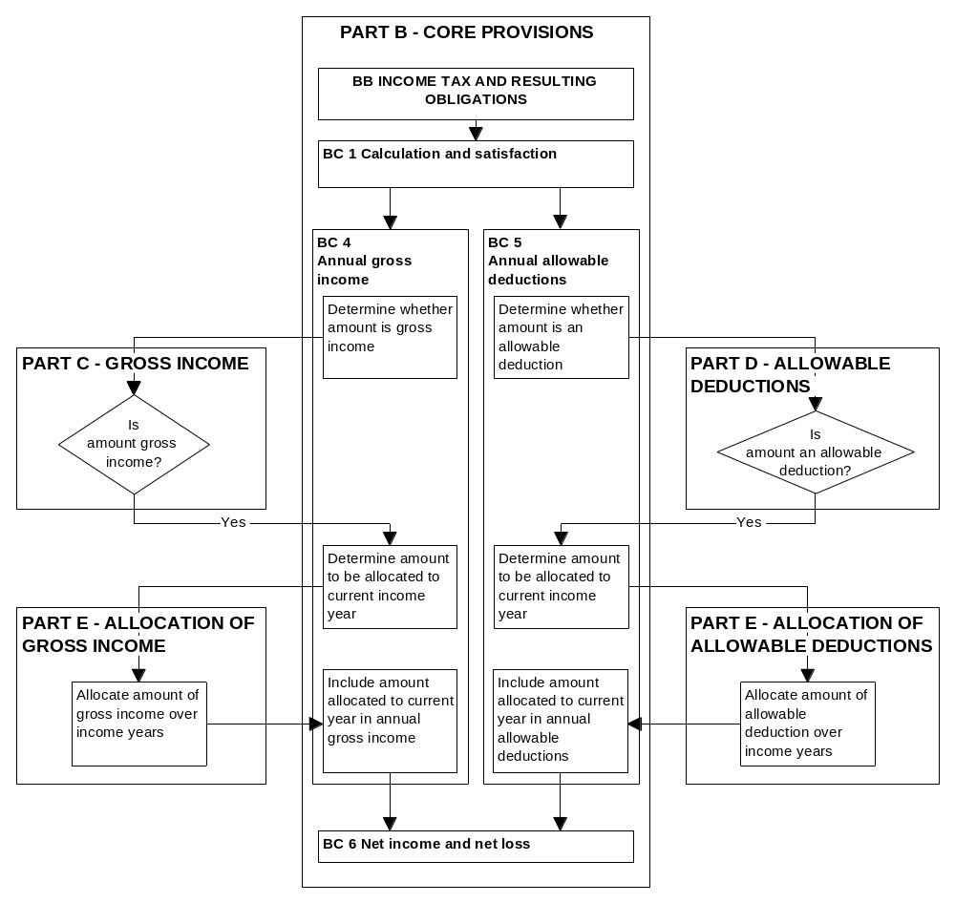

CHAPTER 4

PROPOSED STRUCTURE OF PART C

Summary

The proposals for restructuring Part C are:

- Items of gross income will be grouped according to the type of transaction, as well as the subject matter.

- Each Subpart will be self-contained and have clear, descriptive headings.

- The Subpart groupings will facilitate rationalisation of similar provisions.

Items of gross income will be placed in one of the following categories:

- general gross income (employment and entitlement income, amounts from sales or dispositions, and amounts from investments and other transactions);

- the controlled foreign company and foreign investment fund rules;

- industry rules;

- recoveries and adjustments.

Amounts that would be gross income but are exempt or excluded from gross income will be placed in separate categories. Items of gross income attributed to another taxpayer will be separately identified.

Rules defining items charged with taxes other than income tax (for example, fringe benefit tax and specified superannuation contribution withholding tax) will be moved to Part C because they are equivalent to gross income. The charge is generally, in substance, a final withholding tax. The definitional rules will be rewritten later with the other Part N rules.

- The proposed function of Part C is to enable taxpayers to readily determine their gross income. This will be achieved by grouping within the Part all gross income provisions, including provisions that prescribe what is not gross income and provisions that attribute gross income to a particular taxpayer. Gross income will be quantified in Part C on an untimed basis and then allocated to an income year under Part E.

- Part C will also include “income equivalents”, which are items such as fringe benefits that are subject to tax because they are income of a person other than the person charged with the tax.

Current rules

- The current Part C includes a long list of items that are gross income. Items in the list have been introduced over time to expand the income tax base, often by clarifying the capital/revenue boundary. Accordingly, Part C is now an itemised account of amounts that are within the income tax base.

- The current organisation of Part C provisions is largely based on their similarity of subject matter. However, it can be difficult to ascertain from the Subpart heading what provisions are likely to be found in the Subpart. The organisation of the provisions would be improved if, in addition to subject matter, account were taken of the type of transaction that gives rise to the gross income.

Proposed structure

- One of the main aims in restructuring Part C is to create Subparts with headings from which readers can readily ascertain the likely content.

- A further aim is to create Subparts that are self-contained and do not, therefore, overlap with other Subparts. This will provide readers with the certainty that they do not need to read further.

- Basing the categories on the type of transaction rather than subject matter alone also affords greater scope for the rationalisation of provisions under more general or widely applicable rules – for example, provisions relating to recoveries, as discussed below.

- The structure proposed for Part C is based on the groupings discussed in the remainder of this chapter.

General gross income categories

Employment and entitlement income

- This category includes amounts received as an employee, such as wages and accommodation benefits, and other forms of payment (“entitlement income”) such as ACC, social welfare benefits and the like. The rationale for locating employment and entitlement income together is that entitlement income can substitute for employment income in that it is (often for social policy reasons) provided to those not in paid employment.

Amounts from dispositions

- This category includes amounts from land and personal property transactions if a disposition triggers a tax liability. It will not include all provisions that bring sale proceeds into the tax net. For example, it will not include the dividend rules to the extent that they apply to dispositions between companies and shareholders, because the trigger for the liability is the company/shareholder relationship rather than the disposition itself.

- Provisions that apply both to dispositions and other situations may need to be split and their various elements placed into the relevant categories. The main example of this is the current section that includes amounts derived from a business as gross income (section CD 3).

Amounts from investments and other transactions

- This includes investment income other than dividends. A separate Subpart for dividends is required because of the extent of the legislative detail involved.

Controlled foreign companies and foreign investment funds

- This category includes the definitional aspects of these rules relating to gross income. Timing and quantification aspects will be moved to Part E.

Industry rules

- This category includes the gross income aspects of the life insurance and other industry rules.

Recoveries and adjustments

- Amounts recovered and apportionment add-backs will be included in this category. It will contain several specific provisions relating to recovered amounts that perform essentially the same function and thus could readily be replaced with a general provision.

Amounts that are not gross income

Exempt income

- This category includes items that are specifically exempt from tax, such as the income of charities.

Excluded income

- Excluded income means amounts that the statute excludes from tax other than by specific exemption. Even though they are similar in nature, it may be necessary to retain the distinction between excluded income and exempt income. This is because if the expenditure incurred relates to the derivation of both gross income and exempt income, apportionment principles apply. However, the position with excluded income is less clear. Submissions are invited on the issue.

Attributed income

- The focus of the core provisions is on gross income that “belongs” to a particular taxpayer. Therefore readers need to find out from Part C not only what constitutes gross income but also what constitutes their gross income because of their status. For example, taxpayers who are beneficiaries under a trust should be able to ascertain from Part C that beneficiary income must be included in their gross income.

- This category needs to deal only with amounts derived by a person other than the recipient. It does not include amounts such as trustee income that are derived by a person in a different capacity because the person is a separate taxpayer in each capacity and explicit attribution is not necessary.

Items charged with taxes other than income tax

- These items are included in Part C because they are equivalent to income or would be gross income were it not for the fact that another person is charged. Charges on these items are generally, in substance, a final withholding tax.

- Although these items will appear in Part C, it is not proposed to rewrite all the rules relating to them in this phase of the rewrite. This is best left until Part N is rewritten.

Gross income under ordinary concepts

- Although gross income under ordinary concepts referred to in the current section CD 5 does not sit easily with a codified approach, it will be retained as a catch-all for those occasions when an amount falls outside the specific provisions but nonetheless has revenue characteristics.

- As noted in the May 1995 discussion document Core Provisions: Rewriting the Income Tax Act, key areas of taxation, such as the existing boundaries between capital and revenue, are not intended to be altered by the rewrite.

CHAPTER 5

PROPOSED STRUCTURE OF PART D

Summary

The proposals for restructuring Part D are:

- The general deductibility and capital prohibition rules will be moved to Part D from the core provisions and become the pivotal rule for organising the Part.

- Other deduction provisions will be expressed as expansions of or limitations to the pivotal rule to clarify their relationships

- Provisions that replicate the general deductibility rule, such as the interest provisions, could be removed under the structure proposed. Submissions on the effect of this proposal are invited.

Deductions allowed independently of the general deductibility rule will be separately grouped as “supplementary deductions”. Limitations with wider application to all deduction provisions will also be separately grouped as “general limitations”.

Part D will allow a deduction for an amount equal to the estimated decline in the value of depreciable assets (as opposed to the annual depreciation deduction currently in Part E). The allocation of this deduction to income years will be made in Part E. This will not change the effect of current law.

- The proposed function of Part D is to enable taxpayers to determine, on an untimed basis, all amounts that are allowed as a deduction under the Act. Part D should, therefore, contain all allowable deduction provisions in the Act.

Current rules

- Section BD 2 provides that an amount (if not excluded from being deductible by another provision) is an allowable deduction:

- if it is an allowance for depreciation under Part E; or

- if it is an expenditure or loss that satisfies the general deductibility rule (nexus with the derivation of gross income) specified in section BD 2(1)(b)(i) and (ii); or

- to the extent that it is allowed as a deduction under any other Part.
- Thus allowable deductions are determined solely by the legislation. Through grouping all the entitlement and exclusory provisions together, Part D will govern allowable deductions.

- Under the proposed scheme for Parts C, D and E, it will not be appropriate to continue to describe the depreciation allowance in an income year as an allowable deduction because this amount is a timed concept. To serve its function, Part D will allow a deduction for the estimated decline in the value of a depreciable asset over its expected useful life. In light of the proposed functions of the three Parts, this will not involve a change in the way in which the law operates, but only a change in the expression of the law. It will not necessitate changes in accounting practice.

- Most of the present rules in Part D are exceptions to the rule that denies a deduction for expenditure of a capital nature. A theoretical option for structuring Part D, therefore, would be to replace most of the existing rules with rules specifying only those amounts that are not allowed as a deduction. However, it would be impossible to identify all amounts for which a deduction is not currently allowed, so this approach is not proposed.

- Within the existing structure for Part D it is difficult to work out the relationship between the specific deductibility rules and the more general deductibility rules. The approach proposed for clarifying that relationship is discussed in the remainder of this chapter.

Proposed structure

- The structure proposed for Part D centres around expansions of and limitations to the general deductibility rule in section BD 2 (1)(b)(i) and (ii). Grouping expansions and limitations on the basis of their relationship to the general deductibility rule has the advantage of providing a context within which to interpret provisions. Thus if a specific rule expands the general rule, the structure will clarify that the specific rule allows as a deduction an amount that Parliament has recognised would not be deductible in the absence of the specific rule.

- The proposed structure for Part D also recognises that some deductions are allowed independently of the general deductibility rule, and some limitations apply to nearly all deduction provisions.

The general deductibility rule as a pivotal rule

- The general principle of deductibility can be regarded as an amalgam of the general deductibility rule in section BD 2(1)(b) and the capital prohibition rule in section BD 2(2)(e). It is proposed that Part D be structured with this amalgam as its pivotal rule.
- Rules that seem merely to replicate the existing general deductibility rule will be removed from the Act by the rewrite. The most significant of these is probably in section DD 1(b)(i) and (ii), which relates to deductions for interest payable in deriving gross income or necessarily payable in carrying on a business for the purpose of deriving gross income.

- A consequence of the proposed change is that the deductibility of interest would be expressly subject to the capital prohibition rule. The view this document takes is that this would not have any practical impact in most cases.

- For example, a hotel chain borrows money to finance the construction of a new hotel to be used in its business. Interest incurred during the construction period would not be immediately deductible because the capital is not used in the production of income until the hotel is operational.

- As a consequence of the proposed change, expenditure under the qualified accrual rules will not generally continue to be deemed to be interest payable. Deductions for this expenditure will flow through the pivotal deductibility rule or, when applicable, under the rule that currently allows a deduction for interest in acquiring group company shares.

- The rules governing interest deductibility are obviously a very important part of the Act. Submissions on the proposed change are therefore welcomed.

Expansions of and limitations to the general deductibility rule

- Expansions of the proposed general deductibility rule include:

- amounts that are allowed even though they do not come within the rule;

- amounts that are allowed even though they offend against the capital prohibition aspect of the rule.

- Distinguishing between the two categories could give rise to technical issues at the margin without providing any apparent structural benefit. An example is section DJ 11 (expenditure in borrowing money), which could either override the capital prohibition or allow (otherwise non-deductible) expenditure of a preliminary nature. Therefore it is not proposed to structure the expansions separately.

- Rules that are expressed as limitations to the pivotal rule will either be rules that are currently expressed as such or rules that are essentially limitations. An example of the latter is the treatment of bad debts under both the qualified accrual rules and the general rules.

Supplementary deductions

- Some deductions are allowed independently of the general deductibility rule. These are generally deductions that do not depend on expenditure having been incurred but are incentives provided by Parliament through the legislation. Examples include notional interest deductions for loans by an employer on behalf of an employee to share purchase schemes and deductions for appropriations by mineral miners.

- Part D will, therefore, include a Subpart dealing with supplementary deductions.

General limitations

- The principal limitation provisions in section BD 2 apply to most amounts that might otherwise be allowed as deductions. These include employee expenditure and private or domestic expenditure. These limitations will be set out in Subpart DB.

- A limited category of items will not be subject to the general limitations. The main example of these items is the rule that allows a deduction for interest in acquiring group company shares.

CHAPTER 6

PROPOSED STRUCTURE OF PART E

Summary

The proposals for restructuring Part E rationalise timing rules that have the same effect under two main standardised approaches (allocation on a prospective or retrospective basis, or a derived/incurred basis).

Rules that allocate prospectively will be rationalised using a valuation method that compares opening and closing book values. They include the rules on depreciation, trading stock, accrual expenditure, revenue account property and those that “spread” gross income or allowable deductions. The effect of these rules will not change, and all necessary detail in the legislation will be retained.

Retrospective allocation rules will be placed in a separate category and rationalised as far as possible.

Rules that extend or modify the common law concepts of when income is derived or expenditure incurred will be brought together and logically ordered.

Because the qualified accrual rules and the controlled foreign company and foreign investment fund rules will not be placed on a gross basis, it is proposed to link them to the derived and incurred approach rather than place them under the valuation method. However, the valuation method may be one way to rationalise the qualified accrual rules (including those in the determinations) if all the practical issues involved in rewriting them can be addressed.

- The proposed function of Part E is to allocate amounts of gross income and allowable deductions to an income year either under specific prospective or retrospective allocation rules, or as derived or incurred in that year (including amounts deemed to be derived or incurred). Part E will contain the rules that are relevant to this function.

Current rules

- Part E contains a number of regimes that have similar goals but are subject to different sets of rules. This obscures the scheme of the Act and creates difficulties in determining which rules apply in a given circumstance.

- One of the objectives in restructuring Part E is to rationalise the rules under common themes in order to:

- reduce the repetition of provisions that have the same objective;
- reduce current difficulties in determining which regime applies;

- assist future policy development. Any new requirement for gross income or allowable deductions to be allocated can be implemented within the then prevailing legislative framework.

- The current Part E contains three broad groups of provisions:

- rules that allocate gross income and allowable deductions prospectively over a number of income years (for example, the depreciation, trading stock and accrual expenditure rules);

- rules that deem, or effectively deem, income to be derived or expenditure to be incurred in a particular income year (for example, the controlled foreign company and foreign investment fund rules, the qualified accrual rules and rules relating to single items such as bad debts);

- rules that allow the allocation of gross income or allowable deductions to income years earlier than the year of derivation or incurrence (for example, dispositions of timber and assignments of copyright).

Proposed structure

- For rules that allocate prospectively, the Government proposes a single allocation method based on the opening and closing book values of deferred amounts of gross income or allowable deductions. The proposed method will achieve the same timing result as under current law, but the way it is set out in legislation will change.

- Rules that extend or modify the common law concepts of when income is derived or expenditure is incurred will be set out more clearly in Part E as deemed derivation and incurrence rules.

- Retrospective allocation rules will be placed in a separate category.

The valuation method

- The valuation method focuses on liabilities (amounts of gross income not yet allocated to an income year) and assets (amounts of allowable deductions not yet allocated to an income year). It requires the identification of opening and closing values and the subtraction of the closing value from the opening value in order to determine the amount to be allocated to an income year. The closing value for an income year determines the amount of the gross income or allowable deduction that must be allocated to one or more later income years.
- The main rules that will fall within the valuation method are depreciation, trading stock, accrual expenditure and revenue account property. This method will also apply to a number of spreading provisions such as those relating to premiums on leases and development expenditure of petroleum miners. The substance of these rules will not change, and all the specific detail that is necessary to their operation will be retained in the legislation.

- It will be necessary to allow a deduction in Part D for an amount equal to the estimated decline in the value of depreciable assets to enable that amount to be allocated in accordance with the proposed valuation method. The opening and closing tax book values of depreciable assets can be readily ascertained from the existing depreciation schedules, so there will be little change in practice in the way depreciation is calculated. The proposed method also reflects accounting practice in addressing the disposal of depreciable assets by effectively setting off the gross income from disposal of the asset against the opening tax book value.

- The current trading stock approach treats closing book value as gross income and opening book value as an allowable deduction within Part E. This is inconsistent with the roles proposed for Parts C, D and E. The identification of the opening and closing book values will simply become part of the timing function, and it will no longer be necessary to designate them as either income or expenditure.

- The rules to which the valuation method applies will be split into gross income and deductions rules, with the allocation mechanism applying in the same manner to each category.

The derived and incurred basis

- Defining when an amount is derived or incurred will continue as the preserve of the courts.

- Even so, the legislation contains a number of rules that currently deem the time of derivation or incurrence. In general, these rules will advance the time at which allocation would otherwise occur if the common law concept of derived or incurred applied. In addition, there are several “one off” timing rules that put amounts into income years on a basis that is neither derivation nor incurrence. It is proposed that these rules be incorporated in non-exhaustive definitions of “derived” and “incurred”.

The qualified accrual, controlled foreign company and foreign investment fund rules on a derived and incurred basis

- As discussed in chapter 3, it is not proposed to rewrite the controlled foreign company, foreign investment fund and qualified accrual rules so they operate on a gross basis.

- The controlled foreign company and foreign investment fund rules measure an amount that is gross income or an allowable deduction for a particular income year. The present form of the rules is thus more analogous to the rules that deem a time of derivation or incurrence. Therefore it is proposed to link these rules to the derived and incurred approach rather than to place them on a valuation basis.

- In accordance with the proposed functions of Parts C and E, the provisions in the controlled foreign company and foreign investment fund rules that deal with the quantification of attributed income will be moved from Part C to Part E. The quantification and timing processes in the controlled foreign company and foreign investment fund rules are so closely related that it would be difficult to separate them. However, the definitional aspects of these rules will remain in Part C.

- The qualified accrual rules operate on a net basis, in that annual net outcomes are gross income or an allowable deduction. Therefore it is proposed at this stage to treat the gross income or allowable deductions allocated to a year on a deemed derived or incurred basis.

- The qualified accrual rules themselves, and the determinations issued in accordance with those rules, however, rank highly among the legislation with which taxpayers and advisors have the greatest difficulty.

- The determinations themselves vary in approach and presentation, which suggests that rationalisation of determinations should be explored.

- One possibility would be to use the valuation method if the Government can develop answers to all the practical issues involved in rewriting the qualified accrual rules. In the meantime, the rules will remain substantially as they are now.

Retrospective allocation basis

- Several provisions allow a taxpayer to elect to allocate amounts of gross income or allowable deductions to a given number of previous income years.

- It is difficult to place these rules within a valuation method or on a deemed derived or incurred basis because they involve retrospective adjustments that are not contemplated by those approaches. A common approach will be adopted for these provisions, when appropriate.

CHAPTER 7

EXPRESSING LEGISLATION MORE CLEARLY

Summary

Plain language drafting is about conveying the intended message of the legislation in the plainest possible manner.

The words themselves will provide the primary source of meaning, assisted by purpose provisions when necessary.

Words will be used according to their ordinary meaning, sentence length minimised, provisions formatted consistently and information arranged logically. Flowcharts, diagrams, formulas, tables and schedules may also be used.

Principles discussed in this chapter are illustrated in Part Three of the discussion document, which contains illustrative draft legislation from Parts C, D and E.

- The words of the legislation should provide a clear idea of its policy intent, but in some cases the policy can be obscured by the need to set out a process for achieving the intended result. Therefore purpose provisions may sometimes be necessary to assist interpretation, as envisaged by section AA 3(1):

AA 3(1) The meaning of a provision of this Act is found by reading the words in context and, particularly, in light of the purpose provisions, the core provisions and the way the Act is organised.

- Purpose provisions may be included at either a Part, Subpart or section level if they are likely to be of use to the reader. A carefully drafted purpose provision is a useful aid to interpretation because it conveys to readers the reasons a particular area of the law was enacted and how Parliament intended it to function.

The language of the rewritten Act

- As set out in the December 1994 discussion document Rewriting the Income Tax Act: Objectives, Process, Guidelines, and implemented in the new core provisions, the features of plain language that are being applied in the rewrite project include:

- drafting provisions using common words, applied in a way that is consistent with their ordinary meaning;
- minimising sentence length when possible so that a sentence contains only one central message;

- using grammar that is consistent with that normally used;

- formatting the provisions consistently throughout the Act;

- arranging information so that it can be found where the reader expects it to be found.

- These aspects of plain language drafting reflect a style that conveys the intended message to readers in the plainest possible manner.

Flowcharts, tables and other alternatives for presentation

- Given its complexity, the Income Tax Act can benefit from the use of methods other than the conventional narrative to convey information. They include the careful use of flowcharts, diagrams, formulas, tables and schedules.

Flowcharts

- Flowcharts are a useful means of summarising rules that have a number of complex procedural steps (and were used for this purpose in the core provisions). They help readers find the correct answer to their particular question quickly, by providing an overview of the process and by showing the relationships between different aspects of the process.

- Flowcharts demonstrating the processes involved in Parts C, D and E are set out in Part Two of the discussion document. As with the flowcharts in Part B of the Act, they will not form part of the legislation itself but rather act as an aid to interpretation.

Diagrams

- Part Two also contains diagrams that set out the Subpart structure for Parts C, D and E in a manner similar to that of the diagram preceding section BA 1 in the core provisions. Again, diagrams will act as aids to interpretation rather than as part of the legislation itself.

Formulas

- Formulas are a practical way to express a complex series of calculations, as in section EG 11, which relates to the pool method of depreciation. They can also be used to convey the relationship between items, such as that between income interests and branch equivalent income in section CG 7. This practice will continue as appropriate.

Tables

- Presenting information in tabular form is an effective way of bringing together provisions that perform similar functions or have common elements. It allows readers to locate the relevant rule quickly. Tables can be either part of the legislation or an aid to interpretation, depending on the context. They are linked to the rest of the Act by a reference in the appropriate provisions.

- Part Three explores the use of tables in defining “associated persons” and brings together the various provisions that use the definition.

Schedules

- A schedule can be used to separate material from the body of an Act for reasons of clarity or convenience. Often the material separated is not less important, but is incidental to understanding the law. For example, the rates of income tax are presented in Schedule 1 of the Act. Schedules are part of the legislation, not aids to interpretation.

- The form and content of a schedule can vary. It can take the form of a list, such as the current Schedule 8 (Types and Classes of Livestock), or it can contain detailed rules, as in Schedule 2 (Fringe Benefit Values – Motor Vehicles).

- When detailed rules are put into schedules, key principles are emphasised. This will increase the Act’s readability.

Limits to clear expression

- The rewrite process cannot eliminate all the complexity and inconsistencies that are inevitably part of tax legislation because the subject is inherently complex. The challenge for the rewrite is to ensure that any complexity is a result of genuinely difficult concepts, rather than the way the information is presented. The Government is confident that it can meet that challenge and develop an Income Tax Act that accurately reflects the intention of Parliament in a way that makes it easier for users to read, understand and apply the law.

PART TWO

DETAILS OF PROPOSED STRUCTURES OF
PARTS C, D AND E

Part Two of the discussion document illustrates how Parts C, D and E will be restructured using the principles discussed in Part One. Each chapter in this part contains:

- process flowcharts and commentaries from which readers can find out whether an amount is gross income or an allowable deduction and if so, when that amount is to be recognised;

- a new draft Subpart B for each Part to form the basis for the application of the remaining Subparts. As in the core provisions, Subpart B directs readers to the information that is relevant to their circumstances;

- an organisational chart for each Part showing the structures at a Subpart level;

- lists of the main provisions that will be contained in each Subpart.

CHAPTER 8

PART C: GROSS INCOME

- The purpose of the new Part C will be to define amounts that are gross income and to identify the taxpayer to whom that gross income belongs. It will also define amounts that would be gross income but are exempt or excluded from gross income. The process for determining whether an amount is or is not gross income is shown in figure 2.

General gross income categories

- There will be three general categories of gross income under the proposed structure:

- employment and entitlement income;

- an amount from a disposition of property;

- an amount from investments and other transactions.

- The categories are intended to be mutually exclusive; only one of the three will be applicable to a particular transaction. A new Subpart CB that will include core rules for the Part should make it clear to readers which of the three applies.

- Which category applies will depend on the nature of the event that triggers the tax liability. For example, an amount is a royalty if it is consideration for the use of a particular asset, irrespective of whether it arises from a disposition. Accordingly, royalties will be placed in the category for amounts from other transactions.

- A subcategory of amounts from investments and other transactions will be dividends. This additional Subpart is needed because of the amount of detail involved.

Controlled foreign company and foreign investment fund rules

- This Subpart will contain the specific rules that define attributed foreign income and foreign investment fund income to be included in a taxpayer’s gross income. Provisions in this Subpart that calculate the amount of gross income for recognition in a particular income year will be moved to Part E.

Industry regimes

- These are specific rules relating to:

- the taxation of the business of life insurance in New Zealand;

- the treatment of other industries.

- In accordance with the function of Part C, only rules that define items of gross income will be located here. Again, provisions in this Subpart that calculate the amount of gross income for recognition in a particular income year will be moved to Part E.

Recoveries and adjustments

- A separate Subpart will be established for provisions that treat an amount as gross income for the purposes of either:

- negating the effect of a deduction previously allocated to an income year; or

- limiting the effect of a deduction in the income year to which it is allocated.

- The first group of recoveries and adjustments is triggered by a subsequent event that occurs in relation to the transaction. For example, a bad debt may be allowed as a deduction. If the debt is subsequently recovered, the amount repaid is gross income.

- The second group operates concurrently with the deduction provisions in determining the amount of an allowable deduction. Consistent with the global/gross approach, this category will be extended to encompass some items currently expressed as limitations to deductions. For example, if a taxpayer receives a government grant to which section DC 1 applies, the allowable deductions related to the grant are reduced by the amount of the grant, and the grant is not gross income. Under the proposed treatment, the grant will be an item of gross income to the extent of the deduction allowed for grant-related expenditure.

Ordinary concepts

- An amount not included in one of the previous categories may be gross income under ordinary concepts.

Exempt and excluded income

- Amounts are not gross income if they are exempt or excluded income.

Attribution

- In most cases an amount will be gross income of the taxpayer who derives it. The main exception to this principle relates to gross income derived by a trustee. Under the provisions currently in Subpart HH, gross income may be vested in, or applied for the benefit of, a beneficiary. That amount will be the beneficiary’s gross income rather than gross income of the trustee.

Figure 2
PART C
SUBPART B - PROCESS FOR DETERMINING WHETHER AN AMOUNT IS GROSS INCOME

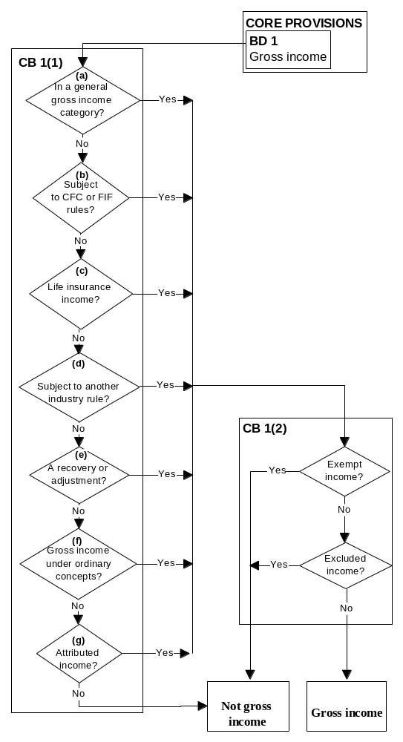

SAMPLE DRAFT LEGISLATION

PART C

GROSS INCOME

Subpart A - Purpose

CA 1 Purpose

The purpose of this Part is to set out the rules under which amounts are gross income of a taxpayer and amounts are not gross income of a taxpayer.

Defined: amount, gross income, taxpayer

Subpart B - General rules

CB 1 What is and what is not gross income?

What is gross income?

(1) An amount is gross income of a taxpayer if

(a) under any of Subparts CC to CF (general gross income categories) it is

(i) employment or entitlement income, or
(ii) an amount from a disposition of property, or
(iii) an amount from an investment or transaction other than a disposition of property, or

(b) under Subpart CG (attributed foreign income and foreign investment fund income) it is attributed foreign income or foreign investment fund income, or
(c) under Subpart CH (life insurance income) it is an amount derived by a life insurer, or
(d) under Subpart CI it is subject to another industry rule, or
(e) it is received as a result of a recovery or an adjustment under Subpart CJ (recoveries and adjustments), or
(f) it is gross income under ordinary concepts, or
(g) it is attributed to the taxpayer as gross income under Subpart CM (attributed income).

What is not gross income?

(2) An amount is not gross income of a taxpayer if it is either

(a) exempt income under Subpart CK (exempt income), or
(b) excluded income under Subpart CL (excluded income).

Defined: amount, attributed foreign income, foreign investment fund income, gross income, life insurer, taxpayer

Figure 3

STRUCTURE OF PART C – GROSS INCOME

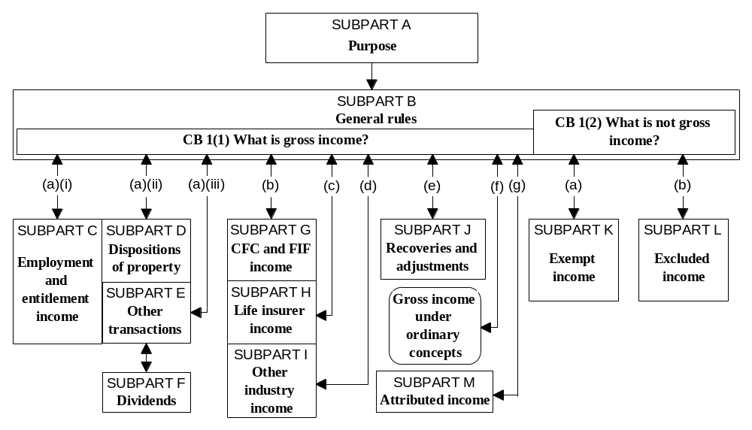

Table 1

PROPOSED ORGANISATION OF PROVISIONS WITHIN PART C

Figure 3 shows the proposed organisation of Subparts. The main items in each Subpart are as follows:

General gross income categories

Subpart CC - Employment and entitlement income

Employment income
Monetary remuneration
Benefits from employee share purchase schemes

Entitlement income
Compensation for loss of earnings
NZ superannuation, income tested benefits, veterans’ pensions and living alone payments
Grants paid under the Education Act

Subpart CD - Dispositions of property

A sale of personal property:
- if the business of the taxpayer comprises dealing in such property;
- if the property was acquired for the purpose of disposing of it;
- in the carrying on of a profit-making undertaking or scheme.
Dispositions of:
- land;
- minerals, flax or timber;
- patent rights;
- a specified lease;
- a petroleum permit or shares or trust interests in a controlled petroleum mining entity;
- property in carrying on a business.

Subpart CE - Investments and other transactions

An amount from a business that is not from a disposition of property
Royalties
Gross income under the accrual rules

To the extent that the accrual rules do not apply:
- interest;
- value of benefit from money advanced;
- commercial bills.
Rents and premiums on leases
An amount from the use or occupation of land

Subpart CF - Dividends

Controlled foreign company/foreign investment fund rules

Subpart CG - Attributed foreign income and foreign investment fund income

Industry regimes

Subpart CH - Life insurer income

Subpart CI - Other industry rules

Non-resident general insurer income
Non-resident film renter income
Non-resident shippers’ income

Recoveries and adjustments

Subpart CJ

Group I
Recovered bad debts
Amounts remitted, cancelled or recouped
Dispositions of depreciable property

Group II
Apportionment for changes of use and private use
Government grants and suspensory loans

Amounts that are not gross income

Subpart CK - Exempt income

Amounts derived by non-profit bodies, charities, public and local authorities, and non-resident aircraft operators
Amounts subject to the 92-day rule
Certain pensions and benefits
Some interest, dividends and share proceeds
Employee allowances and expenditure on account of an employee
Exempt income of public offices

Subpart CL - Excluded income

Output tax charged on a taxable supply and a GST refund
Amounts from consolidated group transactions
A foreign-sourced amount of a trust with no New Zealand-resident settlor
Employer superannuation contributions made to the trustee of a superannuation scheme
A family tax credit
A life insurance premium and life reinsurance policy claim
Payments recoverable by ACC or the ARCI Corporation
Payments refunded to the Social Security Commission by ACC
Farm-in expenditure

Attributed income

Subpart CM

Beneficiary income

Amounts subject to another charge

Subpart CN

A fringe benefit
A specified superannuation contribution
Withdrawal income
A taxable distribution from a non-qualifying trust
Dividends subject to foreign dividend withholding payment

CHAPTER 9

PART D: ALLOWABLE DEDUCTIONS

- The purpose of the new Part D will be to define amounts that are allowable deductions, which will fall into three categories under the proposed structure:

- deductions for expenditure or loss that satisfies the general deductibility rule;

- deductions for expenditure or loss that does not satisfy the general deductibility rule (expansions);

- deductions for amounts created by statute (supplementary deductions).

- The deduction can be denied if a general limitation applies (such as that for private and domestic expenditure).

- Deductions are also subject to specific limitations. Limitations may apply to deny a deduction either for all or part of the expenditure incurred.

- The process is shown in figure 4.

Principles underlying the structure

- The structure proposed for Part D seeks to clarify relationships within the Part by:

- indicating whether a specific deductibility rule narrows or expands the general deductibility rule; or

- making explicit the relationship between expansions and prohibitions – provisions that expand the general deductibility rule are not subject to the capital prohibition, but are usually subject to the general limitations.

- The new general deductibility rule will be an amalgam of the current section BD 2(1)(b)(i) and (ii) and the capital prohibition in section BD 2(2)(e).

Figure 4

SUBPART B – PROCESS FOR DETERMINING WHETHER AN AMOUNT IS AN ALLOWABLE DEDUCTION

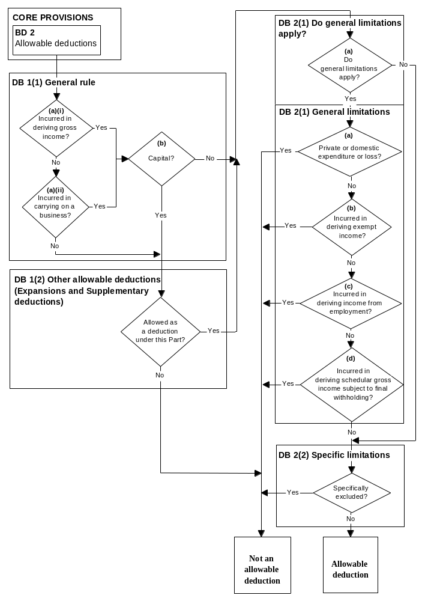

Expansions

- Expansions will allow deductions for expenditure or losses that do not satisfy the proposed general deductibility rule. Examples of provisions that will be included as expansions are those relating to losses from misappropriation by employees, and the proposed allowable deduction based on the cost of depreciable property.

- Expansions override the new general deductibility rule, but are subject to general limitations and specific limitations.

- Overlaps between the new general deductibility rule and expansions will be removed as far as possible. The new rule will be applied first, with the expansion applying only if the rule is not satisfied fully or in part.

Supplementary deductions

- Supplementary deductions will apply independently of the new general deductibility rule. They are generally notional amounts created by the statute and do not require the incurrence of an expenditure or loss. Therefore no overlap with the new general deductibility rule is possible. Examples of notional amounts are notional interest on interest-free loans provided by employers under employee share purchase schemes, and appropriations for mineral miners.

- Supplementary deductions will be subject to general and specific limitations.

General limitations

- In most cases general limitations will override all three deduction streams (the new general deductibility rule, expansions and supplementary deductions). General limitations will be one of the following:

- expenditure or loss of a private or domestic nature;

- expenditure or loss incurred in deriving exempt income;

- expenditure or loss incurred in deriving income from employment;

- expenditure or loss incurred in deriving schedular gross income subject to final withholding.

- The main instance in which the general limitations will not apply is the provision that allows a deduction for interest incurred in acquiring group company shares.

Limitations to the new general deductibility rule

- These limitations deny deductions for amounts that would normally fall within the new general deductibility rule. They will be expressed positively when possible. For example, section DJ 1(a) currently denies a deduction for bad debts, except when (among other things) the bad debt is actually written off. In the rewritten Part D the limitation will simply deny deductions for amounts that are not written off. Amounts of bad debts that are written off will be allowed under the new general deductibility rule, and will not be affected by the limitation.

SAMPLE DRAFT LEGISLATION

PART D

ALLOWABLE DEDUCTIONS

Subpart A - Purpose

DA 1 Purpose

The purpose of this Part is to set out the rules under which amounts are allowed as a deduction to a taxpayer.

Defined: amount, taxpayer

Subpart B - General rules

DB 1 What is an allowable deduction?

General rule

(1) An amount is an allowable deduction of a taxpayer

(a) if it is incurred by the taxpayer

(i) in deriving the taxpayer's gross income, or
(ii) in the course of carrying on a business for the purpose of deriving the taxpayer's gross income,

and

(b) if it is not capital.

Other allowable deductions

(2) An amount is an allowable deduction if, despite subsection (1), it is allowed as a deduction to the taxpayer under Subparts DD-DI.

Defined: amount, gross income, taxpayer

DB 2 What is not an allowable deduction?

General limitations

(1) An amount other than an amount referred to in Subpart DJ is not an allowable deduction of a taxpayer if it is

(a) a private or domestic expenditure or loss, or
(b) an expenditure or loss incurred in deriving exempt income, or
(c) an expenditure or loss incurred in deriving income from employment, or
(d) an expenditure or loss incurred in deriving schedular gross income subject to final withholding.

Specific limitations

(2) An amount is not an allowable deduction to the extent specified in the rules set out in Subpart DC (limitations to the general deductibility rule), Subparts DD to DH (expansions), or Subpart DI (supplementary deductions).

Defined: amount, income from employment, schedular gross income subject to final withholding, taxpayer

Figure 5

STRUCTURE OF PART D – ALLOWABLE DEDUCTIONS

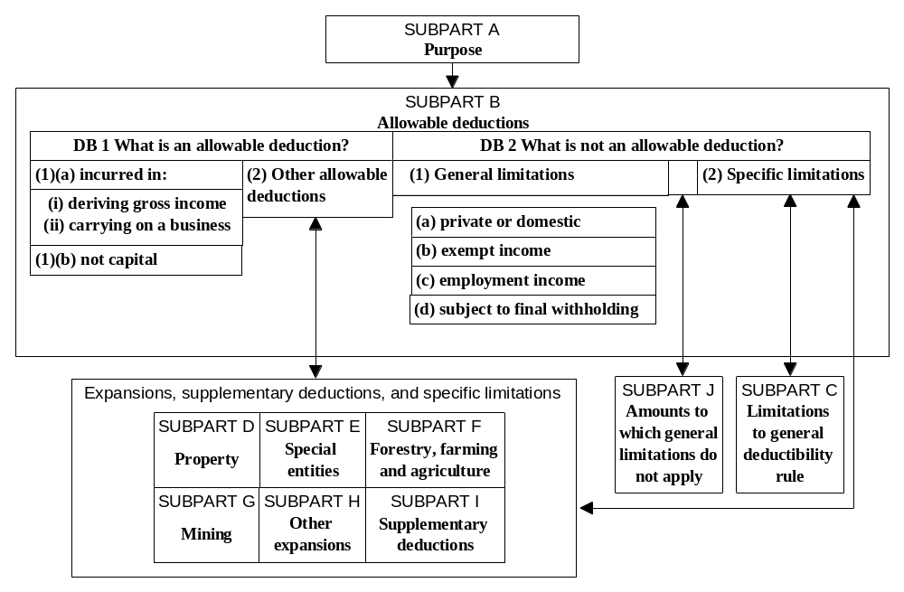
Table 2
PROPOSED ORGANISATION OF PROVISIONS
WITHIN PART D

Figure 5 shows the proposed organisation of Subparts. The main items in each Subpart are as follows:

Limitations to the general deductibility rule

Subpart DC

Income tax
Entertainment expenditure
Bad debts
Value of shares
Employer superannuation contributions
Contributions to employee benefit funds

Expenditure of special entities

- Airport operators
- Racers of bloodstock

Life insurance businesses

- Premiums with respect to policies of life reinsurance
- Claims or amounts credited to holders of policies in actuarial reserves
- Expenditure or loss in deriving policyholder income

Thin capitalisation rules

Expansions

Subpart DD - Deductions for expenditure or loss in relation to property

Depreciable property
Revenue account property
Expenditure on improvements for forestry, farming, agriculture and aquaculture
Misappropriations
Testamentary annuities charged on property
Repairs to fishing vessels
Films

Subpart DE - Deductions for expenditure of special entities

Superannuation funds
Building societies
Maori Authorities
Trustees/beneficiaries
Bad debts charged against beneficiary income

Subpart DF - Forestry, farming and agriculture

Costs of planting and maintaining trees
Certain costs of a forestry business
Cost of temporary access tracks
Certain expenditure incurred in farming business
Farmers’ expenditure on tree planting

Subpart DG - Mining expenditure

Development expenditure and exploration expenditure of petroleum miners
Removal and restoration expenditure
Development expenditure and exploration expenditure of mineral miners
Amounts of written-off loans made by holding companies to mineral mining company

Subpart DH - Other expansions

Pensions and retiring allowances
Interest in acquiring shares in another group or amalgamating company
Expenditure incurred by one company in a group that would be an allowable deduction of another group company
Gift of money
Cost of determining tax liability
Scientific research
Deduction of motor vehicle expenses if insufficient records are kept
Cost of preparing a lease or borrowing money

Supplementary deductions

Subpart DI

Notional interest on loans for employee share purchase schemes
Payment to working partner (distribution of income – not expenditure)
Deduction for non-profit organisations
Appropriations for mineral miners
Deduction from proceeds of land sales if rezoning has occurred
Attributed foreign losses
Foreign investment fund losses

Amounts to which general limitations do not apply

Subpart DJ

Interest in acquiring shares in another group or amalgamating company

CHAPTER 10

PART E: ALLOCATION OF GROSS INCOME AND ALLOWABLE DEDUCTIONS

- The main purpose of the new Part E will be to provide for the timing of gross income (as determined under the new Part C) and allowable deductions (as determined under the new Part D) to appropriate income years. This will be achieved through allocating gross income and allowable deductions to a particular income year, as set out in Part E, on:

- a valuation basis (prospective allocation);

- a retrospective basis; or

- on the basis of a derived or incurred test (the default rule).

- Figure 6 shows how the new Part E will operate.

Steps in the timing process

- Before they can allocate gross income and allowable deductions to an income year, taxpayers must determine whether a specific allocation rule in the legislation applies to them. If not, the default basis of allocation will apply.

Specific allocation rules

- If gross income or an allowable deduction are subject to a specific allocation provision, the method of allocation depends on the nature of that provision. In broad terms, the specific allocation provisions either:

- defer all, or a portion of an amount of gross income or an allowable deduction from one income year to one or more subsequent income years; or

- permit the retrospective allocation of all or a portion of an amount of gross income or an allowable deduction from one income year to one or more prior income years.

- The result is the allocation of amounts of gross income and allowable deductions to an income year. This allocation can be to a single income year or to more than one income year. Amounts allocated to an income year are aggregated to calculate the annual gross income or annual allowable deductions for that income year.

Figure 6
SUBPART B – PROCESS FOR ALLOCATING GROSS INCOME AND ALLOWABLE DEDUCTIONS
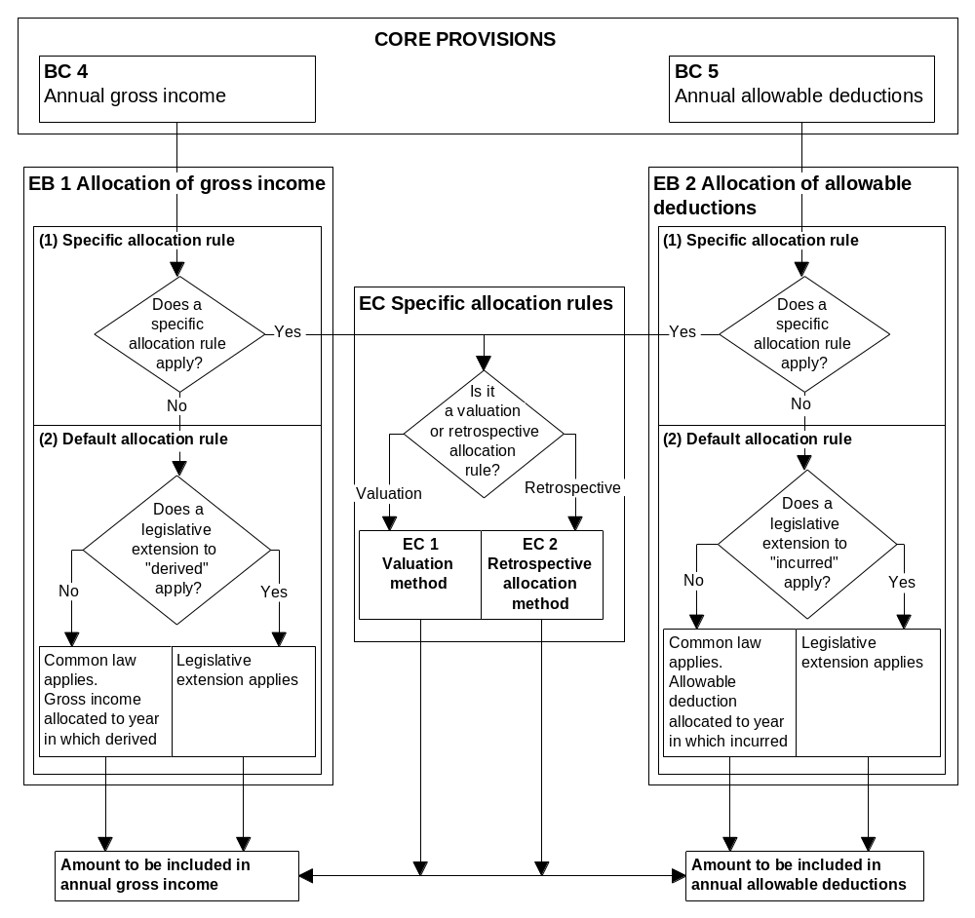

The valuation method

- A valuation method of allocation is proposed for provisions that defer amounts of gross income or allowable deductions to a later income year.

- An amount of gross income that is derived in one income year but recognised for income tax purposes in a later income year is treated as a liability. Similarly, an allowable deduction for which the expenditure is incurred but recognised for income tax purposes in a later income year is treated as an asset.

- The valuation method adopts the financial accounting method for measuring the cost of trading stock allocated to a financial year (the cost of goods sold). By adopting the financial accounting method for measuring the cost of goods sold, the valuation method should lead to tax accounting better reflecting the approach set out in the Statements of Concepts for General Purpose Financial Reporting, issued by the Institute of Chartered Accountants, for the measurement of net income. This leads to greater harmonisation of tax and financial accounting.

- Accountants treat the cost of goods sold as an expense for a financial year. The financial accounting method for calculating the cost of goods sold addresses the allocation of the cost of trading stock to the year in which the trading stock is sold. The amount of the cost of goods sold is measured by subtracting the closing value of trading stock from the sum of the opening value of trading stock and purchases of trading stock made in that year. This approach can be applied to all timing provisions that defer completely, or in part, the recognition of an amount of gross income and allowable deductions to years after the gross income is derived or the expenditure or loss that gives rise to the allowable deduction is incurred.

- A transaction may give rise to an amount of deferred gross income or allowable deduction. For any transaction, the allocation of an amount of gross income is made separately from the allocation of an allowable deduction.

- The allocation method for the valuation method in the year in which the transaction occurs is as follows:

- The closing value of the deferred gross income is subtracted from the gross income derived in that year.

- The closing value of the deferred allowable deduction is subtracted from the allowable deduction for expenditure incurred in that year.

- In subsequent years, unless there are further amounts of gross income or allowable deductions relating to the transaction in question, the valuation approach will normally determine the amount to be allocated. This will be done by measuring the difference in the opening and closing values of the deferred gross income or allowable deduction.
Example

Taxpayer A has a 31 March balance date. On 1 April 1997, the taxpayer derives $12,000 by way of a premium on a three-year lease. Applying the valuation method to the premium on the lease has the following result.

In the first year, the opening value is zero, the closing value is $8,000, and the amount of gross income derived is $12,000. Subtracting the closing value from the sum of the opening value and gross income derived results in $4,000 being allocated to the income year.

In subsequent income years, the amount of gross income derived will be zero. This means the amount allocated in subsequent income years is measured by subtracting the closing value from the opening value and will result in the allocation of $4,000 to each of the remaining years of the lease term.

- If there are further amounts of gross income or allowable deduction relating to the transaction in question in a subsequent income year, they must be taken into account in the allocation process. This will apply to transactions such as purchases of trading stock and capital additions to depreciable property.

Example

Taxpayer B begins business in 1998 and purchases trading stock in each of the 1998 to 2000 income years.

The allocation of the allowable deduction for trading stock for each income year is measured by subtracting the closing value of the trading stock from the sum of the opening value of the trading stock and the cost of purchases incurred in the income year that are allowable deductions.

- The valuation method will value most assets or liabilities by reference to historic cost principles. Generally, this method assumes that the value of a deferred amount of gross income or allowable deduction will decline over time. However, for some types of gross income or allowable deductions (for example, trading stock valued at market value) the closing values are not determined by reference to historic cost principles, and it is possible that the closing value may exceed the opening value. The new section EC 1 provides for this possibility by permitting the result of the calculation of the amount of gross income or allowable deduction to be allocated to an income year to be more or less than zero.

- The detailed provisions in Subparts ED to EF will set out the rules that determine the closing values. Generally, the closing value is measured by reference to the unexpired historic cost information and to the ratio of the unexpired period to the total period relevant to the asset or liability. In the year in which the last portion of an amount of gross income or allowable deduction is allocated, the closing value is zero. Ensuring the closing value is zero may eliminate the need to prohibit the double allocation of gross income or allowable deductions as envisaged in the current sections BD 3(4) and BD 4(4). This possibility will be reviewed.

- The valuation method can be applied to the depreciation rules and focuses on the opening and closing tax values calculated using tax depreciation schedules. This allows for the use of consistent timing approaches and facilitates simpler legislation. An amount equivalent to the estimated decline in value of a depreciable asset over its expected useful life is allowed as a deduction. The estimated decline in value will continue to be measured by reference to the cost of the asset. Consideration from disposals of those depreciable assets is treated as gross income.

- This approach to depreciable assets reflects the current policy and practice of:

- amortising the cost of a depreciable asset over its estimated useful life;

- making adjustments for a change in the use of a depreciable asset based on the taxation effect of the change;

- netting off proceeds from the disposal of a depreciable asset against its opening tax book value to determine the depreciation recovery or loss on disposal.

The retrospective allocation rules

- The retrospective allocation rules change the way annual gross income and annual allowable deductions would otherwise be calculated. Since these provisions retrospectively alter a previously calculated and assessed tax position, they will be placed in a separate Subpart to reflect this difference.

The default rule

- If the amount is not subject to a specific allocation rule, the allocation to an income year is made under a default rule. Gross income is allocated to the income year in which it was derived, and allowable deductions are allocated to the income year in which the expenditure or loss giving rise to the deduction was incurred.

- For the purposes of the default rule, the time of derivation or incurrence is determined under the common law approach or, for certain types of transactions, under a legislative extension to the common law approach.

Extended approach to derivation and incurrence

- Some provisions currently provide that, for taxation purposes, an amount may be deemed to be derived or incurred in a particular income year irrespective of common law principles. Generally, these rules require taxpayers to:

- calculate an amount for an income year in relation to certain transactions or events (as in the qualified accrual rules); or

- alter the time at which a specific type of expenditure is incurred (as happens to employer superannuation contributions under the 63-day rule, for example).

- They will be rewritten more clearly as rules that deem a particular time for derivation and incurrence. These provisions include:

- the qualified accrual rules;

- the international tax rules;

- other rules relating to amounts that are deemed, or effectively deemed, to be derived or incurred in an income year other than that in which they are derived or incurred under common law.

SAMPLE DRAFT LEGISLATION

PART E

ALLOCATION

Subpart A - Purpose

EA 1 Purpose

Purpose of Part

(1) The purpose of this Part is to set out rules that a taxpayer must use to allocate amounts of gross income or allowable deductions to an income year.

Purpose of Rules

(2) The purpose of the rules in this Part is to allocate amounts of gross income and allowable deductions of a taxpayer to a current, future or past income year.

Defined: allowable deductions, amount, gross income, income year, taxpayer

Subpart B - Allocation Rules

EB 1 Allocation of gross income

Specific allocation rules

(1) A taxpayer must allocate every amount of gross income that is subject to a valuation rule or a retrospective allocation rule to the income year to which Subpart EC requires the taxpayer to allocate it.

Default allocation rule

(2) A taxpayer must allocate every amount of gross income that is not subject to a valuation rule or a retrospective allocation rule to the income year in which it is derived.

Defined: amount, gross income, income year, retrospective allocation rule, taxpayer, valuation rule

EB 2 Allocation of allowable deductions

Specific allocation rule

(1) A taxpayer must allocate every amount of allowable deduction that is subject to a valuation rule or a retrospective allocation rule to the income year to which Subpart EC requires the taxpayer to allocate it.

Default allocation rule

(2) A taxpayer must allocate every amount of allowable deduction that is not subject to a valuation rule or a retrospective allocation rule to the income year in which the taxpayer incurs the expenditure or loss or makes the disbursement for which the deduction is allowed.

Defined: amount, allowable deduction, income year, retrospective allocation rule, taxpayer, valuation rule

Subpart EC - Valuation and Retrospective Allocation Rules

EC 1 Allocation using valuation rules

Allocation of gross income

(1) If an amount of gross income is subject to a valuation rule, a taxpayer must calculate the amount of gross income to be allocated to an income year as follows, whether that amount is more or less than zero:

opening value + gross income derived – closing value under the valuation rule

Allocation of allowable deduction

(2) If an amount of allowable deduction is subject to a valuation rule, a taxpayer must calculate the amount of the allowable deduction to be allocated to the current income year as follows using the sum of the allowable deductions for that income year and whether that amount is more or less than zero:

opening value + sum of allowable deductions – closing value under the valuation rule

Defined: allowable deduction, amount, closing value, gross income, income year, opening value, taxpayer, valuation rule

EC 2 Retrospective allocation

If Subpart EG applies to an amount of gross income or allowable deduction, the taxpayer must allocate the amount to an income year in accordance with that Subpart.

Defined: amount, allowable deduction, gross income, income year, taxpayer

New definitions

- The proposed sections EB 1, EB 2, EC 1 and EC 2 will require several new definitions. They are:

- “closing value” with respect to an amount of gross income or allowable deduction, means the amount determined under a valuation rule;

- “opening value” with respect to an amount of gross income or allowable deduction that is subject to a valuation rule, is the same as the closing value of the same gross income or allowable deduction in the immediately preceding income year;

- “retrospective allocation rule” means a rule in Subpart EG;

- “valuation rule” means a rule in Subparts ED, EE or EF.

Figure 7
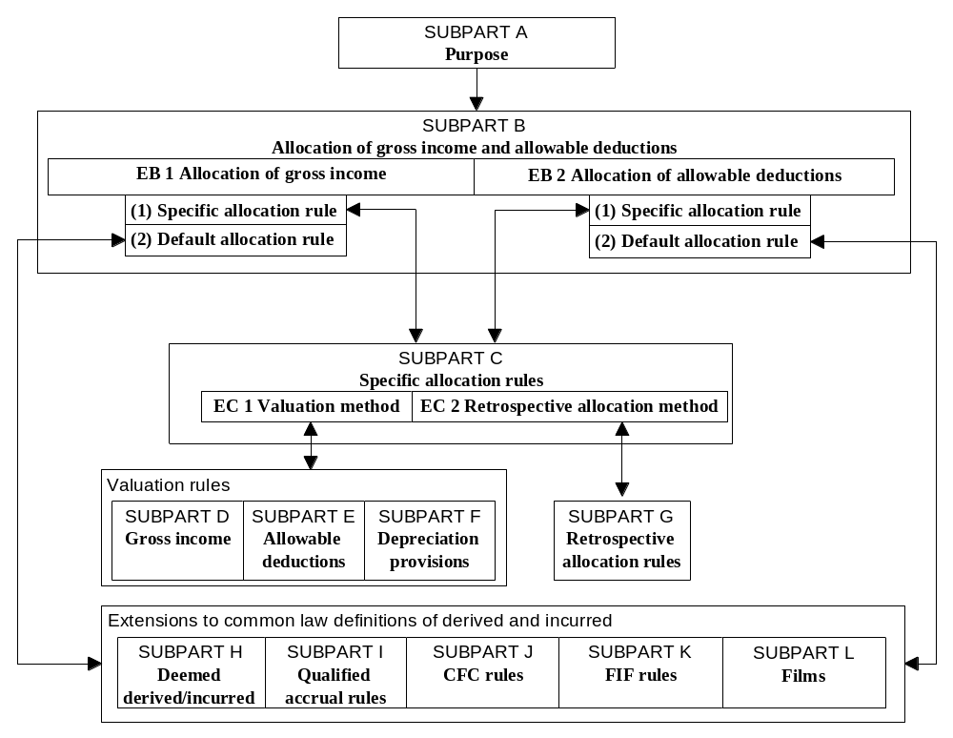STRUCTURE OF PART E – ALLOCATION OF GROSS INCOME AND ALLOWABLE DEDUCTIONS

Table 3

PROPOSED ORGANISATION OF PROVISIONS IN PART E

Figure 7 shows the proposed organisation of Subparts. The main items in each Subpart are as follows:

Valuation rules

Subpart ED - Deferrable gross income

Spreading provisions such as the income equalisation schemes and sale of patent rights
Disposal of land to Crown
Suspensory loans
Sales of mining company shares

Subpart EE - Allowable deductions

Spreading provisions such as premiums on leases and expenditure on forestry, farming, agriculture and aquaculture
Trading stock, including livestock and bloodstock
Unexpired accrual expenditure
Revenue account property
Cost of depreciable assets

Subpart EF - Depreciation provisions

All current depreciation rules other than specific gross income and allowable deduction provisions

Retrospective allocations

Subpart EG

Elective spread for adjustments for incorrect accounting practices
Sales or dispositions of timber
Compensation for non-compliance with covenants to repair
Payments for covenants to repair
Sale or assignment of copyright - not lump-sum payment

Legislative extension of “derived” and “incurred”

Subpart EH - Deemed derived /incurred rules

Prescribed expenditures and receipts, and employer superannuation contributions (payments basis)
Notional receipts and payments, such as notional interest and benefits deemed to be gross income
Calculated amounts deemed to be for an income year, such as the components of underwriting income and policyholder income for life insurers, and gross income derived by non-resident general insurers
Bad debts
Employer superannuation contributions – 63-day rule

Subpart EI - Qualified accrual rules

All of the qualified accrual rules relating to quantification and timing

Subpart EJ - Attributed foreign income under international tax rules

All of the attributed income rules relating to quantification and timing

Subpart EK - Foreign investment fund income under international tax rules

All of the foreign investment fund rules relating to quantification and timing

Subpart EL - Expenditure relating to types of film

PART THREE

THE REWRITE PRINCIPLES IN PRACTICE

CHAPTER 11

DIVIDENDS

Summary

- The redrafted dividend legislation uses a pivotal rule to more clearly identify underlying policy. A dividend is defined conceptually as a transfer of value from company to shareholder, rather than prescriptively by way of lists of payments and credits which are or are not dividends.

- It clarifies relationships between provisions by setting out expansions of and limitations to the pivotal rule.

- It makes the shareholder capacity test implicit in the pivotal rule, rather than explicit.

- It uses language that is plain relative to the complexity of the subject matter, accompanied by a flowchart and diagrams to assist readers understand the law.

- The illustrative draft of the dividend provisions in this chapter shows the benefits of structuring a set of provisions around a pivotal rule. Here the pivotal rule is based on the concept of a benefit passing from the company to the shareholder. The other rules are then grouped according to whether they expand or limit the pivotal rule. The main advantage of this approach is that an exhaustive list of what is and what is not a dividend is not required.

- The proposed approach for dividends is shown in three ways in this chapter. The first is with charts (figures 8 to 10) showing the organisation and application of the dividend definition and of the current Subpart CF. The other two are the legislation itself, and commentary on the legislation. The comments are mainly on the opening sections, where the major changes have been made.

- Finally, as discussed in Part Two, Subpart CB will have a core provisions-like role within Part C. Therefore the current section CF 1, which treats dividends as gross income, will be moved to that Subpart.

Figure 8

ORGANISATION OF DRAFT LEGISLATION
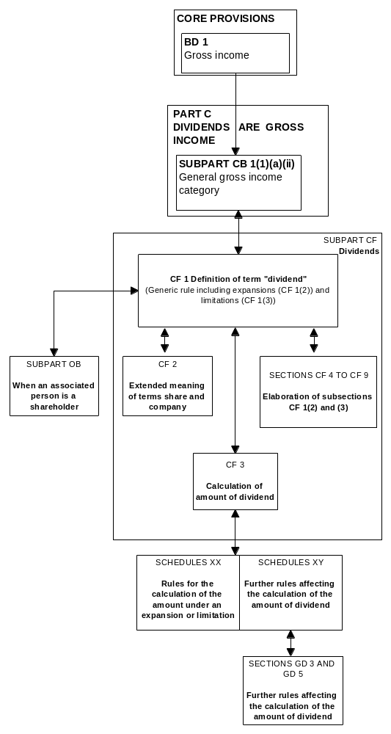

Figure 9
PROCESS FOR DETERMINING DIVIDENDS
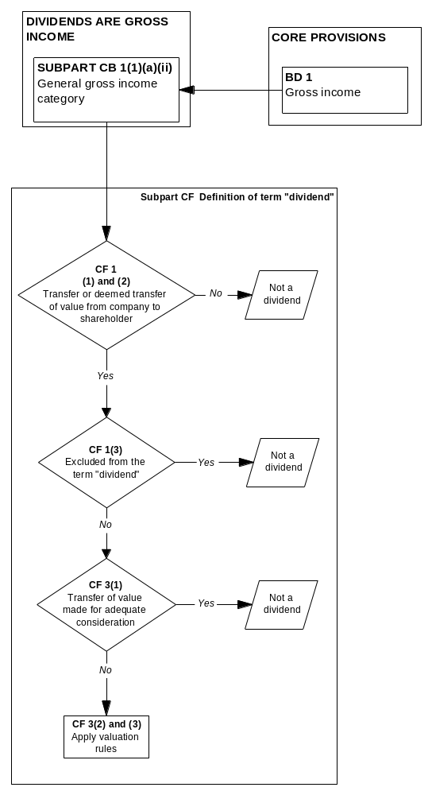

Figure 10
DIVIDEND DEFINITION
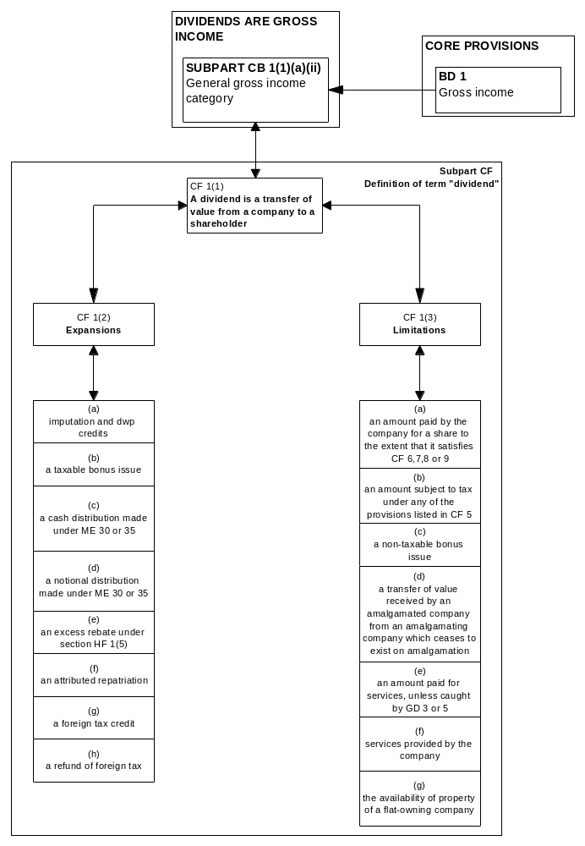

DRAFT LEGISLATION AND COMMENTARY

CF 1 What is a dividend?

General rule

(1) A dividend is a transfer of value from a company to a shareholder.

Expansions to the general rule

(2) The term “dividend” includes

(a) in Parts B, C, E, F, and Subpart LE, but subject to section LB 1, any imputation credit or dividend withholding payment credit attached to a dividend;

(b) a taxable bonus issue;

(c) a cash distribution of a statutory producer board or co-operative company if the board or company makes a determination under section ME 30 or ME 35 to attach an imputation credit to the distribution;

(d) a notional distribution of a statutory producer board or co-operative company if the board or company makes a determination under section ME 30 or ME 35 to attach an imputation credit to the notional distribution;

(e) a rebate paid by a mutual association to a member thereof, to the extent that it is deemed to be a dividend by section HF 1(5);

(f) an attributed repatriation of a person who has an income interest in a controlled foreign company;

(g) a foreign tax credit of a kind specified in section CF 4;

(h) a refund of foreign tax on a dividend of a kind specified in section CF 4.

Limitations to the general rule

(3) The term dividend does not include

(a) the part of an amount, paid in respect of the acquisition, redemption, or other cancellation of a share, that satisfies section CF 6, 7, 8, or 9;
(b) an amount that is otherwise subject to tax under any of the provisions listed in section CF 5;

(c) a non-taxable bonus issue;

(d) property received from, or relief from an obligation owed to, an amalgamating company by the amalgamated company if the amalgamating company does not exist after the amalgamation;

(e) an amount paid for services provided to the company, other than an amount that is deemed to be a dividend by section GD 3 or section GD 5;

(f) services provided by the company;

(g) the making available of property by a flat-owning company.

Defined: amalgamated company, amalgamating company, amount, attributed repatriation, company, controlled foreign company, co-operative company, dividend withholding payment credit, flat-owning company, imputation credit, income interest, non-taxable bonus issue, person, share, shareholder, statutory producer board, tax, taxable bonus issue

Commentary on section CF 1

- This section is the key to the Subpart. Subsection (1) defines “dividend” in a generic manner. Subsections (2) and (3) then amend the definition by, respectively, including or excluding specific amounts that do or do not otherwise come within the generic definition.

- The main benefits of this approach are that it:

- allows taxpayers to tell at a glance whether they need to delve further into the Subpart;

- focuses on the essential characteristic of a dividend, which is a transfer of value from the company to the shareholder;

- facilitates future changes to the definition, since they can readily be accommodated through changes to the expansions and limitations lists as necessary.

- Moving to a generic approach also highlights the different ways in which property and services are treated under the current law. There is no obvious policy reason why services provided to the company at over-value or by the company at under-value should not be dividends in the same manner as goods. However, since this reflects current law, the exclusion of services has been expressly incorporated in the draft legislation by section CF 1(3)(e) and (f). Submissions on this treatment are invited.

- The section contains most of the definitional aspects of the current sections CF 2 and 3, and some that are currently found in other parts of the Act. With two notable exceptions, the other matters currently dealt with in sections CF 2 and 3 (primarily concerning timing, valuation, and ancillary definitions) will be moved according to their subject matter. Schedules will be used when appropriate, for example, for the detailed valuation rules and associated definitions for capital return amounts.

- The two exceptions are the explicit shareholder capacity test and the provisions that allow certain dividends to be reversed with retrospective effect.

Shareholder capacity

- The case law on shareholder capacity has focused on whether or not the shareholder provided consideration for the benefit received from the company. The courts have held that a transfer of value from a company to a shareholder for no (or inadequate) consideration is a dividend, irrespective of the company’s motive for entering into the transaction or the fact that the shareholder is also related to the company in another capacity (such as being an employee).

- The Valabh Committee on the Taxation of Distributions from Companies was apparently of the same view when recommending that the shareholder capacity test be enacted:

In essence, a capacity rule is directed at excluding from the dividend definition “benefits” received from a company for which consideration is provided by the recipient either in the form of money, goods or services.

- The shareholder capacity test in the illustrative draft is inherent in the generic rule, so the explicit test has been removed. In other words, a transfer of value to a shareholder must be in the shareholder’s capacity as such. In addition, the current test implies that the company must have intended to confer a benefit on a person in the person’s capacity as a shareholder. However, the company may not have done so in every case. For example, the dividend can arise even if a company believes that it has sold property at market value and did not, therefore, intend to confer a benefit. (Section CF 2(9A) provides for adjustments in such circumstances.) This can create confusion over the application of the test.

Retrospective reversals

- The Act currently allows a dividend to be reversed with retrospective effect in a number of circumstances. Taking the example used above, a company may transfer property to a shareholder believing that the transaction is at market value. If the property was transferred at undervalue and the shareholder pays the company the difference, section CF 2(9A) reverses the dividend that would otherwise arise.

- In these cases, the Commissioner of Inland Revenue is required to amend the shareholder’s assessment for the year in which the dividend arose so as to disregard the dividend. (It may also be necessary for the Commissioner to make amendments to various tax credit accounts.) The Commissioner must refund any amount of tax that has been overpaid in terms of the amended assessment.

- Measures of this nature are inconsistent with the self-assessment environment. One option would be to modify them so that the reversal is made for the income year in which the payment is made. This proposal is beyond the ambit of the rewrite but could be undertaken as part of the move to codify self-assessment. The reversal provisions have not been included in this illustrative draft.

CF 2 Extended meanings of “share” and “company”

The provisions of this Act that deal specifically with dividends apply to the type of interest listed as if it were a share and the fund, producer board, or mutual association were a company:

(a) an interest in a group investment fund if -

(i) the fund is not a designated group investment fund, and

(ii) the interest is not the result of an investment from a designated source, and

(iii) the investor’s interest is not the result of an investment made in the fund on or before 22 June 1983, including an amount that is deemed to be invested at that date under paragraph (c) or (d) of the definition of “protected amount” in section HE 2(3) (definitions concerning unit trusts);

(b) membership of a statutory producer board;

(c) membership of a mutual association (for the purposes of an excess rebate benefit only).

Defined: amount, association, company, designated group investment fund, dividends, group investment fund, share, statutory producer board

Commentary on section CF 2

- This section deems certain interests to be shares in a company. It is not necessary to also deem the interest holder to be a shareholder because section OB 1 defines “shareholder” to include any holder of a share.

- Two of the three interests covered by the section, namely membership of a statutory producer board and membership of a mutual association, are currently included as a precaution. It is likely that most, if not all, such entities are companies in terms of the Act in any case.

- Consideration is being given to integrating this proposed provision with the appropriate definitions in Part O.

CF 3 Amount of dividend

General rule

(1) The amount of a dividend is the difference between the amount of consideration (if any) provided by the shareholder to the company and the fully adequate consideration amount in respect of the transaction.

Schedularised rules

(2) Despite subsection (1), the amount of the dividend arising from the following transactions is calculated under Schedule XY:

(a) a transfer of property to or from the shareholder;

(b) the making available of property (including a loan) to or by the shareholder;

(c) a taxable bonus issue.

Services

(3) Despite subsection (1), the amount of a dividend that is excessive remuneration for services under sections GD 3 or GD 5 is determined in accordance with those sections.

Consideration for share

(4) Neither the amount paid in respect of the acquisition of a share nor the value of the share itself is to be taken into account when the adequacy of the consideration provided by the shareholder is determined.

Defined: amount, company, dividend, loan, shareholder, taxable bonus issue

Commentary on section CF 3

- This section details some of the valuation rules for dividends and directs users to the location of the remainder of the rules.

CF 4 Certain foreign tax credit amounts and refunds are dividends

Foreign tax credit

(1) A foreign tax credit is a dividend if the shareholder is entitled to the credit

(a) under United Kingdom law for a dividend paid by a company resident in the United Kingdom, or

(b) under a double tax agreement with a foreign country for a dividend paid by a company resident in the foreign country.

Refund

(2) An amount refunded to a shareholder is itself a dividend if the shareholder

(a) derives a dividend from a foreign country, and

(b) is paid the amount on account of a refund of tax of the foreign country for which the taxpayer was not personally liable and the company was authorised to deduct the tax from the dividend.

Defined: amount, company, dividend, double tax agreement, income year, shareholder, tax, taxpayer

Commentary on section CF 4

- This section details the kinds of foreign tax credits and refunds referred to in CF 1(2)(g) and (h).

- The timing rule for credits will be relocated to Part E.

- The provision allowing the Commissioner to amend an assessment at any time, despite the time bar, in order to give effect to the timing rule will be moved to the Tax Administration Act 1994. An alternative is to treat the dividend as being derived in the year it is paid, in which case the time bar is not an issue.

CF 5 Amounts taxed elsewhere

The following are not dividends:

(a) an amount that is taxed as a fringe benefit;

(b) an amount that is gross income because of paragraph (a)(iii) of the definition of “monetary remuneration” (an accommodation benefit);

(c) an amount distributed by a statutory producer board or a co-operative company of the type in section CF 1(2)(c);

(d) an amount derived by a shareholder in a foreign investment fund if the shareholder used either the comparative value or the deemed rate of return method to calculate its income or loss from the fund, unless section CG 22 (taxation on distributions from foreign investment funds) applies to the amount distributed;

(e) a financial arrangement being a low-interest loan that has given rise to an attributed repatriation, except if

(i) section CG 8(12) (transitional relief in respect of contracts entered into prior to the introduction of the controlled foreign company legislation) applies to the controlled foreign company and the low interest loan, or

(ii) section DJ 19(c)(i) or (ii) (loan matures within 5 years or becomes unenforceable) applies to the financial arrangement and the shareholder has taken a deduction in terms of that section.

Defined: amount, attributed repatriation, comparative value method, co-operative company, controlled foreign company, deemed rate of return method, dividend, financial arrangement, foreign investment fund, fringe benefit, gross income, loan, monetary remuneration, shareholder, statutory producer board

Commentary on section CF 5

- The proposed section DJ 19 will allow a current year deduction when an attributed repatriation loan matures within five years of being issued, or the shareholder is released from the obligation to repay the loan.

CF 6 Exclusion from dividend treatment for certain amounts paid on off-market share cancellations

Amount excluded

(1) The term “dividend” does not include the part of an amount, paid by a company on an off-market cancellation, that is not greater than the available subscribed capital per share calculated under the ordering rule, if

(a) one of the bright line tests in subsection (2) is met, and

(b) the company is not an unlisted trust that has chosen the slice rule for the share under subsection (3).

Bright line tests

(2) The following are the bright line tests:

(a) the cancellation is part of a pro-rata cancellation that results in a 15% capital reduction for the company;

(b) the cancellation is part of a pro-rata cancellation that involves a 10% capital reduction and the Commissioner has given a clearance notice under subsection (5);

(c) the cancellation is not part of a pro-rata cancellation and results in the shareholder suffering a 15% interest reduction,

(d) the company is an unlisted trust and the cancellation is not part of a pro-rata cancellation;

(e) the share is a non-participating redeemable share.

Unlisted trust may use slice rule

(3) A company that is an unlisted trust may issue a share on terms that the ordering rule does not apply to the share and that the slice rule does apply. In such cases “dividend” does not include the part of an amount, paid by the company on the off-market cancellation of the share, that is not greater than the available subscribed capital per share calculated under the slice rule.

Insufficient information on certain trusts

(4) If a company is an unlisted widely-held trust not resident in New Zealand and a shareholder cannot obtain sufficient information to calculate the available subscribed capital per share under the ordering rule, the share is treated as if the slice rule applied to the issue and schedule XX applies to determine the amount calculated under the slice rule.

Payment in lieu of dividend

(5) Subsections (1) and (3) do not apply to an amount paid by a company on cancellation of a share if the Commissioner considers that any of the payment is paid instead of a dividend, having regard to

(a) the nature and amount of dividends paid by the company before or after the cancellation, and

(b) the issue of shares in the company after the cancellation, and

(c) the expressed purpose or purposes of the cancellation, and

(d) any other factor the Commissioner considers is relevant.

Notification that subsection (5) does not apply

(6) The Commissioner may notify a company in writing that the Commissioner does not regard subsection (5) as being applicable to a cancellation.

Definitions

(7) In this section,

“counted associate”, in respect of the cancellation of a shareholder’s share, means -

(a) A person associated with the shareholder other than merely by virtue of being a relative;

(b) A person associated with the shareholder merely by virtue of being a spouse, minor child or trustee for a spouse or minor child of the shareholder

“15% capital reduction” means that the total amount paid by the company on account of a pro-rata cancellation (or on account of another pro-rata cancellation of participating shares occurring at the same time) is not less than 15% of the market value of all participating shares in the company at the time the company first notified shareholders of the cancellation

“15% interest reduction” means that immediately after and as a result of the cancellation of a share (together with any other cancellations of participating shares occurring at the same time),

(a) the total direct voting interests in the company of the shareholder and any counted associates is not more than 85% of their total direct voting interests in the company immediately before the cancellation; and

(b) if at the time of the cancellation a market value circumstance exists, the total direct market value interests in the company of the shareholder and any counted associates is not more than 85% of their total direct market value interests immediately before the cancellation

“non-participating redeemable share” means a share if

(a) the share is issued on terms that require or permit the redemption or repayment of the share before the company’s liquidation, and

(b) the share is

(i) a redeemable share under section 66 of the Companies Act 1955, section 68 of the Companies Act 1993, Part IA of the Dairy Board Act 1961, one of New Zealand’s Acts relating to co-operative companies or an equivalent provision of foreign law, or

(ii) subject to section FC 1 (which relates to floating rate debt) or section FC 2 (which relates to debt issued in substitution for shares), or

(iii) a unit in a unit trust that is not a widely-held trust

and

(c) the share is either a fixed rate share or a share with an amount payable on cancellation that is not more than the available subscribed capital per share calculated under the slice rule, and

(d) the only shareholder decision-making right that the shareholder has is a protective right, unless the company is the New Zealand Dairy Board or is subject to one of New Zealand’s Acts relating to co-operative companies

the “participating share” requires that the available subscribed capital per share be calculated in respect of a share by dividing the available subscribed capital by the number of shares of the same class as the share (including the share) which are being cancelled at the relevant time

“participating share” means a share that is not a non-participating redeemable share

“protective right” means a shareholder decision-making right that

(a) arises only if the shareholder’s position may be altered to the shareholder’s detriment or if the company defaults on its obligations under the terms of the share, and

(b) is granted to the shareholder only to assist the shareholder to prevent the alteration or remedy the default, and

(c) is not expected to arise when the share is issued

“share” includes a convertible note to which section FZ 2(2) applies

the “slice rule” requires that the available subscribed capital per share be calculated in respect of a share by dividing the available subscribed capital by the number of shares of the same class as the share (including the share) on issue at the relevant time

“10% capital reduction”, in respect of a pro rata cancellation, means the circumstance where the total amount paid by the company on account of the cancellation (or paid on account of another pro rata cancellation of participating shares occurring at the same time) is not less than 10% of the market value of all participating shares in the company at the time the company first notified shareholders of the cancellation

“unlisted trust” means a unit trust or group investment fund if the units or interests in the trust or fund are not quoted on the official list of a recognised exchange

Defined: amount, associated, available subscribed capital per share, bright line test, company, dividend, group investment fund, New Zealand, off-market cancellation, ordering rule, person, pro rata cancellation, relative, share, shareholder, trustee, unit trust, unlisted widely held trust

Commentary on section CF 6

- Consideration is being given to moving the definitions to Part O.

CF 7 Exclusion from dividend treatment for certain amounts

paid on on-market share acquisitions

Available subscribed capital amount

(1) The term “dividend” does not include the part of an amount, paid by a company on an on-market acquisition, that is not greater than the available subscribed capital per share calculated under the ordering rule.

Excess over available subscribed capital amount

(2) The term “dividend” does not include an amount paid by a company on an on-market acquisition if it is more than the available subscribed capital per share calculated under the ordering rule, except for the purposes of

(a) section GB 1(3) (tax avoidance involving dividend stripping), or

(b) section ME 5(1)(c) (debit to imputation credit account).

Defined: amount, available subscribed capital per share, company, dividend, imputation credit account, on-market acquisition, ordering rule

CF 8 Exclusion from dividend treatment for treasury stock

Exclusion for non-cancelled share

(1) The term “dividend” does not include an amount paid by a company on the acquisition of a share in a company if

(a) the acquisition is treated as if it did not result in the cancellation of the share under section 67A(1) of the Companies Act 1993, section 24 of the Co-operative Companies Act 1996 or section 15N of the Dairy Board Act 1961 (each of which relates to treasury stock), and

(b) the acquisition is not part of a pro-rata cancellation or something that the Commissioner considers is in substance a pro-rata cancellation.

Exclusion for non-reissued share

(2) The term “dividend” does not include an amount paid by a company on the acquisition of a share in the company if

(a) the share is surrendered and not reissued under section 14 of the Co-operative Dairy Companies Act 1949, section 6 of the Co-operative Companies Act 1956, section 6 of the Co-operative Freezing Companies Act 1960 or section 13 of the Co-operative Forestry Companies Act 1978, and

(b) the acquisition is neither part of a pro-rata cancellation nor something that the Commissioner considers is in substance a pro-rata cancellation, and

(c) at the time the share is surrendered, the only shares surrendered and not reissued by the company in excess of 25% or the maximum percentage allowed are shares surrendered only on grounds related to

(i) the capacity of the shareholder to enter into transactions between the company and the shareholder, or

(ii) the level of transactions between the company and the shareholder, or

(iii) the terms of a contract relating to transactions between the company and the shareholder.

Application of subsections (5) to (7)

(3) Subsections (5) to (7) apply to an acquisition of a share to which subsection (1) or (2) applies if

(a) the company cancels the share before the first anniversary of the acquisition, or

(b) the company is not established under New Zealand legislation relating to co-operative companies, is not the New Zealand Dairy Board and has not transferred a share of the same class in an arm’s length transaction before the first anniversary of the acquisition, or

(c) the company is established under New Zealand legislation relating to co-operative companies or is the New Zealand Dairy Board and cancels the share after the first anniversary of the acquisition.

Arm’s length transaction

(4) For the purposes of subsection (3)(b),

(a) a transfer is at arm’s length only if it is to

(i) a person not associated with the company, or

(ii) a person associated with the company in a transaction that occurs on a recognised exchange through a holder or some other agent independent of the company and that is not preceded by any arrangement for the transfer between the associate and the company

and

(b) each arm’s length transfer of a share is taken into account only for a single share acquisition to which subsection (1) applies.

Reduction of available subscribed capital

(5) If subsection (3) applies, on the date of the cancellation or the first anniversary, whichever causes subsection (3) to apply, the available subscribed capital of the class of the share is reduced by the amount that would have been deducted if the acquisition by the company had been an on-market acquisition that occurred on that date.

Debit to imputation credit account

(6) If subsection (3) applies, section ME 5(1)(c) and (2)(c) (which provide for an imputation credit account debit on an on-market acquisition) apply as if the original acquisition were an on-market acquisition made on the date of the acquisition and as if item a of the formula in section ME 5(1)(c) were equal to only the excess of the amount received by the shareholder divided by the reduction described in subsection (5).

Remission of penalties

(7) The Commissioner must remit an imputation penalty tax imposed under section 140B of the Tax Administration Act 1994, and any late payment penalty imposed under that Act in respect of the imputation penalty tax, that would not have arisen had subsection (6) applied only with effect from the date of cancellation or first anniversary, whichever first causes subsection (2) to apply.

Defined: amount, associated, available subscribed capital, company, co-operative company, dividend, holder, imputation credit account, imputation penalty tax, New Zealand, on-market acquisition, person, pro-rata cancellation, share, shareholder

CF 9 Exclusion from dividend treatment for certain amounts paid on liquidation

Capital amounts

(1) The term “dividend” does not include the part of an amount, paid by a company in respect of a share on liquidation of the company, that is not greater than the total of

(a) the available subscribed capital per share calculated under the ordering rule, and

(b) the available capital distribution amount per share calculated under schedule XX.

Capital development levy

(2) The term “dividend” does not include an amount paid by a statutory producer board if the Commissioner is satisfied that

(a) the payment is made in the course of dissolving the board, and

(b) the amount is part or all of a levy charged specifically for capital development.

Capital expenditure

(3) For the purposes of section BD 2(2)(e) (which excludes capital expenditure from being an allowable deduction), the amount to which subsection (2) applies is to be treated as a return of capital.

Defined: allowable deductions, amount, available subscribed capital per share, company, dividend, liquidation, share, statutory producer board

General comment on sections CF 6 to 9

- Sections CF 6 to 9 detail the limitations to the dividend definition referred to in section CF 1(3)(a).

CHAPTER 12
Contributions to employees’ superannuation schemes – Section DC1 (current sDF 3).

Pensions payable to former employees – Section DL 3
(current sDF 4).

Payments to partners for services performed for the partnership – Section DM 1 (current sDF 8).

EMPLOYMENT EXPENDITURE

Summary

The redrafted employment expenditure legislation removes the current section DF 1 so that the remaining rules in the Subpart are no longer expressed as exceptions to a rule denying deductions. The legislation illustrates how the sections in Subpart DF might instead be structured around the proposed general deductibility rule.

The legislation groups the employment expenditure rules into the following categories:

- Limitations to the general deductibility rule - for example, contributions to employee superannuation schemes are deductible only if the superannuation scheme is a superannuation fund or a company.

- Expansions of the general deductibility rule - for example, deductions for pensions and retiring allowances payable to former employees may not be allowed under the general deductibility rule, but are specifically authorised.

- Supplementary deductions - for example, specifically authorised deductions for notional interest on interest-free loans made to employees under an employee share purchase scheme are allowed even though deductions would not be allowed under the general deductibility rule because there is no actual expenditure or loss.

- The illustrative draft of the deductibility rules in this chapter demonstrates how the sections in Subpart DF (employment expenditure) might be structured around the pivotal general deductibility rule discussed earlier.

- The current section DF 1 is intended to restrict deductions for certain items unless the later sections in the Subpart allow a deduction. However, section DF 1 lacks a precise correlation with the later sections and tends to mask their true purpose. Removing section DF 1 and structuring the remaining sections in the Subpart as discussed in this chapter makes the policy intent of each section more evident.

Limitations to the general deductibility rule - employment costs

- The proposed sections DC 5 and DC 6 (current sections DF 3 and DF 2 respectively) cover the deductibility of:

- contributions to employee superannuation schemes;

- contributions to employee benefit funds.

- The current sections allow a deduction to an employer for contributions, amounts or payments made to employee superannuation schemes and benefit funds if:

- the contribution is made to a superannuation scheme that is either a superannuation fund or a company (section DF 3(2)); or

- the “rights of the employees to receive the benefits” have been fully secured (section DF 2(1) proviso).

- Employer contributions to an employee superannuation scheme or an employee benefit fund are normally deductible under the current general deductibility rule because they are made in the continuing interests of the business. (The current section DF 3 is expressly made subject to section BD 2(1)(b)(i) and (ii).)

- The current general deductibility rule is, therefore, restricted by sections DF 2 and DF 3 to circumstances where the stated criteria are met.

- The proposed general deductibility rule includes the capital prohibition (currently section BD 2(2)(e)). The proposed structure for Part D requires “limitation” provisions to flow through all aspects of the general deductibility rule, including the capital prohibition. Although sections DF 2 and DF 3 are not currently subject to the capital prohibition, it is not clear in what circumstances contributions to such schemes and funds could, in fact, be precluded as capital. Comments on the issue are invited.

Expansions of the general deductibility rule

- The proposed sections DH 3 and DH 4 (current sections DF 4 and DF 5 respectively) cover the deductibility of:

- pensions payable to former employees;

- retiring allowances payable to former employees.

- Although the current sections also contain restrictions, their main purpose is to allow deductions for payments made to former employees irrespective of whether they would be ordinarily deductible. Consequently, the rewritten sections are expressed as expansions of the proposed general deductibility rule.

Supplementary deductions

- The proposed section DI 1 (current section DF 7 - Notional interest on loans made to employees under employee share purchase scheme) creates deductions for notional interest independently of the general deductibility rule.

- The proposed section DI 2 (current section DF 8 - Payments to partners for services performed for the partnership) also operates independently of the general deductibility rule. Payments to partners for services performed for the partnership are precluded from deduction by general partnership law, and thus from the general deductibility rule. Section DF 8 overrides this position to give an express deduction.

Figure 11

SUBPART DF -
EMPLOYMENT EXPENDITURE

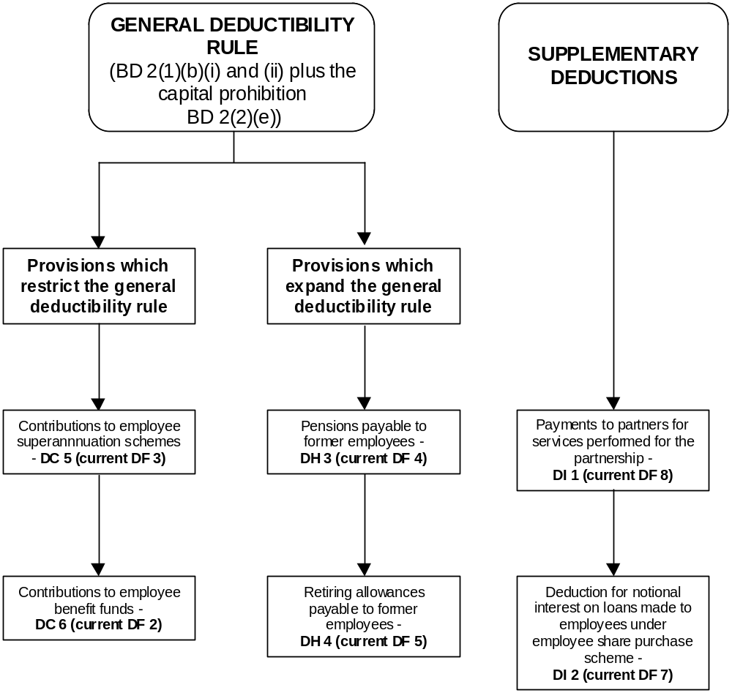

DRAFT LEGISLATION AND COMMENTARY

Rewritten version

DC 5 Employer contributions to employees’ superannuation schemes

A taxpayer who makes a superannuation contribution is allowed a deduction for the contribution only if it is an employer superannuation contribution made to a superannuation scheme that is either a superannuation fund or a company.

Defined: company, employer superannuation contribution, superannuation contribution, superannuation fund, superannuation scheme, taxpayer

Current version

DF 3 - Contributions to employees' superannuation schemes -

(1) Subject to subsections (2) to (4) of this section and to sections BD 2(1)(b)(i) and (ii) and EO 1, a deduction shall be allowed to a person in respect of any employer superannuation contribution made by that person in that income year; and except as provided in section EO 1 any such contribution shall be deemed to be expenditure incurred at the time when the contribution is made.

(2) No deduction shall be allowed under subsection (1) in respect of an employer superannuation contribution made to a superannuation scheme where the superannuation scheme is neither a superannuation fund nor a company.

Commentary on section DC 5

- By classifying the rewritten section DF 3 as a restriction to the proposed general deductibility rule, it is not necessary to retain the specific reference to section BD 2.

- The phrase “only if” in the proposed section DC 5 incorporates the prohibition in the current section DF 3(2).

- The recovery and timing aspects of section DF 3 in subsections (1), (3) and (4) (not rewritten or included here) will be moved to Parts C and E.

Rewritten version

DC 6 Employer contributions to employees’ benefit funds

An employer is allowed a deduction for amounts paid to, or set aside as, a fund to provide individual personal benefits to one or more employees of that employer only if

(a) the fund is not a superannuation scheme, and

(b) the rights of the employees to receive the benefits have been fully secured.

Defined: amount, employee, employer, fund, superannuation scheme

Current version

DF 2 - Contributions to employees' benefit funds -

(1) The Commissioner may allow a deduction to an employer of any amount set aside or paid by the employer as or to a fund (not being a superannuation scheme) to provide individual personal benefits to employees of that employer:

Provided that a deduction shall not be allowed under this section unless the Commissioner is satisfied that the fund has been established or the payment made in such a manner that the rights of the employees to receive the benefits have been fully secured.

(2) The Commissioner shall have an absolute discretion as to whether or not a deduction should be allowed under this section of the whole or any part of any amount set aside or paid by an employer and there shall be no right of challenge to any determination of the Commissioner under this section.

Commentary on section DC 6

- The “Commissioner discretions” have been removed in the rewritten version because they are inconsistent with a self-assessment approach. This issue will be considered further as part of the codification of self-assessment.

- Structuring the rewritten section DF 2 as a restriction to the general deductibility rule requires the general deductibility rule to be satisfied in addition to any requirements of section DF 2 before a deduction is available.

Rewritten version

DH 3 Pensions payable to former employees

A taxpayer who carries on a business is allowed a deduction for an amount paid as a pension to a former employee of the taxpayer in that business, or to the employee’s surviving spouse, if

(a) the amount paid is reasonable in the circumstances, and

(b) the amount is paid for past services of the employee in the business, and

(c) the recipient has a right to receive the pension under a deed for a fixed period or for life or, in the case of a surviving spouse, until the spouse remarries, and

(d) the employee’s employment by the taxpayer ended because the employee retired or was redundant.

Defined: amount, business, employee, spouse, taxpayer

Current version

DF 4 - Pensions payable to former employees -

(1) Subject to this section, the Commissioner may, in any income year, allow a deduction to a taxpayer who carries on a business in respect of any amount (being an amount that is not allowed as a deduction otherwise than under this section and which is, in the opinion of the Commissioner, reasonable in the particular circumstances of the case) paid by the taxpayer in that income year by way of a pension to any former employee of the taxpayer in that business, or to the surviving spouse of any such employee, in consideration of the past services of that employee in that business of the taxpayer, where subject to section FF 17 the Commissioner is satisfied that:

(a) The pension is receivable by the recipient as of right under a deed for a fixed period or for life, or, in the case of a pension receivable by a surviving spouse, for a fixed period or for life or until the surviving spouse remarries; and

(b) Either -

(i) The employee retired from that employment; or

(ii) The employee ceased to be employed by the taxpayer by reason of redundancy or other similar circumstances.

Commentary on section DH 3

- The current section DF 4 overcomes the fact that a pension paid to a former employee may not have a direct connection with the business of the employer. Therefore section DF 4 expands the general deductibility rule.

- This means that these pensions do not have to satisfy the general deductibility rule in order to be deductible under section DF 4. However, pensions that do satisfy the general deductibility rule may be deducted under that provision without the need for the taxpayer to look further.

- The “Commissioner discretions” in the current section DF 4 have been removed in favour of an objective “reasonableness” test.

- The reference to “similar circumstances” in the phrase “redundancy or similar circumstances” of section DF 4(1)(b)(ii) has also been removed because it was not clear precisely what other similar circumstances could exist. Moreover, the phrase seems to have been included in the original subsection out of an abundance of caution.

- The link to section FF 17 (Pensions paid to someone other than the employee under a matrimonial property agreement) has not been replicated. The overriding effect of these re-characterisations will be made clearer in the rewrite of Part F. In the interim, consequential amendments will be necessary to section FF 17 to ensure that it applies to the rewritten section DF 4, as intended.

- The current section DF 4(2) contains an associated persons restriction (not rewritten or included here) on the application of section DF 4. This will be rationalised with other associated persons provisions in Part G. The timing element in subsection (1) will be moved to Part E.

Rewritten version

DH 4 Retiring allowances and redundancy payments payable to employees

Deduction for lump sum retiring allowance or redundancy payment

(1) A taxpayer who carries on a business is allowed a deduction for a lump sum retiring allowance or redundancy payment that is made on the occasion of the retirement or redundancy of an employee if

(a) the employee is an employee or former employee of that business, and

(b) the payment is made because the employee retired or became redundant.

Non-renewal of seasonal employment contract

(2) In this section, “redundancy” includes a situation in which a former seasonal employee cannot be re-employed by the taxpayer because a position of the kind previously held by the employee with the taxpayer is not available.

Defined: business, employee, redundant, taxpayer

Current version

DF 5 - Retiring allowances payable to employees -

(1) The Commissioner may, in any income year, allow a deduction to a taxpayer who carries on a business in respect of the amount of any payment (being a payment which is not allowed as a deduction otherwise than under this section) made in a lump sum by the taxpayer in that income year by way of a bonus, gratuity or retiring allowance to any employee of that business on the occasion of the retirement of that employee.

(2) For the purposes of this section, where the Commissioner is satisfied that -

(a) Any employee of a taxpayer has ceased to be employed in the employment or service of the taxpayer by reason of redundancy or loss of office or employment or other similar circumstances; or

(b) Any former employee of a taxpayer is unable to be re-employed in any seasonal employment or service of the taxpayer by reason of the occurrence of circumstances that, had they resulted in a cessation of that seasonal employment or service, would have been circumstances to which the provisions of paragraph (a) would have applied, -

any payment made to that employee in a lump sum by reason of that employee ceasing to be so employed, or any payment made to that former employee by reason of that former employee being unable to be so re-employed, shall be deemed to be a retiring allowance paid on the occasion of that employee's or that former employee's retirement, and that employee or that former employee shall be deemed to have retired on that date.

Commentary on section DH 4

- Section DF 5 allows a deduction for retirement and redundancy payments if they cannot be deducted under the general deductibility rule. The rewritten section is, therefore, presented as an expansion.

- The “Commissioner discretion” has been removed in the rewritten version in light of the move towards self-assessment.

- The words “bonus or gratuity” in section DF 5(1) arguably do not add anything to “retiring allowance” and have been omitted in the draft. Comments on this proposed change are invited.

- The phrase “on the occasion of” has been retained because of the comment by the Court of Appeal in CIR v Smythe (1981) 5 NZTC 61,038 to the effect that the term was not intended to denote a particular point in time.

- The proposed section DH 4(1) now specifically refers to a deduction being allowed for a “redundancy payment”. This means it is unnecessary to deem a redundancy payment to be a retiring allowance (current section DF 5(2)). The words in current section DF 5(2)(a), in effect, defining “redundancy” as arising “by reason of redundancy or loss of office or employment or similar circumstances” are circular and have been omitted from the draft as unnecessary.

- The effect of section DF 5(2)(b), relating to seasonal employment, has been retained in a considerably simplified form in the rewritten version in an inclusive definition of redundancy (proposed section DH 4(2)). The focus is now on whether a position is available to the employee.

- The reference to an employee being deemed to have retired on the date of the occasion of the employee’s retirement (DF 5(2)) has been omitted as unnecessary.

- Again, the timing element contained in the current section DF 5(1) will be moved to Part E.

Rewritten version

DI 1 Payments to partners for services performed for the partnership

Deduction for share of payment made by partner to working partner

(1) A partner in a partnership is allowed a deduction, for the partner’s share of any payment made to a working partner for services performed for the partnership if

(a) the partnership is not a partnership that is engaged exclusively or principally in the investment of money or the holding or dealing in shares, securities, interests in land or other investments, and

(b) the payment is for services that are personally performed by the working partner as a working partner, and

(c) the payment is made under a contract of service.

Amount allowed as a deduction

(2) The deduction allowed under subsection (1) cannot exceed the amount specified in the contract.

Deduction for bonus payment

(3) In addition to the deduction under subsection (1), a deduction is allowed for any bonus payment made to the working partner to which subsection (1)(b) and (c) apply.

Contract of service

(4) In this section “contract of service” means an agreement in writing among all the partners in the partnership that specifies the terms and conditions under which the partner is a working partner, including the amount payable for the working partner’s services and the period of the contract.

Defined: amount, shares

Current version

DF 8 - Payments to partners for services performed for the partnership –

(1) Subject to section GD 3, where any payment is made by any partnership to any working partner of the partnership for services performed by that working partner as a working partner of the partnership in any period in any income year (being a period commencing not earlier than the date on which the contract of service in relation to that partner becomes binding, and ending not later than the date on which that contract of service terminates), the amount of that payment shall, to the extent that it does not exceed, as the case may be, -

(a) Such amount as, in accordance with that contract of service, is the amount payable to that partner in respect of that period; or

(b) The aggregate of -

(i) The amount referred to in paragraph (a); and

(ii) The amount (being an amount additional to the amount referred to in paragraph (a) payable to that partner in respect of the period referred to in that paragraph) of any payment of bonus or further bonus made by the partnership to that working partner for the services performed by that partner as a working partner, -

be deemed, for the purposes of this Act, to be an amount of expenditure of the kind referred to in section BD 2(1)(b)(ii).

(2) Nothing in this section shall apply in relation to any partnership which is engaged exclusively or principally in the investment of money or the holding of or dealing in shares, securities, investments, or estates or interests in land.

(3) In this section -

"Contract of service", in relation to a partnership and to any partner who is a working partner of the partnership, means a binding agreement in writing, entered into by all the partners, which specifies the terms and conditions under which the partner is to be a working partner of the partnership, including any amount payable to the working partner for services performed by the working partner in the carrying on of the business of the partnership under that agreement, whether or not -

(a) The amount so specified includes any amount, so payable for those services, by way of bonus to the working partner; and

(b) There is so payable for those services, by way of bonus to the working partner, an amount additional to the amount so specified:

"Land" includes -

(a) Any estate or interest in land, whether legal or equitable, corporeal or incorporeal, freehold or chattel; and

(b) Any option to acquire land or any such estate or interest in land:

"Working partner", in relation to a partnership and to any period in an income year, means any partner of the partnership who, in that period, personally and actively performs any of the duties required to be performed in the carrying on of the business of the partnership.

Commentary on section DI 1

- The rewritten section DF 8 will be placed before the rewritten section DF 7 because it is more widely used.

- The rewritten section DF 8 (proposed section DI 1) will be expressed as a supplementary deduction allowed independently of the general deductibility rule.

- Express reference to the payment being “in respect of” a period has been removed as unnecessary.

- The proposed section DI 1 deals with bonuses in a separate subsection (subsection (3)). Bonuses are treated as an additional amount allowed as a deduction rather than as part of the sum allowed. The proposed subsection is intended to have the same effect as the current section, while streamlining the existing wording.

- The definition of “working partner” and aspects of the definition of “contract of service” have been incorporated into the operative provision.

- The specific definition of “land” has been omitted at this stage. The possibility of including it in the more general definition of “land” will be explored.

Rewritten version

DI 2 Notional interest deduction

Deduction for notional interest

(1) If an employing company makes an interest-free loan to an employee under an employee share purchase scheme, the company is allowed a deduction for an amount of notional interest on the loan calculated as if the company were the borrower.

Amount of the deduction

(2) The amount of notional interest allowed as a deduction under subsection (1) to the employing company is 10% per year, with monthly rests.

Limitation

(3) On and after the fifth anniversary of the date of the loan, no further notional interest deductions are allowed to the employing company for that loan.

Group companies

(4) If a company is part of a group of companies and the shares issued under the employee share purchase scheme are not shares of that company but of another company in the group, that other company is the employing company.

Employee transferring to company in same group

(5) An employee whose employment is transferred from one company in a group of companies to another company in the same group is considered to be in the employment of the original employing company for the purposes of deducting notional interest on the loan.

Section OB 1

“shares” means fully-paid ordinary shares in a company that rank equally for all purposes with all existing ordinary voting shares of that company:

Defined: amount, company, employee, employee share purchase scheme, group of companies, loan, shares

Current version

DF 7 - Notional interest on loans made to employees under employee share purchase scheme -

(1) Notwithstanding anything in this Act, where in any income year there has been provided, or there has continued to be provided, under any employee share purchase scheme, financial assistance, whether directly or indirectly, by means of an interest free loan to any employee, the employing company in that income year is allowed a deduction of an amount equal to the amount of interest that would have been payable by the employing company for that income year if -

(a) An amount equal to the amount of the loan to that employee had been borrowed by the employing company at the rate of 10% per annum; and

(b) Repayments made by that employee in respect of that employee's loan had been repayments made by the employing company in respect of the amount borrowed; and

(c) The interest had been calculated with monthly rests:

Provided that no such deduction shall be allowed in relation to any loan for any period commencing 5 years or more after the date of the loan.

(3) In this section -

“Employee” means…

"Employing company", in relation to any employee, means the company by which that employee is employed:

Provided that, for the purposes of subsection (1), in any case where that company is included in a group of companies and the shares issued to or purchased by the employee under the employee share purchase scheme are not shares of that company but are the shares of another company included in that group of companies, that other company shall be the employing company in relation to that employee instead of that first-mentioned company:

“Normal retiring age”, in relation to any employee, means -

“Restrictive period", in relation to any shares purchased or subscribed for by an employee under an employee share purchase scheme, means:

(a)…

Provided that an employee of any employing company, being a company included in a group of companies, shall, in any case where the employee transfers or is transferred to another company included in that group of companies, be deemed not to have ceased the employee's employment with that employing company, and shall be deemed to continue in the employment of that employing company so long as the employee continues to be employed by any company included in that group of companies:…

"Shares", in relation to any company the shares of which are made available for purchase or subscription by any employee under any employee share purchase scheme, means fully paid ordinary shares in the capital of that company, being shares which rank equally for all purposes with all existing ordinary voting shares of that company and which have the same designation as those existing shares:…

“Trustee of the scheme”, or “trustee”, means…

Commentary on section DI 2

- Section DF 7 (proposed section DI 2) allows a deduction to a company for notional amounts. The proposed general deductibility rule does not apply. The section is expressed as a supplementary deduction provision.

- The five-year limit on deductibility of the notional interest has been expressed in a manner that highlights the distinction between claiming and calculating the deduction.

- An employee share purchase scheme must meet the requirements that are currently (for the most part) listed in section DF 7(2) before a company can deduct the notional interest on the loan.

- These requirements must also be met under section CH 2(3) for a benefit received by an employee under the scheme to be valued at nil in calculating monetary remuneration (third proviso to section CH 2(3)).

- It is proposed to move the detailed requirements of section DF 7(2) and (3) (which are not included in the illustrative draft) to Part C (proposed Subpart CC), where the first reference to them is made. The requirements may be better presented in a table in Part C.

- The provisos in the current definitions of “employing company” and “restrictive period” have been included as part of the section. There is no definition of “employing company” in the section because, after moving the proviso, the meaning of the term becomes obvious.

- In the definition of “shares”, the requirement to have the same designation has been omitted as unnecessary.

DF 6 Payments to employees or former employees while on naval, military, or air service

- The current section DF 6 allows a deduction of up to $8 per week for payments made to a former employee of a business who has been called up for service in any naval, military or air forces of the Crown. The current section CC 2 correspondingly treats these payments as gross income.

- It is proposed to repeal sections CC 2, DF 6 and the corresponding definition of “serving employee”, since they now appear to be redundant.

CHAPTER 13

FILMS

Summary

The redrafted film expenditure legislation:

- separates the deduction and timing elements of the current legislation and moves them to Parts D and E respectively;

- minimises overlap between rules;

- arranges the information in a more logical order;

- illustrates how a provision’s location within a structure reflects its underlying policy;

- uses plain language.

- The illustrative legislation in this chapter is an attempt to clarify, through plainer expression, what are among the most confusing and overlapping sets of rules in the Act. There are no intentional policy changes in the draft.

- Deductibility elements have been more clearly placed in Part D and timing elements more clearly placed in Part E. This is consistent with the functions envisaged for Parts D and E.

- Unlike the current provisions, the proposed rules clearly indicate which deductibility and timing rules apply to each category of film, owner and expenditure. Although this approach gives the legislation a repetitive flavour, it will help taxpayers find the rules that apply to their particular circumstances.

- The rules provide for the cost of producing or acquiring a film to be written off over a period of not more than twenty-four months, with deductibility beginning from the point at which the film is completed. These rules were intended to regularise the taxation of films by addressing incentives and loopholes in the law.

- Given the concessionary treatment of film-related expenditure, the provisions do not fit into the depreciation rules.

- The current provisions contain a number of administrative rules such as section EO 4(10) (Revocation). These provisions have not been included in the rewritten version. It is proposed to locate them in the Tax Administration Act 1994.

- The current section EO 4(12) (Expenditure deemed to occur at time of payment) has not been included in the rewritten version. It will be brought together with the current section GC 11(1) (Excessive time for payment).

- The current sections EO 3(8) (Adjustment for depreciation loss) and EO 4(8) (Adjustment after asset disposal) have not been included in the rewritten version. These provisions are being addressed as part of the move towards legislative self-assessment.

The allowable deduction

- To reflect the concessionary treatment of film-related expenditure, the deduction for this expenditure is expressed as an expansion of the general deductibility rule. The proposed section DD 7 sets out the criteria for the deductibility of film-related expenditure, all of which must be met:

- The expenditure must be incurred by the taxpayer.

- The expenditure must be either “cost of production” or “cost of acquisition expenditure”.

- The film must be completed.

- Expenditure incurred before completion of a film meets only two of the tests. Therefore, in order to make such expenditure deductible, the proposed section EH 1 deems expenditure incurred before completion to be incurred in the year of completion.

The allocation of the allowable deduction

- The proposed section EL 1 sets out the rules that govern the allocation of allowable deductions. This is consistent with the approach envisaged by the core provisions (section BD 4(2)).

- No specific timing rules apply to New Zealand film owners, so the expenditure is deductible when it is incurred (in the year of completion).

- The illustrative legislation does not attempt to place the film-allocation provisions on the valuation basis discussed earlier. A guide to the application of the valuation approach is discussed in chapter 14.

DRAFT LEGISLATION AND COMMENTARY

Rewritten version

DD 7 Expenditure relating to a film

Cost of production – film owner

(1) A taxpayer who owns a completed film is allowed a deduction for expenditure incurred by the taxpayer in the cost of production.

Cost of production – owner of right in feature film

(2) A taxpayer who owns a right in a completed feature film is allowed a deduction for expenditure incurred by the taxpayer in the cost of production.

Cost of production – owner of right in other film

(3) A taxpayer who owns a right in a film that is not a feature film is allowed a deduction for expenditure incurred by the taxpayer in the cost of production of the film if

(a) the expenditure is in the cost of production of the film that is incurred in the first income year in which the film is completed, and

(b) the taxpayer incurs the expenditure in the first income year in which the film is completed.

Acquisition cost - feature film or right in feature film

(4) If a taxpayer acquires a feature film or a right in a feature film and the feature film is completed at a time before or after the acquisition, the taxpayer is allowed a deduction for expenditure incurred by the taxpayer in acquiring the feature film or the right.

Acquisition cost – other film or right in other film

(5) A taxpayer who acquires a completed film that is not a feature film or acquires a right in such a film is allowed a deduction for the cost of acquisition expenditure that the taxpayer incurs in the year of acquiring the film or the right.

Current version

EO 4 [This corresponds to proposed section DD 7(1).]

(4) Where, -

(a) In any income year any taxpayer has incurred any film production expenditure in relation to a film in relation to which the taxpayer is a film owner; and

(b) That film has, by means of a final certificate issued by the New Zealand Film Commission, been certified as a New Zealand film,-

the taxpayer shall be allowed a deduction for an amount equal to the amount of that film production expenditure in the later of –

(c) The income year in which that New Zealand film is completed:

(d) The income year in which that film production expenditure is incurred.

(5) Where in any income year any film other than a New Zealand film is completed, and any taxpayer who is a film owner in relation to that film has, whether in that income year or in any income year preceding that income year, incurred any film production expenditure in relation to that film, that taxpayer shall be allowed a deduction, in the following proportions and in the following income years for the amount or the aggregate of the amounts of the film production expenditure, -

(a) The income year first mentioned in this subsection, 50%, and

(b) The income year immediately succeeding that first-mentioned income year, 50%:

EO 3 [This corresponds to proposed section DD 7(2), and (4).]

(4) Subject to sections EO 4 and GD 12, where in any income year any taxpayer who is or becomes in that income year a film owner, owns or becomes the owner of any completed feature film or any right in such a film and remains the owner of that film or right until the end of that income year, a deduction shall be allowed to the taxpayer in that income year of an amount that, in relation to that feature film, is equal to the lesser of, -

(a) The amount of the specified deduction in relation to that income year;

(b) An amount equal to the residual value in relation to that income year:

EO 3 [This corresponds to proposed section DD 7(2), and (4).]

(9) "Residual value", in relation to a film and to any right in relation to a film, and to any taxpayer, and to any income year, means the amount of the cost of acquisition of the film or the right in relation to a film incurred prior to the end of the income year, reduced by so much of the amount as has been allowed as a deduction to the taxpayer in any income year preceding that income year;

"Specified deduction", in relation to an income year and to any feature film, means an amount calculated in accordance with the following formula:

x
x z
y

where -

x is the number of complete months in the period that commenced on the later of the first day of the month in which the film is completed and the first day of the income year, and ends on the last day of the income year; and

y is 24, reduced by such number (if any) as is equal to the number of complete months in the period that commences on the first day of the month in which the film is completed and ends on the last day of the income year that immediately precedes the income year first mentioned in this definition; and

z is an amount equal to the sum of the residual value, in relation to that income year, in relation to that film and to any right in that film.

EO 3 [This corresponds to proposed section DD 7(3), and (5).]

(5) Subject to sections EO 4 and GD 12, where, at any time during an income year, a taxpayer becomes the owner of any completed film other than a feature film, or of any right in any completed film other than a feature film, that taxpayer shall be allowed a deduction for the cost of acquisition of that film or of that right (to the extent that cost of acquisition was incurred by that taxpayer during that income year) in that income year and in the immediately succeeding income year in the following proportions, -

(a) 50% in the income year in which that film or that right was acquired; and

(b) The balance in the income year immediately succeeding the income year in which that film or that right was acquired, -

Rewritten version

Exception for broadcaster or advertising programme

(6) Subsections (1) to (5) apply to a taxpayer unless

(a) the taxpayer is a broadcaster whose main purpose at the time the taxpayer incurs the expenditure is to broadcast the film in New Zealand, or

(b) the taxpayer’s purpose at the time the taxpayer incurs the expenditure is that the film be exhibited as an advertising programme or as a commercial.

Current version

EO 3(1) - Proviso [This corresponds to proposed section DD 7(6)(a).]

Provided that this subsection shall not apply to any person, being a broadcaster, who has in any income year incurred any expenditure consisting of the whole or any part of the cost of production of that film, or incurred any expenditure in acquiring that film or any right in that film, and that film or that right was acquired primarily and principally for the purpose of enabling that broadcaster to broadcast that film in New Zealand.

OB 1 (This corresponds to proposed section DD 7(6)(b))

“Film” – the final phrase of Paragraph (b)

(b) but does not include a film that is intended for exhibition as an advertising programme or as a commercial:

Commentary on section DD 7(6)

Paragraph (a)

- The proposed provision would represent a minor change in the law because, at present, this category of broadcasters is required to deduct “film production expenditure” under section EO 4 (Cost of producing films).

- The removal of these broadcasters from the ambit of the film provisions would mean that the deductibility or otherwise of their film-related expenditure would be determined under the general deductibility rules.

- Currently, the provision that excludes this category of broadcasters from the present section EO 3 (Costs of acquiring any film or any right in any film) is contained in the proviso to section EO 3(1). However, the rule’s central function is to provide an exception to the main principles relating to the deductibility of film-related expenditure outlined in subsection (1). It is more appropriate, therefore, to locate it directly after the general statement of principle.

Paragraph (b)

- At present, advertisers are taken out of the film rules (the present sections EO 3 and EO 4) by being excluded from the definition of “film”. However, excluding advertisers in this way does not place enough emphasis on what is an important qualification to the deductibility of film-related expenditure. Therefore, in the redrafted provisions, this rule has been placed directly after the general principle that it qualifies.

Rewritten version

Reimbursement of amount

(7) If a taxpayer incurs expenditure before a film is completed in reimbursing a person for expenditure in the cost of production, the reimbursement is expenditure in the cost of production.

Defined: broadcaster, completed, cost of production, feature film, film, income year, New Zealand, right, taxpayer

Current version

EO 4 [This corresponds to proposed section DD 7(7).]

(1) For the purposes of this section, any film production expenditure incurred by any taxpayer, prior to the film being completed, in reimbursing any other person for film production expenditure incurred by that other person in relation to that film shall be treated in the same manner as though it were film production expenditure incurred by that taxpayer in producing that film.

Commentary on section DD 7(7)

- At present this rule is contained in section EO 4(1) (reimbursement expenditure). The proposal represents a minor change because section EO 4(1) applies only to the “cost of production” of film owners, not “right” owners. The change is consistent with the underlying policy of section EO 4(1).

Subpart EL 1 - Expenditure relating to types of film

Rewritten version

EL 1 Allocation of deduction for types of film

Owner of non-New Zealand film - cost of production

(1) A taxpayer who becomes the owner of a completed film that is not a New Zealand film may only allocate the allowable deduction for the cost of production of the film for the taxpayer as follows:

(a) to the income year in which the taxpayer becomes the owner of the completed film, an amount equal to the lesser of

(i) the amount of the cost of production that relates to expenditure that the taxpayer incurs in or before the income year,

and

(ii) the greater of:

(A) the gross income that the taxpayer derives in the income year from exploiting the right or the film,

and

(B) 50% of the amount of the cost of production that relates to expenditure that the taxpayer incurs in or before the income year;

(b) to the next income year, the amount of the cost of production that the taxpayer may not allocate to an earlier income year and that relates to expenditure that the taxpayer incurs in or before the income year in which the taxpayer becomes the owner of the completed film.

Current version

EO 4 [This corresponds to proposed section EL 1(1).]

(5) Where in any income year any film other than a New Zealand film is completed, and any taxpayer who is a film owner in relation to that film has, whether in that income year or in any income year preceding that income year, incurred any film production expenditure in relation to that film, that taxpayer shall be allowed a deduction, in the following proportions and in the following income years, for the amount or the aggregate of the amounts of the film production expenditure, -

(a) The income year first mentioned in this subsection, 50%, and

(b) The income year immediately succeeding that first-mentioned income year, 50%:

Provided that in any case where the amount (if any) received or receivable, by or on behalf of the taxpayer from the sale, use, rental, or other exploitation of that film or of any right in that film, in the income year in which that film is completed exceeds the amount of the film production expenditure that, but for this proviso, would be allowable as a deduction to the taxpayer in that income year, that taxpayer shall be allowed a deduction in that income year for such amount as is equal to the lesser of –

(i) The aggregate of the amounts of the film production expenditure incurred by the taxpayer, in relation to that film, in every income year ending on or before the last day of the income year in which that film is completed;

(ii) The amount so received or receivable, by the taxpayer or on the taxpayer's behalf, from that sale, use, rental, or other exploitation, -

and the amount of the deduction that, but for this proviso, would have been allowable to the taxpayer in the income year immediately succeeding the income year first mentioned in this proviso, shall be reduced to only so much as is equal to the amount that remains after subtracting from the aggregate referred to in paragraph (i) of this proviso an amount equal to the amount referred to in paragraph (ii) of this proviso, and only that reduced amount shall be so allowable as a deduction.

Rewritten version

Owner of right in feature film - cost of production

(2) A taxpayer who owns a right in a completed feature film at the end of an income year may only allocate to the income year a portion of the allowable deduction for the cost of production of the feature film for the taxpayer equal to the lesser of

(a) the amount of the cost of production that:

(i) relates to expenditure that the taxpayer incurs in or before the income year; and

(ii) the taxpayer may not allocate to an earlier income year,

and

(b) the greater of:

(i) the amount calculated using the formula:
x
y
x z

where
x is the number of months that occur in the income year and that contain days during which the film is complete,

y is 24 reduced by the number of months that occur before the income year and that contain days during which the film is complete,

z is the amount referred to in paragraph (a),

and

(ii) the gross income that the taxpayer derives in the income year from exploiting the right.

Owner of right in other film - cost of production

(3) A taxpayer who becomes the owner of a right in a completed film that is not a feature film may only allocate the allowable deduction for the cost of production of the film for the taxpayer as follows:

(a) to the income year in which the taxpayer becomes the owner of the right, an amount equal to the lesser of

(i) the amount of the cost of production that relates to expenditure that the taxpayer incurs in the income year, and

(ii) the greater of:

(A) the gross income that the taxpayer derives in the income year from exploiting the right, and

(B) 50% of the amount of the cost of production that relates to expenditure that the taxpayer incurs in the income year;

(b) to the next income year, the amount of the cost of production that the taxpayer may not allocate to an earlier income year and that relates to expenditure that the taxpayer incurs in the income year in which the taxpayer receives the right.

Cost of acquiring feature film

(4) A taxpayer who owns at the end of an income year a completed feature film or a right in a completed feature film may only allocate to the income year a portion of the allowable deduction for the cost of acquisition of the feature film or of the right for the taxpayer equal to the lesser of

(a) the amount of the cost of acquisition that

(i) relates to expenditure that the taxpayer incurs in or before the income year, and

(ii) the taxpayer may not allocate to an earlier income year; and

(b) the greater of:

(i) the amount calculated using the formula
x
y
x z

where
x is the number of months that occur in the income year and that contain days during which the film is complete,

y is 24 reduced by the number of months that occur before the income year and that contain days during which the film is complete,

z is the amount referred to in paragraph (a),

and

(ii) the gross income that the taxpayer derives in the income year from exploiting the feature film or the right.

Cost of acquiring other film

(5) A taxpayer who becomes the owner of a film that is not a feature film or of a right in such a film may only allocate the allowable deduction for the cost of acquisition for the taxpayer as follows:

(a) to the income year in which the taxpayer becomes the owner of the feature film or right, an amount equal to the lesser of

(i) the amount of the cost of acquisition that the taxpayer incurs in or before the income year, and

(ii) the greater of:

(A) the gross income that the taxpayer derives in the income year from exploiting the feature film or right, and

(B) 50% of the amount of the cost of acquisition that relates to expenditure that the taxpayer incurs in or before the income year;

(b) to the next income year, the amount of the cost of acquisition that the taxpayer may not allocate to an earlier income year and that relates to expenditure that the taxpayer incurs in or before the income year in which the taxpayer receives the feature film or right.

Defined: allowable deduction, amount, completed, cost of production, feature film, film, gross income, income year, New Zealand film, right, taxpayer

Current version

EO 3 [This corresponds to proposed section EL 1(2), and (4).]

(4) Subject to sections EO 4 and GD 12, where in any income year any taxpayer who is or becomes in that income year a film owner, owns or becomes the owner of any completed feature film or any right in such a film and remains the owner of that film or right until the end of that income year, a deduction shall be allowed to the taxpayer in that income year of an amount that, in relation to that feature film, is equal to the lesser of –

(a) The amount of the specified deduction in relation to that income year;

(b) An amount equal to the residual value in relation to that income year:

Provided that in any case where the gross income derived by that taxpayer from the sale, use, rental, or other exploitation of that film or that right in that income year exceeds the specified deduction, in relation to that film, for that year, the taxpayer shall be allowed a deduction for such amount of the cost of acquisition of that film or of that right in that income year as is equal to the lesser of -

(c) The amount of the residual value of that film or of that right in relation to that income year;

(d) The gross income derived from the sale, use, rental, or other exploitation of that film or of that right which was derived during that income year.

(9) "Residual value", in relation to a film and to any right in relation to a film, and to any taxpayer, and to any income year, means the amount of the cost of acquisition of the film or the right in relation to a film incurred prior to the end of the income year, reduced by so much of the amount as has been allowed as a deduction to the taxpayer in any income year preceding that income year;

"Specified deduction", in relation to an income year and to any feature film, means an amount calculated in accordance with the following formula:
x
y
x z

where –

x is the number of complete months in the period that commenced on the later of the first day of the month in which the film is completed and the first day of the income year, and ends on the last day of the income year; and

y is 24, reduced by such number (if any) as is equal to the number of complete months in the period that commences on the first day of the month in which the film is completed and ends on the last day of the income year that immediately precedes the income year first mentioned in this definition; and

z is an amount equal to the sum of the residual value, in relation to that income year, in relation to that film and to any right in that film.

EO 3 [This corresponds to proposed section EL 1(3), and (5).]

(5) Subject to sections EO 4 and GD 12, where, at any time during an income year, a taxpayer becomes the owner of any completed film other than a feature film, or of any right in any completed film other than a feature film, that taxpayer shall be allowed a deduction for the cost of acquisition of that film or of that right (to the extent that cost of acquisition was incurred by that taxpayer during that income year) in that income year and in the immediately succeeding income year in the following proportions, -

(a) 50% in the income year in which that film or that right was acquired; and

(b) The balance in the income year immediately succeeding the income year in which that film or that right was acquired, -

Provided that in any case where the gross income derived from the sale, use, rental, or other exploitation of that film or of that right, in the income year in which that film or that right was acquired exceeds 50% of the cost of acquisition of that film or that right which was incurred by that taxpayer prior to the end of that income year, that taxpayer shall be allowed a deduction in that income year of an amount equal to the lesser of –

(c) The cost of acquisition of that film or that right which was incurred by that taxpayer prior to the end of that income year;

(d) The gross income from the sale, use, rental, or other exploitation of that film or that right which was derived during that income year, -

and the amount of the deduction that would, but for this proviso, have been allowed in the next succeeding income year shall be reduced to an amount equal to the amount (if any) which remains after subtracting from the total cost of acquisition of that film or of that right the gross income derived from that film or from that right in that income year.

Rewritten version

EL 2 Further timing rules

Production expenditure after film completed

(1) If a taxpayer owns a completed film and, in an income year beginning after the film is completed, incurs expenditure in calculating the cost of production of the film, the taxpayer may treat the expenditure as being incurred in that income year.

Taxpayer no longer involved with film

(2) If a taxpayer owns a completed film or a right in a completed film at some time during an income year and owns neither the film nor a right in the film at the end of the income year, the taxpayer may allocate to the income year an allowable deduction that has not been allocated to an earlier income year.

Defined: allowable deduction, completed, cost of production, film, income year, right, taxpayer

Current version

EO 4 [This corresponds to proposed section EL 2(1).]

(6) Where, in any income year succeeding the income year in which a film is completed, any taxpayer (being a taxpayer who, in relation to that film, is a film owner) incurs any film production expenditure in relation to that film, that taxpayer shall be allowed a deduction in that income year for an amount equal to the amount of that film production expenditure.

EO 3 [This corresponds to proposed section EL 2(2).]

(6) Subject to sections EO 4 and GD 12, where, in any income year, any taxpayer, being the owner of a film or any right in any film, or being the owner of a film and of any right in that film, ceases to own that film or every right in that film, or, as the case may be, ceases to own that film and every right in that film which that taxpayer possessed at any time during that income year, the balance of any cost of acquiring that film or that right or, as the case may be, any cost of acquiring that film and that right or, where that film is a feature film the balance of the residual value in relation to that feature film, which has not been allowed as a deduction in any income year, shall be allowed as a deduction in the income year in which that taxpayer ceases to own that film or that right.

EO 4 [This corresponds to proposed section EL 2(2).]

(7) Where, in the income year in which any film other than a New Zealand film is completed, any taxpayer, being the owner of that film or any right in that film, ceases to own that film or every right in that film or, as the case may be, ceases to own that film and every right in it which the taxpayer possessed at any time during that income year, the taxpayer shall be allowed a deduction in that income year for an amount equal to the total film production expenditure incurred by the taxpayer in relation to that film.

Commentary on section EL 2

- The proposed section EL 2 contains two timing rules that have a more specific application than the general allocation rules stated in section EL 1. Therefore, in keeping with the principle of ordering from the general to the specific, these rules have been placed after section EL 1.

Rewritten version

EH 1 Expenditure before film completed

A taxpayer who has expenditure in a film before a film is completed incurs the expenditure in the income year in which the film is completed if the expenditure is in

(a) cost of production of the film, or

(b) acquiring the film.

Defined: completed, cost of production, film, income year, taxpayer

Current version

EO 4 [This corresponds to proposed section EH 1.]

(4) Where, -

(a) In any income year any taxpayer has incurred any film production expenditure in relation to a film in relation to which the taxpayer is a film owner; and

(b) That film has, by means of a final certificate issued by the New Zealand Film Commission, been certified as a New Zealand film, -

the taxpayer shall be allowed a deduction for an amount equal to the amount of that film production expenditure in the later of –

(c) The income year in which that New Zealand film is completed;

(d) The income year in which that film production expenditure is incurred.

Commentary on section EH 1

- For New Zealand film owners, the proposed section EH 1 achieves the same effect as the present section EO 4(4).

Replaced definitions

Rewritten version

“Broadcaster” means a person who operates a television station or a television network or a cable television system:

Current version

EO 3(9)

“Broadcaster” means a person who operates a television station or network or a cable television system:

Rewritten version

“Completed”, for a film, means completed to the stage in the production of the film at which the film has been completely edited, shot by shot, to its final length:

Current version

OB 1

“Completed”, in sections EO 3 and EO 4, in relation to a film, means the completion of the film to the double head finecut stage of production or equivalent production stage:

Rewritten version

“Cost of production” of a film for a taxpayer means the taxpayer’s share of

(a) expenditure incurred in producing the film, and

(b) the portion of the allowable deduction for property used to produce the film (being property that is used to produce the film in that income year) that is allocated to the income year that would be allowed to the taxpayer if the property were depreciable property,

but does not include:

(c) expenditure incurred in acquiring depreciable property, or

(d) expenditure incurred in acquiring the film or the right, or

(e) expenditure incurred directly in marketing or selling the film.

Current version

OB 1

“Cost of acquisition”, in sections EO 3 and GC 11, in relation to the acquisition of any film or of any right in any film, means –

(a) In the case of a film owner to whom section EO 3(2)(a) applies, the amount that represents the share borne by the owner of the cost of producing the film; and

(b) In the case of a film owner to whom section EO 3(2)(b) applies, the cost of such acquisition;-

and “cost of acquiring” has a corresponding meaning:

“Cost of production”, in paragraph (a) of the definition of “depreciation loss”, in the definition of "cost of acquisition", and in section EO 3, in relation to a film, means the sum of the film expenditure incurred in producing the film and all other film expenditure incurred after the completion of the film, being in each case film expenditure incurred in relation to the production of the film; but does not include any expenditure directly incurred in marketing or selling the film; and “cost of producing” has a corresponding meaning:

“Depreciation loss”

(a) In the definition of "film expenditure" and in section EO 3, in relation to a film, means the amount of the allowance or the aggregate of the allowances by way of depreciation, in respect of any asset (being an asset used in producing the film) that, had that asset been used in deriving gross income in the income years in which the cost of production of the film was incurred, would have been allowed as a deduction under this Act:

(b) In the definition of "film production expenditure" and in section EO 4, in relation to a film, means the amount of the allowance or the aggregate of the allowances by way of depreciation, in respect of any asset (being an asset used in producing the film) that, had that asset been used in deriving gross income in the income years in which the film production expenditure in relation to the film was incurred, would have been allowed as a deduction under this Act:

“Film expenditure”, in the definition of "cost of production" and in sections EO 3 and GC 11, in relation to a film, means any expenditure (not being expenditure incurred in acquiring any asset in respect of which a deduction by way of depreciation is allowed) in respect of which a deduction is allowed; and includes any loss in respect of which a deduction is allowed in section BD 2(1)(b)(i) and (ii) and any depreciation loss:

“Film production expenditure”, in relation to a film and to any taxpayer, means any expenditure (not being expenditure incurred in acquiring any asset in respect of which a deduction by way of depreciation is allowed) in respect of which a deduction is allowed; and includes any loss which may be allowed as a deduction under section BD 2(1)(b)(i) and (ii), being expenditure and being a loss incurred by the taxpayer in producing any film (whether that expenditure was incurred prior to, on, or subsequent to the date on which the film is completed) in relation to which the taxpayer is, or is expected to become, a film owner; and also includes any depreciation loss in relation to the film; but does not include any expenditure incurred by the taxpayer –

(a) In the acquisition, from any other person, of a film that is completed:

(b) In the acquisition, from any other person, of any right in a film that is completed:

(c) Directly in marketing or selling the film:

Rewritten version

“Film” means a record of visual moving images that is capable of being used in projecting the images in a fixed sequence on to a screen and includes all or a part of the record and a copy of the record and a copy of a part of the record

Current version

OB 1

“Film” -

(b) In paragraphs (a) and (b) of the definition of "depreciation loss" and paragraphs (a) and (c) of the definition of "film owner", in the definitions of "completed", "copyright", "cost of acquisition", "cost of production", "depreciation loss", "double head finecut stage of production", "feature film", "film expenditure", "film production expenditure", "final certificate", and "right", and in sections EO 3, EO 4, GC 11, and GD 12, means a cinematograph film; and includes a videotape, and any other material record of visual moving images that is capable of being used for the subsequent projection of those images in a fixed sequence on to any screen; and also includes any part of any such film, or any copy or part of a copy of the whole or any part of a film; but does not include a film which is intended for exhibition as an advertising programme or as a commercial:

Rewritten version

“New Zealand film” in relation to a film means a completed film that the New Zealand Film Commission certifies as having a significant New Zealand content under the criteria set out in section 18 of the New Zealand Film Commission Act 1978:

Current version

OB 1

“New Zealand film”, in the definition of "final certificate" and in section EO 4, in relation to a film, means a film which has been certified by the New Zealand Film Commission as being a film which that Commission is satisfied has a significant New Zealand content in accordance with the criteria set out in section 18 of the New Zealand Film Commission Act 1978:

Rewritten version

“Right” in relation to a film means a legal or equitable right relating to either or both of the film and the proceeds from exploitation of the film but does not include ownership:

Current version

“Right”, in paragraph (a) of the definition of "film" and paragraph (a) of the definition of "film owner", in the definitions of "copyright", "cost of acquisition", and "film production expenditure", and in sections CJ 2, EO 3, EO 4, FB 6, and GC 11, in relation to a film, means any copyright and any licence in respect of the copyright and any other right which subsists in or attaches to the film (including any right to income or any share of income from sale, use, rental, or other exploitation of that film); and includes any equitable right in respect of any copyright in that film or in respect of any licence under such copyright:

“Copyright”, in the definition of "right" and in sections EO 3 and EO 4, in relation to a film, includes all rights and choses in action (whether present or future, actual or contingent) in or in relation to –

(a) The film; or
(b) The prints of the film; and
(c) Publicity material in relation to the film; and
(d) All other tangible assets in relation to the film:

Deleted definitions
- The following definitions will no longer be included in the legislation as defined terms because their substance has been incorporated into the main provisions or other definitions:

- “cost of acquisition”
- “depreciation loss”
- “double head finecut stage of production”
- “film expenditure”
- “film owner”
- “film production expenditure”

CHAPTER 14

VALUATION APPROACH TO ALLOCATION

Summary

Various rules relating to the allocation of gross income and allowable deductions will be rationalised on a valuation basis.

- A proposed section EC 1 will contain the mechanics for the allocation of amounts of gross income or allowable deductions on the allocation basis. This provision will link up with the individual rules for determining the closing value of gross income or an allowable deduction.

- A common rule for determining closing value, if the allocation takes place over a known period of time, is proposed.

How the changes will operate in relation to the depreciation rules is shown in an example.

- A number of valuation rules that have a similar effect will use a common method to determine closing value. The following method could be used for determining the closing value for provisions that allocate the gross income or allowable deduction over a known period of time:

years remaining
total years
x gross income (or allowable deduction)

- Adopting this common valuation method allows a number of rules to be rationalised. This will lead to the removal of the current approaches to allocating gross income and allowable deductions on a prospective basis. These rules will be rewritten to provide the elements that feed into the common method for determining closing value. The rationalisation and rewriting of these rules should reduce complexity and improve consistency of approach to allocation issues.

Application of the valuation method

- Rationalising the many rules to which the valuation method is applicable will have major benefits. These rules are shown in tables 4 and 5.

Table 4

RULES CURRENTLY LOCATED IN PART D

Specified suspensory loans
Cost of minerals, timber or flax that is trading stock
Cost of timber - amortisation rules
Expenditure on land improvements for forestry - amortisation rules
Petroleum mining development expenditure - amortisation rules
Specified mineral mining - sales of mining company shares
Repairs to fishing boats - amortisation rules
Expenditure on land improvements for land or agriculture - amortisation rules
Expenditure on aquaculture improvements - amortisation rules
Farmers’ expenditure on tree planting - amortisation rules

Table 5

RULES CURRENTLY LOCATED IN PART E

Interest on National Development Bonds or National Savings Certificates
Amounts derived by way of fines, premiums or goodwill on leases
Capitalised mortgage interest
Accrued indexed amounts
Employer premiums
Valuation of trading stock
Unexpired expenditure
Revenue account property
Depreciation
Income equalisation as it relates to the deferral of recognition of gross income
Valuation of livestock
Valuation of bloodstock
Payments received for non-compliance with covenant to repair
Disposals of patent rights
Disposals of land to the Crown
Allowable deductions under non-specified leases
Cost of acquisitions of films
Cost of producing films
Foreign source income and option to use foreign tax balance date

DRAFT LEGISLATION

PART E

Subpart EC - Valuation and Retrospective Allocation Rule

EC 1 Allocation using valuation rules

Allocation of gross income

(1) If an amount of gross income is subject to a valuation rule, a taxpayer must calculate the amount of gross income to be allocated to an income year as follows, whether that amount is more or less than zero:

opening value + gross income derived – closing value under the valuation rule

Allocation of allowable deduction

(2) If an amount of an allowable deduction is subject to a valuation rule, a taxpayer must calculate the amount of the allowable deduction to be allocated to the current income year as follows using the sum of the allowable deductions for that income year and whether that amount is more or less than zero:

opening value + sum of allowable deductions – closing value under the valuation rule

Defined: allowable deduction, amount, closing value, gross income, income year, opening value, taxpayer, valuation rule

Application of the new approach: an example of the tax treatment of depreciable property

- ABC Chemical Processing Ltd bought a pump on 1 April 1997 for $50,000. Owing to the nature of its business, a special depreciation rate of 20% has been authorised under section EG 10. Therefore the pump is amortised on a straight line basis over five years. The pump is sold on 1 April 1999 for $35,000. The company has a 31 March balance date for tax purposes. The tax treatment of the asset under the new structural approach is described in 14.6-14.14.

- Table 6 compares the tax treatment of this depreciable property under the current and proposed legislation.

Year of acquisition: deduction allowed

- Part D provides that $50,000 is allowed as a deduction (step one).

Year of acquisition: allocation of deduction

- Part E determines when that amount is recognised in the calculation of taxable income for an income year.

- An allowable deduction is allocated on the basis of a specific allocation rule if one applies. Otherwise the allocation is made on the basis of when it is incurred (the default basis). A specific allocation rule means any provision in Subparts ED, EE, EF (the depreciation provisions) or EG.

- Under the proposed section EC 1(2) deductions subject to a valuation rule will be allocated in accordance with a valuation based method that compares opening and closing values of an allowable deduction listed in Subpart EE.

- The valuation approach will, therefore, apply to the amount allowed as a deduction for a depreciable asset ($50,000).

- Applying the rules in Subpart EF and the definition of opening and closing values of allowable deductions, the amount allocated to the 1998 income year is $10,000, being the opening value of $50,000 less a closing value of $40,000 (step two).

Subsequent years: allocation of deduction

- Applying the proposed valuation method for the 1999 income year gives the same result ($40,000 less $30,000).

Year of disposition: allocation of deduction and gross income

Sale proceeds less than allowable deduction

- The amount to be allocated in the 2000 income year (the year the pump is sold) is $30,000 (step three). Therefore the opening value of the allowable deduction is allocated to the year of sale. However, under Part C the sale proceeds of $35,000 are gross income (step four). Under section EB 1 the gross income is recognised when it is derived, the year the pump is sold (step five).

Sales proceeds exceed allowable deduction

- If, for instance, the pump were sold to a manufacturer for $55,000, the amount of gross income would be limited to the amount allowed as a deduction under Part D ($50,000). The difference of $5,000 is non-taxable.

Table 6

COMPARISON OF PROPOSED AND CURRENT APPROACHES

Steps in the income tax calculation | Outcome under the proposed approach | Outcome under the current approach
Step one: Amount allowed as a deduction for depreciable property | $50,000 | Zero
Step two: Calculation of taxable income for the 1998 and 1999 income years | $10,000 is allocated to annual allowable deductions in each income year | $10,000 is allowed as a deduction in each income year
Steps three – five: Calculation of the taxable income for the 2000 income year (sale proceeds of $35,000) | $30,000 allocated to annual allowable deductions  $35,000 allocated to annual gross income | Consideration of $35,000 less the adjusted tax value of $30,000 is included in gross income as depreciation recovered
Calculation of taxable income for the 2000 income year (sale proceeds of $55,000, gross income of $50,000) | $30,000 allocated to annual allowable deductions  $50,000 allocated to annual gross income | The lesser of:  Consideration of $55,000 less adjusted tax value of $30,000 ($25,000); and  Aggregate depreciation deductions allowed ($20,000)  is included in gross income as depreciation recovered

Summary:

Proceeds of $35,000

Depreciation allocated (currently termed depreciation allowed) $20,000
less net effect in year of sale (currently termed “depreciation recovered”) $ 5,000

$15,000

Proceeds of $55,000

Depreciation allocated (currently termed “depreciation allowed”) $20,000
less net effect in year of sale(currently termed “depreciation recovered”) $20,000
zero

- Figures 12 and 13 show how the proposed structures for Parts C, D and E will apply in relation to the depreciation rules, using the same example.

Figure 12

THE PROCESS OF CALCULATING AND ALLOCATING DEPRECIATION DEDUCTIONS

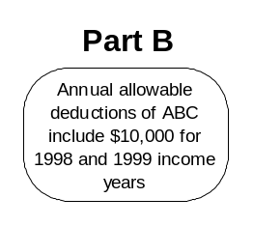
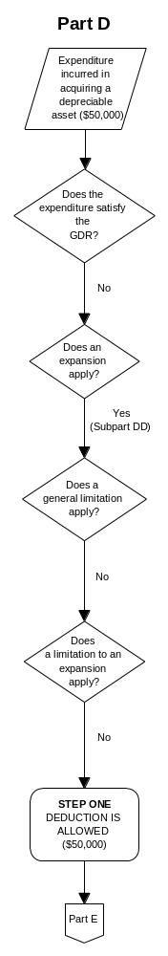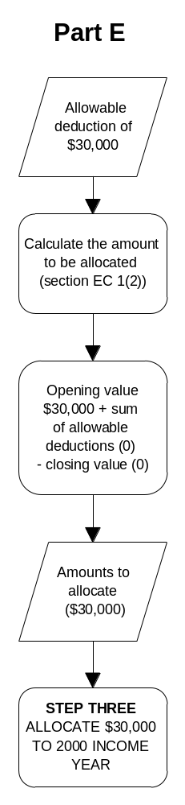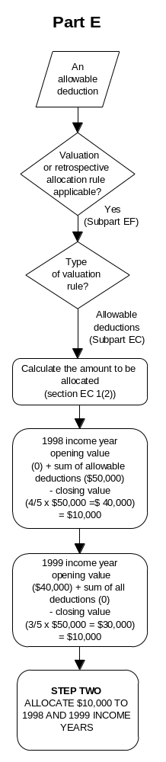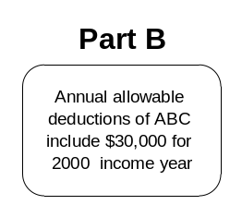
closing value for 1999 of $30,000
via core provisions

Figure 13

THE PROCESS OF CALCULATING AND ALLOCATING GROSS INCOME FROM THE SALE OF A DEPRECIABLE ASSET
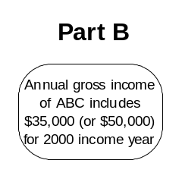
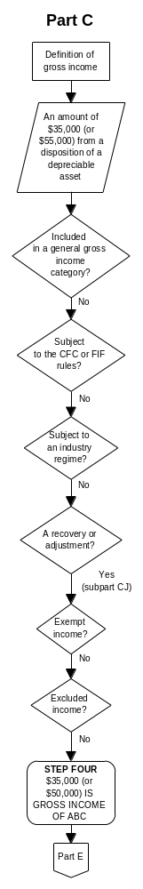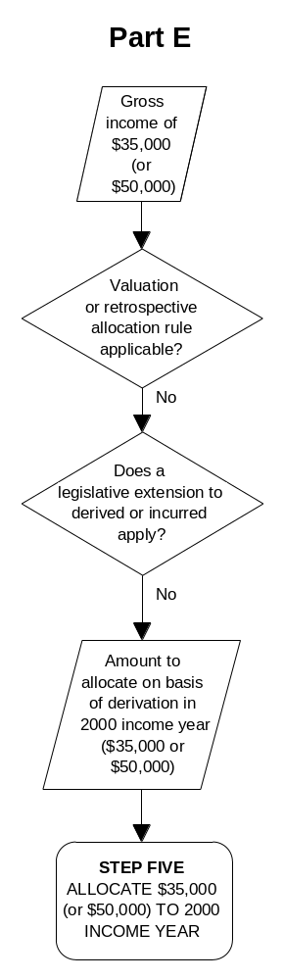
via core provisions

CHAPTER 15

ASSOCIATED PERSONS

Summary

- The redrafted legislation moves the associated person rules in Parts C, D and E to Part G of the Act, in line with the true function of the rules as anti-avoidance provisions.

- It groups and orders the rules generically. The relocated rules will be grouped according to two functions: rules that impute the status or action of one person to another person, and rules that deem transactions between associated persons to take place at market value. Within those two groups, rules are ordered according to whether they relate to income, deductions or timing.

- It uses plain language and tabular formats. The current definitions of associated person are expressed in language which is dense and repetitive. Two proposals are presented that consolidate common elements and use plainer language and tabular formats are presented. Under the first proposal, a self-contained table enables readers to ascertain whether they are associated with other persons. Under the second proposal, the definitions continue to be expressed in narrative, but a table is included to assist interpretation. The associated person rules themselves are also expressed in tabular form.

- Taxpayers may seek to avoid tax by operating through an associated person - an entity or person under the control or influence of the taxpayer. The associated person rules in the Act neutralise that practice by imputing the status or actions of the associated person to the taxpayer or by deeming transactions with associated persons to have been conducted as though the parties were at arm’s length. For example:

- Certain amounts received by a taxpayer from the disposition of land are gross income if the taxpayer carried on the business of developing or subdividing land when the land was acquired. The amounts are also gross income if a person associated with the taxpayer carried on such a business, even if the taxpayer did not (section CD 1(2)(c)).

- If a mining company disposes of an asset which it has acquired as a result of exploration or development expenditure, an amount equal to the consideration received is gross income. If the asset is disposed of to an associated person, the consideration is deemed to be the value of the asset at the date of disposal (section DN 1(10)).

Definition of associated person

Current method

- The Act contains five separate definitions of "associated person". The definitions are referred to in section OB 1 and set out in sections OD 7 and OD 8. They have built up in an ad hoc manner and each applies to a separate group of substantive provisions, as shown in table 7.

- The circumstances in which two entities are associated differ from definition to definition, as shown in table 8.

- The current definitions contain numerous overlaps and inconsistencies:

- The boundaries between definitions are often arbitrary. For example, the section OD 7 definition treats two persons as associated if they are relatives. The section OD 8(3) definition extends application to two persons “habitually acting in concert with respect to certain matters”. The section OD 8(4) definition restricts application to a person and the person’s spouse or infant child, but then extends application to a trustee for either of those.

- The same definition often applies in several unrelated areas. For example, the second section OD 8(3) definition applies in the international tax rules and in provisions addressing the valuation of bailed specified livestock.

- A definition is sometimes adjusted by a substantive provision. For example, section CG 4(3) provides that for the purposes of section CG 4(2), a relative is not an associated person if the relative is a non-resident.

- A substantive provision sometimes substitutes an alternative definition. For example, section CG 11(8) provides that for the purposes of section GD 13, the appropriate associated person test is the test in section OD 7 and the second section OD 8(3) test, not the first section OD 8(3) test, which would ordinarily apply.

Above all, the text of the definitions is dense and repetitive.

Table 7
HOW THE DIFFERENT DEFINITIONS WORK

Category and  definition section | Substantive provisions to which definition applies
Category 1  OD 7 | All situations not covered by the four following definitions
Category 2  OD 8(1) | Income from sale of shares or trust interests in controlled petroleum mining entity (CJ 6)  Deductions allowed to persons associated with petroleum miners (DK 2)  Deductions on dispositions of timber between associated persons (DL 1)  Deductions for petroleum mining expenditure (DM 1 to DM 10)  Avoidance provisions relating to petroleum mining (GC 12)  Distribution of trading stock by company to shareholders and associated persons (GD 2)
Category 3  OD 8(3) | International tax rules  Depreciation deduction on acquisition of depreciated asset from associated person  Cost price option for valuing specified livestock bailed or leased between associated persons (EL 7(3)(b))  Set off of farmer forgiveness of debt against losses of associated person (EZ 9)
Category 4  OD 8(3) | Base value of depreciable property acquired by taxpayer (Paragraph (a) of definition of “adjusted tax value” in OB 1)  Repatriations by controlled foreign companies (CG 8)  Apportionment of interest costs if NZ taxpayer controlled by single non-resident (Subpart FG)  Cross-border arrangements (GD 13)  Liability for tax of company with insufficient assets (HK 11)  Underlying foreign tax credits (Subpart LF)
Category 5  OD 8(4) | Gross income from land transactions (CD 1)  Transfer of land under Matrimonial Property Act (FF 6)  Land transfers between associated persons (GD 9)

Table 8
HOW PERSONS ARE ASSOCIATED

Associated entities | Category 1  OD 7 | Category 2  OD 8(1)
Two companies | Group of persons with:  aggregate voting interests of at least 50% in each company  aggregate market value interests of at least 50% in each company  control of both companies by any other means | Group of persons with:  aggregate voting interests of at least 50% in each company  aggregate market value interests of at least 50% in each company  control of both companies by any other means
Company and non-company | Voting interest of at least 25%  Market value interest of at least 25%  -  - | Voting interest of at least 50%  Market value interest of at least 50%  -  -
Two natural persons | Person and relative (to fourth degree) | Person and relative (to fourth degree)
Partnership and another person | Partnership and partner  Partnership and person associated with partner | Partnership and partner  Partnership and person associated with partner
Trustees | - | Trustees of trusts with common settlor
Trustee and beneficiary | - | Yes
Trustee and settlor | - | -
Person and friendly society, charitable organisation, or non-profit organisation | - | Society or organisation and person or relative controlling
Any two persons

Category 3  OD 8(3) | Category 4  OD 8(3) | Category 5  OD 8(4)
Group of persons with:  aggregate voting interests of at least 50% in each company  aggregate market value interests of at least 50% in each company  control of both companies by any other means  aggregate income interests of at least 50% in each company  but not where one company is not resident in NZ | Group of persons with:  aggregate voting interests of at least 50% in each company  aggregate market value interests of at least 50% in each company  control of both companies by any other means  aggregate income interests of at least 50% in each company | Group of persons with:  aggregate voting interests of at least 50% in each company  aggregate market value interests of at least 50% in each company  control of both companies by any other means
-  -  Income interest of at least 50%  Person associated with another person associated with company | -  -  Income interest of at least 50%  Person associated with another person associated with company | Voting interest of at least 25% by person, spouse of person, infant child of person, or trustee for person, spouse or infant child, or any two or more of those  Market value interest of at least 25% by person, spouse of person, infant child of person, or trustee for person, spouse or infant child, or any two or more of those  -  -
Person and relative (to second degree) | Person and relative (to second degree) | Person and spouse, infant child, or trustee for spouse or infant child
Partnership and partner  Partnership and person associated with partner | Partnership and partner  Partnership and person associated with partner | Partnership and partner  Partnership and person associated with partner
Trustees of trusts with common settlor, but not if employee beneficiaries | Trustees of trusts with common settlor, but not if employee beneficiaries | -
Yes, but not if employee beneficiaries | Yes, but not if employee beneficiaries | -
Yes, but not if employee beneficiaries | Yes, but not if employee beneficiaries | -
- | - | -
Acting in concert in respect of CG 4(4) matters | Acting in concert in respect of CG 4(4) matters

Proposals for improvement

- There are two methods for improving the definitions:

- Method 1. Express the definitions in a table, with limited subordinate text. This method substantially dispenses with narrative. Instead, readers plot their circumstances on a table and obtain a "yes" or "no" answer to the question of whether they are associated with another person in their particular circumstances.

- Method 2. Continue to express the definitions in narrative, but with an accompanying interpretative table. This method is more conventional and is essentially a plain language rewrite of the current text of sections OD 7 and OD 8. The table is an aid to interpretation.

- Illustrative drafts of both methods are set out on the following pages. Both methods endeavour to:

- avoid repetition by consolidating common elements;

- highlight the boundaries between definitions;

- highlight the substantive differences between definitions;

- highlight when persons are not associated.

- Beyond that, each method has its own particular advantages. Submissions on which method is preferred, or on further methods, are invited.

DRAFT LEGISLATION AND COMMENTARY -

Method 1, as a table

Two persons are associated when: | Category 1 | Category 2 | Category 3 | Category 4 | Category 5
Both persons are companies

If a group of persons has:  - aggregate voting interests of at least 50% in each company  - aggregate market value interests of at least 50% in each company (if a market value circumstance exists in either company)  - aggregate income interests of at least 50% in each company  - control of both companies by any other means  * except if one of the companies is not resident in New Zealand | X  X  X | X  X  X | X*  X*  X*  X* | X  X  X  X | X  X  X
One of the persons is a company and the other person is not a company

If the other person has:  - voting interests of at least 25% in the company  - market value interests of at least 25% in the company (if a market value circumstance exists in the company)  - voting interests of at least 50% in the company  - market value interests of at least 50% in the company (if a market value circumstance exists in the company)  - income interests of at least 50% in the company  If the company and the other person are each associated, under the relevant category, with a third person  If the other person, the spouse of the other person, an infant child of the other person, or a trustee of a trust under which the other person, the spouse of the other person or an infant child of the other person has benefited or is eligible to benefit, or any two or more of those, has or have:  - voting interests of at least 25% in the company  - market value interests of at least 25% in the company (if a market value circumstance exists in the company) | X  X | X  X | X  X | X  X | X
Defined: company, group of persons, income interest, market value circumstance, market value interest, person, trust, trustee, voting interest

Commentary on method 1

- The definitions are expressed in a table. For illustrative purposes the model extends only as far as association between two companies and a company and non-company.

Categories of association

- Five formal “categories of association” are established. The categories match the five meanings of “associated person” that are currently contained in sections OB 1, OD 7 and OD 8.

- The associated person rules themselves are currently scattered throughout Parts C, D and E, but will be extracted and moved to the anti-avoidance and non-market transaction Part of the Act (see 15.17, Operative associated person rules). Each rule will be flagged with the definitional category relevant to the rule. For example:

- Associated person rules currently located in section CD 1(2), relating to gross income from land transactions, will have a “Category 5” flag.

- The rule currently in section DM 6, relating to dispositions of shares or trust interests in a controlled petroleum mining entity, will have a “Category 2” flag.

Using the table

- The table presumes users know both their own status (such as company and non-company) and the status of the other person with whom they might be associated. Users begin by locating the relevant combination heading (shaded). They then scroll down the various circumstances under which that combination of persons is associated. Finally, the “category” columns advise whether the relevant circumstances apply in the category to which the relevant operative rules apply.

Supplementary narrative

- A small amount of supplementary narrative will be required to address the holding of rights and interests (material currently contained in sections OD 7(2), OD 8(2) and OD 8(5)).

Clarifications

- The following ambiguities and inconsistencies in the present definitions have been clarified:

- The words “unless the context otherwise requires” currently appear at the beginning of section OD 7, but not at the beginning of section OD 8. To provide greater certainty, that qualification is now eliminated. The rules of association are simply those which appear in the table.

- Three of the existing definitions refer to two companies being associated if there is “a group of persons who have control” of both companies. The other two definitions refer to the group itself having control, rather than the persons. The latter approach is the correct one and is now adopted.

DRAFT LEGISLATION AND COMMENTARY -

Method 2, as narrative

XX X When are persons associated?

General rules

(1) Two persons are associated with each other when one or more of the circumstances described in this section occur at the time in question.

2 companies

(2) A company is associated with another company when one group of persons has:

(a) aggregate voting interests of 50% or more in each company; or

(b) aggregate market value interests of 50% or more in each company if a market value circumstance exists in either company; or

(c) control of both companies by any other means.

Company and non-company

(3) A company and a person that is not a company are associated when the person has:

(a) a voting interest of 25% or more in the company; or

(b) a market value interest of 25% or more in the company if a market value circumstance exists in the company.

Defined: company, group of persons, market value circumstance, market value interest, person, voting interest

XX Y Exceptions to the rules of association in section XX X

Changes for the purposes of section GX B

(1) For the purposes of section GX B, the rules in section XX X are changed so that:

(a) a company and a person that is not a company are associated only when the person has:

(i) a voting interest of 50% or more in the company; or

(ii) a market value interest of 50% or more in the company if a market value circumstance exists in the company.

Changes for the purposes of section GX C

(2) For the purposes of section GX C, the rules in section XX X are changed so that:

(a) a company is not associated with another company when one of the companies is not resident in New Zealand;

Subject to paragraph (a), a company is also associated with another company when one group of persons has an aggregate income interest of 50% or more in each company;

(b) a company and a person that is not a company are associated only when:

(i) the person has an income interest of 50% or more in the company; or

(ii) the company and the person are each associated under this subsection with a third person.

Changes for the purposes of section GX D

(3) For the purposes of section GX D, the rules in section XX X are changed so that:

(a) a company is also associated with another company when one group of persons has an aggregate income interest of 50% or more in each company;

(b) a company and a person that is not a company are associated only when:

(i) the person has an income interest of 50% or more in the company; or

(ii) the company and the person are each associated under this subsection with a third person.

Changes for the purposes of section GX E

(4) For the purposes of section GX E, the rules in section XX X are changed so that a company and a person that is not a company are associated only when the person, the spouse of the person, an infant child of the person, or a trustee of a trust under which the person, the spouse of the person, or an infant child of the person has benefited or is eligible to benefit, or any two or more of them:

(a) have a voting interest of 25% or more in the company; or

(b) have a market value interest of 25% or more in the company if a market value circumstance exists in the company.

Defined: company, group of persons, income interest, market value circumstance, market value interest, New Zealand, person, trust, trustee, voting interest

Commentary on method 2

- The narrative part of the definitions begins by stating the general rules, material currently set out in section OD 7. For illustrative purposes the model extends only as far as association between two companies and a company and non-company. The rules currently set out in section OD 8 are then expressed as exceptions to the general rule.

- Very wide-ranging exceptions which appear at the beginning of the current definitions, out of an abundance of caution, are not replicated, but will be included if such qualifications are found necessary.

Table 9

TABULAR ARRANGEMENT FOR METHOD 2

 | Company | Person (non-company) →
Company | Group of persons with:  Aggregate voting interests or aggregate market value interests of 50% or more in each company or control of both companies (GX 1, 2, 3 (except if one company is non-resident), 4 and 5)  Income interest of 50% or more in each company (GX 3 (except if one company is non-resident) and 4) | Voting interest or market value interest of 25% or more in company (GX 1)  Voting interest or market value interest of 50% or more in company (GX 2)  Income interest of 50% or more in company (GX 3 and 4)  Company and person each associated with third person (GX 3 and 4)  Voting interest or market value interest of 25% or more in company by person, spouse of person, infant child of person, or trustee for any 2 or more of those (GX 5)
Person  (non-company)  ↓ | Voting interest or market value interest of 25% or more in company (GX 1)  Voting interest or market value interest of 50% or more in company (GX 2)  Income interest of 50% or more in company (GX 3 and 4)  Company and person each associated with third person (GX 3 and 4)  Voting interest or market value interest of 25% or more in company by person, spouse of person, infant child of person, or trustee for any 2 or more of those (GX 5)

Commentary on tabular arrangement for method 2

- The tabular arrangement presumes readers know their own status (such as company and non-company) and enables them to ascertain all other persons with whom they are associated.

Operative associated person rules

- Operative associated person rules qualify substantive rules and are scattered throughout Parts C, D and E. A clear example occurs in section CG 6, where a substantive rule, located in subsection (1), provides that a person must calculate attributed foreign income or loss if the person has an income interest of 10% or greater. Subsection (2) then contains a qualifying associated person rule which provides that the person is deemed to hold any income interest of an associate.

Advantage of current method

- In so far as an associated person qualification is merely part of the rules applicable to a particular area, all the rules appear together and can be read together. Section CG 6 is a good example of a substantive and associated person qualification appearing together.

Disadvantages of current method

- Disadvantages of the current method are that:

- The qualifying rule can clutter the substantive provision and make it difficult to read. (Section CG 8, which deals with the calculation and attribution of a controlled foreign company repatriation, is a good example. Associated person qualifications are scattered throughout the section.)

- The qualifying rules clutter Parts C, D and E as a whole by using repetitive language to effect the same policy in a multitude of situations.

- The true anti-avoidance character of the qualifying rules is masked.

Proposal for improvement

- It is proposed to bring the qualifying rules in Parts C, D and E together and locate them in the Act's anti-avoidance and non-market transaction Part (currently Part G).

- The rules would be grouped according to their function:

- those that impute one person's action or status to another person;

- those that govern transactions between associated persons.

- The rules in the latter category have different functions: some deem values, some adjust deductions, and others adjust timing.

- Advantages of the proposed method are that it:

- makes the true anti-avoidance character of the rules more apparent;

- clears clutter from the substantive provisions.

- The illustrative draft on the following pages brings together and groups according to function a selection of qualifying rules from Parts C, D and E. A tabular format is used to better identify the groups and functions.

DRAFT LEGISLATION AND COMMENTARY:

ASSOCIATED PERSONS

Imputation of actions and statuses | Category of association
CB 4(1)(e)  If a trust or company carries on a business for charitable purposes and a person associated with a settlor or trustee of the trust or a shareholder or director of the company gains a benefit or advantage from the carrying on of the business, the benefit or advantage is deemed to have been gained by the settlor, trustee, shareholder, or director. | 1
CD 1(11)  A person who acquires land from an associated person is deemed to have acquired the land when the associated person acquired it. | 5
DM 6  A person is deemed to have disposed of any shares or trust interests in a controlled petroleum mining entity disposed of by an associated person. | 2
EH 6(1)  If an amount payable under a financial arrangement is determined, in terms of the financial arrangement, at the discretion of a person associated with either the issuer or the holder, the amount is deemed to be determined at the discretion of the issuer or the holder, as the case may be. | 1

Transactions between associated persons | Category of  association
Value | Category of  association
CG 8(5)  If a controlled foreign company acquires property from an associated person at an undervalue, the property is deemed to be acquired at market value. | 4
CH 2(2)  If, by one or more transactions between associated persons, a taxpayer disposes of rights under an agreement to sell or issue shares to which s.CH 2(1) applies, the benefit conferred on the taxpayer for the purposes of s.CH 2(1) is the amount by which the market value of the shares on the date they are acquired exceeds the amount paid or to be paid for them. | 1
DN 1(12)  If a mining company acquires property from an associated person the property is deemed to be acquired at market value. | 1
DZ 6(7)  If, before 30 September 1990, a petroleum mining company acquires or disposes of an asset which it has acquired or become possessed of as a result of any exploration expenditure or development expenditure, to or from an associated person, the asset is deemed to be acquired or disposed of at market value. | 1
EL 7(3)(b)  A person who bails specified livestock to an associated person can value the livestock at cost price only if the bailment is at fair market value. | 1

Deductions | Category of association
Disposal and acquisition of timber  If a person disposes of timber, or a right to take timber, to an associated person, any deductions otherwise allowed to the person in respect of the timber, or right to take timber, are limited to the gross income which the person receives from the disposition.  If a person acquires timber, or a right to take timber, from an associated person, the person is allowed a deduction for the aggregate of:  - the cost of the timber to the person, and  - the amount for which the associated person would have been allowed a deduction but for the limitation imposed above. | 2
Disposal and acquisition of petroleum mining assets  If a petroleum miner disposes of a petroleum mining asset, any deductions otherwise allowed to the petroleum miner in respect of the petroleum mining asset are limited to the gross income which the petroleum miner receives from the disposition.  If a person acquires a petroleum mining asset from an associated person who is a petroleum miner, the person is allowed a deduction for the aggregate of:  - the cost of the petroleum mining asset to the person, in the income year of acquisition, and  - the amount for which the associated person would have been allowed a deduction but for the limitation imposed above. | 2
Timing | Category of association
Disposal and acquisition of timber  If a person acquires timber, or a right to take timber, from an associated person, the deduction allowed to the person for the aggregate of:  - the cost of the timber to the person, and  - the amount for which the associated person would have been allowed a deduction but for the limitation imposed above,  is allowed in the income year of acquisition. | 2
Disposal and acquisition of petroleum mining assets  If a person acquires a petroleum mining asset from an associated person who is a petroleum miner:  - the deduction allowed to the person for the cost of the petroleum mining asset is allowed in the income year of acquisition.  - the deduction allowed to the person for the amount for which the associated person would have been allowed a deduction but for the limitation on deduction imposed above is allowed in the income year in which the person first disposes of the asset to a person not associated with the petroleum miner or in which the person ceases to be associated with the petroleum miner. | 2

Commentary on associated persons

- The associated person rules, extracted from substantive provisions in Parts C, D and E, are brought together and located in the Act's anti-avoidance and non-market transaction Part. For illustrative purposes the model is limited to a selection of rules.

- The relevant definitional category (see "Definition of associated person: Method (1)) is noted beside each rule. (This flagging will not be required if definitional Method (1) is not adopted.)

- The rules are grouped according to function:

- imputation of an associate's action or status to the other person;

- transactions between associates:

- deemed value
- adjustment of deduction
- adjustment of timing

- The "deductions" and "timing" categories acknowledge the overall scheme of Parts C, D and E.

Net concepts, such as profit or gain, are placed on a gross footing when possible. For example, the full amount received from the sale of certain land is now gross income, the cost is deductible, and the timing of the deduction is more clearly set out in the legislation. All items of gross income and allowable deductions that are timed to an income year are added together and the total deductions subtracted from the total income to give the net income figure for the year.
Such amendments include the consistent use of terms (for instance, “gross income” in place of “assessable income”, as appropriate, and “net loss” in place of “loss”, as used in the sense of a loss for an income year).
For example, exempt income provisions (which are generally of limited application) will be placed towards the end of Part C rather than at the beginning, as at present. Employment income will appear early in the Part, with the more specialised provisions, such as life insurance, appearing towards the end.
For example, the general deductibility rule and capital prohibition will operate as pivotal rules in Part D to clarify the relationship between those rules and other deduction provisions.
For example, Part E will contain three categories of timing rules – valuation, derivation/incurrence and retrospective spreads – based on the broad function of the various rules.
For example, Part C will contain a Subpart that brings together all provisions on gross income attributable to a disposition of property.
For example, provisions that replicate the general deductibility rule, discussed in chapter 5, will be deleted.
The trading stock, accrual expenditure, and revenue account property rules lend themselves to this kind of rationalisation.
This category of legislation could also be placed in Subpart CD (Dispositions).
CIR v Lactagol (1954) 35 TC 230, Campbell v CIR [1967] NZLR 1, Holland v CIR (1982) 5 NZTC 61,323, Davis v CIR (1983) 61,655.
The Taxation of Distributions from Companies (Final Report), July 1991, p.48.

