
Colmar Brunton undertakes all research projects to the highest possible standards, and in accord with the principles detailed in the MRSNZ Code of Practice which is based on the ESOMAR Code of Conduct for Market Research.
All methodologies and techniques outlined in this report are provided solely for use by the client.
Copyright is reserved by Colmar Brunton.

Measuring the tax compliance costs of small and medium-sized businesses – a benchmark survey
Final Report
Attention:
Stuart Turner and Prue Oxley
Contact:
Jocelyn Rout (09) 919 9212
Issue Date:
20 June 2005
Prepared for:
Inland Revenue
Table of Contents

List of tables 3
1. Executive summary 7
Research purpose 7
Research methodology 7
Key findings 7
Definitions 7
Internal compliance costs 8
External tax advisor costs 9
Payroll services 10
Combined costs 10
Reported stress levels 12
2. Background and objectives 13
Background 13
Policy purposes 13
Alignment with other Inland Revenue priorities 13
Research objectives 13
Defining compliance costs 14
3. Research methodology 16
Overview 16
Scoping and design 17
Acknowledgements 17
Sample design 17
Questionnaire development 18
Main fieldwork – business survey 19
Business survey 19
Tax advisor sub-survey – response rate 23
Data integrity and data processing 24
Database construction 24
Weighting 24
Data imputation 25
Calculation of means 26
Calculation of medians 28
Treatment of missing information 28
Presentation of results 29
Significance testing 29
4. Sample profile 30
Sample profile by business size 30
5. Internal time and costs 38
Internal time 38
Internal time spent on specific tax activities 38
Internal time spent on tax activities by specific types of personnel 43
Internal time spent dealing with child support and student loans 47
Internal time spent on particular income tax-related activities 50
Internal time spent on tax-related activities required for entertainment expenses 52
Value of time analysis 53
Income tax 56
Stress associated with provisional tax compliance 59
GST 63
Accounting system used for GST 65
Basis on which GST is accounted for and GST filing frequency 67
Whether business would still use computerised accounting software if New Zealand was tax-free 68
Stress associated with GST compliance 68
PAYE 72
Method used to process staff wages 74
Filing method 76
Stress associated with PAYE compliance 77
FBT 80
Stress associated with FBT compliance 82
6. External tax advisor costs 84
Use of, and payment for, external tax advisor services – business survey data 84
Tax advisor sub-survey results 85
External compliance costs by tax type 86
Whether a business would still pay their external accountant to do their annual accounts if New Zealand was tax-free 89
7. Payroll services 92
8. Audit 94
9. Combined costs 95
Summary of internal time 95
Summary of compliance costs 97
10. Psychological compliance costs 101
Appendices 104
A. Response rate over time 104
B. Sample profile – unweighted data 105
C. Internal time – excludes those who spent zero hours 113
D. External costs based on businesses who use an advisor 115
E. Payment for external tax services – comparison of tax advisor and business survey data 116
F. Analysis by sector 119
G. Analysis by age of business 124
Questionnaire 127

List of tables

Table 3.1: Response rate analysis 20
Table 3.2: Comparison of respondents and non-respondents 21
Table 3.3: Internal time spent on all tax activities (annual hours) by tax type and date of
questionnaire return – means 22
Table 3.4: Response rate analysis – tax advisor sub-survey 22
Table 4.1: Sample profile by business size (number of employees) 30
Table 4.2: Sample profile by tax type 34
Table 4.3: Tax type by business size 37
Table 5.1: Internal time spent on tax activities (annual hours) by tax type – means 39
Table 5.2: Internal time spent on tax activities (annual hours) by tax type – medians 40
Table 5.3: Internal time spent on tax activities (annual hours) by business size – means 41
Table 5.4: Internal time spent on tax activities (annual hours) by business size – medians 41
Table 5.5: Time spent on all tax activities for each tax type by business size 42
Table 5.6: Internal time spent by personnel on all tax activities (annual hours) by tax type – means 44
Table 5.7: Internal time spent by personnel on all tax activities (annual hours) by tax type – medians 45
Table 5.8: Internal time spent by all personnel on all tax activities (annual hours) by business size
(number of employees) – means 46
Table 5.9: Internal time spent by all personnel on all tax activities (annual hours) by business size
(number of employees) – medians 46
Table 5.10: Internal time spent (annual hours) dealing with child support and student loans by
business size (number of employees) 48
Table 5.11: Internal time spent (annual hours) dealing with child support and student loans by filing method 49
Table 5.12: Internal time spent (annual hours) on particular income tax-related activities by
business size (number of employees) – means 50
Table 5.13: Internal time spent (annual hours) on particular income tax-related activities by
business size (number of employees) – medians 50
Table 5.14: Internal time spent (annual hours) on particular income tax-related activities by age of business 51
Table 5.15: Internal time spent (annual hours) on particular income tax-related activities by
provisional tax options 51
Table 5.16: Internal time spent (annual hours) on tax-related activities required for entertainment expenses 52
Table 5.17: Value of time data relating to owners 54
Table 5.18: Value of time data relating to paid employees 54
Table 5.19: Value of time data relating to unpaid friends or relatives 55
Table 5.20: Summary of internal income tax compliance costs 56
Table 5.21: Internal time spent (annual hours) by personnel on income tax by business size
(number of employees) 57
Table 5.22: Mean internal compliance costs of income tax by business size (number of employees) 57
Table 5.23: Mean internal compliance costs of income tax by use of a tax advisor for income tax 58
Table 5.24: Mean internal compliance costs of income tax by business size (number of employees)
and whether business uses tax advisor for income tax 58
Table 5.25: Mean internal compliance costs of income tax as a percent of turnover 59
Table 5.26: Stress associated with provisional tax compliance 60
Table 5.27: Stress associated with provisional tax compliance – mean scores by business size
(number of employees) and age of business 60
Table 5.28: Stress associated with provisional tax compliance – mean scores by business size
(number of employees) and accounting system 61
Table 5.29: Stress associated with provisional tax compliance – analysed by who answered the question 62
Table 5.30: Summary of internal GST compliance costs 63
Table 5.31: Internal time spent (annual hours) by personnel on GST analysed by business size
(number of employees) 63
Table 5.32: Mean internal compliance costs of GST by business size 64
Table 5.33: Mean internal compliance costs of GST as a proportion of turnover 64
Table 5.34: Internal time spent (annual hours) on GST by age of business and business size (turnover) 65
Table 5.35: Accounting system used for GST by business size (number of employees) 65
Table 5.36: Accounting system used for GST by age of business 66
Table 5.37: Mean internal compliance costs of GST by accounting system and business size (turnover) 66
Table 5.38: Mean internal compliance costs of GST by GST basis and business size (turnover) 67
Table 5.39: Mean internal compliance costs of GST by GST filing frequency and business size (turnover) 67
Table 5.40: Whether business would still use computerised accounting software if New Zealand
was tax-free 68
Table 5.41: Stress associated with GST compliance 69
Table 5.42: Stress associated with GST compliance – mean scores by business size (number of employees)
by age of business 69
Table 5.43: Stress associated with GST compliance – mean scores by business size (number of employees)
by accounting system 70
Table 5.44: Stress associated with GST compliance – mean scores by business size (number of employees)
by accounting system 70
Table 5.45: Stress associated with GST tax compliance 71
Table 5.46: Summary of internal PAYE compliance costs 72
Table 5.47: Internal time spent by personnel on PAYE (annual hours) by business size (number of employees) 73
Table 5.48: Mean internal compliance costs of PAYE by business size (number of employees) 73
Table 5.49: Mean internal compliance costs of PAYE per employee 74
Table 5.50: Mean internal compliance costs of PAYE as a percent of turnover 74
Table 5.51: Method used in processing staff wages by business size (number of employees) 75
Table 5.52: Mean internal compliance costs of PAYE analysed by method used to process staff wages
and business size (number of employees) 75
Table 5.53: Mean internal compliance costs of PAYE analysed by business size (number of employees)
and filing method 76
Table 5.54: Stress associated with PAYE compliance 77
Table 5.55: Stress associated with PAYE compliance – mean scores by business size (number of employees)
and age of business 78
Table 5.56: Stress associated with PAYE compliance – mean scores by business size (number of employees)
by accounting system 78
Table 5.57: Stress associated with PAYE compliance – mean scores by business size (number of employees)
by filing method 79
Table 5.58: Stress associated with PAYE compliance 79
Table 5.59: Summary of internal FBT compliance costs 80
Table 5.60: Mean internal compliance costs of FBT by business size (number of employees) 80
Table 5.61: Mean internal compliance costs of FBT as a percent of turnover 81
Table 5.62: Stress associated with FBT compliance 82
Table 5.63: Stress associated with FBT compliance 83
Table 6.1: Use of, and payment for, external tax advisor services (business survey data) 84
Table 6.2: Profile of tax advisor sub-survey sample 85
Table 6.3: Payment made for external tax services – results from Advisor sub-survey 86
Table 6.4: External mean compliance costs by tax type and business size (number of employees) 87
Table 6.5: External mean compliance costs by tax type and business size (turnover) 87
Table 6.6: Mean external compliance costs tax as a percent of turnover 88
Table 6.7: Payment made for external advice on choice between provisional tax options 88
Table 6.8: Whether a business would still pay their external accountant to do their annual
accounts if New Zealand was tax-free – analysed by business size (number of employees) 89
Table 6.9: Whether a business would still pay their external accountant to do their annual
accounts if New Zealand was tax-free – analysed by entity type 89
Table 6.10: Tax advisors’ views on whether a business would still pay their external accountant to
do their annual accounts if New Zealand was tax-free – analysed by business size (number of employees) 90
Table 6.11: Tax advisors’ views on whether business would still pay their external accountant to
do their annual accounts if New Zealand was tax-free – analysed by entity type 90
Table 6.12: Comparison of tax advisors’ and businesses’ views on whether business would still
pay their external accountant to do their annual accounts if New Zealand was tax-free 91
Table 7.1: Use of, and payment for, external payroll services 92
Table 7.2: Whether business would still pay for external payroll services if New Zealand became tax-free 93
Table 8.1: Incidence of IRD audit and related time and cost incurred by the business 94
Table 9.1: Summary of internal time spent on all tax activities by tax type and business size
(number of employees) 95
Table 9.2: Summary of internal time spent on all tax activities by tax type and business size (turnover) 96
Table 9.3: Internal time spent (mean annual hours) on all tax activities by age of business
and business size (number of employees) 96
Table 9.4: Summary of mean annual compliance costs by business size (number of employees) 97
Table 9.5: Summary of mean annual compliance costs by business size (turnover) 98
Table 9.6: Summary of mean annual compliance costs by entity type 99
Table 10.1: Overall psychological compliance costs and reported stress levels by tax type 100
Table 10.2: Overall psychological compliance costs by business size (number of employees) 101
Table 10.3: Psychological costs associated with overall tax requirements (ignoring finding the money) 102
Table 11.1: Sample profile by business size – unweighted data 104
Table 11.2: Sample profile by tax type – unweighted data 108
Table 11.3: Tax type by business size – unweighted data 111
Table 11.4: Internal time spent on tax activities (annual hours) by tax type – means 112
Table 11.5: Internal time spent by personnel on all tax activities (annual hours) by tax type – means 113
Table 11.6: External mean compliance costs by tax type and business size (number of employees) 113
Table 11.7: Internal time spent on tax activities (annual hours) by sector 118
Table 11.8: Internal time spent by all personnel on all tax activities (annual hours) by sector 119
Table 11.9: Internal time spent on all tax activities for each tax type (annual hours) by sector 119
Table 11.10: Stress associated with provisional tax compliance – mean scores by business size
(number of employees) and sector 120
Table 11.11: Mean internal compliance costs of GST by business size (turnover) and sector 120
Table 11.12: Accounting system used for GST by sector 121
Table 11.13: Stress associated with GST compliance – mean scores by business size (number of employees)
by sector 121
Table 11.14: Stress associated with PAYE compliance – mean scores by business size (number of employees)
and sector 122

1. Executive summary
Research purpose
Inland Revenue has commissioned research to measure the tax compliance costs of small and medium sized businesses (SMEs) so that independent and evidence-based information can be used in developing and evaluating tax policy proposals. The research has been set up so that it can respond to policy proposals as they arise over the next 5-10 years. The starting point is a major benchmark survey quantifying relevant tax compliance costs for small and medium businesses.

Research methodology
A mail-out survey of small and medium businesses was conducted between October and December of 2004. A total of 1907 completed questionnaires were used in the analysis linked to key IRD extracted data. The response rates to the survey were 44% and 45% (for two questionnaire versions).

Extensive qualitative pre-testing and piloting of the questionnaire was undertaken, as well as pilot data verification interviews, to develop and refine the questionnaires as well as to provide reassurance of the validity of the final dataset.

A tax advisor sub-survey was conducted in December 2004 to gather information in order to apportion external tax advisor compliance costs to different tax types (this was especially important for businesses paying for external advice on multiple tax types).

Key findings

Definitions
The measure of compliance costs used in this survey includes internal time and external advisor costs. Data is also collected on psychological costs although this is not converted into dollars. Cash flow, tax deductibility and managerial benefits and government cash grants are not included.

The population of interest is New Zealand’s small and medium businesses (based on number of employees and annual turnover) and self-employed individuals with substantial income from ‘businesses activities’ (SMEs).

Internal compliance costs
Averages for internal compliance costs were calculated using a trimmed mean (i.e. with a few unusually high values removed before averaging) rather than the usual mean (which averages all values).

Internal time spent on all tax activities
The average SME spends 76.7 hours on tax compliance in a year. A breakdown of this amount by personnel type is as follows:
- owners/partners/directors/trustees (56.3 hours)
- paid employees (18.4 hours)
- unpaid friends or relatives (3.4 hours).

The amount of time spent on tax activities is strongly related to business size (from 51.3 hours for businesses without employees up to 204.5 hours for businesses with at least 20 employees).

GST requires the greatest time commitment (44.2 hours for GST-registered businesses), followed by income tax (29.2 hours for those who pay income tax), PAYE (27.5 hours for employers), and FBT (12.8 hours for FBT payers).

Internal time spent dealing with child support and student loans
11% of employers employ staff paying child support. On average, these employers spend 0.5 hours per year dealing with PAYE issues related to child support. This equates to 1.3% of the time they spend on PAYE in total.

20% of employers employ staff making student loan payments. On average, these employers spend 0.5 hours per year dealing with PAYE issues related to student loans. This equates to 1.3% of the time they spend on PAYE in total.

Internal time spent on particular income tax-related activities
On average, businesses spent around two hours in the last 12 months on each of the following activities:
- Calculating provisional tax and deciding which provisional tax option to choose
- Tax activities for depreciation and adjustments for fixed assets, valuing stock
- Other end-of-year adjustments.

The median values associated with these activities are zero indicating that most businesses have not spent any time on these activities in the last 12 months. Medium sized SMEs spend on average 12 hours per year on tax activities for depreciation and adjustments for fixed assets and valuing stock.

Internal time spent on tax-related activities required for entertainment expenses
Seventeen percent of businesses have dealt with the 50% deductibility and GST adjustment required for some entertainment expenses in the last 12 months. Businesses that make these type of adjustments spend around two hours per year on them.

Value of time analysis
The following dollar amounts were used to convert time into compliance costs:
- $43.99 (owners/partners/directors/trustees)
- $20.31 (paid employees)
- $25.70 (unpaid friends or relatives).

Income tax
The mean annual internal compliance cost for income tax is $1224. Income tax compliance costs rise with business size from $1146 for businesses with no employees to $1896 for businesses with 20+ employees. Income tax compliance costs are the same between those that use a tax advisor and those that do not ($1202 respectively).

GST
The mean annual internal compliance cost for GST is $1852 (based on those who file/pay GST). GST compliance costs increase with business size (from $1496 for businesses with no employees to $2369 for businesses with 20+ employees). A similar pattern is evident with regard to turnover. However, other analysis also shows that GST compliance costs as a proportion of turnover diminish sharply with size.

Forty percent of GST-registrants use manual accounting systems for GST, 38% use computerised accounting software (in-house), 15% use ‘other’ computing systems (in-house) and 14% use external support. Those who pay for an external firm to handle aspects of their GST obligations experience the lowest internal GST tax compliance costs ($1399).

Eighty four percent of those who use computerised accounting software say they would ‘definitely’ or ‘probably’ still do so if New Zealand were tax-free, highlighting the importance of this type of software as a management information tool rather than a tax compliance cost.

More frequent filers of GST experience higher internal GST compliance costs (annual mean compliance costs of $1993 for 2-monthly filers compared to $1449 for 6-monthly filers).

PAYE
The mean annual internal compliance cost for PAYE is $937 (based on employers). PAYE compliance costs rise with employer size from $959 for micro businesses (1-5 employees) to $1404 for medium-sized employers (20+ employees). However, smaller employers experience a markedly higher compliance cost on a per employee basis - $520 for micro employers (1-5 employees), $166 for small employers (6-19 employees) and $43 for medium employers (20+ employees).

Sixty percent of employers use a manual system for processing staff wages, 26% use a computerised payroll system, and 10% use ‘other’ computing system (in-house).

FBT
The mean annual compliance cost for FBT is $416 (based on those who make FBT payments). Apart from SMEs with nil employees, FBT compliance costs do not rise with business size.

External tax advisor costs
Eighty percent of businesses pay for external tax advisor services. Among those who pay for these services, the mean annual payment is $1465.
The mean annual payment made for external tax advisor services for each tax type is as follows:
- $480 for services relating to GST (among all GST-registered businesses who pay for external services related to GST)
- $1,202 for services relating to income tax (among all those who pay for external services related to income tax)
- $141 for services relating to PAYE (among all employers who pay for external services related to PAYE)
- $149 for services relating to FBT (among all those who make FBT payments to IRD and who pay for external services related to FBT).

Tax advisors indicate that the average payment made for external advice on the choice between provisional tax options is $159 (although this differs markedly according to business size).

Opinion, among businesses, on whether they would retain the services of an external tax accountant if New Zealand were tax-free is divided: 44% say that they ‘definitely’ or ‘probably’ would, 45% say they ‘definitely’ or ‘probably’ wouldn’t, and 9% are unsure. Tax advisors are similarly divided on this issue.

Payroll services
Seven percent of employers use external payroll services. On average, these businesses spend $1550 on payroll services annually.

And, a small majority (56%) of these businesses indicate that they would ‘definitely’ or ‘probably’ still use external payroll services if New Zealand was tax-free.

Combined costs
The combined compliance costs given in this report are the sum of internal compliance costs and external compliance costs. They do not include costs associated with audits or payroll services nor do they incorporate any estimates of cash flow benefits or benefits of tax deductibility. Psychological costs have been collected but are not valued in dollar terms.

The mean combined compliance costs for businesses are summarised in the first chart below. The average business faces a combined annual tax compliance cost of $4024. GST-related costs and income-tax related costs are by far the largest contributors to this.

Again, the familiar pattern of increasing costs with business size is evident – from $2932 for businesses with no employees to $7649 for businesses with 20 or more employees. However, as illustrated in the subsequent chart, compliance costs clearly diminish as a percentage of turnover.

Figure 1: Combined mean compliance costs (internal plus external)

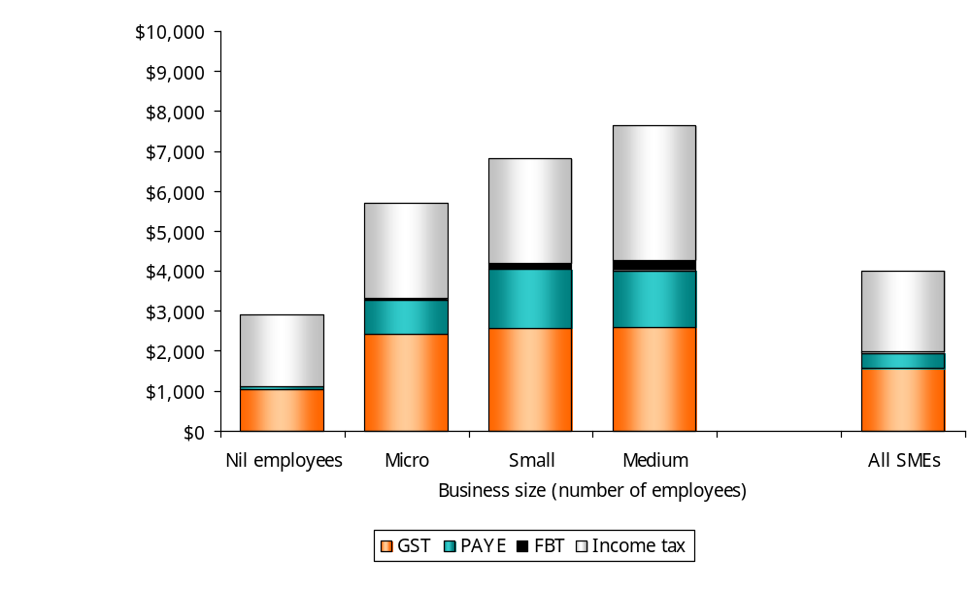

Figure 2: Combined mean compliance costs as % of turnover
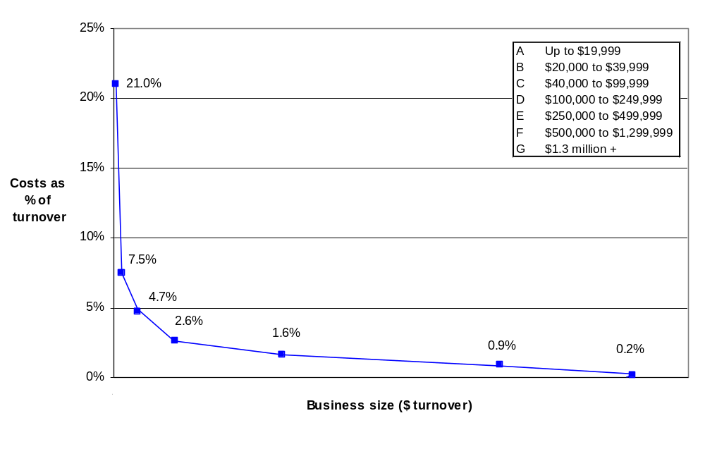
Reported stress levels
Respondents were asked to indicate how stressful they found meeting IRD requirements overall (ignoring finding the money) and for each tax type separately (including finding the money).

Around half (51%) find meeting IRD requirements overall less than moderately stressful (rating of 1 to 3), one quarter (24%) find them moderately stressful, and just under a quarter (23%) find them more than moderately stressful (rating of 5 to 7).

Reported levels of stress in dealing with GST and provisional tax are higher than those relating to PAYE and FBT. However, additional analysis detailed in the body of the report shows that employers tend to report higher stress levels than those without employees in regard to their overall tax requirements, provisional tax and GST.
2. Background and objectives
Background

Policy purposes
The small and medium-sized business (SME) sector in New Zealand is important, as most New Zealand businesses are small. More than 95 percent employ fewer than 20 people while 86 percent employ fewer than five. Small businesses also form a more significant part of the economy in New Zealand than they do in other OECD countries. New Zealand averages around six employees per firm, whereas most other OECD countries average from ten to twenty employees.

The Government’s tax simplification programme recognises that many small businesses struggle to comply with the increasingly complex set of tax laws to which they are subject. Key concerns for small businesses are the costs of compliance and the risks associated with non-compliance. The focus of the simplification programme is on reducing the stress, uncertainty and risks that these concerns place on small business.

A number of discussion documents outlining initiatives to reduce tax compliance costs for small businesses have been released, including the Simplifying Taxpayer Requirements (1997) discussion document and, more recently, the Less Taxing Tax (1999), More Time For Business (2001) and Making Tax Easier for Small Businesses (2003) discussion documents. A number of the initiatives have been implemented.

Research is required to assist in monitoring the impact of past and present legislative and administrative initiatives on reducing business tax compliance costs and also to allow for better consideration of the impact of proposed changes on tax compliance costs at each stage of the tax policy development process. This should also facilitate better compliance with Business Compliance Costs Statement (BCCS) requirements for policy proposals.

Alignment with other Inland Revenue priorities
A priority for Inland Revenue is to tailor interventions to make it easier for small businesses to meet their tax obligations and to increase their confidence in the tax administration. Simplification of tax administration interventions is a key focus of the Department’s strategy and the Government is implementing or considering a number of specific proposals.

Research objectives
The overriding purpose of the research is to provide independent and evidence-based information on the tax compliance costs of small and medium-sized business for the purposes of developing and evaluating tax policy proposals. The research is to be set up so that it can respond to policy proposals as they arise over the next 5-10 years. The starting point is a major benchmark survey quantifying compliance costs in hours and dollar terms for small and medium businesses.

The overall research objectives, which the benchmark survey contributes to, are as follows:
- To estimate the tax compliance costs of small and medium business.
- To provide measures of the impact of actual changes to the tax system on tax compliance costs faced by businesses. In particular:
- By how much and in what direction do compliance costs change?
- Which elements of compliance costs change?
- Which groups of taxpayers are affected?
- To what extent can the changes be attributed to the specific intervention?
- Similarly, for proposed tax initiatives, forecast the expected impact on compliance costs.
- To pre-test the impact of proposed initiatives in a prospective or experimental way.
- To develop and implement a framework for monitoring, over time, the tax compliance costs incurred at various stages of the life (and tax) cycle of a business.
- To provide information for better compliance with BCCS reporting requirements, particularly, in relation to quantitative assessments of compliance costs.

This report presents the results of this benchmark study.

Defining compliance costs
The Government’s objective is to make tax easier for small businesses, and this calls for a broad understanding of tax burdens and costs. For example, some of the proposed initiatives aim to reduce the burden through easing cash flow or budgeting problems and these may potentially involve more time spent on tax than previously. This and the fact that this benchmark survey has an applied policy purpose have a number of implications for the definition and measurement of ‘compliance costs’ adopted by Inland Revenue, a definition which differs from the more conventional ‘total compliance costs’ used in other surveys.

First, reducing cash flow management problems is an integral element of some of the proposed initiatives. Therefore it is important to include a measure of cash flow benefit in the equation, both in terms of dollars saved or foregone as well the less quantifiable benefits of ease of mind. Second, some of the less frequent compliance costs that may generate unusually high costs (eg associated with being audited) and those where the tax component is not easily isolated (eg paying a payroll agency) have been acknowledged and quantified to varying degrees but not included in the main calculations.

Furthermore, this project does not aim to estimate nationwide business compliance costs in total. First, this research has not surveyed all businesses, e.g. large businesses are excluded. Second, calculated compliance costs are based on trimmed means which exclude the extreme values at the upper end, thus providing a more robust basis for comparing compliance costs over time, in the future.

ATAX’s definition of ‘total compliance costs’ is:

(Direct monetary outgoings incurred by taxpayers + Imputed costs of time and resources spent by taxpayers) − (Managerial benefits to taxpayers+ Cash flow benefits to taxpayers + Tax deductibility benefits to taxpayers + Cash grants from the government)

This is the foundation of the definition adopted by Inland Revenue, with the restrictions noted above. The definition for this benchmark quantifying exercise is:

benchmark compliance costs | = | internal time + external advisor costs – (cash flow benefits + tax deductibility) + psychological costs [excluding audit costs, computing and other internal non-labour costs, external payroll provider costs]
where:
internal time | = | imputed costs of time spent by owners, staff, family and friends
external advisor costs | = | direct monetary outgoings to tax advisers (regular & occasional)
cash flow benefits | = | financial benefits arising from the mismatch in timing between when taxes are collected and when they are remitted to the tax authority
tax deductibility | = | for example, costs associated with using a tax advisor
psychological costs | = | the level of stress associated with tax activities including finding the money; measures are not converted to dollars

This survey contributes the data for the core compliance costs, ie internal time and external tax advisor costs. Data on psychological costs has also been collected (though not converted into dollars). Cash flow, tax deductibility and managerial benefits and government cash grants are not included.

3. Research methodology
This section outlines the research methodology used in conducting this benchmark research.

Overview

The diagram below summarises the approach. A more detailed explanation follows.

Figure 3: Overview of methodology

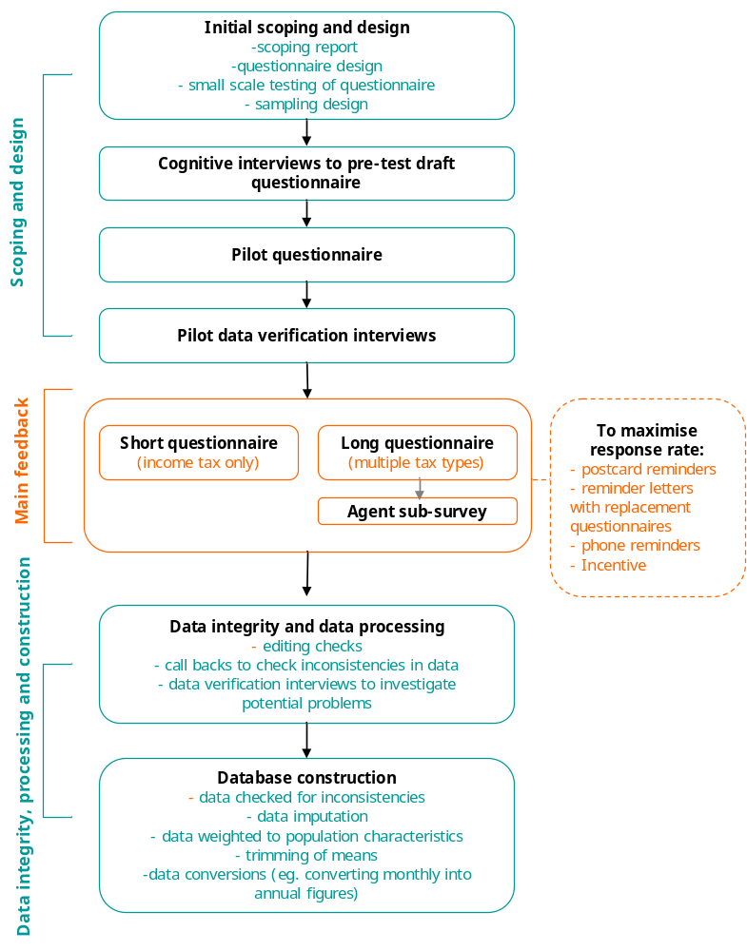

Scoping and design

Acknowledgements
The design of this survey has benefited from the collaborative advice of experts in tax compliance costs, in survey research and in business. Inland Revenue appreciates and acknowledges the assistance from Dr Chris Evans and Dr Binh Tran-Nam from Atax, University of New South Wales; Katherine Ritchie, Senior Lecturer in Taxation at Manukau Institute of Technology; Charles Sullivan of Capital Research; Business New Zealand; the Institute of Chartered Accountants of New Zealand; and Colmar Brunton. The conceptual framework and options provided by Atax are in their report to Inland Revenue, The tax compliance costs of small and medium-sized businesses, by C Evans and B Tran-Nam, January 2004.

Sample design
Inland Revenue selected a sample of businesses for focus in this research.

The population of interest is small and medium businesses in New Zealand, and self-employed individuals with substantial income from such businesses (whose income tax returns are potentially affected by proposed changes to provisional tax). To define this for the purposes of a quantitative survey we used the following dimensions:
- Business ‘Nature’, indicated by
- legal, or business Structure (IRD’s entity type)
- types of tax paid
- Business Size, indicated by
- number of employees
- annual turnover

The survey population is 485,317 SMEs.

In practice, the small and medium business population was defined into two sub-populations:
- multiple tax type businesses, that is paying GST and/or employing staff (in addition to being subject to income tax) (N = 376,929)
- those paying income tax only (individuals with business income, sole traders too small to pay GST or employ staff, a few business entities not liable for other taxes) – around one quarter of the sample was allocated to this group. (N =108,388)

A disproportionate stratified random sample, totalling 4,848 SMEs, was drawn reflecting different levels of turnover, employee numbers, tax type and whether FBT is paid. Data were weighted so that the results can be used to generalise to the entire population of interest (weighting is discussed later in this chapter).

In general terms, SMEs were included if:
- they were registered for either GST or PAYE (as at 30 June 2004) as Companies, Partnerships, Trusts, Maori Authorities or Individual – Self Employed or Employing taxpaying entities, or
- earned sufficient ‘business income’ and were ‘income tax only’ (IR3, IR4, IR6 & IR7 tax return filers).

And excluded if:
- on grounds of size, they employ 50+ staff AND have an annual turnover $10+ million
- were not active i.e. not trading
- were very small or relatively inactive businesses.

An in-depth description and discussion of the sampling design used for this study is given in a document prepared by Inland Revenue:‘Measuring the Compliance Costs of Small and Medium Businesses: Design Summary: Version 2.; 9a. Strata Population Sizes [New Version: including appropriate non-valid addresses].’

Before being given the contact lists of businesses, Inland Revenue sent all the selected businesses a letter introducing the purpose of the forthcoming research and giving businesses an opportunity to withdraw their names from the lists before they were passed onto Colmar Brunton. Following the provision of contact lists of businesses from Inland Revenue, Colmar Brunton removed businesses that had participated in survey research over recent months.

Questionnaire development
Initial scoping work and questionnaire development was undertaken by Charles Sullivan and Katherine Ritchie (including testing questionnaire versions with several businesses).

Colmar Brunton undertook further work on questionnaire design. Two versions of the questionnaire were designed; a ‘long’ version of the questionnaire which was relevant to multiple tax type businesses, and a ‘short’ version of the questionnaire which was relevant to those paying income tax only. The questions in this short questionnaire were essentially a subset of the long (main) questionnaire.

Cognitive interviewing
Colmar Brunton conducted 16 cognitive face-to-face interviews in Auckland, Wellington and Christchurch to qualitatively pre-test both versions of the survey questionnaire. Eleven of the interviews involved testing the ‘long’ questionnaire version and five involved testing the simpler, shortened version of the questionnaire.

Pilot
The questionnaires were then further revised and piloted. The pilot consisted of mailing out 239 questionnaires in total (188 long questionnaires and 51 short questionnaires). Seventy one questionnaires were completed and returned to Colmar Brunton (58 long and 13 short).

Pilot data verification interviews
Following the pilot, 16 data verification interviews were conducted to provide reassurance regarding the validity of key questions. The key issues addressed were:
- Whether respondents regarded the cost of an external tax advisor preparing annual accounts as a tax compliance cost. The data verification interviews indicated that this varied. Inland Revenue subsequently decided that this was a reasonable outcome – it should be left to the respondent to decide whether these costs are tax compliance costs. Following the pilot, ‘check’ questions to ensure the amounts paid to external tax advisors were purely tax-related were revised and emphasised.
- How respondents allocated time in Q13a/13b of the long questionnaire and Q6a/6c of the short questionnaire, and in particular whether double counting occurred. Key findings were:
- Rows were commonly left blank, but all respondents indicated that these blanks meant zero (ie no time was spent on the activity)
- Most respondents claimed to have made an effort to avoid double counting although a few (four of the 16) indicated that there was a degree of overlap between ‘recording information needed for tax’ and ‘dealing with tax advisors’ as it was hard to separate these or break them down into very small time components (eg 5 minutes).
- There was a tendency for respondents to overstate their time in the first tax activity line in the question (i.e. recording information needed for tax, etc.) because they included activities we intended them to cover in the subsequent lines. On realising they had done this, these respondents tended to leave the subsequent lines blank (if they had included this time in the first line) and enter a total at the bottom. This finding suggests that the totals are more reliable than the individual tax activities.
- What respondents used as a basis for valuing the time spent on tax compliance activities (Q14 in the long questionnaire and Q7 in the short questionnaire). Respondents tended to use either a set charge-out rate or calculation based on salaries and wages. This finding was borne in mind in determining appropriate dollar values to use in calculating compliance costs (this is addressed in depth later in the report in the section entitled ‘Value of time analysis’).

The overall conclusion from the pilot data verification interviews was that overall the questionnaire facilitated the collection of data that can be regarded as having high validity, that is, it measures what was intended.

Main fieldwork – business survey

Business survey
Self-completion questionnaires (the long and short versions) were sent to 4848 businesses on the 14th of October 2004. 3686 long questionnaires were dispatched and 1162 short questionnaires were dispatched.

The following measures were undertaken to maximise the response rate:
- Highlighter pens with Post-it flags were sent with the initial questionnaires.
- Postcard reminders were sent to all businesses approximately one week after the initial dispatch.
- Reminder letters with replacement questionnaires were sent to all businesses that had not yet returned a questionnaire.
- 600 telephone reminder calls were made (450 to businesses that were sent the long questionnaire and 150 to businesses that were sent the short questionnaire).

See Appendix A for when the initiatives were employed.

Response rate analysis
In total, 4848 questionnaires were dispatched and 2353 completed questionnaires returned. Therefore, the response rate based on the number of questionnaires dispatched is 49%.

However, this response rate does not take into account the number of businesses that declined to participate when they were sent the ‘consent’ letter (thus, these businesses were not included in the contact lists sent to Colmar Brunton). Therefore, based on all eligible SMEs initially selected for the study the overall response rate to the study is 44%.

Table 3.1: Response rate analysis
 |  | Long Questionnaire | Short Questionnaire | Overall
 | Number of ‘consent’ letters dispatched by Inland Revenue | 4142 | 1478 | 5620
 | Less ineligible ‘businesses’: Withdrew – No longer in business  Less ineligible ‘businesses’: Returned – Address not known | 38  104 | 43  97 | 81  201
A | Overall number of eligible businesses | 4000 | 1338 | 5338
B | Number of contacts provided by Inland Revenue | 3721 | 1184 | 4905
C | Questionnaires dispatched (number remaining after Colmar Brunton’s ‘deduping’ process) | 3686 | 1162 | 4848
D | Completed questionnaires returned | 1749 | 604 | 2353
E | Questionnaires returned indicating we did not have a current address | 51 | 25 | 76
F | Uncompleted questionnaires returned | 56 | 95 | 95
 | ‘Questionnaire’ Response rate (D/C) | 47% | 52% | 49%
 | Overall Response rate (D/A) | 44% | 45% | 44%

Although 604 short questionnaires were returned, only 158 have been used in the analysis. The 446 respondents who have been excluded fall into three categories:
- 381 respondents who ticked income tax and some other tax type in Q1, raising considerable concern about whether the results relating to the taxpayer’s time spent on tax compliance (Q6a) related solely to income tax. This concern was supported by the results of ‘callbacks’ made to 20 of these respondents – the majority were involved in other taxable activities and were not able to or didn't separate the business/entity selected from other interests/subsidiaries mixing all other tax types into their responses to Q6a. Hence we cannot be confident that their recorded time relates to only income tax for one business.
- 26 individuals who Inland Revenue identified as being part of a group that proved to be ineligible after the sample was drawn.
- 39 respondents did not indicate that they filed/paid income tax at Q1.

Item response
In addition to the overall response rates reported above, the following analysis assesses the extent to which we have successfully collected the key data necessary to estimate compliance costs. This analysis takes into account the amount of missing information, responses where the business indicated that they ‘didn’t know’ the amount of time they spent on tax activities, as well as outliers that have been ‘trimmed’ from the mean calculations.

Note, whilst Inland Revenue provided an indication of the tax types relevant to each respondent in the list used for mailing out the surveys, this information did not necessarily match the tax types respondents reported that they filed (at Q1 in the questionnaire). Thus, we are not able to estimate reliable item response rates based on all businesses that were sent a questionnaire and that file the particular tax type in question. Instead, we have looked at the extent to which respondents to the survey were able to answer Q13b.

Question 13b has been used for the basis of this analysis as this question provides the key data for the calculation of internal compliance costs for each tax type.

 | Tax type
 | GST | Income tax | PAYE | FBT
A. The number of respondents of the survey that pay/file the particular tax type (according to their response at Q1) | 1744 | 1854 | 1325 | 343
B. The number of respondents for whom we do not have useable data at Q14b due to missing information, ‘don’t knows’ or outliers. | 125 | 275 | 128 | 32
C. The number of respondents whose responses were used in the calculation of internal compliance costs | 1546 | 1521 | 1155 | 316
Proportion of respondents that provided useable data (C/A) at Q14b | 89% | 82% | 87% | 92%

Non-response bias – long questionnaire
The following table analyses those who responded to the long business survey and those who did not by tax type. Tax type variables were included on the contact lists that Inland Revenue provided. The analysis suggests that there is little non-response bias in terms of tax type, that is, the likelihood of a business responding does not appear to be dependent on tax type.

Table 3.2: Comparison of respondents and non-respondents
Tax type | Questionnaires dispatched | Questionnaires returned |  | Questionnaires not returned
Tax type |  | Number | % of questionnaires dispatched | Number | % of questionnaires dispatched
Income tax | 3686 | 1742 | 47.3 | 1944 | 52.7
GST | 3486 | 1659 | 47.6 | 1827 | 52.4
PAYE | 2316 | 1124 | 48.5 | 1192 | 51.5
FBT | 638 | 305 | 47.8 | 333 | 52.2

Table 3.3 provides further analysis on the possible extent of non-response bias. Respondents have been separated into groups according to how quickly they responded to the survey. This type of analysis surmises that businesses that returned a questionnaire late in the fieldwork period are more likely to be similar in nature to non-responders than businesses that returned a questionnaire early in the fieldwork period.

Responses to Question 13b have been used for the analysis as this question forms the basis for the calculations of internal tax compliance costs (presented later in the report). Weighted data has been used to isolate the nature of possible non-response bias from any bias that the weighting will correct for.

A oneway ANOVA has been carried out to assess whether there are statistically significant differences by tax type. T-tests were then used to determine statistical differences:
- between early and mid responders, or
- between mid and late responders, or
- between early and late responders.

There are significant differences (at the 95% confidence level) by tax type. Further, there are significant differences:
- between early and mid responders in terms of the number of hours spent on tax activities overall (ie 70.1 hours compared to 83.2 hours)
- between early and late responders in terms of the number of hours spent on tax activities overall (ie 70.1 hours compared to 89.1 hours).

This analysis suggests there may be a small degree of non response bias in terms of the number of hours that businesses spend on tax activities.

Table 3.3: Internal time spent on all tax activities (annual hours) by tax type and date of questionnaire return - means
Date of questionnaire return | GST | Income tax (including provisional tax) | PAYE (including child support, student loans, ACC levy) | FBT | All tax types
 | Mean (trimmed) annual number of hours
Early (21/10/04 to 3/11/04) | 43.0  (869) | 29.9  (880) | 25.6  (630) | 12.1  (175) | 71.6  (985)
Mid (4/11/04 to 17/11/04) | 46.3  (409) | 27.4  (372) | 27.9  (333) | 13.9  (93) | 94.6  (440)
Late (18/11/04 to 7/12/04) | 45.8  (236) | 33.8  (213) | 53.8  (191) | 13.7  (47) | 96.6  (243)
All | 44.2  (1521) | 29.4  (1509) | 27.5  (1157) | 12.8  (316) | 76.7  (1714)
Base: All respondents who according to Q1 filed the particular tax type (excluding missing information and outliers)
Source: Long questionnaire Q13b; Short questionnaire Q6b, Q6c

Tax advisor sub-survey – response rate
A tax advisor sub-survey was conducted to gather information in order to apportion external tax advisor compliance costs to different tax types. This information was collected from named tax advisors in respect to specific clients.

A self-completion questionnaire was pre-tested with three tax advisors. Self-completion questionnaires were then sent to 554 tax advisors. Questionnaires were only sent to the tax advisors of businesses that participated in the business survey (long questionnaire) and who gave consent to their tax advisor being contacted for this purpose.

Response data for the tax advisor sub-survey questionnaire is specified below.
Table 3.4: Response rate analysis – tax advisor sub-survey
Number of businesses in long questionnaires that use an external tax advisor | 1488
Questionnaires dispatched (number of respondents who gave consent to their tax advisor being contacted within the survey period) | 554
Completed questionnaires returned | 275
Questionnaires returned indicating wrong address | 10
Uncompleted questionnaires returned | 1
Response rate A (% of tax advisors sent a questionnaire who returned a completed questionnaire) | 50%
Response rate B (% of businesses in long questionnaire who use an external tax advisor and whose tax advisor returned a completed tax advisor questionnaire) | 18%

As indicated in the above table, whilst a good response rate was achieved from tax advisors who were sent the tax advisor questionnaire, the low level of consent from businesses to send tax advisors a questionnaire results in a low overall response rate.

However, the following information should also be considered in determining the extent to which results from the tax advisor sub-survey can be generalised.

Early testing of the questionnaire indicated that businesses were able to reasonably easily report the total payment made to their tax advisor, but businesses were unsure how this amount was allocated by tax type. Hence, the tax advisor sub-survey is most important for businesses that use external tax advice for multiple tax types. This is because the business survey data can be reliably used for payments made for external advice when the business seeks this advice for one tax type only (as this simply involves using the total payment figure from the business survey).

In total, we required information about 1616 respondents (both respondents to the long and short questionnaires) in terms of payments made for external tax advice. Of these 1616 respondents:
- data provided by tax advisors has been used for 275 respondents
- business survey data has been used for 566 because the business pays for advice on one tax type only (covers both long and short questionnaires).

Thus we have data for 841 out of 1616 respondents. This equates to 52%. Thus this is a reasonable basis on which to estimate external tax compliance costs for particular tax types. A detailed explanation of how external tax compliance costs have been calculated is given later in this chapter in the section entitled ‘Data imputation’.

Data integrity and data processing

A number of steps were undertaken with respect to data integrity including the following:
- A series of comprehensive editing checks and database checks to test for the internal validity of the data. This included checking for the distinction between missing values and true 0’s.
- Telephoning respondents back to clarify/check their answers. Telephone calls were made for this purpose to 13% of businesses that completed a questionnaire. The most common reason for these telephone calls was that the respondent had failed to confirm whether the amount paid for external tax advice (at Q10a in the long questionnaire) related to tax requirements only.
- 100% double-entry of data.

We consider the level of internal data validity to be very good. The size of any discrepancies discovered in the data is generally not regarded to be of significant concern. Of particular interest is the reasonably high degree of consistency between:
- responses made to Q13a in the long questionnaire (Q6a in the short questionnaire) which relate to time spent on tax activities by tax type, and
- responses to Q13b in the long questionnaire (Q6c in the short questionnaire) which relate to the amount of time spent by types of personnel for each tax type.

Of respondents who provided values at both Q13a in the long questionnaire (Q6a in the short questionnaire) and Q13b in the long questionnaire (Q6c in the short questionnaire), the total figures given in these two questions matched exactly for:
- 85% of respondents in relation to GST
- 88% of respondents in relation to income tax
- 89% of respondents in relation to PAYE
- 96% of respondents in relation to FBT.

Database construction

Weighting
The data have been weighted so that the survey results can be used to generalise to the entire survey population. Unless otherwise stated, weighted data has been used.

Weighting was conducted in two stages. First, a pre-weight was applied to correct for sample selection probabilities. The pre-weight was calculated as (N(i)/n(i))*(n/N)

Where:
N(i) is the population of statrum i
n(i) is the sample size of statrum i
N is the total population size
And n is the total sample size.

This was followed by weighting by strata to strata proportions (based on the figures provided in a document prepared by Inland Revenue:‘Measuring Compliance the Costs of Small and Medium Businesses: Design Summary: Version 2.; 9a. Strata Population Sizes [New Version: including appropriate non-valid addresses].’. It should be noted that since the only variable being weighted to was strata proportions, the pre-weight stage effectively produced weights to these proportions. The second stage of weighting to strata proportions, while unnecessary, was still performed.

Strata e and i (micro businesses that pay FBT with nil turnover and turnover of less than $100,000 respectively), f and j (small businesses that pay FBT with nil turnover and turnover of less than $100,000 respectively), and t and x (small businesses that don’t pay FBT with nil turnover and turnover of less than $100,000 respectively) were combined to increase cell size. The weighting was calculated based on a target of 1928, being the total number of respondents before removing 21 due to missing database information making it impossible to assign them to a stratum.

Businesses with 20+ employees and turnover of under $100,000 were excluded from the sampling frame and consequently were excluded from the population figures used to calculate weighting proportions. These businesses represent 0.03% of the total population of interest. While any effects from this would be minimal, it should be noted that the results of the survey do not represent these businesses.

Data imputation

Turnover and sector
Missing values for turnover and sector, in the business survey data have been imputed using information from Inland Revenue’s database for turnover and sector.

External tax compliance costs
The calculation of external compliance costs by tax type has been undertaken using both data from the tax advisor sub-survey and the business surveys, as well as data imputation.

Relying solely on the tax advisor sub-survey data would have been problematic due to the relatively low response rate of that survey.

To this end, external compliance costs have been calculated by using the following data:
- For respondents to the long business survey for whom we have data from their tax advisors, we have used the tax advisor-supplied data (regardless of whether it matched the total $ amount that the business gave and regardless of whether they use their tax advisor for one or more tax types).
- For respondents to the long business survey for whom we do not have data from their tax advisors, but who only ticked one tax type at Q10b, we have used the $ amount given at Q10a (if they confirmed at Q10a that the amount only included tax-related costs).
- For respondents to the short questionnaire we have used their response to Q4 (if they confirmed at Q4 that the amount only included tax-related costs) as reflective of the amount they paid for external tax services in relation to income tax.

We therefore had ‘missing information’ for respondents to the long questionnaire who use external tax advice for multiple tax types, but for whom we do not have data from their tax advisors. Imputed data (utilising results to Q10b as well as industry sector) has been used for these respondents.

As a check on the reliability of the above process, an assessment of the extent to which tax advisor reported data and business survey data matches (in terms of the total tax payment made for external advice) was undertaken. This analysis is appended to the report (see Appendix E) and shows a reasonably strong (positive) correlation between these two sets of data.

To impute for long questionnaire respondents with multiple tax types, without tax advisor data, groups of respondents based on industry and the number of tax types they filed for were created.

From the tax advisor data the proportion of the advisor costs that went to each tax type for each of the previously mentioned segments were found.

This proportion was then applied to the total amount that the respondent claimed they paid to their tax advisor in Q10a if they had indicated in Q10aiii that the fees they paid only included tax fees.

Long questionnaire respondents with multiple tax types, without tax advisor data who had not indicated in Q10aiii that the fees they paid only included tax fees did not have any external costs imputed for them.

Calculation of means
Trimmed means have been used extensively in the analysis and reporting of the amount of time businesses spend on tax compliance and associated tax compliance costs. This involved excluding any values whose log falls outside of the Median(log10(x)) + 2.24 MAD(log10(x)) where MAD is the median absolute deviation normalized to approximate the standard deviation for normally distributed data. The constant 2.24 was selected so that only the most extreme values would be trimmed. Given the highly skewed nature of the results, no values were trimmed from the bottom end. Note that by taking logs, zero values are excluded from the trimming process, but the zeros are re-introduced for the mean and median calculations.

The primary reasons for the decision to use trimmed means rather than conventional means were as follows:
- To avoid misleading descriptions of tax compliance costs – conventional means are prone to considerable influence with the presence of a small number of very high values.
- Trimmed means were regarded to be a better fit with policy objectives, that is policy initiatives will likely be aimed at reductions in compliance costs for a broad range of businesses rather than a few businesses with unusually high costs (eg due to audit).
- Trimmed means are more sensitive to detecting changes over time than conventional means. When data is affected by a few high values, conventional tests of differences between means can often fail to detect real change.

The following graphs show the effect of the trimming process. The first is a histogram of the total annual hours spent on GST returns (Skewness 5.934924; Kurtosis 56.90451).

Figure 4: Total annual hours spent on GST returns

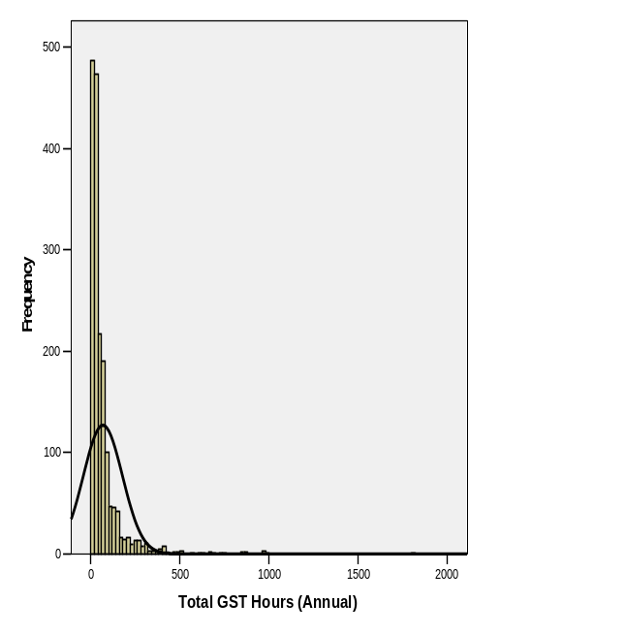

Taking the log of this variable has two effects. It removes zero values and changes the distribution to a much more normal distribution (Skewness 0.070814; Kurtosis 0.378891).

Figure 5: Log values of total annual hours spent on GST returns

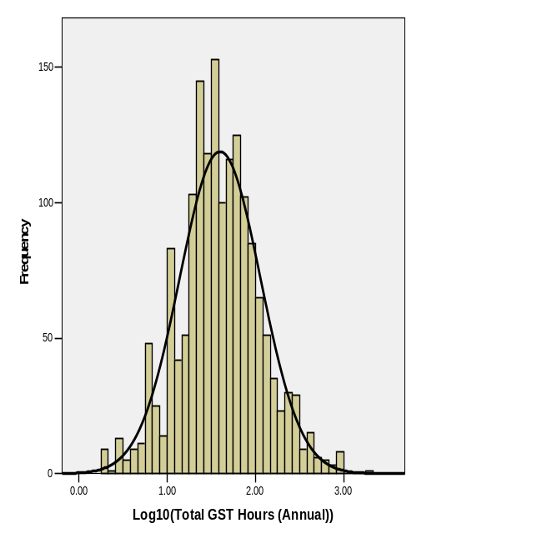

The final graph shows the trimmed variable (Skewness 2.199625; Kurtosis, 5.425463).

Figure 6: Trimmed total annual hours spent on GST returns

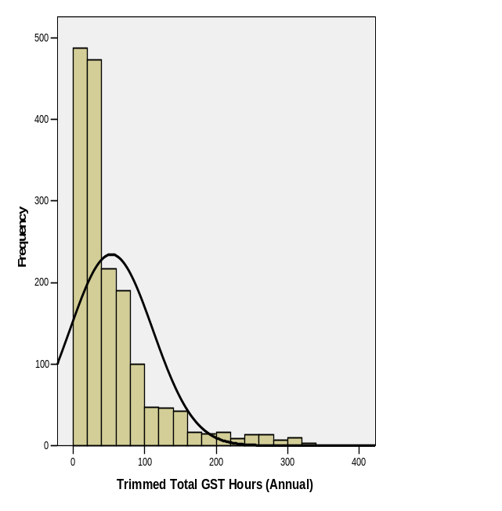

Calculation of medians
Outliers have not been removed in calculating medians. Unlike the mean calculations, inclusion of outliers in the median calculations had very little effect.

Treatment of missing information
The following data has been excluded from the calculation of mean and median values:
- Missing information
- Don’t knows

Where the respondent did not complete Q13a or Q13b and they wrote on the questionnaire that their accountant dealt with the particular tax type, these have been treated as ‘zero’ responses and this included in the mean and median calculations.

Missing information has been reported as a separate category for results that are presented as percentages. Thus, missing information has been included in the base in calculating these percentages.

Presentation of results
The survey results are largely presented in tables. The following explanations may assist the reader in interpreting the data:
- The numbers given in the brackets refer to the unweighted sample size.
- Where means have been trimmed, this is specified.
- Where percentages do not add to 100% this may be due to rounding or because more than one response category potentially applied to the respondent.

Analyses by industry sector are detailed in Appendix F as variations by sector appear to largely be a result of business size variations. Analysis by business size is presented extensively throughout the body of the report.

Significance testing
Estimated sampling errors have been calculated for the results presented in the section entitled ‘Combined costs’. To account for the imputation and trimming process of the external costs, confidence intervals have been estimated through bootstrapping. This process involved drawing a random sample (with replacement). The resulting sample was reweighted, imputed and trimmed. The mean of the variable of interest was then stored. This was repeated 200 times. The stored mean values is an estimate of the sampling distribution for the variable of interest and therefore the standard deviation is an estimate of the standard error of the variable. This was then used to calculate the confidence interval for the variable. Confidence intervals for internal costs were simply calculated based on the standard error of the variable.

In addition, some tests for the statistical significance of apparent differences in the survey results between questions and/or subgroups have been carried out. Unless otherwise specified, all tests have been carried out at the 95% confidence level. Use of the word ‘significant’ in the report refers to statistical significance (at the 95% confidence level).

Two types of tests have been used:
- In comparing proportions between samples, a z-test has been used to determine statistical significance. The notation is: z=(p1-p2)/sqrt((p1*(1-p1)/n1)+(p2*(1-p2)/n2)) where n1/n2 are the sample sizes and p1/p2 are the proportions we are comparing. The resulting z-value is compared to the Normal (0,1) distribution.
- In comparing means, the two-tailed t-tests available in the statistical packages SPSS and Toolbox have been used. The sample sizes used in these tests exclude any outliers that were removed as part of the trimming process.

4. Sample profile
This chapter provides a profile of the sample. All percentages use weighted data. Similar tables have been constructed using unweighted data and are appended to the report.

Sample profile by business size

Table 4.1: Sample profile by business size (number of employees)
 | Business size (number of employees) |  |  |  | All  %
 | Nil employees  % | Micro (1-5)  % | Small (6-19)  % | Medium (20+)  % | All  %
Number of owners working in the business  0  1  2  3+  Don’t know  Missing information | 40  34  22  2  *  2 | 3  44  46  7  -  * | 4  34  49  13  -  1 | 16  20  38  26  -  1 | 27  36  31  5  *  2
Business size - Number of employees (full-time and part-time combined)  Nil  Micro (1-5 employees)  Small (6-19 employees)  Medium (20+ employees)  Missing information | 100  -  -  -  - | -  100  -  -  - | -  -  100  -  - | -  -  -  100  - | 63  28  7  3  -
Business size - turnover  Nothing  $1 – $19,999  $20,000 – $39,999  $40,000 – $99,999  $100,000 – $249,999  $250,000 – $499,999  $500,000 – $1,299,999  $1.3 million – $4,999,999  $5 million – $9,999,999  $10 million – $49,999,999  $50 million – $99,999,999  $100 million or more  Missing information  Don’t know | 1  12  21  30  23  8  2  1  -  -  -  -  1  * | 1  2  6  16  30  23  18  4  1  -  -  *  -  * | 1  *  1  3  6  17  39  29  1  1  -  -  -  - | 1  -  1  -  -  3  19  46  15  15  1  -  -  - | 1  8  15  24  23  13  9  5  1  *  *  *  1  *
Table 4.1: Sample profile by business size (number of employees) (cont.)
Length of time in business  Less than 1 year  1 – 2 years  3 – 5 years  6 – 10 years  > 10 years  Missing information | 3  12  18  17  49  1 | 3  11  20  18  46  2 | 4  9  17  19  50  2 | 4  8  13  17  57  1 | 3  11  18  17  48  1
Use of a tax advisor  Use a tax advisor  Don’t use a tax advisor  Missing information | 77  23  * | 87  23  * | 86  13  - | 84  14  4 | 80  20  *
Main business activity  Agriculture  Mining  Manufacturing  Electricity  Construction  Wholesale  Retail  Accommodation  Transport  Communication  Finance  Property  Education  Health and community services  Cultural and recreational services  Personal & other services  Other  Missing information | 18  -  3  1  10  2  6  2  2  3  5  27  4  6  1  10  *  * | 27  *  4  2  13  3  11  3  4  3  1  13  1  4  1  9  *  1 | 15  -  12  1  9  5  13  11  4  1  1  9  4  6  2  8  -  - | 9  -  15  1  12  4  9  15  4  -  -  10  2  8  7  4  -  - | 21  *  4  1  11  3  8  3  3  2  4  21  3  5  2  9  *  *
Industry sector groupings  Primary produce  Industrial  Distribution  Business and finance  Service  Missing information | 18  14  10  32  25  * | 28  19  18  14  21  1 | 15  21  22  9  33  - | 9  27  17  10  37  - | 21  16  13  25  25  *
Number of sites  1  2  3  4  Missing information | 95  4  1  *  - | 93  7  *  *  * | 89  9  2  -  - | 97  2  -  1  - | 94  5  1  *  *
Legal entity  Company  Individual  Partnership  Trust  Missing information | 22  49  21  8  - | 46  23  28  3  * | 73  12  12  3  - | 73  5  10  12  - | 34  38  22  6  *
Table 4.1: Sample profile by business size (number of employees) (cont.)
Provisional tax option used 03/04  Missing information  Unknown – non provisional taxpayer  New business elects to make payment  Safe Harbour  Estimated | 5  41  *  45  8 | 6  54  *  34  5 | 9  43  -  42  6 | 4  30  -  53  13 | 6  45  *  42  7
Number of respondents (unweighted) | (724) | (767) | (290) | (116) | (1907)
SME Population (calculated using weighted base sizes) | 303,721 | 134,875 | 32,209 | 12,330 | 485,149
* = 0.0% < 0.5%
Base: All respondents
Source: Long questionnaire Q3, Q4, Q10a, Q20, Q21, Q22; Short questionnaire Q4, Q11, Q13, Q12; IRD database information used for Filing method for EMS, GST basis, Nature of GST registration, GST filing frequency.

Table 4.1: Sample profile by business size (number of employees) (cont.)
 | Business size (number of employees) |  |  |  | All  %
 | Nil employees*  % | Micro (1-5)  % | Small (6-19)  % | Medium (20+)  % | All  %
Filing method for EMS  Missing information/No filing option recorded  Electronic  Manual | 61  2  37 | 12  5  83 | 13  17  70 | 32  47  21 | 25  9  66
Number of respondents (unweighted) | (193) | (718) | (290) | (116) | (1324)
SME Population (calculated using weighted base sizes) | 50,075 | 117,261 | 32,209 | 12,330 | 212,882
Base: All respondents who pay/file PAYE (Q1); excludes all ‘not applicables’ in Filing method
Source: Long questionnaire Q4; IRD database information used for Filing method for EMS
*Respondents were asked how many employees they had at the end of ‘last month’. Thus, respondents in the ‘nil employees’ category can be regarded as not currently employing staff, but having done so in the last 12 months (as they indicated at
Question 1 that they had paid/filed PAYE in the last 12 months).

Table 4.1: Sample profile by business size (number of employees) (cont.)
 | Business size (number of employees) |  |  |  | All  %
 | Nil employees  % | Micro (1-5)  % | Small (6-19)  % | Medium (20+)  % | All  %
GST basis  Missing information  Hybrid  Invoice  Payments | 4  *  17  79 | 2  -  14  84 | 1  1  32  66 | 1  1  62  37 | 3  *  19  78
Nature of GST registration  Missing information  Required  Voluntary  Forced | 4  78  18  * | 2  90  8  - | 1  95  3  - | 1  89  10  - | 3  85  13  *
GST filing frequency  Missing information  Monthly  Six Monthly  Two Monthly | 4  5  33  58 | 4  3  17  77 | 2  6  9  83 | 1  17  5  77 | 3  5  24  68
Number of respondents (unweighted) | (568) | (763) | (290) | (116) | (1747)
SME Population (calculated using weighted base sizes) | 199,042 | 133,869 | 32,209 | 12,330 | 379,211
* = 0.0% < 0.5%
Base: All respondents who pay/file GST (Q1)
Source: Long questionnaire Q4; IRD database information used for GST basis, Nature of GST registration, GST filing frequency.

Table 4.2: Sample profile by tax type
 | Tax type |  |  |  | All  %
 | GST  % | Income tax  % | PAYE  % | FBT^  % | All  %
Number of owners working in the business  0  1  2  3+  Don’t know  Missing information | 6  46  39  6  *  2 | 27  36  31  5  *  1 | 5  39  47  9  -  1 | 7  28  53  12  -  1 | 27  36  31  5  *  2
Business size - Number of employees (full-time and part-time combined)  Nil  Micro (1-5 employees)  Small (6-19 employees)  Medium (20+ employees)  Missing information | 52  35  8  3  * | 63  28  7  3  * | 23  55  15  6  * | 24  35  24  17  - | 63  28  7  3  *
Business size - turnover  Nothing  $1 – $19,999  $20,000 – $39,999  $40,000 – $99,999  $100,000 – $249,999  $250,000 – $499,999  $500,000 – $1,299,999  $1.3 million – $4,999,999  $5 million – $9,999,999  $10 million – $49,999,999  $50 million – $99,999,999  $100 million or more  Don’t know  Missing information | 1  6  11  25  24  14  12  6  1  1  *  *  *  1 | 1  8  15  23  23  13  9  5  1  *  *  *  *  1 | 1  3  6  16  25  19  18  10  1  1  *  *  *  - | -  1  2  7  20  15  21  24  5  5  *  -  -  - | 1  8  15  24  23  13  9  5  1  *  *  *  *  1
Length of time in business  Less than 1 year  1 – 2 years  3 – 5 years  6 – 10 years  > 10 years  Missing information | 4  12  21  17  45  1 | 3  11  19  17  49  1 | 3  11  21  17  46  1 | 2  9  18  18  52  1 | 3  11  18  17  48  1
Table 4.2: Sample profile by tax type (cont.)
Main business activity  Agriculture  Mining  Manufacturing  Electricity  Construction  Wholesale  Retail  Accommodation  Transport  Communication  Finance  Property  Education  Health and community services  Cultural and recreational services  Personal & other services  Other  Missing information | 23  *  5  1  12  3  9  3  3  2  2  20  1  5  2  9  *  * | 21  *  4  1  11  3  8  3  3  2  4  21  3  5  2  9  *  * | 25  *  7  1  12  3  11  5  4  2  1  13  1  5  2  9  *  * | 12  -  12  *  12  8  13  4  6  2  2  14  3  4  3  4  -  - | 21  *  4  1  11  3  8  3  3  2  4  21  3  5  2  9  *  *
Industry sector groupings  Primary produce  Industrial  Distribution  Business and finance  Service  Missing information | 23  18  15  22  22  * | 21  16  13  25  25  * | 25  20  18  14  23  * | 12  25  28  16  20  * | 21  16  13  25  25  *
Number of sites  Missing information  1  2  3  4 | 93  6  1  * | 94  5  1  * | 93  6  1  * | 91  8  1  1 | 94  5  1  *
Legal entity  Missing information  Company  Individual  Partnership  Trust | *  43  27  25  6 | *  33  38  22  6 | *  50  21  25  3 | -  82  4  8  5 | *  34  38  22  6
Use of a tax advisor  Use a tax advisor  Don’t use a tax advisor  Missing information | 84  15  * | 81  19  * | 86  13  * | 88  12  - | 80  20  *
Provisional tax option used 03/04  Unknown – non provisional taxpayer  New business elects to make payment  Safe Harbour  Estimated | 7  51  36  6 | 5  44  43  7 | 7  52  35  6 | 5  43  41  10 | 6  45  42  7
Number of respondents (unweighted) | (1747) | (1854) | (1326) | (343) | (1907)
SME Population (calculated using weighted base sizes) | 379,463 | 472,567 | 212,882 | 35,732 | 485,149
* = 0.0% < 0.5%
^= excludes those who filed FBT-nil returns only
Base: All respondents
Source: Long questionnaire Q3, Q4, Q10a, Q20, Q21, Q22; Short questionnaire Q4, Q11, Q13, Q12; IRD database information used for Filing method for EMS, GST basis, Nature of GST registration, GST filing frequency.
Table 4.2: Sample profile by tax type (cont.)
 | Tax type |  |  |  | All  %
 | GST  % | Income tax  % | PAYE  % | FBT^  % | All  %
Filing method for EMS  Missing information/No filing option recorded  Electronic (E,F)  Manual (H) | 25  9  66 | 25  9  66 | 25  9  66 | 27  21  53 | 25  9  66
Number of respondents (unweighted) | (1320) | (1288) | (1324) | (325) | (1324)
SME Population (calculated using weighted base sizes) | 211,875 | 206,591 | 212,882 | 31,203 | 212,882
^= excludes those who filed FBT-nil returns only
Base: All respondents who pay/file PAYE (Q1)
Source: Long questionnaire Q1; IRD database information used for Filing method for EMS

Table 4.2: Sample profile by tax type (cont.)
 | Tax Type |  |  |  | All  %
 | GST  % | Income tax  % | PAYE  % | FBT^  % | All  %
GST basis  Missing information  Hybrid  Invoice  Payments | 3  *  19  78 | 3  *  19  78 | 2  *  21  77 | 1  2  34  62 | 3  *  19  78
Nature of GST registration  Missing information  Required  Voluntary  Forced | 3  85  13  * | 3  84  13  * | 2  90  8  - | 1  93  6  - | 3  85  13  *
GST filing frequency  Missing information  Monthly  Six Month  Two Monthly | 3  5  24  68 | 3  5  24  68 | 3  5  16  76 | 3  6  11  79 | 3  5  24  68
Number of respondents (unweighted) | (1747) | (1697) | (1322) | (343) | (1747)
SME Population (calculated using weighted base sizes) | 379,211 | 367,385 | 212,127 | 35,732 | 379,211
* = 0.0% < 0.5%
^= excludes those who filed FBT-nil returns only
Base: All respondents who pay/file GST (Q1)
Source: Long questionnaire Q4; IRD database information used for GST basis, Nature of GST registration, GST filing frequency.
Table 4.3: Tax type by business size
 | Business size (number of employees) |  |  |  | All
 | Nil employees | Micro 1-5 | Small 6-19 | Medium 20+ | All
Tax type | % | % | % | % | %
Income | 97 | 98 | 96 | 100 | 97
GST | 66 | 99 | 100 | 100 | 78
PAYE | 16 | 87 | 100 | 100 | 44
FBT | 3 | 9 | 27 | 49 | 7
Tax type combination
Income only | 34 | * | - | - | 22
Income, GST | 40 | 11 | - | - | 29
Income, GST, PAYE | 11 | 55 | 49 | 28 | 26
Income, GST, PAYE, FBT | 5 | 30 | 47 | 72 | 16
Income, PAYE | - | * | - | - | *
Income, PAYE, FBT | - | - | - | - | -
GST only | 2 | * | - | - | 1
GST, PAYE | * | 2 | 4 | - | 1
GST, PAYE, FBT | * | * | - | - | *
PAYE only | * | * | - | - | *
PAYE, FBT | * | - | - | - | *
Income, GST, FBT | 7 | 1 | - | - | 5
Number of respondents (unweighted) | (724) | (767) | (290) | (116) | (1907)
SME Population (calculated using weighted base sizes) | 303,721 | 134,875 | 32,209 | 12,330 | 485,149
* = 0.0% < 0.5%
Base: All respondents
Source: Long questionnaire Q1, Q4; Short questionnaire Q1

5. Internal time and costs
This chapter examines the internal time that businesses spend on tax compliance activities, followed by an analysis of the value of that time and estimates of internal tax compliance costs.

The costs incurred by businesses through the purchase of external tax advice/services are covered in Chapter 6.

Internal time
Internal time spent on specific tax activities
Respondents were asked to estimate the average number of hours per month the business spent on tax activities during the last 12 months (See Figure 7). For each tax type, they were asked to record this information by tax activity. Although monthly data was collected, for analysis and reporting purposes, this data has been converted to annual figures.

Figure 7: Question 13a in long questionnaire
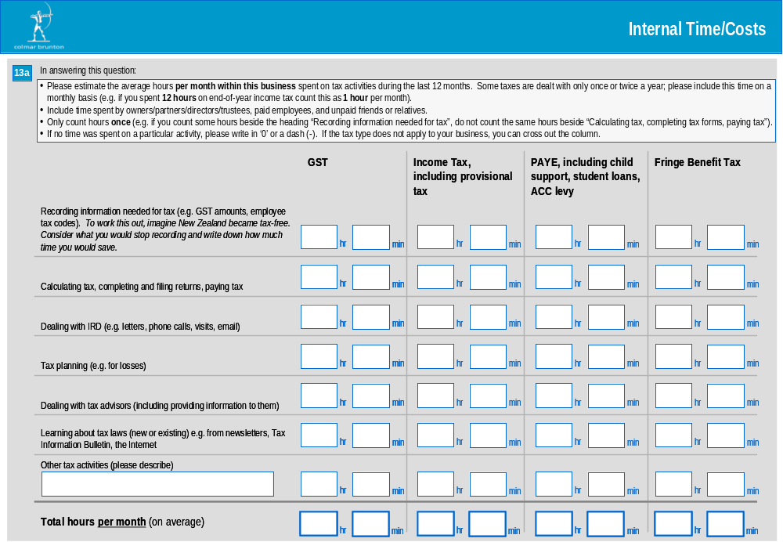

Tables 5.1 and 5.2 detail the amount of time spent on specific tax activities for each tax type. Table 5.1 uses mean values and Table 5.2 uses medians. Sample sizes are shown in brackets.

On average, businesses spend 75.6 hours per year on tax activities. GST accounts for a considerable portion of the time spent on tax activities with GST registrants spending on average 49.3 hours. Income tax and PAYE require similar amounts of time with 29.7 hours and 29.2 hours respectively spent on these tax types (among those who file these tax types).

The medians given in Table 5.2 are notably lower than the means given in Table 5.1. This indicates that the distribution of businesses is skewed towards the bottom end (ie towards zero); a minority of businesses with higher hours is essentially ‘pulling’ the means upward. However, this situation is not as marked as it would have been had we not used ‘trimmed’ means.

The bulk of the time spent on tax activities appears to be spent in recording information, calculating tax, completing and filing returns and paying tax. Recording information is clearly the dominant tax activity in relation to GST and Income tax. This is evident from the tables and is illustrated pictorially in Figure 8.

In interpreting the data, the reader should note the following. As discussed earlier in this report under the chapter entitled ‘Research methodology’, the data verification interviews conducted following the pilot indicated that there was a tendency for some respondents to overstate their time in the first tax activity line in the question (i.e. recording information needed for tax, etc.) because they included activities we intended them to cover in the subsequent lines. On realising they had done this, these respondents tended to leave the subsequent lines blank (if they had included this time in the first line) and enter a total at the bottom. This finding suggests that the totals are more reliable than the individual tax activities. The data verification interviews also suggested there was a degree of overlap between ‘recording information needed for tax’ and ‘dealing with tax advisors’ as it was hard to separate these or break them down time into very small time components (eg 5 minutes).

Table 5.1: Internal time spent on tax activities (annual hours) by tax type – means
 | GST | Income tax (including provisional tax) | PAYE (including child support, student loans, ACC levy) | FBT | All tax types
 | Mean (trimmed) annual number of hours
Recording information | 24.2  (1592) | 12.1  (1587) | 11.6  (1202) | 4.0  (313) | 33.7  (1506)
Calculating tax, completing and filing returns, paying tax | 11.6  (1653) | 5.9  (1579) | 8.4  (1203) | 3.6  (316) | 18.8  (1556
Dealing with IRD | 2.4  (1650 | 1.7  (1607 | 1.9  (1211) | 0.7  (319) | 4.7  (1568)
Tax planning | 1.4  (1664) | 1.9  (1604) | 0.7  (1228) | 0.4  (318) | 3.0  (1568)
Dealing with tax advisors (including providing information to them) | 4.7  (1650) | 6.0  (1593) | 2.6  (1220) | 2.2  (316) | 10.3  (1557)
Learning about tax laws (new or existing) | 2.9  (1645) | 2.1  (1589) | 2.7  (1220) | 2.0  (316) | 5.2  (1542)
Other | 0.3  (1668) | 0.1  (1601) | 0.1  (1229) | 0.0  (316) | 0.4  (1565)
All activities | 49.3  (1593) | 29.7  (1542) | 29.2  (1191) | 14.1  (311) | 75.6  (1479)
Base: All respondents who according to Q1 filed/paid the particular tax type (excluding missing information and outliers)
Source: Long questionnaire Q13a; Short questionnaire Q6a
Sample sizes are shown in brackets

Figure 8: Internal time spent on tax activities (annual hours) by tax type

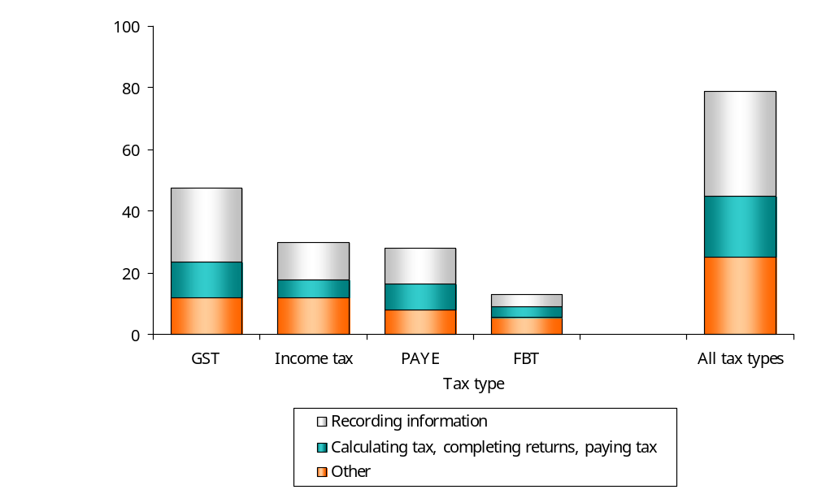

Table 5.2: Internal time spent on tax activities (annual hours) by tax type – medians
 | GST | Income tax (including provisional tax) | PAYE (including child support, student loans, ACC levy) | FBT | All tax types
 | Median number of hours (annual)
Recording information | 12.0  (1668) | 6.0  (1609) | 6.0  (1229) | 2.0  (319) | 13.0  (1907)
Calculating tax, completing and filing returns, paying tax | 6.0  (1667) | 2.0  (1609) | 6.0  (1229) | 2.0  (319) | 6.0  (1907)
Dealing with IRD | 0.0  (1666) | 0.0  (1609) | 0.0  (1228) | 0.0  (319) | 0.0  (1907)
Tax planning | 0.0  (1667) | 0.0  (1608) | 0.0  (1229) | 0.0  (319) | 0.0  (1907)
Dealing with tax advisors (including providing information to them) | 1.0  (1667) | 3.0  (1612) | 0.0  (1229) | 0.0  (319) | 3.0  (1907)
Learning about tax laws (new or existing) | 1.0  (1667) | 0.0  (1610) | 0.6  (1229) | 0.0  (319) | 0.0  (1907)
Other | 0.0  (1668) | 0.0  (1601) | 0.0  (1229) | 0.0  (318) | 0.0  (1907)
All activities | 33.0  (1637) | 18.0  (1578) | 15.0  (1209) | 8.1  (314) | 35.0  (1907)
Base: All respondents who according to Q1 filed/paid the particular tax type (excluding missing information)
Source: Long questionnaire Q13a; Short questionnaire Q6a

Tables 5.3 and 5.4 detail the amount of time spent on specific tax activities by size of business (defined in terms of number of employees).

There is a strong correlation between business size and the number of hours a business spends on tax activities per year. This pattern is also evident within each of the tax activities (with the exception of ‘other’ tax activities).

Table 5.3: Internal time spent on tax activities (annual hours) by business size - means
Tax activity | Business size (number of employees) |  |  |  | All
Tax activity | Nil employees | Micro (1-5) | Small (6-19) | Medium (20+) | All
 | Mean (trimmed) annual number of hours
Recording information | 24.2  (716) | 46.8  (738) | 57.4  (265) | 74.3  (102) | 33.7  (1831)
Calculating tax, completing and filing returns, paying tax | 12.7  (720) | 25.9  (759) | 36.1  (285) | 48.1  (113) | 18.8  (1887)
Dealing with IRD | 2.8  (723) | 6.3  (766) | 9.0  (289) | 22.1  (113) | 4.7  (1901)
Tax planning | 1.9  (721) | 4.7  (766) | 4.4  (289) | 9.9  (116) | 3.0  (1902)
Dealing with tax advisors (including providing information to them) | 7.4  (721) | 13.8  (768) | 17.5  (289) | 24.9  (113) | 10.3  (1887)
Learning about tax laws (new or existing) | 3.3  (719) | 7.4  (755) | 10.4  (281) | 16.7  (109) | 5.2  (1874)
Other | 0.2  (724) | 0.8  (767) | 0.4  (290) | 0.2  (116) | 0.4  (1907)
All activities | 51.9  (716) | 105.7  (745) | 144.3  (273) | 181.9  (102) | 75.6  (1846)
Base: All respondents excluding missing information and outliers
Source: Long questionnaire Q13a, Q4; Short questionnaire Q6a

Table 5.4: Internal time spent on tax activities (annual hours) by business size - medians
Tax activity | Business size (number of employees) |  |  |  | All
Tax activity | Nil employees | Micro (1-5) | Small (6-19) | Medium (20+) | All
 | Median number of hours (annual)
Recording information | 12.0  (699) | 28.0  (738) | 40.4  (281) | 72.0  (110) | 16.0  (1836)
Calculating tax, completing and filing returns, paying tax | 6.0  (698) | 12.0  (738) | 22.2  (281) | 40.9  (110) | 6.0  (1835)
Dealing with IRD | 0.0  (698) | 0.0  (738) | 0.2  (281) | 8.6  (110) | 0.0  (1835)
Tax planning | 0.0  (698) | 0.0  (738) | 0.0  (281) | 0.0  (110) | 0.0  (1835)
Dealing with tax advisors (including providing information to them) | 2.0  (700) | 6.0  (738) | 10.0  (281) | 23.5  (110) | 3.1  (1837)
Learning about tax laws (new or existing) | 0.0  (699) | 2.0  (738) | 6.0  (281) | 12.0  (110) | 0.0  (1835)
Other | 0.0  (699) | 0.0  (738) | 0.0  (281) | 0.0  (110) | 0.0  (1836)
All activities | 27.0  (702) | 61.0  (738) | 95.0  (281) | 160.0  (110) | 36.0  (1839)
Base: All respondents excluding missing information
Source: Long questionnaire Q13a, Q4; Short questionnaire Q6a

Figure 9 details the mean amount of time spent on all tax activities by size of business (defined in terms of number of employees). Table 5.5 breaks this information down by tax type.

The time spent on tax activities associated with each of the specific tax types tends to increase as business size increases. However, the differences between some business size groupings are not significantly different. For example between those with no employees and micro-sized businesses in relation to income tax, and between small and medium-sized businesses in relation to FBT.

Figure 9: Time spent on all tax activities for each tax type by business size
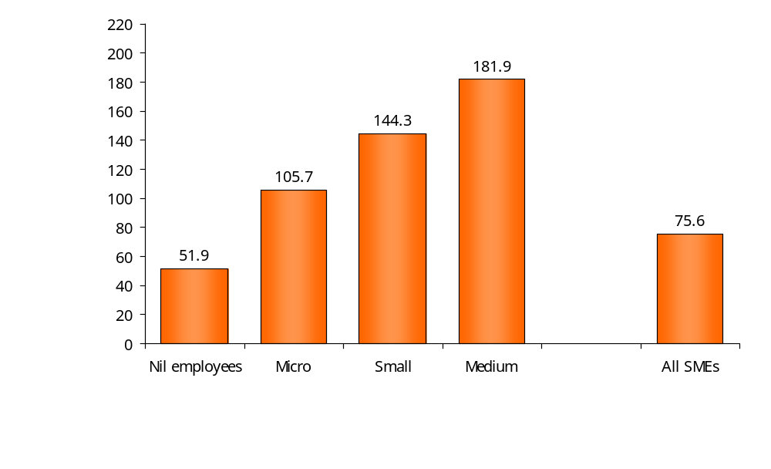

Table 5.5: Time spent on all tax activities for each tax type by business size
Tax type | Business size (number of employees) |  |  |  | All
Tax type | Nil employees | Micro (1-5) | Small (6-19) | Medium (20+) | All
 | Mean (trimmed) annual number of hours
GST | 38.4  (531) | 58.5  (688) | 67.4  (263) | 89.0  (103) | 49.3  (1593)
Income tax (including provisional tax) | 26.8  (602) | 31.4  (598) | 40.5  (234) | 61.6  (101) | 29.7  (1542)
PAYE (including child support, student loans, ACC levy) | 13.1  (170) | 26.7  (646) | 49.5  (266) | 65.9  (103) | 29.2  (1191)
FBT | 8.2  (40) | 13.2  (97) | 17.9  (107) | 18.8  (67) | 14.1  (311)
All tax types | 51.9  (716) | 105.7  (745) | 144.3  (273) | 181.9  (102) | 75.6  (1846)
Base: All respondents who file the tax type indicated at Q1 excluding missing information and outliers
Source: Long questionnaire Q1, Q4, Q13a; Short questionnaire Q6a
*Respondents were asked how many employees they had at the end of ‘last month’. Thus, respondents in the ‘nil employees’ category can be regarded as not currently employing staff, but having done so in the last 12 months (as they indicated at
Question 1 that they had paid/filed PAYE in the last 12 months).

Internal time spent on tax activities by specific types of personnel
Similarly, for each tax type, respondents were asked to estimate how many hours per month different types of people (eg owners, paid employees, unpaid friends or relatives) spent on tax activities during the last 12 months. Again, this data has been converted into annual figures.

Table 5.6, Figure 10, and Table 5.7 detail the amount of time that different types of personnel spend on tax activities in relation to each tax type. Table 5.6 and Figure 10 use mean values and Table 5.7 uses medians.

Ideally the amount of time spent by all personnel (as specified in the following tables) should match the amount of time spent on all tax activities (as specified in the previous tables). Whilst these figures are very close, they do not match exactly because two different questions were used to produce these two sets of data. Check questions and telephone call backs were successfully employed to avoid any major discrepancy.

Using the data from this question (Q13b), businesses spend an average of 76.7 hours per year on tax activities (across all personnel categories). This compares to 75.6 hours reported earlier in response to Q13a (which asked the respondent to record time by tax activity). Q13b has been used for the bulk of the analysis in this report – including the calculation of compliance costs – for two reasons. First, it enables us to place values on the time of different personnel categories (this is explained in detail in the section entitled ‘Value of Time’). And second, Q13b is possibly less prone to double-counting.

The data in the tables below indicate that owners/partners/directors/trustees spend the most time on tax activities (on average 56.3 hours per year) ahead of paid employees (18.4 hours) and unpaid friends or relatives (3.4 hours). This pattern is evident across all tax types with the exception of FBT. (However, as shown in Tables 5.8 and 5.9, this pattern does not hold across all business size groupings.)

Again, the median measures are notably lower than the means. The median measures for the time that paid employees, and unpaid friends or relatives, spend on tax activities is zero. This indicates that for the majority of businesses, no time is spent on tax activities by these types of personnel (either because these businesses do not have these types of personnel or if they do they do not spend time on tax activities).

Table 5.6: Internal time spent by personnel on all tax activities (annual hours) by tax type - means
Personnel | GST | Income tax (including provisional tax) | PAYE (including child support, student loans, ACC levy) | FBT | All tax types
 | Mean (trimmed) annual number of hours
Owners/partners/directors/trustees | 33.8  (1599) | 23.1  (1564) | 15.8  (1178) | 6.8  (308) | 56.3  (1494)
Paid employees | 11.1  (1619) | 3.6  (1566) | 8.8  (1186) | 6.4  (310) | 18.4  (1518)
Unpaid friends or relatives | 2.2  (1623) | 1.0  (1572) | 0.8  (1198) | 0.0  (309) | 3.4  (1517)
All personnel | 44.2  (1521) | 29.4  (1509) | 27.5  (1157) | 12.8  (316) | 76.7  (1714)
Base: All respondents who according to Q1 filed the particular tax type (excluding missing information and outliers)
Source: Long questionnaire Q13b; Short questionnaire Q6b, Q6c

Figure 10: Internal time spent on all tax activities (annual hours) by tax type - means
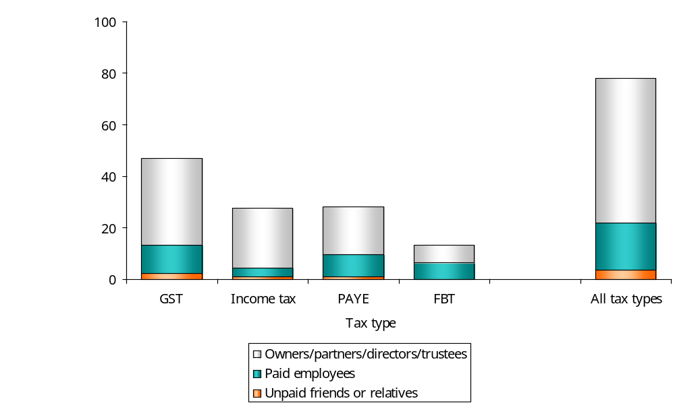

Table 5.7: Internal time spent by personnel on all tax activities (annual hours) by tax type - medians
Personnel | GST | Income tax (including provisional tax) | PAYE (including child support, student loans, ACC levy) | FBT | All tax types
 | Median number of hours (annual)
Owners/partners/directors/trustees | 24.0  (1627) | 12.0  (1585) | 8.0  (1201) | 3.0  (311) | 30.7  (1517)
Paid employees | 0.0  (1623) | 0.0  (1582) | 0.0  (1198) | 0.0  (311) | 0.0  (1521)
Unpaid friends or relatives | 0.0  (1626) | 0.0  (1582) | 0.0  (1199) | 0.0  (311) | 0.0  (1520)
All personnel | 30.0  (1569) | 18.0  (1536) | 14.0  (1174) | 8.0  (320) | 45.0  (1755)
Base: All respondents who according to Q1 filed the particular tax type (excluding missing information)
Source: Long questionnaire Q13b; Short questionnaire Q6b, Q6c

Figure 11, Table 5.8, and Table 5.9 detail the amount of time that different types of personnel spend on tax activities over all tax types by size of business (defined in terms of number of employees).

Larger businesses are clearly more reliant on paid employees to undertake tax work with these personnel carrying out most of this type of work (88%) in medium-sized SMEs, compared to 42% of tax work carried out by paid employees in small SMEs, and 30% in Micro.

Figure 11: Internal time spent by personnel by tax type - means

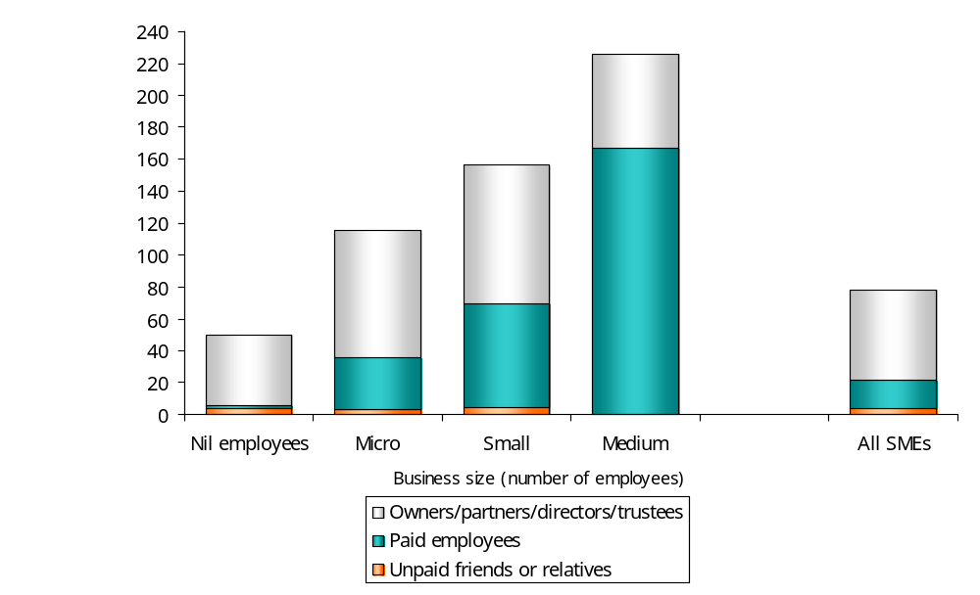

Table 5.8: Internal time spent by all personnel on all tax activities (annual hours) by business size (number of employees) - means
Personnel | Business size (number of employees)
Personnel | Nil employees | Micro (1-5) | Small (6-19) | Medium (20+) | All
 | Mean (trimmed) annual number of hours
Owners/partners/directors/trustees | 44.2  (591) | 79.9  (568) | 86.9  (235) | 59.4  (98) | 56.3  (1494)
Paid employees | 2.2  (599) | 32.9  (579) | 65.0  (239) | 166.7  (98) | 18.4  (1518)
Unpaid friends or relatives | 3.6  (595) | 3.0  (578) | 4.3  (241) | 0.0  (100) | 3.4  (1517)
All personnel | 51.3  (674) | 108.0  (688) | 156.7  (251) | 204.5  (94) | 76.7  (1714)
Base: All respondents (excluding missing information and outliers)
Source: Long questionnaire Q4, Q13b; Short questionnaire Q6b, Q6c

Table 5.9: Internal time spent by all personnel on all tax activities (annual hours) by business size (number of employees) - medians
Personnel | Business size (number of employees)
Personnel | Nil employees | Micro (1-5) | Small (6-19) | Medium (20+) | All
 | Median number of hours (annual)
Owners/partners/directors/trustees | 26.0  (724) | 50.0  (767) | 41.1  (290) | 24.0  (116) | 32.0  (1907)
Paid employees | 0.0  (724) | 0.0  (767) | 18.0  (290) | 84.0  (116) | 0.0  (1907)
Unpaid friends or relatives | 0.0  (724) | 0.0  (767) | 0.0  (290) | 0.0  (116) | 0.0  (1907)
All personnel | 30.0  (720) | 67.4  (764) | 109.1  (289) | 174.4  (116) | 42.0  (1898)
Base: All respondents (excluding missing information)
Source: Long questionnaire Q4, Q13b; Short questionnaire Q6b, Q6c

Internal time spent dealing with child support and student loans
Table 5.10 assesses the amount of time that employers in different business size groupings spend dealing with activities associated with child support payments and student loan payments.

11% of employers employ staff paying child support. On average, these employers spend 0.5 hours per year dealing with PAYE issues related to child support. This equates to 1.2% of the time they spend on PAYE in total.

20% of employers employ staff making student loan payments. On average, these employers spend 0.5 hours per year dealing with PAYE issues related to student loans. This equates to 1.3% of the time they spend on PAYE in total.

Due to small sample sizes, care should be taken in interpreting the results by business size. However, the data shows that more larger businesses employ staff paying child support and student loans. Among businesses that employ these types of staff, the amount of time spent on child support and student loan issues does not appear to differ according to business size (defined in terms of the total number of employees a business has).

Table 5.10: Internal time spent (annual hours) dealing with child support and student loans by business size (number of employees)
 | Business size (number of employees) |  |  |  | All
 | Nil employees± | Micro (1-5) | Small (6-19) | Medium (20+) | All
PAYE  Mean (trimmed) number of hours that those who employ staff paying child support spent on PAYE (including child support, student loans, ACC levy)** | 0.0  (1) | 44.6  (38) | 53.9  (81) | 48.5  (62) | 49.5  (182)
Mean (trimmed) number of hours that those who employ staff paying student loans spent on PAYE (including child support, student loans, ACC levy)*** | 10.6  (9) | 32.9  (101) | 48.1  (118) | 55.2  (86) | 42.7  (315)
Child support
% who employ staff paying child support* | 1%  (5 of 192)^ | 5%  (43 of 720)^ | 29%  (89 of 290)^ | 60%  (73 of 115)^ | 11%  (210 of 1325)^
Mean (trimmed) number of hours spent dealing with child support** | 1.0  (4) | 0.5  (37) | 0.5  (73) | 0.5  (57) | 0.5  (171)
% of PAYE related time spent on child  support** | -  (-) | 1.3%  (33) | 1.1%  (64) | 1.2%  (48) | 1.2%  (145)
Student loans
% who employ staff paying student loans* | 3%  (12 of 192)^ | 13%  (114 of 720)^ | 46%  (137 of 290)^ | 79%  (97 of 116)^ | 20%  (362 of 1325)^
Mean (trimmed) number of hours spent dealing with student loans*** | 0.2  (10) | 0.4  (105) | 0.4  (120) | 0.5  (86) | 0.5  (322)
% of PAYE related time spent on  student loans*** | 2.6%  (7) | 1.7%  (91) | 0.9%  (105) | 1.1%  (73) | 1.3%  (277)
Base: *All who indicated they file PAYE at Q1; **All those who indicated they employ staff paying child support at Q15; ***All those who indicated they employ staff paying student loans at Q16

Source: Long questionnaire Q4, Q13b, Q15 and Q16
^The numbers in brackets use unweighted data (ie the actual number of respondents) whereas the % is a weighted value.
±Note: Respondents were asked how many employees they had at the end of ‘last month’. Thus, respondents in the ‘nil employees’ category can be regarded as not currently employing staff, but having done so in the last 12 months (as they indicated at Question 1 that they had paid/filed PAYE in the last 12 months).

A similar analysis to that presented in the previous table is shown below, but with an assessment made by PAYE filing method.

The results suggest that those who file electronically are more likely to employ staff that pay child support and student loans. However, this is likely to be a function of business size (as supported by the sample profile tables earlier in the report).

There is no significant difference in the amount of time spent on child support issues or student loan issues between those who file electronically and those who file manually.

Table 5.11: Internal time spent (annual hours) dealing with child support and student loans by filing method
 | Filing method |  | All
 | Electronic | Manual | All
PAYE  Mean (trimmed) number of hours that those who employ staff paying child support spent on PAYE (including child support, student loans, ACC levy)** | 51.4  (75) | 51.9  (97) | 49.5  (182)
Mean (trimmed) number of hours that those who employ staff paying student loans spent on PAYE (including child support, student loans, ACC levy)*** | 47.0  (115) | 40.6  (191) | 42.7  (315)
Child support
% who employ staff paying child support* | 35%  (89 of 208)^ | 9%  (108 of 990)^ | 11%  (210 of 1325)^
Mean (trimmed) number of hours spent dealing with child support** | 0.4  (70) | 0.5  (92) | 0.5  (171)
% of PAYE related time spent on child support** | 1.1%  (58) | 1.3%  (80) | 1.2%  (145)
Student loans
% who employ staff paying student loans* | 54%  (31 of 208)^ | 19%  (219 of 990)^ | 20%  (362 of 1325)^
Mean (trimmed) number of hours spent dealing with student loans*** | 0.4  (113) | 0.4  (197) | 0.5  (322)
% of PAYE related time spent on student loans*** | 0.8%  (97) | 1.5%  (171) | 1.3%  (277)
Base: *All who indicated they file PAYE at Q1; **All those who indicated they employ staff paying child support at Q15; ***All those who indicated they employ staff paying student loans at Q16

Source: Long questionnaire Q13b, Q15 and Q16; IRD database information used for filing method
^The numbers in brackets use unweighted data (ie the actual number of respondents) whereas the % is a weighted value.

Internal time spent on particular income tax-related activities
Respondents were asked to indicate how many hours their business had spent (internally) on the three income tax-related activities listed in the following table.

Tables 5.12 and 5.13 present this data by business size using means and medians respectively.

On average, around two hours per year is spent on each of these activities. Time spent on tax activities for depreciation, and adjustments for fixed assets/valuing stock is higher among median SMEs (12.0 hours).

Table 5.12: Internal time spent (annual hours) on particular income tax-related activities by business size (number of employees) – means
Tax activity | Business size (number of employees) |  |  |  | All
 | Nil employees | Micro (1-5) | Small (6-19) | Medium (20+) | All
 | Mean (trimmed) annual number of hours
Calculating provisional tax and deciding which provisional tax option to choose | 1.2  (538) | 1.9  (721) | 1.6  (272) | 1.5  (113) | 1.5  (1653)
Tax activities for depreciation and adjustments for fixed assets, valuing stock | 1.2  (503) | 1.9  (695) | 3.7  (264) | 12.0  (111) | 2.1  (1582)
Other end-of-year adjustments | 1.2  (493) | 1.5  (679) | 2.3  (261) | 3.2  (109) | 1.5  (1551)
Mean hours for income tax | 26.3  (590) | 31.9  (587) | 39.3  (229) | 57.2  (97) | 29.4  (1509)
Base: All respondents (those who ticked ‘none’ have been included as zero)
Source: Long questionnaire Q4 and Q17; Short questionnaire Q8

Table 5.13: Internal time spent (annual hours) on particular income tax-related activities by business size (number of employees) – medians
Tax activity | Business size (number of employees) |  |  |  | All
 | Nil employees | Micro (1-5) | Small (6-19) | Medium (20+) | All
 | Median number of hours (annual)
Calculating provisional tax and deciding which provisional tax option to choose | 0.0  (1207) | 0.0  (536) | 0.0  (128) | 0.0  (49) | 0.0  (1928)
Tax activities for depreciation and adjustments for fixed assets, valuing stock | 0.0  (1207) | 0.0  (536) | 0.0  (128) | 1.6  (49) | 0.0  (1928)
Other end-of-year adjustments | 0.0  (1207) | 0.0  (536) | 0.0  (128) | 1.8  (49) | 0.0  (1928)
Median hours for income tax | 13  (699) | 12  (749) | 20.7  (282) | 36.9  (115) | 14  (1854)
Base: All respondents (those who ticked ‘none’ have been included as zero)
Source: Long questionnaire Q4 and Q17; Short questionnaire Q8

Tables 5.14 and 5.15 present similar tables (using trimmed mean values) by age of business and provisional tax option. No marked differences are evident except for income tax.

Table 5.14: Internal time spent (annual hours) on particular income tax-related activities by age of business

Tax activity | Age of business |  |  |  |  | All
 | Less than 12 months | 1-2 years | 3-5 years | 6-10 years | 10 years +
 | Mean (trimmed) annual number of hours
Calculating provisional tax and deciding which provisional tax option to choose | 0.5  (46) | 0.5  (196) | 0.4  (351) | 0.4  (336) | 0.3  (929) | 0.4  (1890)
Tax activities for depreciation and adjustments for fixed assets, valuing stock | 0.6  (46) | 0.5  (199) | 0.6  (350) | 0.6  (335) | 0.5  (912) | 0.5  (1873)
Other end-of-year adjustments | 0.5  (46) | 0.6  (199) | 0.7  (352) | 0.7  (337) | 0.5  (929) | 0.6  (1895)
Mean hours for income tax | 36.4  (30) | 33.5  (152) | 29.2  (286) | 28.5  (273) | 28.6  (748) | 29.4  (1509)
Base: All respondents (those who ticked ‘none’ have been included as zero)
Source: Long questionnaire Q17, Q22; Short questionnaire Q8, Q9, Q13

Table 5.15: Internal time spent (annual hours) on particular income tax-related activities by provisional tax options
Tax activity | Provisional tax options |  | All
Tax activity | Estimated | Safe harbour | All
 | Mean (trimmed) annual number of hours
Calculating provisional tax and deciding which provisional tax option to choose | 0.5  (132) | 0.3  (746) | 0.4  (1888)
Tax activities for depreciation and adjustments for fixed assets, valuing stock | 0.6  (126) | 0.4  (744) | 0.5  (1871)
Other end-of-year adjustments | 0.7  (130) | 0.4  (750) | 0.6  (1893)
Mean hours for income tax | 41.3  (117) | 28.1  (596) | 26.0  (1878)
Base: All respondents (those who ticked ‘none’ have been included as zero)
Source: Long questionnaire Q17, Q13b; Short Q6b, Q8, Q9; IRD database information on provisional tax options.

Internal time spent on tax-related activities required for entertainment expenses
Respondents were asked whether their business spent time during the last 12 months dealing with the 50% deductibility and GST adjustment required for some entertainment expenses and, if so, how much time was spent.

Seventeen percent of all SMEs have dealt with these types of adjustments in the last 12 months. This figure rises markedly with business size with around half of medium-sized businesses having spent time on these types of adjustments.

The mean number of hours spent per year on these adjustments is low across all business size groupings with businesses that make these types of adjustments spending around two hours per year.

Table 5.16: Internal time spent (annual hours) on tax-related activities required for entertainment expenses
 | Business size (number of employees) |  |  |  | All
 | Nil employees | Micro (1-5) | Small (6-19) | Medium (20+) | All
% who made these types of adjustments (based on all SMEs) | 13%  (93 of 724)* | 21%  (177 of 767)* | 27%  (89 of 290)* | 53%  (57 of 116)* | 17%  (418 of 1907)*
 | Mean (trimmed) annual number of hours
Mean number of hours spent per year on GST adjustments & 50% deductibility required for entertainment expenses (based on All SMEs) | 0.2  (723) | 0.5  (764) | 0.6  (286) | 1.3  (112) | 0.3  (1895)
Mean number of hours spent per year on GST adjustments & 50% deductibility required for entertainment expenses (based on only those SMEs that made these type of adjustments) | 1.9  (87) | 2.2  (170) | 2.4  (83) | 2.8  (50) | 2.1  (391)
Base: Varies - see explanation in table
Source: Long questionnaire Q4, Q18; Short questionnaire Q9
*The numbers in brackets use unweighted data (ie the actual number of respondents) whereas the % is a weighted value.
Value of time analysis

The task of converting time into a monetary value relies on the robust estimation of the value of time, that is, the time spent by:
- owners/partners/directors/trustees
- paid employees
- unpaid friends or relatives' time.

A number of options were considered as follows:
- Basing the value of time on the survey responses, ie using ‘reported values’ (Question 7 in the ‘short’ questionnaire and Question 14 in the ‘long’ questionnaire).
- Using official statistics.
- New Zealand’s Department of Statistics publishes quarterly average hourly rate figures from the NZ Income Survey. It is possible to obtain these rates by both main job occupation or by business nature or sector.
- New Zealand’s Department of Statistics undertakes the Quarterly Employment Survey (QES) which is designed to measure quarterly estimates of change and levels of average hourly and weekly (pre-tax) earnings, average weekly paid hours, and the number of filled jobs.
- MED produce a table under ‘SMEs in New Zealand: Structure and Dynamics’ which allows a rough estimate (based on 1,920 hours worked per year – 48 weeks /yr , 40 hr /wk). Statistics in this section are drawn from the Annual Enterprise Survey conducted by Statistics New Zealand.
- Imputing a value. The wage rates for self-employed business taxpayers can be imputed either by:
- asking business taxpayers the minimum wage that would induce them to supply an extra hour of their labour time (the ‘reservation’ wage rate); or
- the wage rates of people who have comparable human capital to those business taxpayers, for example using external recruitment sources – Hayes Salary Survey 2004 (this is somewhat arbitrary but practical).

Following an in-depth investigation of each of these options, Inland Revenue made a number of recommendations. These recommendations, and the supporting evidence which led to these recommendations, are detailed in a paper prepared by Inland Revenue ‘Measuring the Compliance Costs of Small and Medium Businesses: Value of time – Estimating an appropriate value’. In summary, the recommendations are as follows.

The recommendation was made that we can assume that there is no difference in time values between respondents of the ‘short’ income tax only questionnaire and those who completed the ‘long’ multiple tax type questionnaire – that they are ‘equivalent’ small and medium businesses. In drawing this assumption, we escape some of the problems encountered in previous research by not having to differentiate between individuals, sole traders and conventional business structures. We can focus on differences in business size and the role of the person whether it is as an owner/manager or paid employee or unpaid friend/relative.

No real gains can be made by introducing the added complexity of value of time across sector type.

The ATAX scoping report supported the use of trimmed means for respondent data (which are on average 9% higher than the trimmed medians in our case) over medians. In comparing values we used the trimmed means.

Owners/partners/directors/trustees
For paid employees, hourly wage rates provide a convenient estimate of opportunity cost. With business owners/directors, selecting a value to apply is less objective and has more difficulties to valuing time spent on personal tax affairs (because owners may do the tax compliance work in what would otherwise be leisure time).

Table 5.17: Value of time data relating to owners
 |  |  | Hayes Personnel Services: Salary Survey 2004
 | Respondent Data | NZ Stats  (NZIS Jun 04) | Finance Manager | Site Manager (Construction) | GM Sales & Marketing | Retail Centre Manager
Nil employees | $45.09 | -
Micro (1-5) | $41.93 | - | $41.67
Small (6-19) | $39.09 | - | $46.88
Medium (20+) | $50.98 | -
Total | $43.99 | $25.76^ |  | $36.46 | $93.75* | $26.04 - $52.08
^Based on Main Job Occupations: (Note: reports only on incomes received from wage and salary jobs.)
- Legislators, Administrators & Managers
- Professionals
*Based on larger, higher turnover enterprises than generally the target of this research.

Again, given that the variation across business size is not too large, one figure has been used to value time for owners/partners/directors/trustees. A decision to use respondent data as the best estimate was made as it compares favourably with comparisons to data from the Hayes salary survey, and other research.

The value of time figure for owners/partners/directors/trustees was $43.99.

Paid employees
In line with other research, a recommendation was made to value the time of paid employees based on external data. The close alignment between respondent data and Statistics New Zealand data supports this decision (see table below).

Table 5.18: Value of time data relating to paid employees
 | Respondent Data | NZ Stats  (QES Sep 04) | NZ Stats  (NZIS Jun 04)
Nil employees | $25.52 | - | -
Micro (1-5) | $ 23.01 | $20.37 | -
Small (6-19) | $21.87 | $19.61 | -
Medium (20+) | $25.75 | $20.35 | -
Total | $23.39 | $20.31 * | $18.25 **
*Average total hourly earnings (private sector) from Quarterly Employment Survey Sept 04’
** Average hourly rate from the New Zealand Income Survey June 2004 quarter

Given the small variation across business size, the decision to use one figure for all business size groupings was made.

The value of time figure used for paid employees was $20.31.

Unpaid friends or relatives
Most interesting, and probably hardest to estimate, is the value of unpaid friends or relatives. This is because they have no real market wage rate. Also, about one-third of survey respondents indicated that an approximate value for this time was $0. The difficulty with this is that it is not clear whether the helper’s time really has no value or the result of the respondent misunderstanding the point of the question.

Table 5.19: Value of time data relating to unpaid friends or relatives
 |  | Hayes Personnel Services: Salary Survey 2004
 | Respondent Data* | Payroll Clerk | Teller | General Accounts Clerk
Nil employees | $27.40
Micro (1-5) | $21.70
Small (6-19) | $19.50
Medium (20+) | -
Total | $25.70 | $18.23 | $17.18 | $18.23
*Respondents reporting $0 were not included in the mean calculations.

Again, given the variation across business size is relatively small, the decision was made to use one figure to value time for unpaid friends or relatives. A decision was made to use respondent data as the best estimate. While slightly higher than comparisons to data from the Hayes salary survey and other research, IRD did not want to underestimate compliance costs.

The value of time figure for unpaid friends or relatives is $25.70.

Value of time analysis summary
The following dollar amounts were used to convert time into compliance costs:
- $43.99 (owners/partners/directors/trustees)
- $20.31 (paid employees)
- $25.70 (unpaid friends or relatives).

Income tax

This section reports on the internal tax compliance costs associated with income tax.

Table 5.20 provides a summary of the internal compliance costs of income tax. The first column of figures summarises the internal time that various categories of personnel spent on income tax.

The second column of figures gives the estimated compliance costs of income tax (time multiplied by $).

And the last column expresses the compliance costs associated with a particular category of personnel as a percentage of the compliance cost associated with all personnel.

On average, businesses spend 29.4 hours per year on tax activities associated with income tax. This equates to $1224. The vast majority of this cost is the result of time spent by owners/partners/directors /trustees.

Table 5.20: Summary of internal income tax compliance costs
Personnel | Mean (trimmed) time – an annual hours | Mean (trimmed) compliance cost – annual $ | Mean compliance cost expressed as a % of mean compliance cost of all personnel
 | Hours | $ | %*
Owners/partners/directors/trustees | 23.1  (1564) | $1103  (1569) | 90.1%
Paid employees | 3.6  (1566) | $75  (1567) | 6.1%
Unpaid friends or relatives | 1.0  (1572) | $36  (1578) | 2.9%
All personnel | 29.4  (1509) | $1224  (1521) | 100.0%
Base: All respondents who file/pay income tax (Q1 in long questionnaire) and all respondents of short questionnaire (excluding missing information and outliers)
Source: Long questionnaire Q13b, and Q14; Short questionnaire Q6a, Q6b, Q6c, Q7
*The percentages in this column do not add to 100% because the mean compliance costs each have slightly different bases due to the process of trimming outliers.

Tables 5.21 and 5.22 respectively show the internal time and costs spent on income tax analysed by business size (number of employees) and distinguishing the different categories of personnel.

Table 5.21: Internal time spent (annual hours) by personnel on income tax by business size (number of employees)
Personnel | Business size (number of employees) |  |  |  | All
Personnel | Nil employees | Micro (1-5) | Small (6-19) | Medium (20+) | All
 | Mean (trimmed) annual number of hours
Owners/partners/directors/trustees | 23.0  (604) | 22.2  (608) | 24.2  (642) | 31.1  (104) | 23.1  (1564)
Paid employees | 0.8  (612) | 5.8  (611) | 12.0  (239) | 28.3  (98) | 3.6  (1566)
Unpaid friends or relatives | 1.3  (606) | 0.6  (611) | 0.5  (245) | 0.0  (104) | 1.0  (1572)
All personnel | 26.3  (590) | 31.9  (587) | 39.3  (229) | 57.2  (97) | 29.4  (1509)
Base: All respondents who file/pay income tax (Q1 in long questionnaire) and all respondents of short questionnaire (excluding missing information and outliers)
Source: Long questionnaire Q4 and Q13b; Short questionnaire Q6a, Q6b, and Q6c

Income tax compliance costs rise with business size. This is largely the result of the time spent on tax activities by paid employees.

Note there is very little difference in the income tax related costs between SMEs employing nil employees and micro SMEs. Costs incurred by owners are reasonably constant across business size with the exception of medium SMEs.

Table 5.22: Mean internal compliance costs of income tax by business size (number of employees)
Personnel | Business size (number of employees) |  |  |  | All
Personnel | Nil employees | Micro (1-5) | Small (6-19) | Medium (20+) | All
 | Mean (trimmed) annual compliance costs
Owners/partners/directors/trustees | $1,097  (606) | $1,087  (611) | $1,097  (242) | $1,409  (104) | $1,103  (1569)
Paid employees | $17  (612) | $128  (612) | $248  (239) | $574  (98) | $75  (1567)
Unpaid friends or relatives | $44  (609) | $22  (613) | $32  (246) | $0  (104) | $36  (1578)
All personnel | $1,146  (591) | $1,298  (590) | $1,462  (234) | $1,896  (100) | $1,224  (1521)
Base: All respondents who file/pay income tax (Q1 in long questionnaire) and all respondents of short questionnaire (excluding missing information and outliers)
Source: Long questionnaire Q4, Q13b and Q14; Short questionnaire Q6a, Q6b, Q6c and Q7

Table 5.23 shows the internal compliance costs of income tax analysed by whether or not a business uses a tax advisor for income tax purposes. Table 5.24 provides a breakdown by business size. Compliance costs between those who do and do not use a tax advisor are the same overall. However, those who use a tax advisor appear more reliant on, and those who don’t use a tax advisor appear less reliant on, paid employees. In interpreting these results, the reader should bear in mind that those who do not use tax advisors are more likely to be smaller businesses; 80% of those who do not use a tax advisor for income tax have no employees compared to only 51% of those who use a tax advisor for income tax.

Table 5.23: Mean internal compliance costs of income tax by use of a tax advisor for income tax
Personnel | Whether business uses a tax advisor for income tax |  | All
Personnel | Use tax advisor | Do not use tax advisor | All
 | Mean compliance costs in dollars (annual)
Owners/partners/directors/trustees | $1,054  (1141) | $1,063  (278) | $1,103  (1569)
Paid employees | $107  (1135) | $49  (279) | $75  (1567)
Unpaid friends or relatives | $32  (1146) | $37  (282) | $36  (1578)
All personnel | $1,202  (1103) | $1,202  (272) | $1,224  (1521)
Base: All respondents who file/pay income tax (Q1 in long questionnaire) and all respondents of short questionnaire (excluding missing information and outliers)
Source: Long questionnaire Q10a, 10b (income tax), Q13b and Q14; Short questionnaire Q4, Q6a, Q6b, Q6c and Q7

Table 5.24 Mean internal compliance costs of income tax by business size (number of employees) and whether business uses tax advisor for income tax
Use of tax advisor | Business size (number of employees) |  |  |  | All
Use of tax advisor | Nil employees | Micro (1-5) | Small (6-19) | Medium (20+) | All
 | Mean (trimmed) annual compliance costs
Use tax advisor for income tax | $1,027  (349) | $1,297  (486) | $1,587  (185) | $1,827  (81) | $1,202  (1103)
Don’t use tax advisor for income tax | $1,163  (121) | $1,307  (87) | $1,088  (43) | $2,174  (19) | $1,202  (272)
All | $1,146  (591) | $1,298  (590) | $1,462  (234) | $1,896  (100) | $1,224  (1521)
Base: All respondents who file/pay income tax (Q1 in long questionnaire) and all respondents of short questionnaire (excluding missing information and outliers)
Source: Long questionnaire Q4, Q13b and Q14; Short questionnaire Q6a, Q6b, Q6c and Q7

Table 5.25 shows that compliance costs as a proportion of turnover diminish markedly with size.

Table 5.25: Mean internal compliance costs of income tax as a percent of turnover
Turnover | Mean (trimmed) compliance costs | Mean compliance costs as a percent of turnover*
Up to $19,999  (mean in range = $11,013) | $915  (75) | 8.3%
$20,000 – $39,999  (mean in range = $29,461) | $919  (131) | 3.1%
$40,000 – $99,999  (mean in range = $65,508) | $1,007  (257) | 1.5%
$100,000 – $249,999  (mean range = $160,580) | $1,250  (321) | 0.8%
$250,000 – $499,999  (mean in range = $353,613) | $1,708  (248) | 0.5%
$500,000 - $1,299,999  (mean in range = $788,472) | $1,575  (232) | 0.2%
$1.3 million+  (mean in range = $3,672,309) | $1,629  (255) | 0.0%
Base: All respondents who file/pay income tax (Q1 in long questionnaire) and all respondents of short questionnaire (excluding missing information and outliers). *The mean turnover values used to calculate these figures were provided by Inland Revenue.
Source: Long questionnaire Q13b, Q14 and Q20; Short questionnaire Q6a, Q6b, Q6c, Q7 and Q11.

Stress associated with provisional tax compliance
Respondents were asked to indicate how stressful they found meeting requirements for provisional tax, including finding the money. A seven point scale (see Figure 12) was used.

Figure 12: Question 25 – Long questionnaire
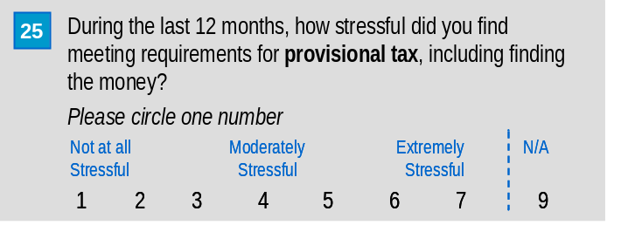

Reported levels of stress associated with provisional tax requirements vary widely. Under half (45%) find provisional tax requirements less than moderately stressful (rating of 1 to 3), around one in five (18%) find them moderately stressful, and just over one-third (36%) find them more than moderately stressful (rating of 5 to 7).

Businesses with no employees find meeting provisional tax requirements notably less stressful. This may be because, unlike employers, they do not face the dilemma of whether to pay staff or IRD first when experiencing cashflow difficulties.

Table 5.26: Stress associated with provisional tax compliance
Level of reported stress | Business size (number of employees) |  |  |  | All
 | Nil employees | Micro (1-5) | Small (6-19) | Medium (20+) | All
 | (596)  % | (668)  % | (251)  % | (105)  % | (1628)  %
1 (not all stressful) | 20 | 12 | 9 | 14 | 17
2 | 14 | 11 | 14 | 8 | 13
3 | 15 | 15 | 14 | 14 | 15
4 (moderately stressful) | 17 | 20 | 18 | 23 | 18
5 | 14 | 14 | 16 | 13 | 14
6 | 10 | 14 | 14 | 19 | 12
7 (extremely stressful) | 8 | 12 | 12 | 9 | 10
Missing information | 2 | 1 | 2 | 1 | 2
Mean score | 3.5 | 4.1 | 4.1 | 4.0 | 3.7
Base: All respondents who file/pay income tax (Q1 in long questionnaire) and all respondents of short questionnaire; excludes those who indicated Q25 was not applicable.
Source: Long questionnaire Q4 and Q25; Short questionnaire Q15

As illustrated in Table 5.27, overall newer businesses tend to report higher levels of stress in meeting provisional tax requirements than more established businesses. However this pattern is not consistent across all business sizes.

Table 5.27: Stress associated with provisional tax compliance – mean scores by business size (number of employees) and age of business
Age of business | Business size (number of employees) |  |  |  | All
 | Nil employees | Micro (1-5) | Small (6-19) | Medium (20+)
 | Mean stress score
Less than 12 months | 4.9  (14) | 3.9  (12) | 3.2  (3) | 6.0  (1) | 4.5  (30)
1-2 years | 3.9  (64) | 3.8  (59) | 4.5  (20) | 4.1  (7) | 3.9  (151)
3-5 years | 3.5  (128) | 4.3  (123) | 4.4  (38) | 4.7  (13) | 3.8  (302)
6-10 years | 3.6  (102) | 4.1  (126) | 3.7  (47) | 4.3  (18) | 3.8  (295)
10 years + | 3.3  (278) | 4.0  (339) | 4.2  (136) | 3.8  (65) | 3.6  (823)
All | 3.5  (596) | 4.1  (668) | 4.1  (251) | 4.0  (105) | 3.7  (1628)
Base: All respondents who file/pay income tax (Q1 in long questionnaire) and all respondents of short questionnaire; excludes those who indicated Q25 was not applicable.
Source: Long questionnaire Q4, Q22 and Q25; Short questionnaire Q13 and Q15

Table 5.28 analyses the mean reported stress levels associated with provisional tax requirements by business size and GST accounting system. The latter was chosen as a variable worth investigating as it was felt to be potentially indicative of the degree to which a business is organised in collating information for tax purposes (including, eventually, income tax).

Perhaps in contrast to initial expectations, the reported stress levels of those with manual systems are lower than those with computerised accounting software (see figures in last column). However, as the data in the table indicates, this pattern only holds for businesses with no employees. Further analysis of the database also shows that businesses with no employees and who use manual accounting systems have markedly lower levels of turnover than businesses with no employees and who use computerised systems. Thus, there is no conclusive evidence that the type of GST accounting system contributes to reported levels of stress associated with provisional tax requirements.

Table 5.28: Stress associated with provisional tax compliance – mean scores by business size (number of employees) and accounting system
Accounting system used for GST | Business size (number of employees) |  |  |  | All
Accounting system used for GST | Nil employees | Micro (1-5) | Small (6-19) | Medium (20+)
 | Mean stress score
Manual/paper-based | 3.6  (214) | 4.2  (219) | 4.1  (45) | 5.3  (6) | 3.8  (486)
Computerised accounting software (in-house) | 4.0  (145) | 4.1  (307) | 4.1  (173) | 4.0  (88) | 4.0  (716)
Other computing used in-house | 4.0  (78) | 4.0  (87) | 3.8  (13) | 4.6  (8) | 4.0  (189)
External | 4.1  (63) | 4.0  (105) | 4.6  (39) | 2.7  (9) | 4.1  (217)
Base: All respondents who file/pay income tax (Q1 in long questionnaire) and all respondents of short questionnaire; excludes those who indicated Q25 was not applicable.
Source: Long questionnaire Q4, Q6 and Q25; Short questionnaire Q15

A question was included in the long questionnaire to ascertain who answered the questions about how stressful tax activities are. The results to this question have been used as an analysis variable in Table 5.29.

In relation to multiple taxpaying businesses, owners/partners, managers, and clerks/IT staff report significantly higher levels of stress associated with meeting provisional tax requirements than internal accountants/lawyers or external tax advisors. Income tax only taxpayers (respondents of the short questionnaire) also report significantly lower levels of stress.

Table 5.29: Stress associated with provisional tax compliance – analysed by who answered the question
Level of reported stress | Person who answered question |  |  |  |  |  |  |  | All
Level of reported stress | Owner/ partner/ director/ trustee | Manager | Internal accountant or lawyer | External accountant or tax advisor | Clerk or IT staff | Unpaid friend or family member | Other (long questionnaire) | Respondent of short questionnaire | All
 | (1196)  % | (144)  % | (78)  % | (50)  % | (106)  % | (33)  % | (3)  % | (132)  % | (1628)  %
1 (not all stressful) | 13 | 16 | 22 | 27 | 9 | 18 | - | 26 | 17
2 | 12 | 7 | 12 | 14 | 15 | 13 | - | 18 | 13
3 | 15 | 18 | 10 | 21 | 19 | 11 | - | 16 | 15
4 (moderately stressful) | 19 | 18 | 30 | 19 | 14 | 26 | 25 | 16 | 18
5 | 16 | 11 | 5 | 9 | 14 | 7 | - | 13 | 14
6 | 15 | 21 | 16 | 1 | 12 | 13 | 38 | 4 | 12
7 (extremely stressful) | 10 | 9 | 4 | 9 | 15 | 13 | 38 | 7 | 10
Missing information | 1 | - | 1 | - | 3 | - | - | * | 2
Mean score | 4.0 | 4.0 | 3.5 | 3.1 | 4.1 | 3.8 | 5.9 | 3.1 | 3.7
Base: All respondents who file/pay income tax (Q1 in long questionnaire) and all respondents of short questionnaire; excludes those who indicated Q25 was not applicable.
Source: Long questionnaire Q25 and Q28; Short questionnaire Q15

GST

This section reports on the internal tax compliance costs associated with GST.

GST-registrants spend on average 44.2 hours per year on tax activities associated with GST. The value of this time equates to $1,852. For all SMEs, most of this can be attributed to time spent by owners/partners/directors/trustees. However, a different pattern emerges for larger businesses (see Table 5.31), where paid employees provide increasing proportions of the labour as business size grows.

Table 5.30: Summary of internal GST compliance costs
Personnel | Mean (trimmed) time – annual hours | Mean (trimmed) compliance cost – annual $ | Mean compliance cost expressed as a % of mean compliance cost of all personnel
 | Hours | $ | %*
Owners/ partners /directors /trustees | 33.8  (1599) | $1,634  (1608) | 88.2%
Paid employees | 11.1  (1619) | $229  (1580) | 12.4%
Unpaid friends or relatives | 2.2  (1623) | $61  (1583) | 3.3%
All personnel | 44.2  (1521) | $1,852  (1546) | 100.0%
Base: All respondents who file GST (Q1) excluding missing information and outliers
Source: Long questionnaire Q13b and Q14
*The percentages in this column do not add to 100% because the mean compliance costs each have slightly different bases due to the process of trimming outliers.

Tables 5.31 and 5.32 display the mean hours and compliance costs of GST associated with different categories of personnel and business size groupings. The proportion of time that paid employees spend on GST increases as business size increases, with paid employees accounting for the bulk of time spent on GST for medium-sized-businesses.

Table 5.31: Internal time spent (annual hours) by personnel on GST analysed by business size (number of employees)
Personnel | Business size (number of employees) |  |  |  | All
Personnel | Nil employees | Micro (1-5) | Small (6-19) | Medium (20+) | All
 | Mean (trimmed) annual number of hours
Owners/partners/directors/trustees | 30.2  (528) | 39.8  (692) | 32.7  (263) | 32.2  (108) | 33.9  (1599)
Paid employees | 1.9  (535) | 15.4  (699) | 28.8  (269) | 71.1  (108) | 11.1  (1619)
Unpaid friends or relatives | 2.5  (534) | 2.2  (702) | 1.9  (270) | 0.0  (109) | 2.2  (1623)
All personnel | 33.7  (509) | 54.0  (655) | 59.9  (251) | 73.0  (98) | 44.2  (1521)
Base: All respondents who file GST (Q1) excluding missing information and outliers
Source: Long questionnaire Q4 and Q13b

Table 5.32: Mean internal compliance costs of GST by business size
Personnel | Business size (number of employees) |  |  |  | All
Personnel | Nil employees | Micro (1-5) | Small (6-19) | Medium (20+) | All
 | Mean (trimmed) annual compliance costs
Owners/partners/directors/trustees | $1,454  (530) | $1,909  (696) | $1,699  (266) | $1,418  (108) | $1,634  (1608)
Paid employees | $40  (517) | $314  (686) | $588  (262) | $1,455  (107) | $229  (1580)
Unpaid friends or relatives | $70  (516) | $56  (688) | $51  (263) | $0  (108) | $61  (1583)
All personnel | $1,496  (510) | $2,244  (665) | $2,285  (257) | $2,369  (106) | $1,852  (1546)
Base: All respondents who file GST (Q1) excluding missing information and outliers
Source: Long questionnaire Q4, Q13b and Q14

Table 5.33 shows that GST compliance costs as a proportion of turnover diminish markedly with business size (defined in terms of turnover).

Table 5.33: Mean internal compliance costs of GST as a proportion of turnover
Turnover | Mean (trimmed) GST-related compliance costs | Mean compliance costs as a percent of turnover*
Up to $19,999  (mean in range = $11,013) | $1,665  (60) | 15.1%
$20,000 – $39,999  (mean in range = $29,461) | $1,447  (98) | 4.9%
$40,000 – $99,999  (mean in range = $65,508) | $1,478  (247) | 2.3%
$100,000 – $249,999  (mean range = $160,580) | $1,795  (359) | 1.1%
$250,000 – $499,999  (mean in range = $353,613) | $2,238  (258) | 0.6%
$500,000 - $1,299,999  (mean in range = $788,472) | $2,502  (252) | 0.3%
$1.3 million+  (mean in range = $3,672,309) | $2,389  (270) | 0.0%
Base: All respondents who file GST (Q1) excluding missing information and outliers. *The mean turnover values used to calculate these figures were provided by Inland Revenue and based on population characteristics.
Source: Long questionnaire Q13b, Q14 and Q21

Table 5.34 looks at the internal time spent on GST by turnover and age of business.

With the exception of new businesses (ie those who have been in business for less than 12 months) which on average spend slightly more time than older businesses, time spent on GST does not vary much by age of business.

Table 5.34: Internal time spent (annual hours) on GST by age of business and business size (turnover)
Turnover | Age of business |  |  |  |  | All
Turnover | Less than 12 months | 1-2 years | 3-5 years | 6-10 years | 10 years + | All
 | Mean (trimmed) annual number of hours
Up to $39,999 | 47.7  (12) | 44.5  (23) | 35.6  (49) | 33.9  (25) | 32.3  (46) | 36.1  (158)
$40,000 to $99,999 | 58.4  (11) | 44.0  (41) | 38.6  (58) | 31.0  (44) | 24.6  (89) | 33.4  (246)
$100,000 to $1,299,999 | 48.7  (14) | 50.6  (88) | 54.1  (149) | 54.3  (151) | 46.1  (445) | 49.5  (858)
$1.3 million + | 86.4  (2) | 54.2  (14) | 79.8  (31) | 70.2  (48) | 62.0  (159) | 66.4  (257)
All | 52.5  (39) | 47.2  (167) | 46.7  (287) | 46.5  (268) | 41.0  (740) | 44.2  (1521)
Base: All respondents who file GST (Q1) excluding missing information and outliers
Source: Long questionnaire Q13b, Q20 and Q22

Accounting system used for GST
Respondents were asked what type of accounting system they use for GST. The results by business size are shown in Table 5.35. Forty percent of businesses use some type of manual system for their GST. This is markedly more common the smaller the business. A similar proportion (38%) uses computerised in-house accounting software. Likewise, the use of computerised accounting software increases as business size increases. A further 15% use some other type of computer system. And 14% rely on an external tax advisor for their GST.

Table 5.35: Accounting system used for GST by business size (number of employees)
Accounting system | Business size (number of employees) |  |  |  | All
Accounting system | Nil employees | Micro  (1-5) | Small  (6-19) | Medium (20+) | All
 | (568)  % | (762)  % | (290)  % | (115)  % | (1745)  %
Manual - paper based | 49 | 36 | 21 | 7 | 40
Computerised accounting software (in-house) | 28 | 44 | 64 | 84 | 38
Other computing used in-house (e.g. spreadsheets) | 17 | 14 | 8 | 10 | 15
External | 12 | 16 | 19 | 13 | 14
Missing information | 1 | * | 1 | - | 1
Base: All respondents who file GST (Q1); excludes those who indicated Q6 was not applicable.
Source: Long questionnaire Q4 and Q6

Table 5.36 indicates that the type of accounting system used for GST does not vary markedly by age of business. Established businesses (10 years+) are significantly less likely to use ‘other computing systems’ than their younger counterparts.

Table 5.36: Accounting system used for GST by age of business
Accounting system | Age of business |  |  |  |  | All
Accounting system | Less than 12 months | 1-2 years | 3-5 years | 6-10 years | 10 years + | All
 | (46)  % | (191)  % | (325)  % | (308)  % | (846)  % | (1745)  %
Manual - paper based | 32 | 37 | 36 | 43 | 43 | 40
Computerised accounting software (in-house) | 42 | 42 | 42 | 39 | 36 | 38
Other computing used in-house (e.g. spreadsheets) | 21 | 17 | 20 | 15 | 12 | 15
External | 18 | 11 | 13 | 13 | 15 | 14
Missing information | - | 2 | 1 | - | 1 | 1
Base: All respondents who file GST (Q1); excludes those who indicated Q6 was not applicable.
Source: Long questionnaire Q6 and Q22

Table 5.37 shows that businesses that use computerised accounting software (in-house) face the highest GST-related compliance costs. However, this pattern is not evident among those with up to $39,999 in turnover. Note these costs relate to hours spent on all GST, not just on the accounting system.

Logically, those who pay for an external tax accountant to handle aspects of their GST obligations experience the lowest internal tax compliance costs.

Table 5.37: Mean internal compliance costs of GST by accounting system and business size (turnover)
Business size | Accounting system
(Turnover) | Manual - paper based | Computerised accounting software (in-house) | Other computing used in-house (e.g. spreadsheets) | External
 | Mean (trimmed) annual compliance costs
Up to $39,999 | $1,452  (81) | $1,662  (47) | $2,294  (29) | $1,292  (18)
$40,000 to $99,999 | $1,440  (130) | $1,897  (62) | $1,491  (52) | $1,153  (27)
$100,000 to $1,299,999 | $2,024  (284) | $2,425  (421) | $2,156  (107) | $1,423  (124)
$1.3 million + | $2,182  (26) | $2,457  (211) | $2,273  (20) | $2,246  (25)
All | $1,699  (521) | $2,264  (742) | $1,959  (208) | $1,399  (195)
Base: All respondents who file GST (Q1) excluding missing information and outliers
Source: Long questionnaire Q6, Q13b, Q14 and Q20

Basis on which GST is accounted for and GST filing frequency
There is little variation in mean internal compliance costs of GST between those that account for GST on an invoice basis and those that account for GST on a payments basis (see Table 5.38). Note, data for those that account for GST on a hybrid basis are not shown due to small sample sizes.

Table 5.38: Mean internal compliance costs of GST by GST basis and business size (turnover)
Business size (turnover) | GST basis
Business size (turnover) | Invoice | Payments
Business size (turnover) | Mean (trimmed) annual compliance costs
Up to $39,999 | $1,730  (27) | $1,501  (128)
$40,000 to $99,999 | $1,224  (31) | $1,498  (214)
$100,000 to $1,299,999 | $1,885  (147) | $2,162  (703)
$1.3 million + | $2,528  (191) | $2,182  (70)
All | $1,912  (396) | $1,866  (1116)
Base: All respondents who file GST (Q1) excluding missing information and outliers
Source: Long questionnaire Q13b, Q14 and Q20; IRD database information on GST basis

Table 5.39 shows that GST-registrants who file more frequently face significantly higher GST compliance costs.

Table 5.39: Mean internal compliance costs of GST by GST filing frequency and business size (turnover)
Business size (turnover) | GST filing frequency
Business size (turnover) | Monthly | 2-monthly | 6-monthly
Business size (turnover) | Mean (trimmed) annual compliance costs
Up to $39,999 | $1,147  (6) | $1,745  (101) | $1,173  (48)
$40,000 to $99,999 | $1,100  (10) | $1,634  (159) | $1,185  (75)
$100,000 to $1,299,999 | $2,788  (40) | $2,146  (685) | $1,824  (120)
$1.3 million + | $2,768  (36) | $2,420  (228) | $1,083  (3)
All | $2,253  (92) | $1,993  (1174) | $1,449  (246)
Base: All respondents who file GST (Q1) excluding missing information and outliers
Source: Long questionnaire Q13b, Q14 and Q20; IRD database information on GST filing frequency
^ Businesses filing ‘6 monthly’ are required to have a turnover of less than $250k. Possible explanations as to why these 3 businesses with turnover in excess of $1.3 million have 6 monthly filing frequencies are:
- change in circumstance
- questionnaire timing
- respondent inaccuracies

Whether business would still use computerised accounting software if New Zealand was tax-free
Respondents who use computerised accounting software (in-house) for GST were asked to imagine that New Zealand was tax-free, and if it were whether they would still use computerised accounting software. They were asked to assume that the costs of buying and updating the software remain as they are now. The distribution of response to this question is provided in Table 5.40.

With the vast majority (84%) indicating that they would ‘definitely’ or ‘probably’ still use computerised accounting software if New Zealand was tax-free, the software appears to be an important management information tool for businesses and clearly serves purposes beyond those related to tax. This is particularly the case for larger businesses (small and medium-sized businesses).

Table 5.40: Whether business would still use computerised accounting software if New Zealand was tax-free
 | Business size (number of employees) |  |  |  | All
 | Nil employees | Micro (1-5) | Small (6-19) | Medium (20+) | All
 | (177)  % | (350)  % | (198)  % | (98)  % | (826)  %
Definitely yes | 54 | 53 | 72 | 76 | 58
Probably yes | 24 | 32 | 18 | 13 | 26
Unsure | 5 | 5 | 4 | 2 | 5
Probably not | 10 | 7 | 3 | 5 | 7
Definitely not | 5 | 2 | 3 | 4 | 4
Missing information | 2 | 1 | 1 | - | 1
Total | 100% | 100% | 100% | 100% | 100%
Base: All respondents who use computerised accounting software (in-house) (at Q6)
Source: Long questionnaire Q4 and Q7

Stress associated with GST compliance
Respondents were asked to indicate how stressful they found meeting requirements for GST, including finding the money. A seven point scale was used (as described in Table 5.41).

Reported levels of stress associated with GST are wide-ranging. Under half (41%) find GST requirements less than moderately stressful (rating of 1 to 3), around one in five (22%) find them moderately stressful, and just over one-third (35%) find them more than moderately stressful (rating of 5 to 7).

The pattern by business size is not as clear as was apparent in regard to provisional tax. However, as the data in the table below shows, businesses with no employees report significantly lower levels of stress in meeting GST requirements than micro or small businesses.

Table 5.41: Stress associated with GST compliance
Level of reported stress | Business size (number of employees) |  |  |  | All
 | Nil employees | Micro (1-5) | Small (6-19) | Medium (20+)
 | (560)  % | (759)  % | (289)  % | (116)  % | (1734)  %
1 (not all stressful) | 12 | 8 | 10 | 9 | 11
2 | 13 | 13 | 13 | 18 | 13
3 | 18 | 18 | 13 | 16 | 17
4 (moderately stressful) | 21 | 24 | 20 | 15 | 22
5 | 17 | 15 | 21 | 16 | 16
6 | 11 | 13 | 11 | 20 | 12
7 (extremely stressful) | 5 | 8 | 10 | 6 | 7
Missing information | 1 | 1 | 2 | - | 1
Mean score | 3.7 | 4.0 | 4.0 | 3.9 | 3.8
Base: All respondents who file GST (Q1); excludes those who indicated Q24 was not applicable.
Source: Long questionnaire Q4 and Q24

Table 5.42 illustrates that newer businesses (two years or less) report significantly higher levels of stress in dealing with GST than more established businesses (10 years and over). This pattern is not consistent within the business size groupings.

Table 5.42: Stress associated with GST compliance – mean scores by business size (number of employees) by age of business
Age of business | Business size (number of employees) |  |  |  | All
Age of business | Nil employees | Micro (1-5) | Small (6-19) | Medium (20+) | All
 | Mean stress score
Less than 12 months | 3.6  (21) | 4.5  (17) | 4.1  (6) | 6.0  (2) | 4.0  (46)
1-2 years | 4.3  (75) | 3.6  (78) | 4.6  (27) | 4.4  (7) | 4.1  (189)
3-5 years | 3.6  (125) | 4.2  (144) | 4.6  (38) | 4.5  (14) | 3.9  (321)
6-10 years | 3.9  (90) | 3.9  (141) | 3.7  (52) | 4.8  (20) | 3.9  (305)
10 years+ | 3.5  (240) | 4.0  (369) | 3.9  (158) | 3.4  (72) | 3.7  (844)
All SMEs | 3.7  (560) | 4.0  (759) | 4.0  (289) | 3.9  (116) | 3.8  (1734)
Base: All respondents who file GST (Q1); excludes those who indicated Q24 was not applicable.
Source: Long questionnaire Q4, Q22 and Q24

Table 5.43 shows that the type of GST accounting system does not have a significant bearing on the reported level of stress in dealing with GST.

Table 5.43: Stress associated with GST compliance – mean scores by business size (number of employees) by accounting system
GST accounting system | Business size (number of employees) |  |  |  | All
GST accounting system | Nil employees | Micro (1-5) | Small (6-19) | Medium (20+) | All
 | Mean stress score
Manual/paper-based | 3.8  (257) | 4.0  (259) | 3.9  (55) | 5.0  (7) | 3.8  (582)
Computerised accounting software (in-house) | 3.8  (175) | 3.9  (347) | 4.0  (198) | 4.0  (98) | 3.9  (821)
Other computing used in-house | 3.8  (95) | 4.2  (99) | 4.4  (17) | 3.5  (9) | 3.9  (223)
External | 3.8  (71) | 4.2  (114) | 4.2  (45) | 4.1  (11) | 4.0  (242)
Base: All respondents who file GST (Q1); excludes those who indicated Q6 and/or Q24 were not applicable.
Source: Long questionnaire Q4, Q6 and Q24

As shown in Table 5.44, there is no evidence that reported levels of stress in dealing with GST vary significantly according to the frequency of filing GST.

Table 5.44: Stress associated with GST compliance – mean scores by business size (number of employees) by accounting system
Filing frequency | Business size (number of employees) |  |  |  | All
Filing frequency | Nil employees | Micro (1-5) | Small (6-19) | Medium (20+) | All
 | Mean stress score
2-monthly | 3.7  (346) | 4.0  (612) | 3.9  (254) | 4.0  (89) | 3.9  (1320)
6-monthly | 3.7  (170) | 4.1  (96) | 5.2  (12) | 4.3  (3) | 3.9  (282)
Base: All respondents who file GST (Q1); excludes those who indicated Q6 and/or Q24 were not applicable.
Source: Long questionnaire Q4 and Q24, IRD database information on filing frequency.

Table 5.45 assesses levels of reported stress with GST compliance in light of who answered the question.

Owners/partners and managers along with clerks and unpaid friends or family members report significantly higher levels of stress associated with meeting GST requirements than internal accountants/lawyers.

Table 5.45: Stress associated with GST tax compliance
Level of reported stress | Person who answered question |  |  |  |  |  |  | All
Level of reported stress | Owner/ partner/ director/ trustee | Manager | Internal accountant or lawyer | External accountant or tax advisor | Clerk or IT staff | Unpaid friend or family member | Other | All
 | (1373)  % | (164)  % | (92)  % | (56)  % | (135)  % | (43)  % | (4)  % | (1734)  %
1 (not all stressful) | 10 | 8 | 15 | 17 | 11 | 20 | - | 11
2 | 13 | 13 | 15 | 17 | 17 | 9 | - | 13
3 | 18 | 20 | 27 | 16 | 10 | 12 | - | 17
4 (moderately stressful) | 22 | 21 | 17 | 21 | 25 | 15 | 27 | 22
5 | 17 | 14 | 10 | 15 | 19 | 18 | - | 16
6 | 12 | 15 | 5 | 9 | 10 | 15 | 45 | 12
7 (extremely stressful) | 7 | 9 | 10 | 6 | 8 | 11 | 27 | 7
Missing information | * | - | - | - | 1 | - | - | 1
Mean score | 3.9 | 4.0 | 3.5 | 3.5 | 3.9 | 3.9 | 5.7 | 3.8
Base: All respondents who file GST (Q1); excludes those who indicated Q24 was not applicable.
Source: Long questionnaire Q24 and Q28

PAYE
This section reports on the internal tax compliance costs associated with PAYE.

The following table summarises the PAYE compliance costs for all businesses. On average, businesses spend 27.5 hours per year on PAYE compliance. In dollar terms, this equates to $937. The majority of these costs are the result of time spent by owners/partners/directors/trustees.

Table 5.46: Summary of internal PAYE compliance costs
Personnel | Mean (trimmed) time – annual hours | Mean (trimmed) compliance cost – annual $ | Mean compliance cost expressed as a % of mean compliance cost of all personnel
 | Hours | $ | %*
Owners/ partners /directors /trustees | 15.8  (1178) | $704  (1179) | 75.1%
Paid employees | 8.8  (1186) | $200  (1191) | 21.3%
Unpaid friends or relatives | 0.8  (1198) | $21  (1198) | 2.2%
All personnel | 27.5  (1157) | $937  (1155) | 100%
Base: All respondents who file PAYE (Q1) excluding missing information and outliers
Source: Long questionnaire Q13b and Q14
*The percentages in this column do not add to 100% because the mean compliance costs each have slightly different bases due to the process of trimming outliers.

In the remainder of this section on PAYE, a number of the tables present an analysis by business size (defined in terms of the number of employees). The reader will note that there is a category for those with ‘nil employees’. Respondents were asked how many employees they had at the end of ‘last month’. Thus, respondents in the ‘nil employees’ category can be regarded as not currently employing staff, but having done so in the last 12 months (as they indicated at Question 1 that they had paid/filed PAYE in the last 12 months).

The following two tables show that the time businesses spend on PAYE (and the corresponding tax compliance costs) increase as business size increases. Not unexpectedly, in larger businesses, proportionately more time is spent on PAYE compliance by paid employees than owners/partners, compared to smaller businesses, (67% for medium SMEs compared to 25% for Micro).

Table 5.47: Internal time spent by personnel on PAYE (annual hours) by business size (number of employees)
Personnel | Business size (number of employees) |  |  |  | All
Personnel | Nil employees | Micro (1-5) | Small (6-19) | Medium (20+) | All
 | Mean (trimmed) annual number of hours
Owners/partners/directors/trustees | 8.8  (166) | 17.7  (641) | 20.1  (260) | 14.3  (106) | 15.8  (1179)
Paid employees | 1.8  (168) | 6.5  (644) | 18.0  (270) | 34.6  (106) | 8.8  (1191)
Unpaid friends or relatives | 0.8  (167) | 0.7  (646) | 1.3  (271) | 0.4  (108) | 0.8  (1198)
All personnel | 13.2  (163) | 26.1  (626) | 45.2  (259) | 51.9  (101) | 27.5  (1155)
Base: All respondents who file PAYE (Q1) excluding missing information and outliers
Source: Long questionnaire Q4 and Q13b

Table 5.48: Mean internal compliance costs of PAYE by business size (number of employees)
Personnel | Business size (number of employees) |  |  |  | All
Personnel | Nil employees | Micro (1-5) | Small (6-19) | Medium (20+) | All
 | Mean (trimmed) annual compliance costs
Owners/partners/directors/trustees | $338  (166) | $791  (641) | $906  (260) | $627  (106) | $704  (1179)
Paid employees | $37  (168) | $138  (644) | $412  (270) | $855  (104) | $200  (1191)
Unpaid friends or relatives | $20  (167) | $19  (646) | $34  (271) | $9  (108) | $21  (1198)
All personnel | $436  (163) | $959  (626) | $1,442  (259) | $1,404  (101) | $937  (1155)
Base: All respondents who file PAYE (Q1) excluding missing information and outliers
Source: Long questionnaire Q4, Q13b and Q14

Table 5.49 shows the mean compliance costs per employee. Larger employers enjoy markedly lower compliance costs per employee than smaller employers.

Table 5.49: Mean internal compliance costs of PAYE per employee
Business size (number of employees) | Overall mean (trimmed) compliance cost | Mean compliance cost per employee*
Nil employees | $436  (163) | N/A
Micro (1-5) | $959  (626) | $520
Small (6-19) | $1,442  (259) | $166
Medium (20+) | $1,404  (101) | $43
Base: All respondents who file PAYE (Q1) excluding missing information and outliers
Source: Long questionnaire Q4, Q13b and Q14
*These calculations have been conducted at an individual level, ie by using the respondent’s answer at Q4.

Likewise, as Table 5.50 illustrates, mean compliance costs as a proportion of turnover diminish as business size increases.

Table 5.50: Mean internal compliance costs of PAYE as a percent of turnover
Turnover | Mean (trimmed) compliance costs | Mean compliance costs as a percent of turnover*
Up to $19,999  (mean in range = $11,013) | $298  (18) | 2.7%
$20,000 – $39,999  (mean in range = $29,461) | $472  (40) | 1.6%
$40,000 – $99,999  (mean in range = $65,508) | $577  (119) | 0.9%
$100,000 – $249,999  (mean in range = $160,580) | $810  (255) | 0.5%
$250,000 – $499,999  (mean in range = $353,613) | $1,156  (222) | 0.3%
$500,000 - $1,299,999  (mean in range = $788,472) | $1,226  (238) | 0.2%
$1.3 million+  (mean in range = $3,672,309) | $1,221  (262) | 0.0%
Base: All respondents who file PAYE (Q1) excluding missing information and outliers. *The mean turnover values used to calculate these figures were provided by Inland Revenue and based on population characteristics.
Source: Long questionnaire Q13b, Q14 and Q20

Method used to process staff wages
Employers were asked how their business processes staff wages. The results are presented in Table 5.51.

More than half (61%) use a manual system for processing staff wages. This is considerably more common among micro businesses (73%), less common among small businesses (36%) and virtually non existent among medium businesses (3%). In contrast, the larger the business, the greater the use of computerised payroll or accounting software (eg 88% of medium businesses). One quarter (27%) of all SMEs overall use computerised payroll or accounting software with a further 11% using some other computing system to process staff wages. Overall, only 5% of SMEs employing staff use an external process for managing staff wages.

Table 5.51: Method used in processing staff wages by business size (number of employees)
 | Business size (number of employees) |  |  |  | All
 | Nil employees | Micro (1-5) | Small (6-19) | Medium (20+) | All
 | (27)  % | (713)  % | (290)  % | (116)  % | (1153)  %
Manual/Paper - based | 77 | 73 | 36 | 3 | 61
Computerised payroll or accounting software (in-house) | 3 | 15 | 49 | 88 | 27
Other computing used in-house | 19 | 11 | 9 | 7 | 11
External | - | 4 | 10 | 8 | 5
Not answered | - | 3 | 1 | - | 2
Base: All respondents who file PAYE (Q1); excluding those who indicated Q5 was not applicable.
Source: Long questionnaire Q4 and Q5
Percentages do not add to 100% because respondents could select more than one category.

Table 5.52 shows that the mean compliance costs of businesses with computerised payroll systems tend to be higher than those with manual systems. However, this is clearly a function of the former having more employees than the latter. The differences between compliance costs of PAYE within business size groupings are not significantly different and generally follow the ‘larger the SME the larger the PAYE compliance cost’ pattern.

Table 5.52: Mean internal compliance costs of PAYE analysed by method used to process staff wages and business size (number of employees)
Accounting system | Business size (number of employees) |  |  |  | All
Accounting system | Nil employees | Micro (1-5) | Small (6-19) | Medium (20+) | All
 | Mean (trimmed) annual compliance costs
Manual | $619  (21) | $932  (450) | $1,511  (91) | $2,716  (4) | $994  (569)
Computerised payroll or accounting software (in-house) | $366  (1) | $901  (112) | $1,402  (142) | $1,431  (91) | $1,207  (349)
Other computing used in-house | $867  (4) | $1,223  (72) | $1,748  (29) | $948  (7) | $1,270  (105)
External | $0  (0) | $1,438  (19) | $2,079  (17) | $1,245  (7) | $1,697  (43)
All SMEs | $436  (163) | $959  (626) | $1142  (259) | $1404  (101) | $937  (1155)
Base: All respondents who file PAYE (Q1) excluding missing information and outliers
Source: Long questionnaire Q4, Q13b, and Q14

Filing method
Likewise, as Table 5.53 illustrates, whilst businesses that file PAYE electronically have higher mean compliance costs than those who file PAYE on a manual basis, this appears to be largely a function of the number of employees rather than filing method, ie electronic filers are more likely to have a greater number of employees.

Table 5.53: Mean internal compliance costs of PAYE analysed by business size (number of employees) and filing method
Filing method | Business size (number of employees) |  |  |  | All
Filing method | Nil employees | Micro (1-5) | Small (6-19) | Medium (20+) | All
 | Mean (trimmed) annual compliance costs
Electronic | $305  (9) | $1,209  (38) | $1,141  (65) | $1,436  (73) | $1,227  (181)
Manual | $636  (114) | $919  (556) | $1,550  (187) | $1,772  (20) | $1,003  (867)
Base: All respondents who file PAYE (Q1) excluding missing information and outliers
Source: Long questionnaire Q4, Q13b, and Q14; IRD database information on filing method

Stress associated with PAYE compliance
Respondents were asked to indicate how stressful they found meeting requirements for PAYE, including finding the money. The results are presented in Table 5.54.

Lower levels of stress are reported in relation to PAYE than other tax types (with the exception of FBT). Over half (58%) find PAYE requirements less than moderately stressful (rating of 1 to 3), around one in five (19%) find them moderately stressful, and a similar proportion (21%) find them more than moderately stressful (rating of 5 to 7).

Medium-sized businesses report slightly higher levels of stress in dealing with PAYE than micro-sized businesses.

Table 5.54: Stress associated with PAYE compliance
Level of reported stress | Business size (number of employees) |  |  |  | All
 | Nil employees | Micro (1-5) | Small (6-19) | Medium (20+) | All
 | (143)  % | (707)  % | (288)  % | (116)  % | (1261)  %
1 (not all stressful) | 24 | 17 | 12 | 14 | 17
2 | 13 | 22 | 23 | 21 | 21
3 | 9 | 23 | 19 | 18 | 20
4 (moderately stressful) | 23 | 18 | 20 | 16 | 19
5 | 8 | 7 | 12 | 8 | 8
6 | 7 | 7 | 9 | 21 | 8
7 (extremely stressful) | 7 | 5 | 3 | 1 | 5
Missing information | 4 | 1 | 2 | - | 1
Mean score | 3.3 | 3.2 | 3.4 | 3.5 | 3.2
Base: All respondents who file PAYE (Q1); excludes those who indicated Q26 was not applicable.
Source: Long questionnaire Q4 and Q26

The age of a business does not have a significant bearing on the reported level of stress in complying with PAYE (see Table 5.55), except that those operating less than 12 months may perhaps report more stress (note, however, that the sample size of this subgroup is very small).

Table 5.55: Stress associated with PAYE compliance – mean scores by business size (number of employees) and age of business
Age of business | Business size (number of employees) |  |  |  | All
Age of business | Nil employees | Micro (1-5) | Small (6-19) | Medium (20+) | All
 | Mean stress score
Less than 12 months | 4.0  (1) | 3.6  (16) | 3.4  (6) | 5.8  (2) | 3.7  (25)
1-2 years | 3.4  (19) | 3.0  (71) | 3.9  (27) | 3.8  (7) | 3.3  (126)
3-5 years | 2.8  (33) | 3.2  (134) | 3.8  (39) | 4.3  (14) | 3.3  (220)
6-10 years | 3.7  (19) | 3.1  (130) | 2.8  (51) | 4.4  (20) | 3.2  (221)
10 years + | 3.4  (68) | 3.2  (346) | 3.4  (157) | 2.9  (72) | 3.2  (647)
All | 3.3  (143) | 3.2  (707) | 3.4  (288) | 3.5  (116) | 3.2  (1261)
Base: All respondents who file PAYE (Q1); excludes those who indicated Q26 was not applicable.
Source: Long questionnaire Q4, Q22 and Q26

As illustrated in Table 5.56, the accounting system that a business uses to process staff wages does not have a significant bearing on reported levels of stress in dealing with PAYE.

Table 5.56: Stress associated with PAYE compliance – mean scores by business size (number of employees) by accounting system
Accounting system | Business size (number of employees) |  |  |  | All
Accounting system | Nil employees | Micro (1-5) | Small (6-19) | Medium (20+) | All
 | Mean stress score
Manual | 3.4  (19) | 3.2  (505) | 3.2  (47) | 2.7  (5) | 3.2  (629)
Computerised payroll or accounting software (in-house) | 5.0  (1) | 3.0  (124) | 3.4  (158) | 3.5  (103) | 3.3  (389)
Other computing used in-house | 3.7  (5) | 3.4  (76) | 3.7  (25) | 4.1  (7) | 3.5  (114)
External | -  (-) | 3.2  (30) | 3.7  (21) | 3.1  (10) | 3.4  (61)
Base: All respondents who file PAYE (Q1); excludes those who indicated Q5 and/orQ26 were not applicable.
Source: Long questionnaire Q4, Q5 and Q26

Table 5.57 illustrates that there are no significant differences in levels of stress associated with GST between those who file electronically and those who file manually.

Table 5.57: Stress associated with PAYE compliance – mean scores by business size (number of employees) by filing method
Filing method | Business size (number of employees) |  |  |  | All
Filing method | Nil employees | Micro (1-5) | Small (6-19) | Medium (20+) | All
 | Mean stress score
Electronic | 6.4  (2) | 3.2  (45) | 3.2  (72) | 3.6  (82) | 3.4  (201)
Manual | 3.2  (22) | 3.1  (637) | 3.5  (206) | 4.1  (23) | 3.2  (896)
Base: All respondents who file PAYE (Q1); excludes those who indicated Q5 and/orQ26 were not applicable.
Source: Long questionnaire Q4 and Q26 and IRD database information on filing method

Table 5.58 assesses levels of reported stress with PAYE compliance in the context of who answered the question.

There is little variation in reported levels of stress with PAYE compliance by who answered the question. Owners/partners and internal accountants/lawyers report significantly higher levels of stress associated with meeting PAYE requirements than clerks or IT staff.

Table 5.58: Stress associated with PAYE compliance
Level of reported stress | Person who answered question |  |  |  |  |  |  | All
Level of reported stress | Owner/ partner/ director/ trustee | Manager | Internal accountant or lawyer | External accountant or tax advisor | Clerk or IT staff | Unpaid friend or family member | Other | All
 | (954)  % | (146)  % | (85)  % | (34)  % | (129)  % | (25)  % | (4)  % | (1261)  %
1 (not all stressful) | 17 | 17 | 16 | 15 | 19 | 34 | - | 17
2 | 20 | 24 | 23 | 18 | 26 | 26 | - | 21
3 | 20 | 16 | 9 | 25 | 26 | 3 | 27 | 20
4 (moderately stressful) | 20 | 23 | 16 | 19 | 15 | 14 | 73 | 19
5 | 8 | 7 | 11 | 13 | 7 | 3 | - | 8
6 | 8 | 8 | 20 | 9 | 8 | 11 | - | 8
7 (extremely stressful) | 6 | 6 | 4 | 2 | 1 | 9 | - | 5
Missing information | 1 | - | - | - | 1 | - | - | 1
Mean score | 3.3 | 3.3 | 3.6 | 3.3 | 2.9 | 2.9 | 3.7 | 3.2
Base: All respondents who file PAYE (Q1); excludes those who indicated Q26 was not applicable.
Source: Long questionnaire Q26 and Q28
FBT
This section reports on the internal tax compliance costs associated with FBT. The respondents that are the subject of the analysis in this section indicated that they had filed at least one return requiring payment within the last 12 months. Respondents who had only filed nil returns have been excluded from the analysis.

On average, employers who pay FBT spend 12.8 hours per year within the business on FBT compliance. This equates to $416 in dollar terms.

Table 5.59: Summary of internal FBT compliance costs
Personnel | Mean (trimmed) time – annual hours | Mean (trimmed) compliance cost – annual $ | Mean compliance cost expressed as a % of mean compliance cost of all personnel
 | Hours | $ | %*
Owners/ partners /directors /trustees | 6.8  (308) | $299  (308) | 71.9%
Paid employees | 6.4  (310) | $133  (310) | 32.0%
Unpaid friends or relatives | 0.0  (309) | $0  (309) | 0%
All personnel | 12.8  (316) | $416  (316) | 100%
Base: All respondents who have made an FBT payment in last 12 months (Q1) excluding missing information and outliers. Note, base does not include those who have made a nil return for FBT in the last 12 months unless they have also made an FBT payment.
Source: Long questionnaire Q13b and Q14
*The percentages in this column do not add to 100% because the mean compliance costs each have slightly different bases due to the process of trimming outliers.

Table 5.60 shows that there is very little difference in the mean compliance costs incurred by micro, small, and medium-sized businesses. However, business size plays a part in terms of who within the business spends time on FBT. Paid employees in larger SMEs spend proportionately more time on FBT than paid employees in smaller businesses. Note that unpaid friends or relatives do not feature in assisting in FBT compliance.

Table 5.60: Mean internal compliance costs of FBT by business size (number of employees)
Personnel | Business size (number of employees) |  |  |  | All
Personnel | Nil employees | Micro (1-5) | Small (6-19) | Medium (20+) | All
 | Mean (trimmed) annual compliance costs
Owners/partners/directors/trustees | $279  (38) | $393  (94) | $280  (108) | $166  (68) | $299  (308)
Paid employees | $7  (39) | $85  (94) | $203  (110) | $304  (67) | $133  (310)
Unpaid friends or relatives | $0  (39) | $0  (93) | $0  (109) | $0  (68) | $0  (309)
All personnel | $258  (41) | $467  (99) | $466  (111) | $483  (65) | $416  (316)
Base: All respondents who have made an FBT payment in last 12 months (Q1) excluding missing information and outliers.
Source: Long questionnaire Q4, Q13b and Q14

Again, the familiar pattern of diminishing compliance costs as a percentage of turnover is evident in relation to FBT.

Table 5.61: Mean internal compliance costs of FBT as a percent of turnover
Turnover | Mean (trimmed) compliance costs | Mean compliance costs as a percent of turnover*
Up to $19,999 (mean in range = $11,013) | $1.015  (1) | 9.2%
$20,000 – $39,999 (mean in range = $29,461) | $181  (2) | 0.6%
$40,000 – $99,999 (mean in range = $65,508) | $272  (13) | 0.4%
$100,000 – $249,999 (mean range = $160,580) | $407  (39) | 0.3%
$250,000 – $499,999 (mean in range = $353,613) | $396  (36) | 0.1%
$500,000 - $1,299,999 (mean in range = $788,472) | $437  (72) | 0.0%
$1.3 million+ (mean in range = $3,672,309) | $452  (153) | 0.0%
Base: All respondents who have made an FBT payment in last 12 months (Q1) excluding missing information and outliers. *The mean turnover values used to calculate these figures were provided by Inland Revenue and based on population characteristics.
Source: Long questionnaire Q13b, Q14 and Q20

Stress associated with FBT compliance
Respondents were asked to indicate how stressful they found meeting requirements for FBT, including finding the money.

Lower levels of stress are reported in relation to FBT than GST or income tax. Over half (60%) find FBT requirements less than moderately stressful (rating of 1 to 3), less than one in five (17%) find them moderately stressful, and around one in five (21%) find them more than moderately stressful (rating of 5 to 7).

There is no significant variation in stress levels by business size (in terms of number of employees).

Table 5.62: Stress associated with FBT compliance
Level of reported stress | Business size (number of employees) |  |  |  | All
Level of reported stress | Nil employees | Micro (1-5) | Small (6-19) | Medium (20+) | All
 | (42)  % | (107)  % | (116)  % | (69)  % | (334)  %
1 (not all stressful) | 29 | 15 | 12 | 19 | 18
2 | 15 | 21 | 26 | 15 | 20
3 | 21 | 29 | 14 | 20 | 22
4 (moderately stressful) | 17 | 15 | 23 | 16 | 17
5 | 12 | 11 | 13 | 17 | 12
6 | - | 4 | 7 | 5 | 4
7 (extremely stressful) | 3 | 5 | 6 | 8 | 5
Missing information | 3 | 1 | 1 | - | 1
Mean score | 2.8 | 3.2 | 3.4 | 3.4 | 3.2
Base: All respondents who have made an FBT payment in last 12 months (Q1); excludes those who have made an FBT nil return only and those who answered ‘not applicable’ at Q27
Source: Q4 and Q27

Likewise, who answered the question is not a determinant of reported levels of stress in dealing with FBT (see Table 5.63).

Table 5.63: Stress associated with FBT compliance
Level of reported stress | Person who answered question |  |  |  |  |  | All
Level of reported stress | Owner/ partner/ director/ trustee | Manager | Internal accountant or lawyer | External accountant or tax advisor | Clerk or IT staff | Unpaid friend or family member | All
 | (219)  % | (55)  % | (44)  % | (7)  % | (44)  % | (3)  % | (334)  %
1 (not all stressful) | 19 | 15 | 7 | 13 | 17 | 31 | 18
2 | 18 | 31 | 25 | 42 | 20 | 69 | 20
3 | 25 | 16 | 21 | 6 | 8 | - | 22
4 (moderately stressful) | 16 | 16 | 20 | 16 | 32 | - | 17
5 | 14 | 8 | 20 | - | 13 | - | 12
6 | 3 | 9 | 5 | 23 | 8 | - | 4
7 (extremely stressful) | 6 | 1 | 1 | - | 3 | - | 5
Missing information | * | 4 | - | - | - | - | 1
Mean score | 3.2 | 3.0 | 3.4 | 3.2 | 3.4 | 1.7 | 3.2
Base: All respondents who have made an FBT payment in last 12 months (Q1); excludes those who have made an FBT nil return only and those who answered ‘Not applicable’ at Q27
Source: Q27 and Q28
6. External tax advisor costs
This chapter reports on external tax compliance costs, ie payments made for tax services from advisors such as external tax accountants, tax advisors or lawyers.

Use of, and payment for, external tax advisor services – business survey data
Table 6.1 gives the proportion of businesses that paid for any tax advisors in the last 12 months from an advisor outside the business with a breakdown of tax types to which the payments relate. The reader should note that the percentages are calculated using a base of SMEs that file the particular tax type in question. The table also gives the mean tax-related payments made for external tax advice. The information in this section is provided by SME respondents.

Eighty percent of businesses pay for external tax services. Businesses with no employees are less likely to pay for external tax services relating to income tax and more likely for FBT. Medium GST-registered businesses are less likely to pay for external tax services regarding GST compared to other GST-registered businesses. Likewise, medium-sized-employers are less likely to pay for external services regarding PAYE than smaller employers.

The mean annual tax related payment is $1465. This calculation (along with the other mean calculations in this table) is based only on businesses that pay for external tax services. Those who do not pay for these services have been excluded from the calculations. Mean payment increases with business size with the exception of medium-sized businesses.

Table 6.1: Use of, and payment for, external tax advisor services (business survey data)
Tax type | Business size (number of employees) |  |  |  | All  %
Tax type | Nil employees  % | Micro (1-5)  % | Small (6-19)  % | Medium (20+)  % | All  %
GST* | 44  (254 of 568)^ | 46  (354 of 763)^ | 49  (122 of 290)^ | 35  (42 of 116)^ | 45  (772 of 1747)^
Income tax* | 50  (432 of 699)^ | 81  (620 of 749)^ | 76  (218 of 282)^ | 75  (93 of 115)^ | 61  (1367 of 1854)^
FBT* | 63  (28 of 45)^ | 48  (35 of 109)^ | 49  (48 of 119)^ | 44  (26 of 70)^ | 51  (157 of 343)^
PAYE* | 29  (58 of 193)^ | 30  (220 of 720)^ | 29  (69 of 290)^ | 15  (16 of 116)^ | 29  (364 of 1326) ^
Any tax related services** | 77  (587 of 724)^ | 87  (671 of 767)^ | 86  (252 of 290)^ | 84  (100 of 116)^ | 80  (1616 of 1907)^
Mean (trimmed) tax related payment to external tax advisors*** | $1150  (483) | $1835  (521) | $2499  (173) | $2424  (60) | $1465  (1241)
Bases: * Respondents who file the particular tax type (Q1);
** All respondents
*** Mean tax payment calculations only include businesses that confirmed at Q10a (long questionnaire) or Q4 (short questionnaire) that the dollar value they gave related only to tax-related activities. Of the 1611 respondents that gave a dollar value, 1288 indicated that the amount only covered tax-related activities. The amount of 1288 differs from the total sample size of 1241 in the above table because of the trimming process that removed outliers.
Source: Long questionnaire Q10a and 10b; Short questionnaire Q4
^The numbers in brackets use unweighted data (ie the actual number of respondents) whereas the % is a weighted value.

Tax advisor sub-survey results
A tax advisor sub-survey was conducted to gather information in order to apportion external tax advisor compliance costs to different tax types.

A profile of the tax advisor sub-sample survey is given below with a comparison from the business survey. The business survey data is only based on businesses that use external tax services.

Table 6.2: Profile of tax advisor sub-survey sample
 | Advisor sample* |  | Business sample (long questionnaire)**
 | Number | % | Number | %
Entity type  Company  Individual  Partnership  Trust | 148  46  66  15 | 54  17  24  5 | 548  301  332  77 | 44  24  26  6
Tax type  GST  Income tax  PAYE  FBT | 275  269  206  55 | 100  98  75  20 | 1254  1231  721  125 | 100  98  57  10
Business size (number of employees)  Nil employees  Micro (1-5)  Small (6-19)  Medium (20+) | 87  126  42  18 | 32  46  15  7 | 638  465  110  41 | 51  37  9  3
All | 275 | 100 | 1544 | 100
Base: *All in Advisor sub-survey; **All SMEs in long questionnaire that pay for external tax services.
Source: Long questionnaire Q1, Q4, IRD database information on entity type, + Advisor sub-survey Q5

The tax advisor sub-survey over represents companies, those who pay PAYE and micro SMEs, and under represents those with no employees.
Table 6.3 presents the results from the Advisor sub-survey. Note, more complete and reliable estimates of external compliance costs which incorporate business survey data follow shortly.

As the SME size increases the proportion of non-tax related tax advisor fees increases.

Table 6.3: Payment made for external tax services – results from Advisor sub-survey
Tax type | Business size (employee numbers) |  |  |  | All
Tax type | Nil employees | Micro (1-5) | Small (6-19) | Medium (20+) | All
Mean (trimmed) payment to tax advisors (Q1)* | $1,363  (87) | $2,533  (126) | $4,510  (42) | $9,139  (18) | $2,362  (275)
Mean (trimmed) tax related payment to external tax advisors (Q4)* | $1,228  (87) | $1,829  (126) | $3,150  (42) | $5,393  (17) | $1,772  (274)
Mean (trimmed) tax related payment by tax type (Q5)**  GST  Income tax  PAYE etc  FBT  Other | $460  (47)  $1,011  (84)  $166  (7)  $138  (9)  $425  (2) | $677  (67)  $1,409  (125)  $204  (27)  $196  (16)  $133  (12) | $889  (25)  $2,342  (41)  $562  (13)  $241  (14)  $508  (10) | $2,376  (10)  $3,080  (18)  $975  (2)  $1,311  (3)  $724  (3) | $679  (149)  $1,355  (270)  $280  (42)  $226  (51)  $364  (27)
Base: *All in Advisor sub-survey; **All non-zero payments for the particular tax type
Source: Advisor sub-survey Q1, Q4, and Q5. Business size has been sourced from the business questionnaire – Long questionnaire Q4.

External compliance costs by tax type
Advisor responses tend to be somewhat higher than business survey results. One reason for discrepancies is the mismatch between tax advisor and business views over the extent to which work on annual accounts is tax related (see Table 6.12 later).

Table 6.4 and Table 6.5 present external compliance costs by tax type and business size. Imputed data has been used to produce these results (see section on ‘Research Methodology’ for details of the data imputation process). The amounts under each tax type relate to the average payment made for external advice in regard to that tax type among businesses that file that tax type whether or not they pay for external advice . Note, those who do not pay for external tax services relating to that tax type have been allocated a zero value and included in the calculation.

The final column is based on all businesses and gives the average payment made for tax services relating to any tax type according to business size. Again, businesses that do not pay for external tax services have been allocated a zero value in the calculation.

On average, businesses pay $1022 for external tax services. The mean payment made for any external tax services increases with business size (see last column). This trend is the result of increasing payments for external services in relation to income tax and GST.

Table 6.4: External mean compliance costs by tax type and business size (number of employees)
Business size (number of employees) | Tax type* |  |  |  | All^
Business size (number of employees) | Mean (trimmed) external annual compliance costs
 | GST | Income tax | PAYE | FBT
Nil employees | $164  (536) | $714  (623) | $28  (185) | $67  (40) | $808
Micro (1-5) | $211  (709) | $1,133  (635) | $30  (685) | $65  (103) | $1,350
Small (6-19) | $275  (258) | $1,315  (213) | $40  (272) | $46  (105) | $1,590
Medium (20+) | $214  (105) | $1,488  (82) | $28  (114) | $60  (64) | $1,751
All | $190  (1618) | $879  (1561) | $31  (1263) | $61  (312) | $1,022
Base: *Utilises imputed data, business survey data and tax advisor data. Base is all businesses who file the particular tax type at Q1
Source: Long questionnaire Q4, Q10a, Q10b, Q10d; Short questionnaire Q4; Advisor sub-survey Q5.
^This figures in this column have been calculated by taking the sum of the external costs for each tax type that are shown in Table 9.4 (as the costs in Table 9.4 are based on all businesses).

Table 6.5: External mean compliance costs by tax type and business size (turnover)
Turnover | Tax type* |  |  |  | All^
Turnover | Mean (trimmed) external annual compliance costs
 | GST | Income tax | PAYE | FBT
Up to $19,999 | $164  (64) | $494  (80) | $21  (24) | $0  (1) | $550
$20,000 – $39,999 | $102  (108) | $398  (138) | $18  (44) | $104  (4) | $452
$40,000 – $99,999 | $145  (266) | $661  (278) | $25  (135) | $64  (14) | $764
$100,000 – $249,999 | $200  (383) | $994  (361) | $26  (280) | $50  (39) | $1,161
$250,000 – $499,999 | $235  (266) | $1,264  (257) | $32  (240) | $58  (39) | $1,464
$500,000 - $1,299,999 | $285  (261) | $1,494  (225) | $33  (258) | $75  (69) | $1,788
$1.3 million+ | $257  (266) | $1,618  (217) | $50  (280) | $56  (146) | $1,938
All SMEs | $190  (1618) | $879  (1561) | $31  (1263) | $61  (312) | $1,022
Base: *Utilises imputed data, business survey data and tax advisor data. Base is all businesses who file the particular tax type at Q1
Source: Long questionnaire Q10a, Q10b, Q10d, Q20; Short questionnaire Q4; Advisor sub-survey Q5.
^This figures in this column have been calculated by taking the sum of the external costs for each tax type that are shown in Table 9.5 (as the costs in Table 9.5 are based on all businesses).

Table 6.6 illustrates that mean external compliance costs decrease as a proportion of turnover.

Table 6.6: Mean external compliance costs tax as a percent of turnover
Turnover | Mean (trimmed) compliance costs | Mean external compliance costs as a percent of turnover*
Up to $19,999  (mean in range = $11,013) | $550 | 5.0%
$20,000 – $39,999  (mean in range = $29,461) | $452 | 1.5%
$40,000 – $99,999  (mean in range = $65,508) | $764 | 1.2%
$100,000 – $249,999  (mean range = $160,580) | $1,161 | 0.7%
$250,000 – $499,999  (mean in range = $353,613) | $1,464 | 0.4%
$500,000 - $1,299,999  (mean in range = $788,472) | $1,788 | 0.2%
$1.3 million+  (mean in range = $3,672,309) | $1,938 | 0.1%
Base: All respondents who file/pay income tax (Q1 in long questionnaire) and all respondents of short questionnaire (excluding missing information and outliers). *The mean turnover values used to calculate these figures were provided by Inland Revenue.

Tax advisors were asked to specify how much their client paid for external advice on the choice between provisional tax options (ie the time the tax advisor spent on the preparation of information, discussions, and advice about this choice, plus time calculating provisional tax). Table 6.7 specifies the mean payments made for this across different business size groupings. The average payment overall is $159. Payment increases with business size.

Table 6.7: Payment made for external advice on choice between provisional tax options
Business size (number of employees) | Sample size | Mean amount paid for external advice on choice between provisional tax options (ie the time the tax advisor spent on the preparation of information, discussions, and advice about this choice, plus time calculating provisional tax)
Nil employees | 86 | $89
Micro (1-5) | 124 | $139
Small (6-19) | 42 | $498
Medium (20+) | 18 | $501
All SMEs | 272 | $159
Base: All respondents in long questionnaire for whom we have tax advisor responses
Source: Tax advisor questionnaire Q6; long questionnaire Q4

Whether a business would still pay their external accountant to do their annual accounts if New Zealand was tax-free
Businesses that used an external accountant were asked to imagine that New Zealand was tax-free and if it was whether they would still pay their external accountant to do their annual accounts. Results are presented in Table 6.8.

Reaction to this proposition is evenly divided: 44% indicate that they would ‘definitely’ or ‘probably’ still pay their accountant to do their annual accounts if New Zealand was tax-free and 45% indicate that they ‘definitely’ or ‘probably’ not do so. Nine percent are unsure.

Opinion varies by size of business. Larger businesses (small and medium) appear more definite that they would still use an external accountant. Businesses without any employees are least likely to feel certain that they would still use an external accountant.

Table 6.8: Whether a business would still pay their external accountant to do their annual accounts if New Zealand was tax-free – analysed by business size (number of employees)
 | Business size (number of employees) |  |  |  | All
 | Nil employees | Micro (1-5) | Small (6-19) | Medium (20+) | All
 | (566)  % | (657)  % | (244)  % | (95)  % | (1568)  %
Definitely yes | 17 | 22 | 34 | 30 | 20
Probably yes | 23 | 25 | 27 | 25 | 24
Unsure | 9 | 10 | 5 | 8 | 9
Probably not | 24 | 26 | 25 | 19 | 24
Definitely not | 25 | 15 | 10 | 17 | 21
Missing information | 1 | 1 | - | 1 | 1
Base: All respondents who file/pay income tax (Q1 in long questionnaire) and all respondents of short questionnaire; excludes those who indicated Q11 was not applicable.
Source: Long questionnaire Q11; Short questionnaire Q5

Table 6.9 shows that companies and trusts are the more definite about wanting to retain the services of an external accountant to prepare their annual accounts. Conversely, individuals are the most definite about not wanting to retain these services.

Table 6.9: Whether a business would still pay their external accountant to do their annual accounts if New Zealand was tax-free – analysed by entity type
 | Entity type |  |  |  | All
 | Company | Individual | Partnership | Trust | All
 | (844)  % | (280)  % | (355)  % | (87)  % | (1568)  %
Definitely yes | 27 | 15 | 18 | 21 | 20
Probably yes | 24 | 22 | 27 | 33 | 24
Unsure | 8 | 10 | 8 | 10 | 9
Probably not | 26 | 22 | 26 | 23 | 24
Definitely not | 14 | 30 | 21 | 12 | 21
Missing information | 1 | 2 | - | - | 1
Base: All respondents who file/pay income tax (Q1 in long questionnaire) and all respondents of short questionnaire; excludes those who indicated Q11 was not applicable.
Source: Long questionnaire Q11; Short questionnaire Q5; IRD database information on entity type

Tax advisors were also asked for their views on whether their client would still pay them to do the business’s annual accounts if New Zealand was tax-free. Their views are presented in Table 6.10. Again consistent with the views of businesses, but more exaggerated, tax advisors believe their larger clients would retain their services and that their smaller clients – especially those with no employees – would not require their services.

Table 6.10: Tax advisors’ views on whether a business would still pay their external accountant to do their annual accounts if New Zealand was tax-free – analysed by business size (number of employees)

 | Business size (number of employees) |  |  |  | All
 | Nil employees | Micro (1-5) | Small (6-19) | Medium (20+) | All
 | (85)  % | (124)  % | (42)  % | (18)  % | (271)  %
Definitely yes | 7 | 14 | 24 | 56 | 16
Probably yes | 25 | 29 | 48 | 22 | 31
Unsure | 9 | 11 | 5 | 6 | 9
Probably not | 42 | 36 | 19 | 17 | 34
Definitely not | 16 | 9 | 5 | - | 10
Missing information | - | 1 | - | - | *
Base: All respondents in long questionnaire for whom we have tax advisor responses
Source: Tax advisor questionnaire Q2; Long questionnaire Q4

Likewise, tax advisors believe that companies would be most likely to retain their services and that individuals and partnerships would be least likely to retain their services (refer to Table 6.11).

Table 6.11: Tax advisors’ views on whether business would still pay their external accountant to do their annual accounts if New Zealand was tax-free – analysed by entity type
 | Entity type |  |  |  | All
 | Company | Individual | Partnership | Trust | All
 | (148)  % | (44)  % | (64)  % | (15)  % | (271)  %
Definitely yes | 24 | 7 | 5 | 13 | 16
Probably yes | 35 | 20 | 25 | 40 | 31
Unsure | 11 | 9 | 8 | - | 9
Probably not | 21 | 52 | 50 | 40 | 34
Definitely not | 9 | 11 | 12 | 7 | 10
Missing information | 1 | - | - | - | *
Base: All respondents in long questionnaire for whom we have tax advisor responses
Source: Tax advisor questionnaire Q2; IRD database information on entity type

Comparison of tax advisors’ and businesses’ views
Table 6.12 assesses the degree of match between tax advisors’ and businesses’ views on this matter. Data is presented in terms of the number of respondents (not percentages). For example, of the 42 tax advisors who said that their client would ‘definitely’ retain the tax advisor’s services, 15 of their clients also held this view (to this degree of certainty).

The data indicates that the views of tax advisors and their clients do not necessarily match. There is a mismatch in views for around a third of tax advisors who believe their clients would retain their services (‘definitely’ or ‘probably’), that is, around a third of these tax advisors’ clients say they would not retain the tax advisor’s services (‘probably’ or ‘definitely’). Interestingly, the mismatch is somewhat higher for tax advisors who believe their clients would not retain their services (well over 40% of these tax advisors’ clients say they ‘definitely’ or ‘probably’ would retain the tax advisor’s services).

Table 6.12: Comparison of tax advisors’ and businesses’ views on whether business would still pay their external accountant to do their annual accounts if New Zealand was tax-free
Business’s view | Tax advisor’s view
Business’s view | Definitely yes  (42) | Probably yes  (83) | Unsure  (25) | Probably not  (92) | Definitely not  (25) | Missing information  (1)
Definitely yes | 15 | 15 | 6 | 17 | 9 | 1
Probably yes | 12 | 30 | 5 | 29 | 2 | -
Unsure | 3 | 5 | 5 | 11 | - | -
Probably not | 9 | 18 | 5 | 26 | 7 | -
Definitely not | 3 | 15 | 4 | 8 | 7 | -
Missing information | - | - | - | 1 | - | -
Base: All respondents in long questionnaire for whom we have tax advisor responses; Not applicable for Q2 (Tax advisors) and Q11 (Long) excluded
Source: Tax advisor questionnaire Q2, Long questionnaire Q11

7. Payroll services
This chapter examines payroll services.

Table 7.1 shows the proportion of businesses that use external payroll services and the mean payment made for these services.

Seven percent of all businesses that file PAYE have used external payroll services in the last 12 months. Usage is markedly higher among small businesses and to a lesser extent medium-sized businesses compared to micro-sized businesses.

On average, businesses spend $1550 on payroll services annually. No clear pattern by business size is evident due to small sample sizes.

Table 7.1: Use of, and payment for, external payroll services
 | Business size (number of employees) |  |  |  | All
 | Nil employees* | Micro (1-5) | Small (6-19) | Medium (20+) | All
% use external payroll services in last 12 months | 1%  (6 of 192)^ | 6%  (45 of 720)^ | 20%  (49 of 290)^ | 13%  (19 of 116)^ | 7%  (119 of 1325)^
Mean amount paid for external payroll services | $1,313  (5) | $645  (33) | $2,284  (41) | $2,041  (17) | $1,550  (96)
Base: All SMEs that file/pay PAYE (Q1)
Source: Long questionnaire Q12a
* Respondents were asked how many employees they had at the end of ‘last month’. Thus, respondents in the ‘nil employees’ category can be regarded as not currently employing staff, but having done so in the last 12 months (as they indicated at Question 1 that they had paid/filed PAYE in the last 12 months).
^The numbers in brackets use unweighted data (ie the actual number of respondents) whereas the % is a weighted value.

Respondents who use external payroll services were asked to imagine that if New Zealand was tax-free whether they would still use these services. They were asked to assume that the costs would remain the same.

Just over half (56%) indicate that they would ‘definitely’ or ‘probably’ still use external payroll services if New Zealand was tax-free.

Analysis by business size is limited due to small sample sizes.

Table 7.2: Whether business would still pay for external payroll services if New Zealand became tax-free
 | Business size (number of employees) |  |  |  | All
 | Nil employees  (6)  % | Micro (1-5)  (45)  % | Small (6-19)  (49)  % | Medium (20+)  (19)  % | (119)  %
Definitely yes | 8 | 19 | 28 | 33 | 24
Probably yes | 18 | 31 | 33 | 32 | 32
Unsure | - | 5 | 7 | 32 | 8
Probably not | 45 | 24 | 21 | 3 | 21
Definitely not | 28 | 19 | 11 | - | 14
Missing information | - | 2 | 1 | - | 1
Base: All respondents who file PAYE (Q1)
Source: Long questionnaire Q4, Q12b

8. Audit
This chapter examines SMEs’ experience of tax audits carried out by Inland Revenue in the last 12 months.

Costs associated with being audited are reported separately and are not included in the combined compliance cost calculation. There was a concern that a few very large audit-related costs would create extreme values for particular groups of businesses or business types. Also it is not possible to split audit compliance costs across tax types.

Inland Revenue administers a risk-based audit programme whereas the results of this survey relate to a random sample. The audit programme is comprised of different types of audit, ranging from single revenue ones to multi-revenue audits, from checks to in-depth investigations. This, plus such factors as the circumstances of the business being audited, determines the time and cost involved in being audited. Information reported in Table 8.1 is the businesses’ self reported estimates of the time and external costs involved in their audits.

3% of the sampled SMEs reported being audited by Inland Revenue in the last 12 months. The incidence of being audited is higher the larger the business (up to 14% for medium-sized businesses).

On average, a SME which is audited spends 38.8 hours within the business as a result of the audit. Additionally, a SME who is audited incurs on average $1801 in external costs (for example fees to an external accountant, but excluding any change in tax liability or penalties). Analysis of this data by business size is limited due to small sample sizes. However, there does appear to be a positive correlation between size of business and costs incurred as a result of the audit (both in terms of the number of hours a business spends on audit activities and external costs). However, there is no evidence of any significant variation in costs between small and medium businesses.

Table 8.1: Incidence of IRD audit and related time and cost incurred by the business
 | Business size (number of employees) |  |  |  | All
 | Nil employees | Micro (1-5) | Small (6-19) | Medium (20+) | All
% had audit in last 12 months | 2%  (18 of 724)^ | 3%  (17 of 767)^ | 8%  (21 of 290)^ | 14%  (15 of 116)^ | 3%  (71 of 1907)^
Trimmed mean number of hours within business | 12.5  (17) | 18.2  (13) | 68.5  (18) | 77.5  (14) | 33.8  (62)
External costs associated with audit (excluding any change in tax liability or penalties) | $947  (17) | $1,969  (12) | $2,853  (17) | $3,130  (11) | $1,801  (57)
Base: All SMEs
Source: Long questionnaire Q8; Short questionnaire Q2
^The numbers in brackets use unweighted data (ie the actual number of respondents) whereas the % is a weighted value.

9. Combined costs

This chapter presents a summary of the internal time spent on tax compliance as well as combined compliance costs, that is, costs that combine both internal and external costs.

Summary of internal time
Tables 9.1 and 9.2 summarise the internal time spent on tax activities on an annual basis (using mean values). Note, in order to calculate the figures in the last column of these tables – the mean amount of time spent by a business (covering all tax types) – the calculations of hours relating to each individual tax type have used a base of all SMEs rather than those that pay/file a particular tax type. In practice, this means that those who do not file/pay a particular tax type have been allocated a value of zero for that tax type. This is a different approach to that used in the chapter on ‘internal time and costs’. The calculations in that chapter used a base of businesses that pay/file a particular tax type.

The average business spends 76.7 hours per year on tax activities. Business size is a clear determinant of time spent on tax activities with the average number of hours being as low as 51.3 hours for businesses without employees and as high as 204.5 hours for SMEs with at least 20 employees. A similar pattern is evident in relation to turnover.

In terms of particular tax types, the average SME spends 28.5 hours on income tax, 33.4 hours on GST, 11.1 hours on PAYE, and 1 hour on FBT. For SMEs with no employees, income tax takes as much time as GST.

Table 9.1: Summary of internal time spent on all tax activities by tax type and business size (number of employees)
Business size (number of employees) | Mean (trimmed) annual number of hours |  |  |  | All
 | GST | Income tax | PAYE | FBT
Nil employees | 21.2  (665) | 25.6  (605) | 1.9  (695) | 0.2  (696) | 51.3  (678)
Micro (1-5) | 53.4  (661) | 31.3  (593) | 22.3  (673) | 1.2  (677) | 108.0  (688)
Small (6-19) | 59.8  (252) | 36.6  (233) | 45.1  (261) | 4.1  (265) | 156.7  (251)
Medium (20+) | 72.7  (99) | 57.4  (95) | 51.9  (101) | 9.5  (106) | 204.5  (94)
All SMEs | 33.4  (1685) | 28.5  (1533) | 11.1  (1739) | 0.9  (1753) | 76.7  (1714)
Base: All respondents (excluding missing values and outliers )
Source: Long questionnaire Q1, Q4, Q13b; Short questionnaire Q6a, Q6b, Q6c
Table 9.2: Summary of internal time spent on all tax activities by tax type and business size (turnover)
Business size (turnover) | Mean (trimmed) annual number of hours |  |  |  | All
 | GST | Income tax | PAYE | FBT
Up to $19,999 | 19.5  (89) | 19.9  (83) | 0.9  (92) | 0.1  (93) | 43.5  (92)
$20,000 – $39,999 | 18.9  (141) | 21.7  (134) | 2.4  (148) | 0.0  (148) | 47.4  (144)
$40,000 – $99,999 | 26.4  (294) | 22.5  (263) | 3.8  (307) | 0.2  (308) | 56.6  (294)
$100,000 – $249,999 | 33.7  (378) | 28.2  (326) | 10.3  (387) | 0.7  (388) | 74.8  (378)
$250,000 – $499,999 | 42.9  (274) | 41.8  (246) | 19.1  (277) | 0.9  (277) | 95.9  (274)
$500,000 - $1,299,999 | 59.6  (246) | 37.2  (230) | 30.1  (260) | 2.2  (262) | 137.9  (246)
$1.3 million+ | 66.1  (259) | 44.7  (247) | 39.6  (263) | 6.9  (272) | 167.7  (259)
All SMEs | 33.4  (1685) | 28.5  (1533) | 11.1  (1739) | 0.9  (1753) | 76.7  (1714)
Base: All respondents
Source: Long questionnaire Q1, Q13b, Q20; Short questionnaire Q6b, Q11

Table 9.3 presents the mean number of hours spent on tax activities analysed by business size and age of business. Age of business does not have a marked effect on time spent on tax activities with the possible exception of new businesses (those who have been in business less than 12 months). By the time a SME has been operating for 6 or more years, time on tax appears to settle to be slightly less than the early years of a SME.

Table 9.3: Internal time spent (mean annual hours) on all tax activities by age of business and business size (number of employees)
Business size (number of employees) | Age of business |  |  |  |  | All
Business size (number of employees) | Less than 12 months | 1-2 years | 3-5 years | 6-10 years | 10 years + | All
Nil employees | 82.6  (22) | 64.4  (77) | 53.3  (149) | 47.2  (114) | 46.7  (305) | 51.3  (674)
Micro (1-5) | 116.6  (15) | 101.4  (70) | 114.1  (126) | 115.0  (132) | 105.3  (336) | 108.0  (688)
Small (6-19) | 196.8  (5) | 125.4  (25) | 193.9  (33) | 160.2  (44) | 144.4  (138) | 156.7  (251)
Medium (20+) | 252.7  (2) | 201.0  (6) | 243.3  (12) | 168.3  (16) | 204.1  (57) | 204.5  (94)
All SMEs | 105.8  (44) | 79.6  (180) | 80.8  (320) | 76.7  (307) | 72.6  (840) | 76.7  (1714)
Base: All respondents
Source: Long questionnaire Q4, Q13b, Q14 and Q22; Short questionnaire Q6b, Q6c and Q13

Summary of compliance costs
The next two graphs and three tables summarise mean compliance costs. Note, in order to calculate a combined mean compliance cost for all businesses, the compliance costs relating to each individual tax type have been calculated using a base of all businesses rather than those that pay/file a particular tax type. In practice, this means that those who do not file/pay a particular tax type have been allocated a value of zero. Likewise, the external compliance cost figures are based on all businesses rather than just those who pay for external advice/services. This means that those who do not use an external tax advisor have been allocated a value of zero.

This is a different approach to that used in the sections relating to each tax type in the chapter on internal and external compliance costs. Those compliance costs have been calculated using a base of businesses that pay/file a particular tax type.

As with the previous tables in this report, the base size is shown in the brackets in the tables. Estimated sampling errors are shown below the base sizes.

The average business faces a combined tax compliance cost (incorporating both internal and external costs) of $4,024. GST-related costs and Income-tax related costs are by far the largest contributors to this. Again, the familiar pattern of increasing costs with business size is evident – from $2,932 for businesses with no employees to $7,649 for businesses with 20 or more employees. A similar pattern is evident in relation to turnover. However, as illustrated in Figure 14, combined compliance costs clearly diminish as a percentage of turnover.

Figure 13: Combined mean compliance costs (internal plus external)

Table 9.4: Summary of mean annual compliance costs by business size (number of employees)
Business size  (number  of employees) | GST |  | Income tax |  | PAYE |  | FBT |  | Combined costs (internal and external)
 | Internal | External | Internal | External | Internal | External | Internal | External
Nil employees | $942  (666)  +/-$84 | $105  (692)  +/-$21 | $1,112  (616)  +/-$88 | $695  (648)  +/-$59 | $63  (694)  +/-$17 | $5  (716)  +/-$1 | $7  (696)  +/-$4 | $3  (718)  +/-$1 | $2,932
Micro (1-5) | $2,221  (669)  +/-$211 | $209  (713)  +/-$36 | $1,259  (608)  +/-$162 | $1,107  (653)  +/-$88 | $820  (673)  +/-$92 | $26  (732)  +/-$5 | $44  (677)  +/-$19 | $8  (761)  +/-$3 | $5,694
Small (6-19) | $2,285  (257)  +/-$489 | $275  (258)  +/-$90 | $1,387  (242)  +/-$358 | $1,257  (221)  +/-$167 | $1,442  (259)  +/-$300 | $40  (272)  +/-$12 | $123  (265)  +/-$62 | $18  (276)  +/-$6 | $6,827
Medium (20+) | $2,369  (106)  +/-$686 | $214  (105)  +/-$106 | $1,888  (101)  +/-$614 | $1,481  (83)  +/-$337 | $1,404  (101)  +/-$419 | $28  (114)  +/-$26 | $237  (106)  +/-$119 | $28  (110)  +/-$9 | $7,649
All SMEs | $1,407  (1706)  +/-$90 | $146  (1778)  +/-$20 | $1,187  (1574)  +/-$76 | $856  (1614)  +/-$45 | $378  (1736)  +/-$40 | $14  (1844)  +/-$2 | $30  (1753)  +/-$8 | $6  (1875)  +/-$1 | $4,024
Base: All respondents
Source: Long questionnaire Q4, Q10a, Q13b and Q14; Short questionnaire Q4, Q6b, Q6c and Q7

Figure 14: Combined mean compliance costs as % of turnover

Table 9.5: Summary of mean annual compliance costs by business size (turnover)
Business size  (turnover) | GST |  | Income tax |  | PAYE |  | FBT |  | Combined costs (internal and external) | Combined mean compliance costs as % of turnover*
 | Internal | External | Internal | External | Internal | External | Internal | External
Up to $19,999  (mean in range = $11,013) | $877  (89)  +/-$229 | $90  (93)  +/-$42 | $847  (83)  +/-$164 | $455  (88)  +/-$112 | $33  (92)  +/-$19 | $3  (98)  +/-$2 | $4  (93)  +/-$9 | $2  (98)  +/-$1 | $2,311 | 21.0%
$20,000 – $39,999  (mean in range = $29,461) | $769  (141)  +/-$155 | $56  (151)  +/-$20 | $895  (136)  +/-$126 | $391  (143)  +/-$63 | $78  (148)  +/-$34 | $3  (152)  +/-$2 | $1  (148)  +/-$2 | $2  (154)  +/-$1 | $2,195 | 7.5%
$40,000 – $99,999  (mean in range = $65,508) | $1,169  (295)  +/-$139 | $116  (314)  +/-$35 | $962  (271)  +/-$140 | $638  (293)  +/-$75 | $147  (307)  +/-$46 | $8  (323)  +/-$3 | $6  (308)  +/-$5 | $2  (329)  +/-$1 | $3,048 | 4.7%
$100,000 – $249,999  (mean range = $160,580) | $1,440  (379)  +/-$183 | $162  (403)  +/-$33 | $1,228  (332)  +/-$159 | $981  (372)  +/-$112 | $351  (385)  +/-$73 | $12  (410)  +/-$3 | $27  (308)  +/-$17 | $6  (424)  +/-$1 | $4,207 | 2.6%
$250,000 – $499,999  (mean in range = $353,613) | $1,781  (276)  +/-$294 | $188  (284)  +/-$48 | $1,689  (252)  +/-$291 | $1,249  (261)  +/-$174 | $688  (275)  +/-$145 | $19  (293)  +/-$5 | $33  (277)  +/-$25 | $8  (304)  +/-$3 | $5,655 | 1.6%
$500,000 - $1,299,999  (mean in range = $788,472) | $2,502  (252)  +/-$387 | $285  (261)  +/-$57 | $1,529  (238)  +/-$284 | $1,458  (231)  +/-$168 | $1,041  (258)  +/-$205 | $31  (278)  +/-$9 | $76  (262)  +/-$35 | $14  (281)  +/-$5 | $6,936 | 0.9%
$1.3 million+  (mean in range = $3,672,309) | $2,389  (270)  +/-$526 | $257  (266)  +/-$72 | $1,617  (258)  +/-$375 | $1,604  (220)  +/-$241 | $1,167  (266)  +/-$258 | $48  (284)  +/-$19 | $185  (272)  +/-$70 | $29  (279)  +/-$9 | $7,296 | 0.2%
All SMEs | $1,407  (1706)  +/-$90 | $146  (1778)  +/-$20 | $1,187  (1574)  +/-$76 | $856  (1614)  +/-$45 | $378  (1736)  +/-$40 | $14  (1844)  +/-$2 | $30  (1753)  +/-$8 | $6  (1875)  +/-$1 | $4,024
Base: All respondents
Source: Long questionnaire Q10a, Q13b, Q14 and Q20; Short questionnaire Q4, Q6b, Q6c, Q7 and Q11
*The mean turnover values used to calculate these figures were provided by Inland Revenue and based on population characteristics.

Table 9.6 details tax compliance costs by entity type. Companies and to a lesser extent Partnerships experience higher combined compliance costs than Trust and Individuals.

Table 9.6: Summary of mean annual compliance costs by entity type
Entity type | GST |  | Income tax |  | PAYE |  | FBT |  | Combined costs (internal and external)
 | Internal | External | Internal | External | Internal | External | Internal | External | $
Company | $2,065  (909)  +/$-175 | $231  (926)  +/-$39 | $1,409  (850)  +/-$162 | $1,182  (818)  +/-$87 | $677  (916)  +/-$90 | $19  (973)  +/-$4 | $77  (924)  +/-$21 | $17  (979)  +/-$3 | $5,677
Individual | $754  (328)  +/-$108 | $64  (363)  +/-$19 | $1,072  (298)  +/-$100 | $507  (337)  +/-$78 | $115  (341)  +/-$27 | $6  (367)  +/-$2 | $3  (347)  +/-$4 | $0  (376)  +/-$0 | $2,521
Partnership | $1,707  (366)  +/-$206 | $166  (382)  +/-$29 | $1,105  (331)  +/-$157 | $970  (362)  +/-$88 | $440  (370)  +/-$93 | $19  (394)  +/-$4 | $7  (373)  +/-$9 | $2  (411)  +/-$1 | $4,416
Trust | $866  (102)  +/-$264 | $161  (105)  +/-$61 | $993  (93)  +/-$210 | $961  (95)  +/-$190 | $191  (107)  +/-$94 | $6  (108)  +/-$5 | $23  (107)  +/-$20 | $1  (107)  +/-$1 | $3,202
All SMEs | $1,407  (1706)  +/-$90 | $146  (1778)  +/-$20 | $1,187  (1574)  +/-$76 | $856  (1614)  +/-$45 | $378  (1736)  +/-$40 | $14  (1844)  +/-$2 | $30  (1753)  +/-$8 | $6  (1875)  +/-$1 | $4,024
Base: All respondents
Source: Long questionnaire Q10a, Q13b, and Q14; Short questionnaire Q4, Q6b, Q6c, Q7 and entity type from IRD database information.

10. Psychological compliance costs
This chapter examines the psychological compliance costs that businesses experience in meeting tax requirements overall. Specifically, they were asked to rate how stressful they found meeting IRD requirements overall during the last 12 months (ignoring finding the money).

This chapter also draws together the reported stress levels associated with meeting requirements for each of the individual tax types (as reported in separate sections earlier in this report). Note, however, that the questions relating to individual tax type asked respondents to include any stress involved in finding the money. Therefore, the data pertaining to individual tax types are not purely psychological compliance costs.

The psychological costs associated with meeting tax requirements overall (ignoring finding the money) vary widely.

Around half (51%) find meeting IRD requirements overall less than moderately stressful (rating of 1 to 3), one quarter (24%) find them moderately stressful, and just under a quarter (23%) find them more than moderately stressful (rating of 5 to 7).

Reported levels of stress in dealing with GST and provisional tax are significantly higher than those relating to PAYE and FBT.

Table 10.1: Overall psychological compliance costs and reported stress levels by tax type
Level of reported stress | Overall tax requirements (ignoring finding the money) | GST | Provisional tax | PAYE | FBT
 | (1877)  % | (1734)  % | (1628)  % | (1261)  % | (334)  %
1 (not all stressful) | 13 | 11 | 17 | 17 | 18
2 | 16 | 13 | 13 | 21 | 20
3 | 22 | 17 | 15 | 20 | 22
4 (moderately stressful) | 24 | 22 | 18 | 19 | 17
5 | 14 | 16 | 14 | 8 | 12
6 | 6 | 12 | 12 | 8 | 4
7 (extremely stressful) | 3 | 7 | 10 | 5 | 5
Missing information | 1 | 1 | 2 | 1 | 1
Mean score | 3.4 | 3.8 | 3.7 | 3.2 | 3.2
Base: All who pay/file the tax type in question (Q1); excludes those who indicated Q23 was not applicable.
Source: Long questionnaire Q23-Q27; Short questionnaire Q14 and Q15

Table 10.2 shows that reported levels of stress with IRD requirements overall are significantly higher among employers (micro, small and medium businesses) than those with no employees.

Table 10.2: Overall psychological compliance costs by business size (number of employees)
Level of reported stress | Business size (number of employees) |  |  |  | All
 | Nil employees | Micro (1-5) | Small (6-19) | Medium (20+)
 | (701)  % | (762)  % | (289)  % | (115)  % | (1877)  %
1 (not all stressful) | 16 | 10 | 10 | 10 | 13
2 | 17 | 14 | 17 | 16 | 16
3 | 22 | 22 | 18 | 21 | 22
4 (moderately stressful) | 22 | 30 | 26 | 17 | 24
5 | 15 | 12 | 17 | 20 | 14
6 | 5 | 7 | 6 | 14 | 6
7 (extremely stressful) | 2 | 4 | 3 | 4 | 3
Missing information | 1 | 2 | 2 | - | 1
Mean score | 3.3 | 3.6 | 3.5 | 3.8 | 3.4
Base: All respondents excluding those who indicated Q23 was not applicable.
Source: Long questionnaire Q4 and Q23

A question was included in the long questionnaire to ascertain who answered the questions about the stress associated with meeting IRD requirements overall. The results to this question are in Table 10.3.

Owners/partners and managers reported higher stress levels than external tax advisors or clerks/IT staff. Unpaid friends or family members also reported high levels of stress. However, because of the small sample size this is only significantly higher than clerks/IT staff.

Table 10.3: Psychological costs associated with overall tax requirements (ignoring finding the money)
Level of reported stress | Person who answered question |  |  |  |  |  |  |  | All
Level of reported stress | Owner/ partner/ director/ trustee | Manager | Internal accountant or lawyer | External accountant or tax advisor | Clerk or IT staff | Unpaid friend or family member | Other (long questionnaire) | Respondent of short questionnaire | All
 | (1372)  % | (165)  % | (92)  % | (57)  % | (133)  % | (43)  % | (4)  % | (148)  % | (1877)  %
1 (not all stressful) | 12 | 10 | 16 | 21 | 13 | 16 | - | 18 | 13
2 | 13 | 16 | 12 | 21 | 22 | 10 | - | 24 | 16
3 | 21 | 24 | 25 | 16 | 20 | 15 | - | 27 | 22
4 (moderately stressful) | 28 | 19 | 29 | 24 | 32 | 26 | 82 | 15 | 24
5 | 15 | 11 | 8 | 12 | 9 | 12 | - | 16 | 14
6 | 8 | 8 | 10 | 5 | 2 | 5 | 18 | 1 | 6
7 (extremely stressful) | 3 | 7 | - | 2 | 1 | 12 | - | * | 3
Missing information | * | 3 | - | - | 1 | 4 | - | * | 1
Mean score | 3.6 | 3.6 | 3.3 | 3.1 | 3.1 | 3.7 | 4.4 | 2.9 | 3.4
Base: All respondents excluding those who indicated Q23 was not applicable.
Source: Long questionnaire Q23 and Q28; Short questionnaire Q14

Appendices
A. Response rate over time

Figure 15: Analysis of response rates over time
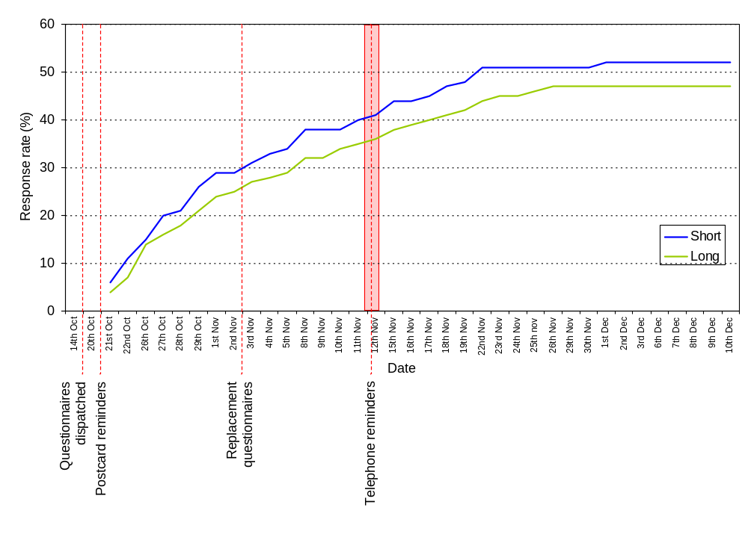
B. Sample profile – unweighted data

Table 11.1: Sample profile by business size – unweighted data
 | Business size (number of employees) |  |  |  | All  %
 | Nil employees  % | Micro (1-5)  % | Small (6-19)  % | Medium (20+)  % | All  %
Number of owners working in the business  0  1  2  3+  Don’t know  Missing information | 27  37  31  3  *  2 | 3  41  48  7  -  * | 5  33  49  13  -  1 | 22  23  35  16  -  3 | 13  37  41  7  *  2
Business size - Number of employees (full-time and part-time combined)  Nil  Micro (1-5 employees)  Small (6-19 employees)  Medium (20+ employees)  Missing information | 100  -  -  -  - | -  100  -  -  - | -  -  100  -  - | -  -  -  100  - | 38  40  15  6  1
Business size - turnover  Nothing  $1 – $19,999  $20,000 – $39,999  $40,000 – $99,999  $100,000 – $249,999  $250,000 – $499,999*  $500,000 – $1,299,999  $1.3 million – $4,999,999  $5 million – $9,999,999  $10 million – $49,999,999  $50 million – $99,999,999  $100 million or more  Missing information  Don’t know | 2  10  17  32  24  10  3  2  *  *  -  -  1  - | 1  1  4  11  31  25  20  7  1  *  -  *  -  * | *  *  *  2  4  14  36  39  3  1  -  -  -  - | -  -  1  -  -  3  13  46  17  18  2  -  -  - | 1  4  8  17  22  16  15  12  2  1  *  *  *  *

Table 11.1: Sample profile by business size – unweighted data (cont.)
Length of time in business  Less than 1 year  1 – 2 years  3 – 5 years  6 – 10 years  > 10 years  Missing information | 3  12  21  17  46  1 | 2  10  19  19  48  2 | 2  9  13  18  54  3 | 2  6  12  17  62  1 | 2  10  19  18  49  2
Use of a tax advisor  Use a tax advisor  Don’t use a tax advisor  Missing information | 81  19  * | 87  12  * | 87  13  * | 86  13  - | 85  15  *
Main business activity  Agriculture  Mining  Manufacturing  Electricity  Construction  Wholesale  Retail  Accommodation  Transport  Communication  Finance  Property  Education  Health and community services  Cultural and recreational services  Personal & other services  Other  Missing information | 20  -  2  1  10  3  6  3  2  2  9  26  2  5  2  7  *  1 | 26  *  5  2  13  4  13  3  4  2  2  11  1  4  1  9  *  1 | 13  -  14  1  8  7  16  9  4  2  1  8  2  4  3  7  *  * | 9  -  16  1  10  6  9  12  7  -  1  9  2  10  4  3  -  - | 21  *  6  1  11  4  10  4  3  2  4  16  2  5  2  8  *  1
Industry sector groupings  Primary produce  Industrial  Distribution  Business and finance  Service  Missing information | 20  13  10  35  21  1 | 26  19  21  13  20  1 | 13  23  27  9  28  * | 9  27  22  10  32  - | 21  18  18  20  22  1
Number of sites  1  2  3  4  10  Missing information | 94  5  1  *  -  * | 92  7  *  *  -  * | 89  8  2  *  -  - | 94  3  1  1  1  - | 92  6  1  *  *  *
Legal entity  Company  Individual  Partnership  Trust  Missing information | 36  28  25  11  - | 52  19  26  2  * | 82  7  8  2  - | 87  3  6  4  - | 53  20  22  6  *
Table 11.1: Sample profile by business size – unweighted data (cont.)
Provisional tax option used 03/04  Missing information  Unknown – non provisional taxpayer  Safe harbour option – new taxpayers  New business elects to make payment  Safe harbour  Estimated | 6  49  *  -  38  6 | 5  53  *  *  36  5 | 7  38  -  -  47  9 | 4  23  1  -  55  16 | 6  47  *  *  40  7
Number of respondents | 724 | 767 | 290 | 116 | 1907
* = 0.0% < 0.5%
Base: All respondents
Source: Long questionnaire Q3, Q4, Q10a, Q20, Q21, Q22; Short questionnaire Q4, Q11, Q13, Q12; IRD database information used for Filing method for EMS, GST basis, Nature of GST registration, GST filing frequency.

Table 11.1: Sample profile by business size – unweighted data (cont.)
 | Business size (number of employees) |  |  |  | All  %
 | Nil employees  % | Micro (1-5)  % | Small (6-19)  % | Medium (20+)  % | All  %
Filing method for EMS  Missing information/No filing option recorded  Electronic  Manual | 36  5  59 | 5  6  89 | 3  25  71 | 9  71  20 | 10  16  75
Number of respondents | 193 | 718 | 290 | 116 | 1324
Base: All respondents who pay/file PAYE (Q1)
Source: Long questionnaire Q4; IRD database information used for Filing method for EMS

Table 11.1: Sample profile by business size – unweighted data (cont.)
 | Business size (number of employees) |  |  |  | All  %
 | Nil employees  % | Micro (1-5)  % | Small (6-19)  % | Medium (20+)  % | All  %
GST basis  Missing information  Hybrid  Invoice  Payments  Both | 2  *  18  79  - | 1  *  17  81  * | 1  2  43  54  * | 1  1  72  26  - | 1  1  25  73  *
Nature of GST registration  Missing information  Required  Voluntary  Required, Voluntary  Forced | 2  82  16  -  * | 1  92  7  *  - | 1  97  3  -  - | 1  95  4  -  - | 1  90  9  *  *
GST filing frequency  Missing information  Monthly  Six Monthly  Two Monthly | 2  6  30  62 | 3  4  13  81 | 1  7  4  88 | 1  19  3  78 | 2  6  16  76
Number of respondents | 193 | 720 | 290 | 116 | 1326
* = 0.0% < 0.5%
Base: All respondents who pay/file GST (Q1)
Source: Long questionnaire Q4; IRD database information used for GST basis, Nature of GST registration, GST filing frequency.

Table 11.2: Sample profile by tax type – unweighted data
 | Tax type |  |  |  | All  %
 | GST  % | Income tax  % | PAYE  % | FBT^  % | All  %
Number of owners working in the business  0  1  2  3+  Don’t know  Missing information | 6  40  45  7  *  2 | 13  37  41  7  *  1 | 5  36  49  9  -  1 | 10  28  49  12  -  1 | 13  37  41  7  *  2
Business size - Number of employees (full-time and part-time combined)  Nil  Micro (1-5 employees)  Small (6-19 employees)  Medium (20+ employees)  Missing information | 33  44  17  7  1 | 38  40  15  6  * | 15  54  22  9  1 | 13  32  35  20  - | 38  40  15  6  1
Business size - turnover  Nothing  $1 – $19,999  $20,000 – $39,999  $40,000 – $99,999  $100,000 – $249,999  $250,000 – $499,999  $500,000 – $1,299,999  $1.3 million – $4,999,999  $5 million – $9,999,999  $10 million – $49,999,999  $50 million – $99,999,999  $100 million or more  Don’t know  Missing information | 1  3  6  16  23  16  17  13  2  2  *  *  *  * | 1  4  8  17  22  16  15  12  2  1  *  *  *  * | 1  1  3  11  22  19  20  17  3  2  *  *  *  - | -  1  1  4  12  12  22  33  8  7  1  -  -  - | 1  4  8  17  22  16  15  12  2  2  *  *  *  *
Length of time in business  Less than 1 year  1 – 2 years  3 – 5 years  6 – 10 years  > 10 years  Missing information | 3  11  19  18  49  2 | 2  10  19  18  49  2 | 2  10  18  18  50  2 | 1  7  13  17  60  1 | 2  10  19  18  49  2
Use of a tax advisor  Use a tax advisor  Don’t use a tax advisor  Missing information | 86  14  * | 86  14  * | 87  13  * | 89  13  * | 85  15  *
Table 11.2: Sample profile by tax type – unweighted data (cont.)
Main business activity  Agriculture  Mining  Manufacturing  Electricity  Construction  Wholesale  Retail  Accommodation  Transport  Communication  Finance  Property  Education  Health and community services  Cultural and recreational services  Personal & other services  Other  Missing information | 22  *  6  1  12  4  11  4  4  2  2  15  1  5  2  8  *  * | 21  *  6  1  11  4  11  4  3  2  4  16  2  5  2  8  *  1 | 22  *  8  1  11  5  13  5  4  2  2  11  1  5  2  8  *  * | 8  -  15  *  9  10  17  4  6  3  3  12  1  4  2  5  -  * | 21  *  6  1  11  4  10  4  3  2  4  16  2  5  2  8  *  1
Industry sector groupings  Primary produce  Industrial  Distribution  Business and finance  Service  Missing information | 22  19  19  17  22  * | 21  18  18  20  22  1 | 22  20  22  12  23  * | 8  25  32  15  19  * | 21  18  18  20  22  1
Number of sites  Missing information  1  2  3  4  10 | *  92  7  1  *  * | *  92  7  1  *  * | *  91  7  1  *  * | *  90  7  1  1  * | *  92  6  1  *  *
Legal entity  Missing information  Company  Individual  Partnership  Trust | *  56  19  22  4 | *  53  20  22  6 | *  62  15  21  2 | *  92  1  4  3 | *  53  20  22  6
Provisional tax option used 03/04  Missing information  Non-provisional taxpayer  Safe harbour option - new taxpayers  Safe harbour  Estimated | 6  48  *  38  7 | 5  47  *  40  7 | 6  48  *  39  7 | 3  36  *  48  12 | 6  47  *  40  7
Number of respondents | 1747 | 1854 | 1326 | 343 | 1907
* = 0.0% < 0.5%
^= excludes those who filed FBT-nil returns only
Base: All respondents
Source: Long questionnaire Q3, Q4, Q10a, Q20, Q21, Q22; Short questionnaire Q4, Q11, Q13, Q12; IRD database information used for Filing method for EMS, GST basis, Nature of GST registration, GST filing frequency.
Table 11.2: Sample profile by tax type – unweighted data (cont.)
 | Tax type |  |  |  | All  %
 | GST  % | Income tax  % | PAYE  % | FBT^  % | All  %
Filing method for EMS  Missing information/No filing option recorded  Electronic  Manual | 10  16  75 | 10  16  75 | 10  16  75 | 7  34  59 | 10  16  75
Number of respondents | 1320 | 1288 | 1324 | 325 | 1324
Base: All respondents who pay/file PAYE (Q1)
Source: Long questionnaire Q4; IRD database information used for Filing method for EMS

Table 11.2: Sample profile by tax type – unweighted data (cont.)
 | Tax type |  |  |  | All  %
 | GST  % | Income tax  % | PAYE  % | FBT^  % | All  %
GST basis  Missing information  Both  Hybrid  Invoice  Payments | 1  *  1  25  73 | 1  *  1  26  72 | 1  *  1  28  70 | 1  1  2  48  48 | 1  *  1  25  73
Nature of GST registration  Missing information  Required  Voluntary  Required, Voluntary  Forced | 1  90  9  *  * | 1  90  9  *  * | 1  93  6  *  - | 1  96  3  *  - | 1  90  9  *  *
GST filing frequency  Missing information  Monthly  Six Monthly  Two Monthly | 2  6  16  76 | 2  6  16  76 | 2  6  11  81 | 2  8  6  84 | 2  6  16  80
Number of respondents | 1747 | 1697 | 1322 | 343 | 1747
* = 0.0% < 0.5%
^= excludes those who filed FBT-nil returns only
Base: All respondents who pay/file PAYE (Q1)
Source: Long questionnaire Q4; IRD database information used for GST basis, Nature of GST registration, GST filing frequency.

Table 11.3: Tax type by business size – unweighted data
 | Business size (number of employees) |  |  |  | All
 | Nil employees | Micro 1-5 | Small 6-19 | Medium 20+ | All
Tax type | % | % | % | % | %
Income | 97 | 98 | 97 | 99 | 97
GST | 78 | 99 | 100 | 100 | 92
PAYE | 27 | 94 | 100 | 100 | 70
FBT | 6 | 14 | 41 | 60 | 18
Tax type combination
Income only | 21 | * | - | - | 8
Income, GST | 41 | 5 | - | - | 18
Income, GST, PAYE | 16 | 57 | 39 | 27 | 37
Income, GST, PAYE, FBT | 9 | 35 | 58 | 72 | 31
Income, PAYE | - | * | - | - | *
Income, PAYE, FBT | - | - | - | - | -
GST only | 2 | * | - | - | 1
GST, PAYE | 1 | 2 | 2 | - | 1
GST, PAYE, FBT | 1 | * | * | * | *
PAYE only | * | * | - | - | *
PAYE, FBT | * | - | - | - | *
Income, GST, FBT | 9 | * | - | - | 4
* = 0.0% < 0.5%
Base: All respondents
Source: Long questionnaire Q1, Q4; Short questionnaire Q1

C. Internal time – excludes those who spent zero hours
Table 11.4 gives the number of hours spent on specifics tax activities for each tax type. The number of hours in each cell has been calculated using a base that excludes respondents who indicated they spent zero hours (for that tax activity in relation to that tax type).

Table 11.4: Internal time spent on tax activities (annual hours) by tax type – means
 | GST | Income tax (including provisional tax) | PAYE (including child support, student loans, ACC levy) | FBT | All tax types
 | Mean (trimmed) annual number of hours
Recording information | 27.4  (1406) | 17.5  (1068) | 14.8  (995) | 6.3  (210) | 39.6  (1597)
Calculating tax, completing and filing returns, paying tax | 14.8  (1348) | 9.8  (928) | 10.7  (985) | 5.6  (228) | 24.4  (1529)
Dealing with IRD | 6.3  (649) | 5.9  (461) | 5.5  (455) | 4.0  (58) | 11.1  (887)
Tax planning | 10.1  (235) | 9.0  (379) | 8.4  (105) | 6.1  (21) | 14.1  (465)
Dealing with tax advisors (including providing information to them) | 9.4  (840) | 9.3  (1087) | 8.1  (386) | 5.4  (122) | 15.5  (1310)
Learning about tax laws (new or existing) | 5.5  (940) | 5.5  (685) | 5.3  (670) | 4.6  (155) | 10.5  (1100)
Other | 39.7  (12) | 15.7  (14) | 17.5  (5) | 0.0  (-) | 33.4  (25)
All activities | 51.7  (15.34) | 31.8  (1429) | 31.3  (1134) | 16.4  (277) | 79.5  (1750)
Base: All respondents who according to Q1 filed/paid the particular tax type (excluding missing information and outliers) and gave a response of more than zero hours on the particular task.
Source: Long questionnaire Q13a; Short questionnaire Q6a
Sample sizes are shown in brackets

Table 11.5 details the amount of time that different types of personnel spend on tax activities in relation to each tax type. The number of hours in each cell has been calculated using a base that excludes respondents who indicated they spent zero hours on that tax type.

Table 11.5: Internal time spent by personnel on all tax activities (annual hours) by tax type - means
Personnel | GST | Income tax (including provisional tax) | PAYE (including child support, student loans, ACC levy) | FBT | All tax types
 | Mean (trimmed) annual number of hours
Owners/partners/directors/trustees | 39.9  (1271) | 26.9  (1263) | 21.6  (801) | 10.7  (170) | 62.4  (1286)
Paid employees | 58.3  (483) | 28.0  (366) | 29.8  (450) | 18.2  (149) | 106.9  (484)
Unpaid friends or relatives | 32.5  (85) | 13.4  (71) | 21.0  (39) | 0.0  (0) | 38.4  (90)
All personnel | 46.9  (1447) | 31.4  (1388) | 29.4  (1098) | 15.5  (271) | 78.6  (1670)
Base: All respondents who according to Q1 filed the particular tax type (excluding missing information and outliers) and gave a response of more than zero hours for that tax type.
Source: Long questionnaire Q13b; Short questionnaire Q6b, Q6c
D. External costs based on businesses who use an advisor

Table 11.6 presents external compliance costs by tax type and business size. The amounts under each tax type relate to the average payment made for external advice in regard to that tax type among businesses that file that tax type and who pay for external advice. Note, those who do not pay for external tax services relating to that tax type have been excluded from the bases for these calculations.

The final column is based on all businesses and gives the average payment made for tax services relating to any tax type according to business size. Again, businesses that do not pay for external tax services have been excluded from the calculations.

Table 11.6: External mean compliance costs by tax type and business size (number of employees)
Business size (number of employees) | Tax type* |  |  |  | All
Business size (number of employees) | Mean (trimmed) external annual compliance costs
 | GST | Income tax | PAYE | FBT
Nil employees | $418  (212) | $998  (475) | $113  (46) | $115  (21) | $1,143  (488)
Micro (1-5) | $519  (292) | $1,447  (510) | $134  (155) | $156  (46) | $1,720  (521)
Small (6-19) | $631  (93) | $1,839  (152) | $178  (53) | $143  (31) | $2,183  (161)
Medium (20+) | $708  (30) | $2,261  (60) | $324  (10) | $268  (15) | $2,495  (58)
All | $480  (627) | $1,202  (1200) | $141  (266) | $149  (113) | $1,398  (1231)
Base: *Utilises imputed data, business survey data and tax advisor data. Base is all businesses who file the particular tax type at Q1
Source: Long questionnaire Q4, Q10a, Q10b, Q10d; Short questionnaire Q4; Advisor sub-survey Q5.

E. Payment for external tax services – comparison of tax advisor and business survey data

Figure 16: All SMEs (n= 204, r=0.56)

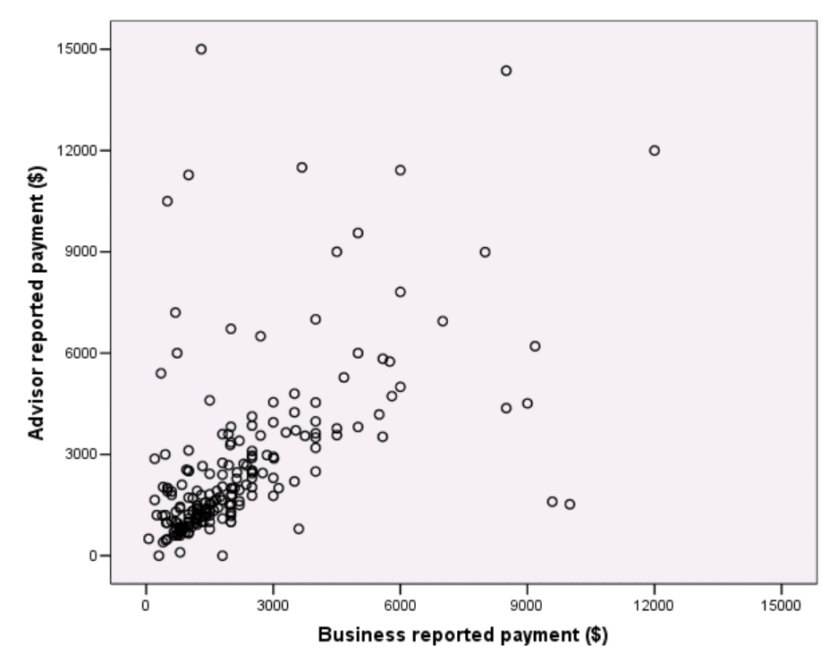
Figure 17: SMEs with no employees (n=63, r=0.56)

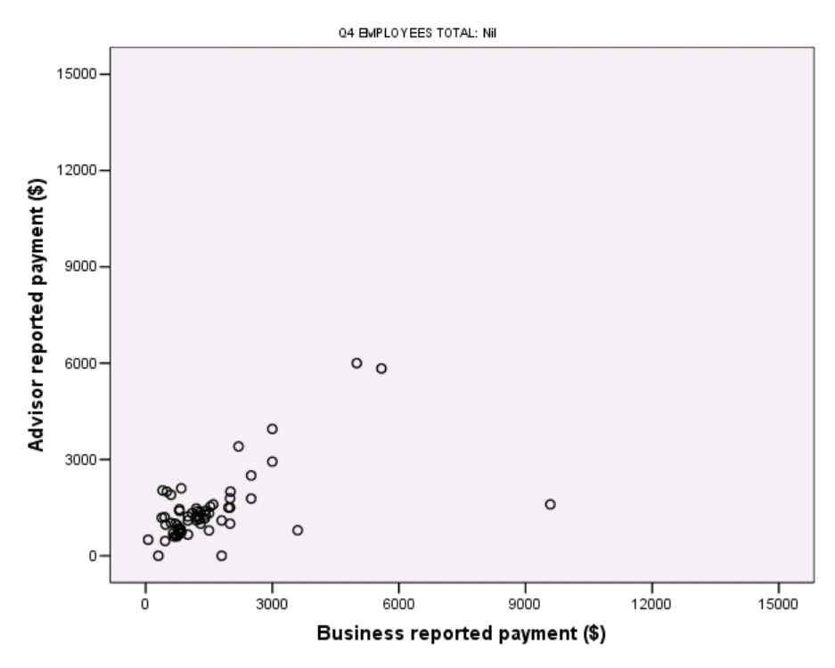

Figure 18: Micro-sized businesses (n=98, r=0.64)
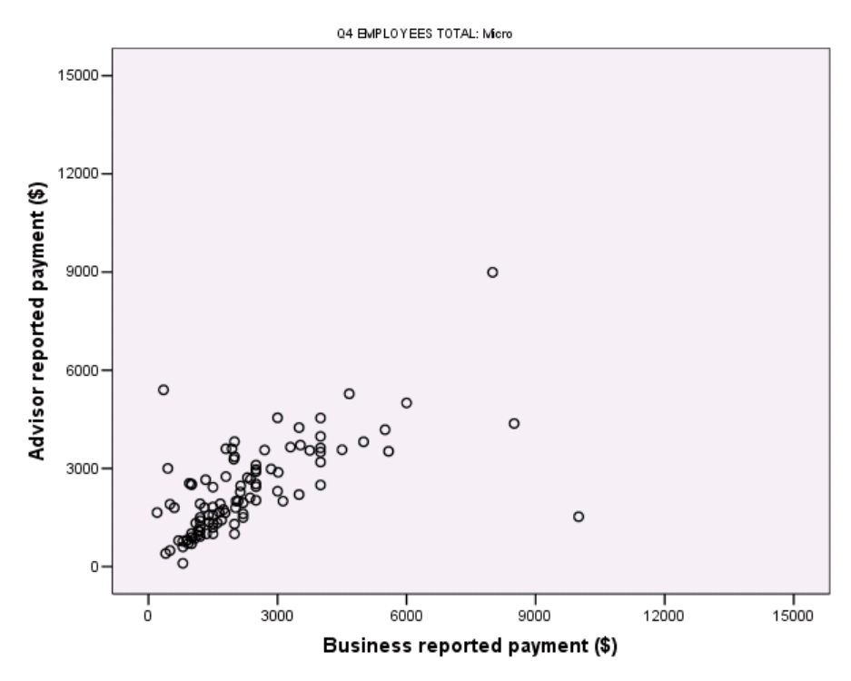

Figure 19: Small businesses (n=29, r=0.61)
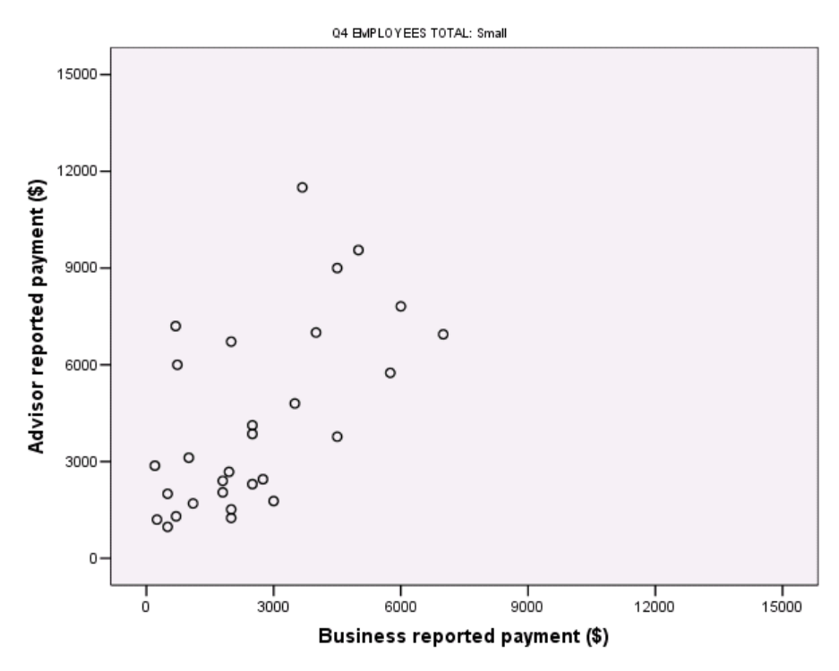

Figure 20: Medium-sized businesses (n=13, r=0.19)

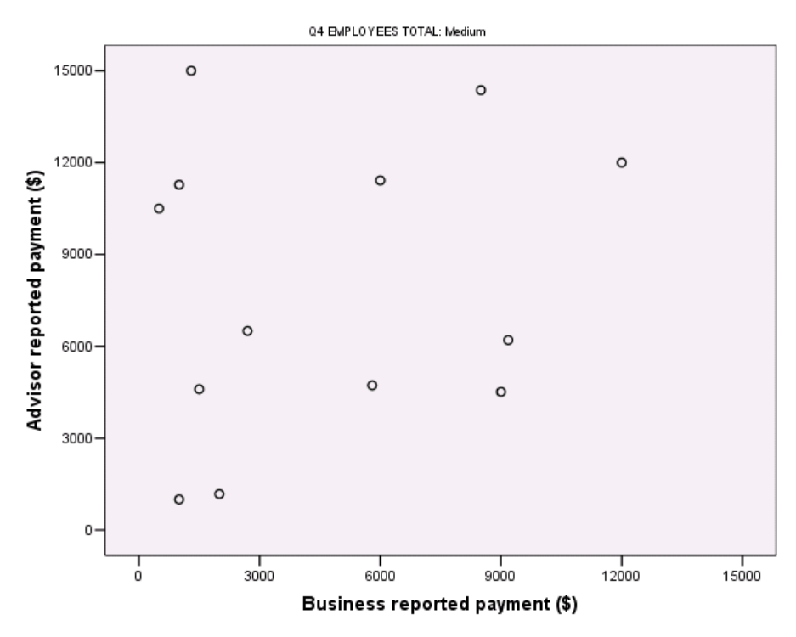
F. Analysis by sector
This section provides analyses by sector.

SMEs in the Distribution sector tend to spend the most time on tax activities with those in the Business and Finance sector spending the least time. However, this may well be a function of business size with those in the Distribution sector having more employees than those in the Business and Finance sector (see sample profile tables earlier in this report).

Table 11.7: Internal time spent on tax activities (annual hours) by sector
Tax activity | Sector |  |  |  |  | All sectors
Tax activity | Primary produce | Industrial | Distribution | Business & Finance | Service | All sectors
 | Mean number of hours (annual)
Recording information | 36.0  (382) | 37.7  (324) | 38.6  (321) | 24.5  (384) | 36.0  (408) | 33.7  (1831)
Calculating tax, completing and filing returns, paying tax | 16.8  (387) | 22.5  (336) | 25.6  (339) | 14.0  (388) | 19.4  (425) | 18.8  (1887)
Dealing with IRD | 4.7  (392) | 5.0  (341) | 6.5  (340) | 3.5  (390) | 4.6  (426) | 4.7  (1901)
Tax planning | 3.4  (392) | 2.3  (341) | 4.7  (340) | 2.1  (390) | 3.4  (427) | 3.0  (1902)
Dealing with tax advisors (including providing information to them) | 11.6  (389) | 10.3  (340) | 11.9  (335) | 6.8  (389) | 12.0  (422) | 10.3  (1887)
Learning about tax laws (new or existing) | 5.1  (386) | 5.7  (334) | 6.3  (336) | 4.5  (386) | 5.1  (420) | 5.2  (1874)
Other | 0.5  (394) | 0.0  (342) | 0.3  (341) | 0.2  (390) | 0.4  (428) | 0.4  (1907)
All activities | 79.5  (383) | 81.8  (325) | 92.8  (328) | 56.5  (385) | 79.2  (413) | 75.6  (1846)
Base: All respondents excluding missing information and outliers
Source: Long questionnaire Q13a, Q21; Short questionnaire Q6a, Q12

Table 11.8 shows the amount of time that different types of personnel spend on tax activities for each tax type by size of sector.

Consistent with the pattern identified above (in relation to the data on specific tax activities), the data below shows that businesses in the Distribution sector spend the most time meeting their tax obligations whereas those in the Business and Finance sector spend the least time. As noted earlier, this appears to be a function of business size (defined in terms of the number of employees).

Table 11.8: Internal time spent by all personnel on all tax activities (annual hours) by sector
Personnel | Sector |  |  |  |  | All sectors
Personnel | Primary produce | Industrial | Distribution | Business & Finance | Service | All sectors
 | Mean number of hours (annual)
Owners/partners/directors/trustees | 60.5  (282) | 58.5  (275) | 69.5  (272) | 42.9  (329) | 58.5  (335) | 56.0  (1501)
Paid employees | 13.3  (290) | 27.3  (274) | 33.4  (277) | 10.2  (329) | 17.9  (340) | 18.4  (1518)
Unpaid friends or relatives | 3.7  (288) | 7.2  (275) | 1.7  (277) | 2.1  (331) | 3.1  (339) | 3.4  (1518)
All personnel | 75.2  (350) | 86.9  (310) | 101.0  (308) | 54.7  (366) | 80.8  (381) | 76.2  (1723)
Base: All respondents (excluding missing information and outliers)
Source: Long questionnaire Q13b, Q21; Short questionnaire Q6b, Q6c, Q12

Table 11.9 details the amount of time that businesses (covering all personnel) spend on each tax type by sector.

The variations in time spent on tax work by sector commented on in relation to the previous table do not hold true for all tax types.

Table 11.9: Internal time spent on all tax activities for each tax type (annual hours) by sector
Tax type | Sector |  |  |  |  | All sectors
Tax type | Primary produce | Industrial | Distribution | Business & Finance | Service | All sectors
 | Mean number of hours (annual)
GST | 42.9  (325) | 47.5  (287) | 51.2  (300) | 35.5  (270) | 47.3  (335) | 44.2  (1521)
Income tax (including provisional tax) | 23.1  (295) | 30.9  (274) | 33.6  (274) | 26.9  (328) | 33.5  (330) | 29.4  (1509)
PAYE (including child support, student loans, ACC levy) | 22.6  (244) | 29.1  (237) | 34.0  (263) | 18.3  (142) | 31.5  (268) | 27.5  (1157)
FBT | 7.1  (24) | 10.6  (80) | 15.7  (105) | 12.9  (49) | 14.6  (57) | 12.9  (316)
All tax types | 76.5  (345) | 87.3  (309) | 101.2  (307) | 54.8  (365) | 81.1  (380) | 76.7  (1714)
Base: All respondents who according to Q1 filed the particular tax type (excluding missing information and outliers)
Source: Long questionnaire Q13b, Q21; Short questionnaire Q6a, Q12

Table 11.10 shows that businesses in the Industrial, Distribution and Service sector groupings tend to report the highest levels of stress associated with provisional tax requirements. SMEs in the Primary produce and Business & Finance sector groupings report the lowest levels of stress.

Table 11.10: Stress associated with provisional tax compliance – mean scores by business size (number of employees) and sector
Sector | Business size (number of employees) |  |  |  | All
 | Nil employees | Micro (1-5) | Small (6-19) | Medium (20+)
 | Mean stress score
Primary produce | 3.3  (113) | 3.7  (180) | 4.3  (32) | 2.8  (9) | 3.5  (337)
Industrial | 4.1  (87) | 4.3  (132) | 4.5  (63) | 3.8  (31) | 4.2  (313)
Distribution | 4.2  (63) | 4.2  (138) | 4.1  (70) | 3.5  (23) | 4.1  (296)
Business & Finance | 3.0  (206) | 3.7  (84) | 3.4  (22) | 4.6  (11) | 3.2  (323)
Service | 3.7  (122) | 4.4  (130) | 4.0  (63) | 4.8  (31) | 3.9  (349)
All sectors | 3.5  (596) | 4.1  (668) | 4.1  (251) | 4.0  (105) | 3.7  (1628)
Base: All respondents who file/pay income tax (Q1 in long questionnaire) and all respondents of short questionnaire; excludes those who indicated Q25 was not applicable.
Source: Long questionnaire Q21 and Q25; Short questionnaire Q12 and Q15

Table 11.11 looks at mean internal compliance costs of GST by turnover and sector.

Compliance costs of GST increase as turnover increases. Compliance costs of GST vary by industry sector with businesses in the Distribution sector experiencing the highest costs. However, this pattern does not always hold within business size groupings – the higher costs of the Distribution sector is largely due to those Distribution businesses with between $100,000 and $1,299,999

Table 11.11: Mean internal compliance costs of GST by business size (turnover) and sector
Business size (turnover) | Primary produce | Industrial | Distribution | Business & Finance | Service | All
Business size (turnover) | Mean (trimmed) annual compliance costs
Up to $39,999 | $1,734  (38) | $1,909  (21) | $1,475  (18) | $1,152  (39) | $1,544  (42) | $1,528  (158)
$40,000 to $99,999 | $1,339  (47) | $1,430  (47) | $1,544  (25) | $1,472  (65) | $1,632  (62) | $1,478  (247)
$100,000 to $1,299,999 | $2,003  (218) | $2,001  (142) | $2,753  (172) | $1,573  (144) | $2,145  (190) | $2,083  (869)
$1.3 million + | $2,853  (25) | $2,056  (82) | $2,351  (92) | $1,955  (23) | $2,246  (48) | $2,389  (270)
All | $1,850  (328) | $1,922  (292) | $2,288  (308) | $1,467  (272) | $1,897  (342) | $1,852  (1546)
Base: All respondents who file GST (Q1) excluding missing information and outliers
Source: Long questionnaire Q13b, Q14, Q20 and Q21

There are a few variations in the accounting system used for GST by sector (see Table 11.12). SMEs in the Distribution sector are more likely than average to use computerised accounting software. SMEs in Primary produce are more likely than other businesses to rely on an external accountant for GST. And those in the Business & Finance sector are more likely than average to use ‘other computing systems’.

Table 11.12: Accounting system used for GST by sector
Accounting system | Sector |  |  |  |  | All sectors
Accounting system | Primary produce | Industrial | Distribution | Business & Finance | Service | All sectors
 | (383)  % | (334)  % | (338)  % | (291)  % | (392)  % | (1745)  %
Manual - paper based | 42 | 44 | 36 | 40 | 38 | 40
Computerised accounting software (in-house) | 36 | 37 | 45 | 39 | 37 | 38
Other computing used in-house (e.g. spreadsheets) | 9 | 15 | 12 | 20 | 19 | 15
External | 20 | 12 | 9 | 11 | 16 | 14
Missing information | 1 | * | 1 | * | 1 | 1
Base: All respondents who file GST (Q1); excludes those who indicated Q6 was not applicable.
Source: Long questionnaire Q6 and Q21

SMEs in the Services, Industrial, and Distribution sectors report higher levels of stress in dealing with GST than businesses in the Primary produce and Business & Finance sectors (see Table 11.13).

This pattern also tends to be evident within the business size groupings – however, due to some small sample sizes, these are not necessarily statistically significant.

Table 11.13: Stress associated with GST compliance – mean scores by business size (number of employees) by sector
Sector | Business size (number of employees) |  |  |  | All
Sector | Nil employees | Micro (1-5) | Small (6-19) | Medium (20+) | All
 | Mean stress score
Primary produce | 3.6  (130) | 3.9  (198) | 4.0  (39) | 3.2  (10) | 3.7  (380)
Industrial | 4.2  (88) | 3.9  (147) | 4.2  (67) | 3.6  (31) | 4.1  (334)
Distribution | 4.1  (70) | 4.0  (159) | 4.2  (77) | 3.6  (26) | 4.0  (334)
Business & Finance | 3.2  (153) | 3.4  (98) | 2.8  (26) | 3.5  (12) | 3.2  (290)
Services | 4.1  (117) | 4.5  (153) | 4.2  (79) | 4.7  (37) | 4.3  (389)
All sectors | 3.7  (560) | 4.0  (759) | 4.0  (289) | 3.9  (116) | 3.8  (1734)
Base: All respondents who file GST (Q1); excludes those who indicated Q24 was not applicable.
Source: Long questionnaire Q4, Q21 and Q24

Table 11.14 shows that businesses in the Services sector report higher levels of stress in dealing with PAYE compliance than businesses in the Industrial, Distribution and Business & Finance sectors. SMEs in the Primary produce sector also report higher levels of stress than businesses in the Business & Finance sector.

This pattern is not as clear-cut within the business size groupings – this analysis is hampered by small sample sizes in some cases.

Table 11.14: Stress associated with PAYE compliance – mean scores by business size (number of employees) and sector
Sector | Business size (number of employees) |  |  |  | All
Sector | Nil employees | Micro (1-5) | Small (6-19) | Medium (20+) | All
 | Mean stress score
Primary produce | 3.3  (43) | 3.3  (182) | 3.8  (38) | 2.9  (10) | 3.3  (275)
Industrial | 3.4  (26) | 3.0  (135) | 3.6  (67) | 3.0  (31) | 3.1  (260)
Distribution | 3.0  (19) | 2.9  (156) | 3.3  (77) | 4.0  (26) | 3.1  (279)
Business & Finance | 3.2  (24) | 3.0  (84) | 2.2  (26) | 3.1  (12) | 3.0  (146)
Services | 3.4  (31) | 3.5  (146) | 3.5  (79) | 4.0  (37) | 3.5  (296)
All sectors | 3.3  (143) | 3.2  (707) | 3.4  (288) | 3.5  (116) | 3.2  (1261)
Base: All respondents who file PAYE (Q1); excludes those who indicated Q26 was not applicable.
Source: Long questionnaire Q21 and Q26

Table 11.5 summarises the combined annual compliance costs by sector.

Table 11.15: Summary of mean annual compliance costs by business size (number of employees)
Business size  (number  of employees) | GST |  | Income tax |  | PAYE |  | FBT |  | Combined costs (internal and external)
 | Internal | External | Internal | External | Internal | External | Internal | External
Primary produce | $1588  (339) | $208  (355) | $1050  (304) | $1074  (329) | $426  (346) | $26  (374) | $11  (351) | $2  (389) | $4385
Industrial | $1593  (300) | $133  (321) | $1235  (282) | $940  (284) | $484  (312) | $20  (332) | $33  (314) | $8  (334) | $4446
Distribution | $2074  (311) | $173  (325) | $1306  (286) | $1038  (287) | $602  (314) | $13  (332) | $74  (316) | $17  (334) | $5297
Business & Finance | $974  (370) | $118  (375) | $1062  (342) | $645  (342) | $134  (368) | $6  (384) | $22  (376) | $5  (389) | $2966
Services | $1257  (377) | $123  (390) | $1328  (350) | $749  (360) | $405  (386) | $7  (410) | $27  (392) | $5  (417) | $3901
All SMEs | $1,407  (1706) | $146  (1778) | $1,187  (1574) | $856  (1614) | $378  (1736) | $14  (1844) | $30  (1753) | $6  (1875) | $4,024
Base: All respondents
Source: Long questionnaire Q10a, Q13b, Q14 and Q21; Short questionnaire Q6b, Q6c, Q7 and Q12.

G. Analysis by age of business

The next four tables show the internal time spent on tax compliance for each of the tax types with an analysis by age of business and turnover. Newer businesses, and larger businesses (in terms of turnover), tend to spend more time on tax compliance.

Table 11.16: Internal time spent (annual hours) on Income tax by age of business and business size (turnover)
Turnover | Age of business |  |  |  |  | All
Turnover | Less than 12 months | 1-2 years | 3-5 years | 6-10 years | 10 years + | All
 | Mean (trimmed) annual number of hours
Up to $39,999 | 43.0  (10) | 30.2  (27) | 21.4  (59) | 17.6  (36) | 19.1  (69) | 22.0  (205)
$40,000 to $99,999 | 24.8  (8) | 20.7  (31) | 19.6  (56) | 17.0  (44) | 27.7  (111) | 23.5  (254)
$100,000 to $1,299,999 | 27.3  (11) | 44.7  (82) | 38.0  (142) | 37.3  (143) | 30.5  (411) | 34.3  (798)
$1.3 million + | 84.0  (1) | 31.1  (11) | 53.3  (28) | 40.0  (50) | 45.6  (156) | 45.5  (249)
All | 36.4  (30) | 33.5  (152) | 29.2  (286) | 28.5  (273) | 28.6  (748) | 29.4  (1509)
Base: All respondents who file Income tax (Q1) excluding missing information and outliers
Source: Long questionnaire Q13b, Q20 and Q22; short questionnaire Q6b, Q11 and Q13.

Table 11.17: Internal time spent (annual hours) on GST by age of business and business size (turnover)
Turnover | Age of business |  |  |  |  | All
Turnover | Less than 12 months | 1-2 years | 3-5 years | 6-10 years | 10 years + | All
 | Mean (trimmed) annual number of hours
Up to $39,999 | 47.7  (12) | 44.5  (23) | 35.6  (49) | 33.9  (25) | 32.3  (46) | 36.1  (158)
$40,000 to $99,999 | 58.4  (11) | 44.0  (41) | 38.6  (58) | 31.0  (44) | 24.6  (89) | 33.4  (246)
$100,000 to $1,299,999 | 48.7  (14) | 50.6  (88) | 54.1  (149) | 54.3  (151) | 46.1  (445) | 49.5  (858)
$1.3 million + | 86.4  (2) | 54.2  (14) | 79.8  (31) | 70.2  (48) | 62.0  (159) | 66.4  (257)
All | 52.5  (39) | 47.2  (167) | 46.7  (287) | 46.5  (268) | 41.0  (740) | 44.2  (1521)
Base: All respondents who file GST (Q1) excluding missing information and outliers
Source: Long questionnaire Q13b, Q20 and Q22

Table 11.18: Internal time spent (annual hours) on PAYE by age of business and business size (turnover)
Turnover | Age of business |  |  |  |  | All
Turnover | Less than 12 months | 1-2 years | 3-5 years | 6-10 years | 10 years + | All
 | Mean (trimmed) annual number of hours
Up to $39,999 | 6.5  (4) | 6.9  (4) | 13.6  (28) | 8.7  (6) | 17.0  (15) | 12.8  (58)
$40,000 to $99,999 | 56.2  (5) | 16.2  (24) | 10.1  (25) | 16.8  (23) | 11.0  (40) | 14.9  (119)
$100,000 to $1,299,999 | 28.5  (11) | 25.7  (73) | 38.0  (124) | 27.2  (129) | 28.7  (372) | 29.7  (720)
$1.3 million + | 84.1  (2) | 19.0  (14) | 47.3  (28) | 40.0  (49) | 41.3  (164) | 41.4  (259)
All | 35.0  (22) | 21.1  (116) | 29.2  (205) | 26.8  (207) | 28.3  (591) | 27.5  (1157)
Base: All respondents who file PAYE (Q1) excluding missing information and outliers
Source: Long questionnaire Q13b, Q20 and Q22

Table 11.19: Internal time spent (annual hours) on FBT by age of business and business size (turnover)
Turnover | Age of business |  |  |  |  | All
Turnover | Less than 12 months | 1-2 years | 3-5 years | 6-10 years | 10 years + | All
 | Mean (trimmed) annual number of hours
Up to $39,999 | 0.0  (0) | 0.0  (0) | 0.0  (1) | 0.0  (0) | 12.7  (2) | 11.0  (3)
$40,000 to $99,999 | 0.0  (0) | 14.8  (3) | 11.7  (3) | 5.7  (5) | 2.4  (2) | 7.5  (13)
$100,000 to $1,299,999 | 14.7  (3) | 18.4  (14) | 9.0  (24) | 13.0  (25) | 10.1  (78) | 11.3  (147)
$1.3 million + | 0.0  (0) | 13.4  (4) | 23.6  (13) | 14.7  (26) | 16.1  (109) | 16.8  (153)
All | 14.7  (3) | 17.6  (21) | 12.6  (41) | 12.3  (56) | 12.5  (191) | 12.9  (316)
Base: All respondents who file FBT (Q1) excluding missing information and outliers
Source: Long questionnaire Q13b, Q20 and Q22

Table 11.20 shows the combined annual compliance costs by age of business. New businesses (less than 12 months) experience the highest combined annual compliance costs.

Table 11.20: Summary of mean annual compliance costs by age of business
Business size  (number  of employees) | GST |  | Income tax |  | PAYE |  | FBT |  | Combined costs (internal and external)
 | Internal | External | Internal | External | Internal | External | Internal | External
Less than 12 months | $1782  (40) | $247  (44) | $1333  (38) | $631  (42) | $465  (42) | $13  (47) | $14  (43) | $2  (46) | $4487
1-2 years | $1566  (177) | $156  (182) | $1295  (164) | $670  (166) | $311  (181) | $10  (191) | $33  (183) | $8  (198) | $4049
3-5 years | $1651  (318) | $155  (336) | $1129  (292) | $843  (313) | $465  (320) | $15  (341) | $33  (323) | $3  (350) | $4294
6-10 years | $1491  (305) | $138  (315) | $1205  (283) | $764  (289) | $374  (309) | $14  (328) | $34  (311) | $7  (333) | $4027
10 years + | $1232  (843) | $137  (871) | $1179  (774) | $950  (775) | $360  (858) | $14  (1906) | $27  (866) | $7  (917) | $3906
All SMEs | $1,407  (1706) | $146  (1778) | $1,187  (1574) | $856  (1614) | $378  (1736) | $14  (1844) | $30  (1753) | $6  (1875) | $4,024
Base: All respondents
Source: Long questionnaire Q10a, Q13b, Q14 and Q22; Short questionnaire Q4, Q6b, Q6c, Q7 and Q13.

Questionnaire
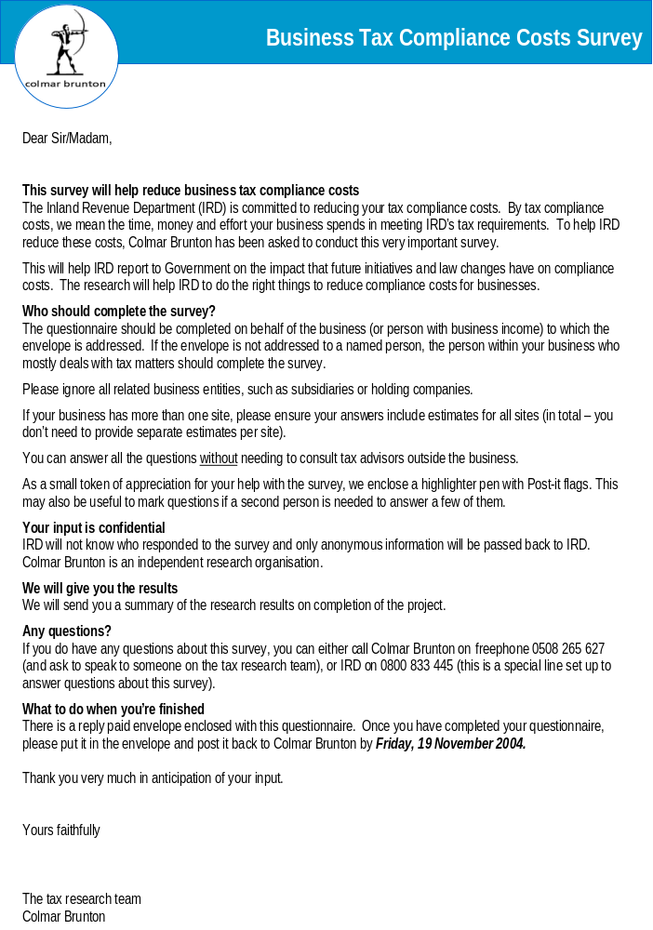
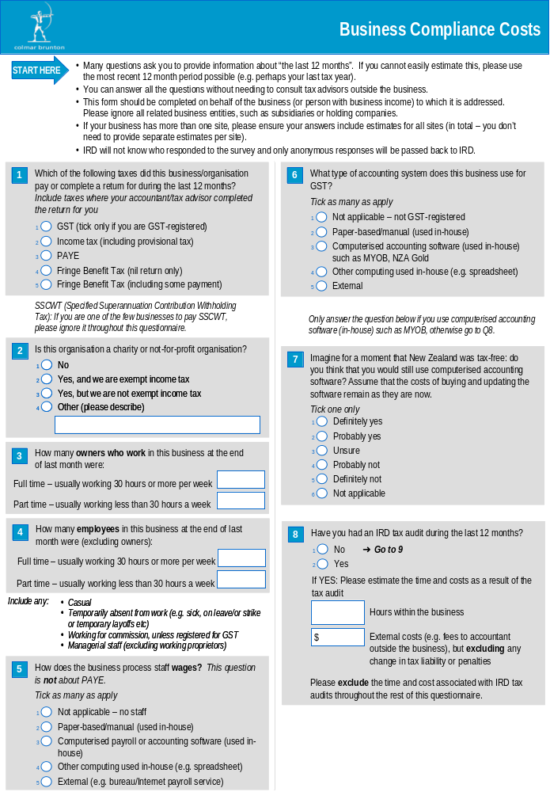
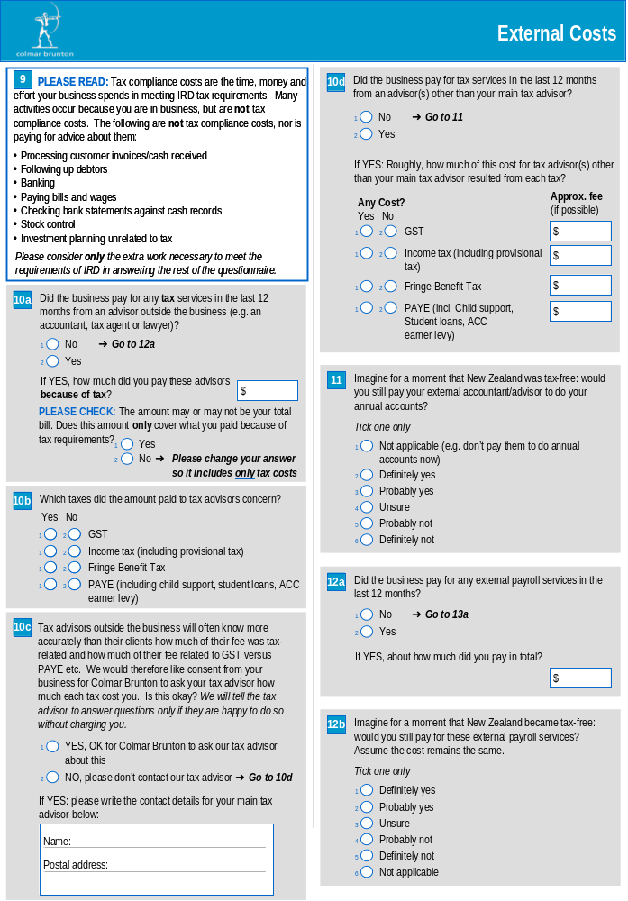
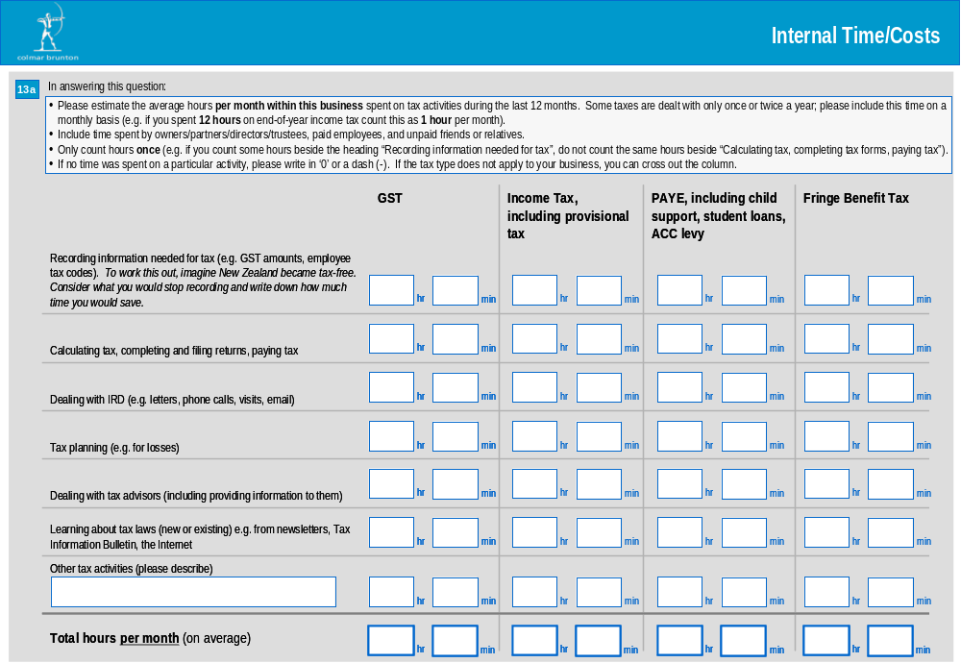
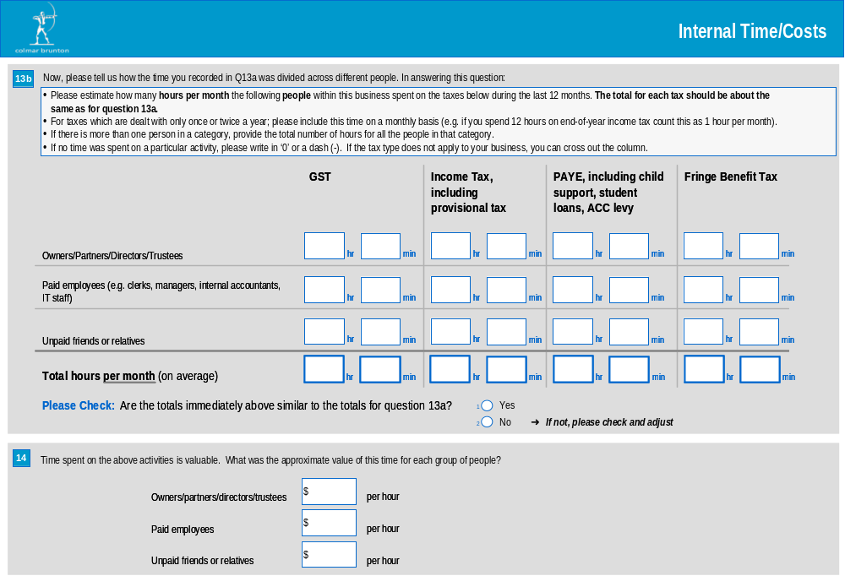
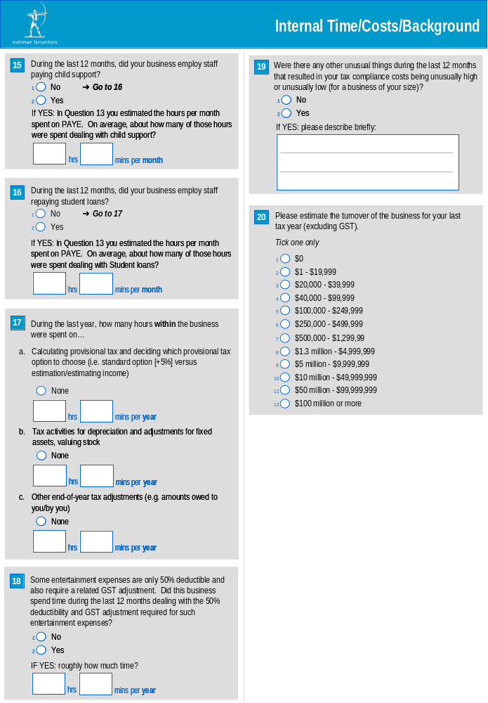
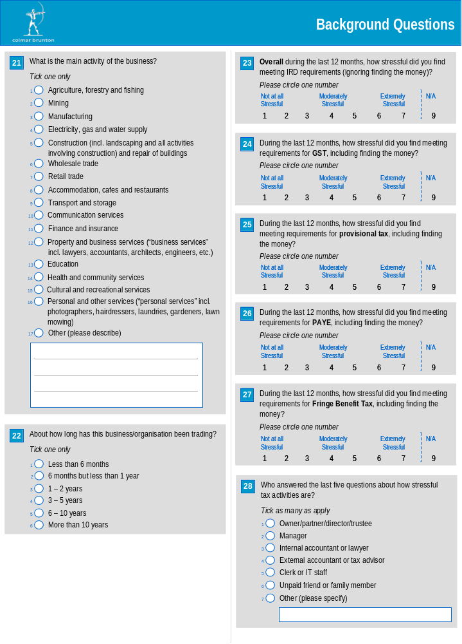
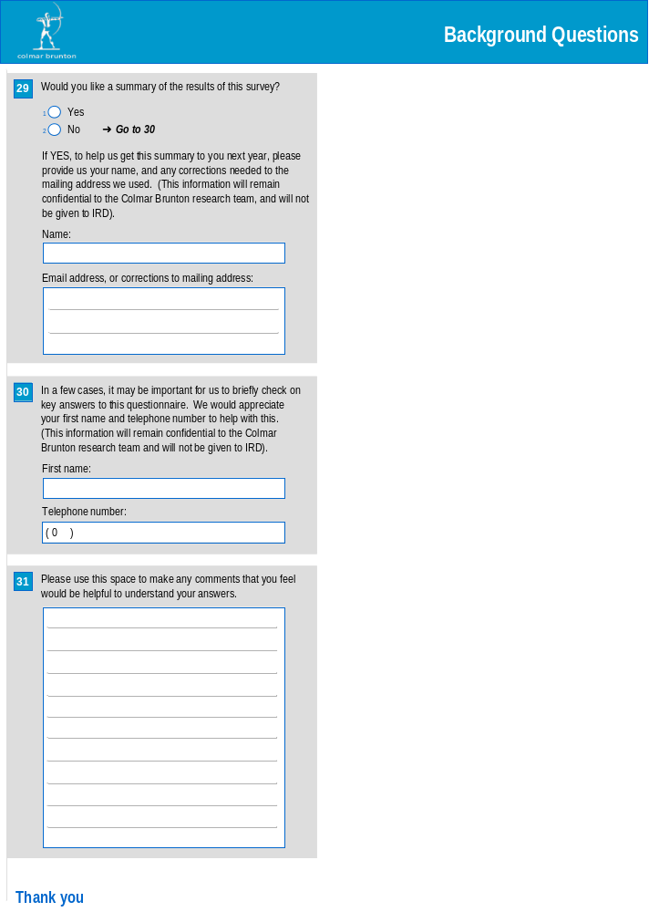

Two versions of the questionnaire were designed; a ‘long’ version of the questionnaire which was relevant to multiple tax type businesses, and a ‘short’ version of the questionnaire which was relevant to those paying income tax only. The questions in this short questionnaire were essentially a subset of the long (main) questionnaire.
Inland Revenue, ‘Our Statement of Intent’, 2004-2005, p23
The tax compliance costs of small and medium-sized business, C Evans and B Tran-Nam, ATAX, University of New South Wales, January 2004, page 12.
Note, individual self-employed entities were limited to those receiving income from business activity which was judged distinct from rental, investment or overseas income.
A series of editing rules were developed, and applied, regarding the interpretation of ‘blank’ rows.
This response rate is slightly underestimated because it does not exclude those businesses that were removed from the dispatch lists because of the ‘deduping’ process (that ensured businesses who had recently participated in a Colmar Brunton survey were not sent a questionnaire for this study). Further, some of the businesses that declined at the ‘consent’ letter stage may also have been removed at the ‘deduping’ stage had they reached this point.
IRD sent out letters to SMEs asking them to participate in a survey which measures their tax compliance costs. If they did not want to take part they had the opportunity of opting out.
‘Businesses’ for which IRD does not hold current address information were excluded on the basis that they are no longer trading businesses and hence ineligible.
6 respondents had ticked both income tax and another tax type, but were included in the final sample for analysis because they had clearly separated out these additional tax types in their responses at Q6a (under the category ‘other’).
‘Trimmed mean’ normally refers to a mean calculated after first removing a fixed percentage of values from the top and bottom of the distribution (eg a 5% trimmed mean is the average after 5% of the smallest values and 5% of the larges values have been removed). We used a more flexible trimming process in which the percentage of values trimmed varied depending on the extent to which a particular question elicited extreme values (outliers); only such outliers were removed before averaging.
The database contains both cases of ‘Value missing’ and ‘system missing value’. The former is what we have labelled as ‘missing information’ in this report. It refers to the situation when a respondent has not provided a response, but yet we would have expected them to have. Whereas a system missing value refers to the situation when a respondent has not provided a response and we did not require them to provide one (eg Questions pertaining to GST were not required to be answered by those who did not file/pay GST).
This refers to the total number of full-time employees plus the total number of part-time employees.
Due to some businesses experiencing marked variability in employee numbers over a year, respondents were asked to estimate the number of employees they had at a particular point in time.
Odd figures here (16% of SMEs with nil employees paid PAYE) may be explained due to the questionnaire asking for information relating to a specific point in time e.g. number of employees at the end of last month, or respondent interpretation e.g. the income tax of Partnerships.
The mean values are trimmed. The median values are not trimmed. See explanation on the trimming of means in the report chapter entitled ‘Research Methodology’ for more detail.
Much larger discrepancies occurred between the similar questions in a major Australian survey. For example, median annual hours spent on all tax activities for ‘medium’ businesses (turnover between $100,000 and $10 million) was 132 hours, whereas when measured in response to list of different tax types median time was only 48 hours (Evans et al., 1996, pp.125, 129).
Previous research conducted for Inland Revenue (Colmar Brunton, On-time filing and paying compliance, June 2004) indicates that 63% of employers would pay their staff, and 8% would pay their suppliers, before IRD if they faced cashflow difficulties. Just 26% would give priority to IRD. In contrast, IRD is the payment priority for 57% of businesses without employees; 34% would pay suppliers before IRD.
Due to some businesses experiencing marked variability in employee numbers over a year, respondents were asked to estimate the number of employees they had at a particular point in time.
Note this result is in relation to Q5. The figure is different to the results presented in Chapter 7 on Payroll Services which relate to Q12a.
33% of electronic filers are medium-sized SMEs (compared to 2% of manual filers), 30% are small (compared to 16% of manual filers), 33% are micro (compared to 69% of manual filers) and 5% currently have no employees (compared to 13% of manual filers).
Due to some businesses experiencing marked variability in employee numbers over a year, respondents were asked to estimate the number of employees they had at a particular point in time.
Excluding payroll and audit costs

