David Cunliffe address to 2002 tax conference of the Institute of Chartered Accountants of New Zealand, 11 October 2002

I am very pleased to have the opportunity to address your annual tax conference today.

It is my honour to represent the Minister of Finance and Revenue, Hon Dr Michael Cullen, for whom it is my privilege to serve as Parliamentary Private Secretary.

Dr Cullen could not be here today as he is in a high level forum on growth strategy with 60 of NZ’s top CEOs and the PM in Parliament. He sends his best wishes – and me.

As his PPS I have responsibility for specific projects as instructed by the Minister, currently in aspects of the value for money and growth strategies. It is also my pleasure to represent him on occasions such as this.

However, in the nature of full disclosure, I have a confession to make: I am not a tax specialist.

Before entering Parliament I trained in economics and politics, and worked as a diplomat and then in management consulting.

Since I was elected to Parliament in 1999 I have served on the Finance and Expenditure Committee, through which I have been involved in the many issues raised in taxation bills.

Taxation is an area of great complexity and great importance. Along with other members of the Finance and Expenditure Committee I have come to appreciate the enormous contribution the Institute of Chartered Accountants makes to tax policy development. Sometimes we agree with you, and sometimes we do not. But your views always deserve careful consideration, and very often are instrumental in guiding the select committee’s consideration. I would like to offer a personal tribute to Chris, Alan, Jeff, Julia, Aylton, John and the rest of the team for their work with FEC.
In my speech today I shall focus on the government’s growth and innovation framework and, in particular, on how tax policy initiatives over the next two years will contribute to that. I will then outline some of the other key aspects of the government’s tax policy work programme announced yesterday by Dr Cullen.

The government’s growth and innovation framework

The aim of the government’s growth and innovation framework is to lift New Zealand’s economic performance. Our goal is to return our per capita income to the top half of the OECD rankings over time. We have had an improved rate of growth over the last decade, compared to the OECD average and this year we could be looking at a rate approaching 4%. However, in order to sustain and lift this we must improve the total factor productivity growth rate.

Step one is to recognise the importance of sound fundamentals: a healthy fiscal balance, an independent monetary policy, a world class education system, and the quality social services needed to retain and develop a high calibre workforce.

Step two is to use smart techniques to accelerate New Zealand’s ability to become a source of high-value innovation in particular sectors of the global economy. The government believes the problem must be tackled on several fronts:

- by developing and retaining New Zealanders’ skills and talent and attracting overseas talent to live and work here;
- by enhancing the innovation system to allow better commercialisation of our ideas;
- and by increasing what is called our “global connectedness” – attracting more foreign direct investment, improving our export promotion, and modernising New Zealand’s branding.

With this strategic framework the government will also be focusing its resources on several areas of the economy that have the potential to leverage productivity and growth across the economy: biotechnology, information and communications technology, and the creative industries.

In summary then, the government’s growth and innovation policy framework sets out a way of identifying what is needed to achieve long-term improvements that will get us there. It involves a whole-of-government approach, in partnership with business and industry.

As an example of this approach, at a practical level, the government has already begun a number of initiatives aimed at facilitating business growth. These initiatives are targeted at businesses at all stages of the business life-cycle, as shown in figure 1.
Figure 1: Working with business

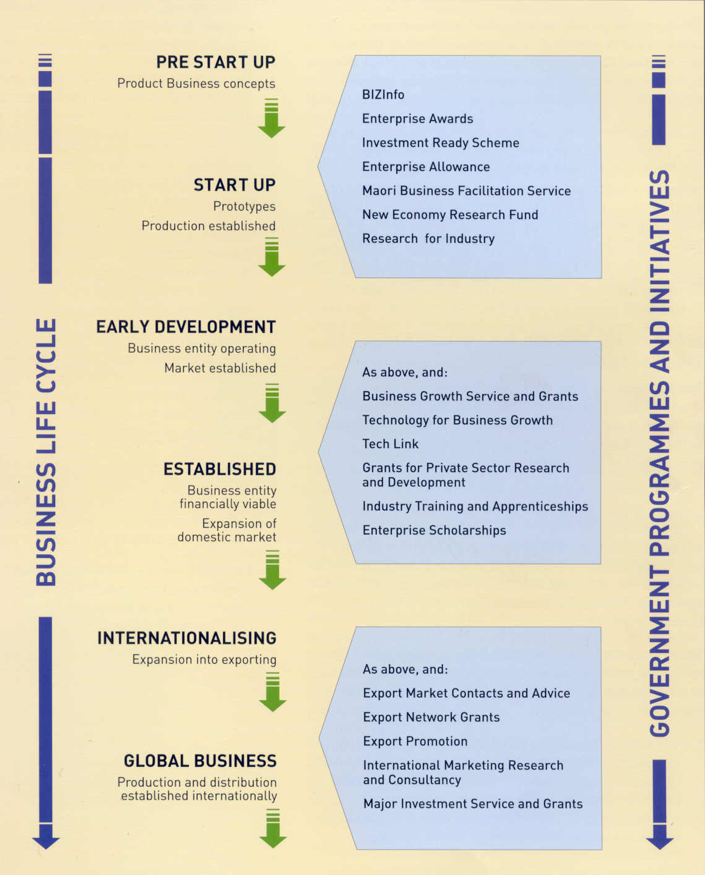
Role of tax in the growth and innovation strategy

Given the important relationship of tax and business, the government’s growth and innovation goals require tax policy that is both innovative and sound. Tax policy must support the government’s fiscal position, while ensuring that business decisions are made for good business reasons – not for tax reasons.

With this proviso, it has the potential, if properly used, to assist and reinforce the key levers of productivity growth.

If used poorly it can have the reverse effect - the Muldoon government of the late 1970s and early 1980s used tax policy to encourage things it wanted to see happen and to discourage things it did not approve of. The result of uncoordinated and heavy-handed interventions was a jumble of incentives and disincentives that created numerous, sometimes gross, distortions.

From the mid-1980s to late 1990s, the pendulum swung radically in the other direction, towards a broad-base, low-rate model that offered little room for the tax system to shape economic decisions.

However, the disappointing growth performance over the decade of the 1990s as a whole, and the increasing social division and dislocation which emerged with it, left a majority of New Zealanders convinced that the neoclassical model had produced too little gain, for too much pain.

Moreover, neoclassicism applied with puritanical zeal in a remote, small economy, was demonstrably unable to provide the rate of increase in productivity growth we need to realise our economic and social goals.

There are some people still alive and in politics today who, like broken records, are stuck on the same old track. That LP fell off the hit parade about 1999 and can now only be bought in curiosity shops.

Over the last three years the model has evolved again. We have demonstrated a moderate, pragmatic approach to smart, active government. Within that we see tax policy as having a positive role to play in building a fairer society.

We agree with the McLeod Tax Review that the basic architecture of our tax system is sound and should not be radically altered. In the election Labour made a commitment that it would not increase income tax or GST. We will keep to that commitment.

We also agree with the McLeod report that we would not be better off with a general capital gains tax, death duties or similar tax measures used in other countries.

The sound, sensible, relatively simple tax system that we have in New Zealand is a key competitive advantage internationally. We will keep that. But there may be features of the tax system that are proving to be a barrier to growth and innovation, and we are keen to identify them and remove them where we can.

The government has identified three areas on which we should focus: international tax, compliance costs for small to medium-sized enterprises, and specific issues identified by various growth and innovation taskforces.

International linkages

One way tax policy can contribute to growth and innovation is to reduce the extent to which tax is a barrier to New Zealand doing business with the rest of the world. Good double tax agreements with key trading partners have an important role to play here. So do government efforts to ensure that our tax laws facilitate cross-border business.

More radical changes to the tax system to rationalise the taxation of outbound investment and to make New Zealand more attractive to overseas capital and migrants were proposed by the Tax Review in its report to the government just under a year ago.

The government is continuing to consider and consult on these recommendations. One, relating to New Zealanders’ offshore portfolio equity investments, is – in certain circumstances – to apply a simpler, risk-free rate of return method of taxing investments.

Another Tax Review recommendation under consideration is aimed at attracting highly skilled, high-income migrants to work and live here. The idea would be to grant them an exemption for a limited period from taxation in New Zealand on certain foreign-sourced income.

A third Tax Review recommendation relating to international taxation was to reduce the tax burden on new foreign direct investment from 33 percent to 18 percent, in the case of company tax. As the Minister of Revenue announced at the time of the May budget, the government had been advised by officials that the proposal was unworkable, except as a transitional measure.

The Minister said that before he concluded his consideration, however, he would release officials’ analysis of the proposal for comment from interested parties. That report is now available at this conference and on the website of the Policy Advice Division of Inland Revenue. The release of the report is a further step in the policy development process, and, meanwhile, officials are continuing to look at options in this area.

However, it is important to note that the government’s commitment to encouraging strategic foreign investment in high-leverage areas of the real economy is strong.

That is reflected in the creation of the new Investment Promotion Agency, and it is an area in which I will personally take a close ongoing interest.

Compliance costs for small to medium-sized enterprises

A second way tax policy affects growth and innovation is through the tax-related compliance cost of doing business.

The government is seeking to reduce the compliance costs of tax, with the spotlight on small to medium-sized enterprises, since they form a more significant part of the economy in New Zealand than they do in most other OECD countries.

New Zealand has an average of six employees per firm, whereas businesses in most other OECD companies average from ten to twenty employees each. Small to medium-sized businesses with fewer than twenty employees account for 97 percent of all businesses in New Zealand.

They are also important to the business income tax base, as shown in figure 2. Self-employed people who work on their own or businesses that employ five or fewer staff contribute 41 percent of business income tax revenue. The next significant contribution to the business income tax base, 26 percent, comes from a small number of large businesses, with relatively little from the middle.

Figure 2: New Zealand’s business income tax base by number of employees

-20
-10
0
10
20
30
40
50
60
70
80
90
100+
110
120
-20000
0
20000
40000
60000
80000
100000
120000
140000
160000
180000
cat
dog
dog
number of
employees
number
of firms
Income Tax
5 or fewer employees
41%
26%
100+ employees

The government is looking at both legislation and administrative practices to reduce compliance costs on small to medium-sized enterprises in particular. The compliance cost burden seems to fall on this group disproportionately, since many compliance costs are largely fixed, no matter the size of the business.

For example, when a business takes on its first employee it also encounters extra regulatory requirements in relation to PAYE, possibly fringe benefit tax, ACC, OSH and so on. The burden of doing so is little different for the first employee, the tenth or the hundredth. That’s why small business is most sensitive to compliance costs.

There is scope for improving tax design and tax administration to help reduce compliance costs for these businesses. But the emphasis now is moving from simplifying systems per se, to looking at how those systems impact on growing businesses – in other words, looking at the business life-cycle and tax impacts at the key moments in that life cycle.

The life-cycle approach involves looking at the different problems businesses face when they start up, once they are established, during expansion and on maturity or cessation.

Officials have been instructed to think outside the square. The government is keen to look at proposals that make for positive change, and not just tinkering with the system.

Nevertheless, we have to be realistic about tax-related compliance costs. There is a natural limit to how much compliance costs can be reduced for these businesses, especially when you consider that New Zealand imposes relatively low costs.

A recently published OECD survey on compliance costs in ten countries found New Zealand’s tax-related compliance costs to be at the low end of the scale, as shown in figure 3.

Figure 3: OECD figures on tax-related compliance costs for
companies with 1-19 employees
US dollars

Taskforces

A third way tax policy can contribute to growth and innovation is for the government to be open to the concerns of the various business sectors. This does not mean introducing tax incentives for target sectors. Rather, it means government and business working together to identify roadblocks to growth, and working in a co-operative way to unblock them.

A partnership between the government and the private sector is far more achievable in a country the size of New Zealand than in a large one. We have achieved a lot in this area, and it is a key international advantage for New Zealand.

The government is strongly committed to delivering real gains through partnership with the business and community. Only by the broader community understanding and owning the imperative that we must “play to win” as “team NZ” can we accelerate productivity gains to the necessary level in the increasingly complex global game.

As part of this approach, the government has chosen to focus resources on three key lateral areas that have been identified for their high-growth potential and, more importantly, their leverage value across the economy as a whole. They are biotechnology, information and communication technology, and the creative industries.

Figure 4: Growth and innovation framework

The government has set up a Growth and Innovation Advisory Board comprising representatives from the private sector to advise it on the overall implementation of the growth and innovation framework.

As shown in figure 4, four private sector taskforces working within the target sectors are also part of the growth and innovation framework. They are:

- the Biotechnology Sector Taskforce, which reports to the Minister of Research, Science and Technology;
- the Information and Communication Technology Taskforce, which reports to the Minister for Information Technology;
- and for the creative industries, the Screen Production Industry Taskforce and the Design Industry Taskforce, both reporting to the Minister for Economic Development.

These focus areas will help drive productivity gains across a range of specific industry sectors. Work is continuing with major sectors like dairy, forestry, fisheries, and others to accelerate the drivers and reduce the roadblocks to growth as we apply the emerging results of the lateral focus areas I have just described.

The various taskforces have been charged with identifying and considering measures that will help their sectors grow. Tax has already emerged as an issue as the taskforces progress their work, and officials are working closely with them to ensure that tax issues can be properly considered from different perspectives.

The government expects there to emerge from this work a small but important package of useful tax issues that are central to the growth and innovation strategy. They will then be progressed through the normal generic tax policy process.

A tax issue that has surfaced so far is the way the shareholder continuity rules affect small, rapidly growing companies. This does not mean allowing larger companies to shelter income by buying the tax losses incurred by others. We have rules to stop this and we do not intend to alter that position.

However, those rules also mean that when a small company with a history of tax losses introduces a new equity partner as it expands it can lose all its accumulated losses. This can hinder the growth of such firms for reasons unrelated to tax loss trading. We need to see whether we can protect the tax base without such adverse consequences.

The taskforces are looking at identifying a small number of issues of a similar nature. We also need to confirm that the new research and development tax rules deliver the intended policy result.

R&D

The last few days have seen renewed comment in the media on research and development expenditure. There has been a call for more private and public sector investment in R&D from the Knowledge Wave Trust. Larry Ellison of Oracle has also been reported as saying he is looking at setting up an R&D facility here in New Zealand.

In 2001 the government changed the law relating to the tax treatment of R&D expenditure, aligning it more closely with the accounting treatment. This Institute helped the government to develop that reform. What the change meant was that, in practice, expenditure that most jurisdictions consider to be R&D is immediately deductible for tax purposes.

The government chose to allow immediate deductions rather than take the road of Australia, which allows more than 100 percent deductibility for some types of R&D expenditure, but is surrounded by complex rules and red tape to protect the revenue base. Instead, the government supplemented immediate deductibility with more generous R&D grants.

A liaison group of private sector people, Dr Cullen and Mr Hodgson has been set up to ensure that the new rules operate as intended, though we think we have solved most of the problems that people identified with the uncertainties of the previous rules. The government is keen to hear if problems arise in the interpretation of the new rules.

Update on other major issues

GST and financial services

You will no doubt be aware of the release earlier this week of the government discussion document on proposed changes to the GST treatment of financial services. These are the latest proposals to emerge from the government’s continuing review of the GST legislation.

I am aware that New Zealand’s GST is regarded internationally as a model for its simplicity and for its comprehensive coverage, although the financial services area is one of the few exemptions. The aim of the latest discussion document is to broaden the ambit of GST to enable financial institutions to be treated more like other businesses.

The government is therefore proposing to bring more financial services within the GST system, and one means of achieving this is by zero-rating the supply of these services to registered businesses. This would enable financial institutions to recover GST on purchases related to the supply of their services to businesses.

Tax and privilege

I see from your programme that tax privilege is the subject of tomorrow’s keynote address. As you know, in a discussion document released in June for public comment, the government proposed a new code for tax and privilege to replace the current legal privilege in tax matters.

Submissions on the proposals have been received, and the government is now considering them. Needless to say, the submissions demonstrate a variety of views on the proposals. It will be interesting to see what new perspectives emerge from this conference’s consideration of the proposals.

Compliance and penalties review

The first stage of the government’s compliance and penalties review is nearing completion. The bill containing major reforms to the taxpayer debt and hardship rules in the Tax Administration Act is close to enactment. Another bill containing further changes arising from the review – in relation to shortfall penalties, Inland Revenue’s information-gathering powers, and a new promoter penalty – is being considered by the Finance and Expenditure Committee.

The government is planning a broader look at the legislation for the second stage of the compliance and penalties review, together with a number of technical problems that need sorting out, many of which were raised in submissions. The work will include an investigation of whether the current rules are improving voluntary compliance.

Triangular taxation

Plans for a joint New Zealand-Australian approach to relieving double taxation of investments in companies that operate in both countries are progressing. Following the release of the joint discussion document in March, both governments have considered the submissions and have undertaken further consultation. The next step is for legislation to be introduced in both countries. There is a good chance that this could happen next year, the twentieth anniversary of CER with Australia.

Tax policy work programme

More information about current tax policy issues is to be found on the government’s tax policy work programme, which was released yesterday. The programme is built around the two planks of supporting the government’s growth and innovation framework and its policies to build social cohesion. This is where most tax policy resources are going. Also included in the work programme are base maintenance measures to protect the revenue stream that have not been announced, though work on them is continuing, you will be pleased to know. The work programme also includes a number of initiatives that are already in progress, such as the review of credit unions.

To conclude, she’s a hard road finding the perfect tax system. Perhaps this conference provides the tax equivalent of a brewery tasting vault.

I hope my comments today have thrown light on where the government’s growth and innovation framework is going, and the role of tax policy in contributing to growth and innovation.

Thank you.

